VIET NAM NATIONAL UNIVERSITY HO CHI MINH CITY
HO CHI MINH CITY UNIVERSITY OF TECHNOLOGY
FACULTY OF ELECTRICAL AND ELECTRONICS ENGINEERING
DEPARTMENT OF ELECTRONICS

THESIS PROPOSAL
DESIGN OF A 32-BIT RISC-V PROCESSOR

Proposed Supervisor: PhD. TRAN HOANG LINH
Student: CAO XUAN HAI
Student ID: 1510903
Ho Chi Minh City, June 2019
Vietnam National University HCMC  HCMC University of Technology  -----✩-----  No.: _________/________  Faculty of Electrical and Electronics Engineering  Department of Electronics | SOCIALIST REPUBLIC OF VIETNAM  Independence – Freedom – Happiness  -----✩-----
THESIS DUTIES
- Student: CAO XUAN HAI Student ID: 1510903
- Major: ELECTRONICS ENGINEERING Class: DD15KSVT
- Title of thesis: DESIGN OF A 32-BIT RISC-V PROCESSOR
- Thesis duties:
  - Design and analyze of 32-bit RISC processor using pipelining.
  - Implement the processor on an FPGA kit.
- Date of thesis receiving: November 30, 2018
- Date of thesis finishing:
- Proposed supervisor: PhD. TRAN HOANG LINH
Content and requirements of the thesis are approved by Head of Department.
Ho Chi Minh City, , 20  HEAD OF DEPARTMENT  (Signature) | PROPOSED SUPERVISOR  (Signature)
FOR DEPARTMENT USE ONLY
Approved by:

Date approved:
Final grade:
Thesis archive:

ACKNOWLEDGEMENT
To aid students perfectly prepare their thesis, Bach Khoa University, formerly Ho Chi Minh City University of Technology, opens a course called “Thesis Proposal”. It is useful for all students since they have two semesters to complete their thesis.
As a senior in the university, I am working on my thesis proposal under the help of my teacher, PhD. Tran Hoang Linh. Therefore, I would like to express my special thanks of gratitude to him for his guidance and support. I came to know about so many new things, and gained valuable skills.
I would like to thank my friends in the university, for without their guidance, I would be lost in the difficulty of designing a processor.
I am looking forward to hearing the instructions and advices of my supervisor, other teachers, and my friends to make the thesis better.
Ho Chi Minh City, June 13, 2019
Student

CAO XUAN HAI

TABLES OF CONTENTS
ACKNOWLEDGEMENT i
TABLES OF CONTENTS ii
LIST OF TABLES iv
LIST OF FIGURES v
LIST OF SYMBOLS AND ABBREVIATIONS vii
CHAPTER 1. INTRODUCTION 1
1.1 Processor Design 1
1.2 Literature review 2
1.2.1 The demand of ISA 2
1.2.2 Design of processor in reality 3
1.3 Thesis purpose 4
CHAPTER 2. CONTENT OF THE THESIS 5
CHAPTER 3. SOLUTIONS 6
3.1 RISC-V ISA 6
3.2 SystemVerilog 7
3.3 The concept of pipelining 8
3.4 The concept of BTB, RAS 11
3.4.1 BTB 11
3.4.2 RAS 14
3.5 Interrupt 15
3.6 AMBA bus protocol 16
3.6.1 APB 16
3.6.2 AHB-lite 16
3.7 Design of a 32-bit processor 21
3.8 DE10 – FPGA kit 26
CHAPTER 4. EXPECTED RESULTS 27
4.1 Preliminary results 27
4.1.1 Testbench 28
4.2 Expected result 31
CHAPTER 5. PROCEDURE 32
APPENDIX A. TESTBENCH SORTING AN ARRAY 33
APPENDIX B. DE10 SPECIFICATION 34
REFERENCES 37

LIST OF TABLES
Table 1.1 Summary of several ISAs 2
Table 3.1 Comparison of three HDLs 7
Table 3.2 AQUAcore specification 21
Table 4.1 AQUA Progress log 27
Table 5.1 The procedure for the other works of thesis 32

LIST OF FIGURES
Figure 1.1 The Intel 4004 processor 1
Figure 1.2 Moore's Law 3
Figure 3.1 The laundry analogy for pipelining 8
Figure 3.2 Illustrate pipeline operation 9
Figure 3.3 Example of structural hazards – Read and Write at the same time 9
Figure 3.4 Example of data hazards – Read after Write 10
Figure 3.5 Example of control hazards – Branch instruction 10
Figure 3.6 Prefetch diagram 11
Figure 3.7 A Branch-Target Buffer 12
Figure 3.8 Tagged BTB 13
Figure 3.9 BTB and BHT 13
Figure 3.10 2-bit counter scheme 14
Figure 3.11 APB – Write transfer 17
Figure 3.12 APB – Write transfer with wait states 17
Figure 3.13 APB – Read transfer 18
Figure 3.14 APB – Read transfer with wait state 18
Figure 3.15 AHB-lite– Write transfer 19
Figure 3.16 AHB-lite– Write transfer with wait states 19
Figure 3.17 AHB-lite – Read transfer 20
Figure 3.18 AHB-lite – Read transfer with wait state 20
Figure 3.19 AQUA processor 21
Figure 3.20 Datapath of AQUAcore (in progress) 22
Figure 3.21 AQUAcore with two memories 23
Figure 3.22 Enable signal and ready-structure of AQUA 24
Figure 3.23 The relationship of flush signal and valid signal 24
Figure 3.24 The top-layout of DE10 26
Figure 4.1 Data in Data Memory 28
Figure 4.2 The result of the testbench in Transcript window 29
Figure 4.3 The waveform of bubble sort testbench 30
Figure B.0.1 Block Diagram of the DE10-Standard Board 36

LIST OF SYMBOLS AND ABBREVIATIONS
AHB-lite | Advanced High-Performance Bus
AMBA | Advanced Micro-controller Bus Architecture
APB | Advanced Peripheral Bus
BHT | Branch History Table
BTB | Branch Target Buffers
CISC | Complex Instruction Set Computer
CPU | Central Processing Unit
FPGA | Field Programmable Gate Array
IC | Integrated Circuit
ISA | Instruction Set Architecture
PC | Program Counter
RAS | Return Address Stack
RISC | Reduced Instruction Set Computer

INTRODUCTION

Processor Design
In 1823, Baron Jons Jackob Berzelius discovered Si, which is the key component of processors. With the help of Ted Hoff, Intel released the Intel 4004 on November 15, 1971. The 4004, the first stand-alone computer processor, contains 16 registers of 4 bits each; its maximum clock rate is 740 kHz. This amazing processor can execute 60,000 operations per second.
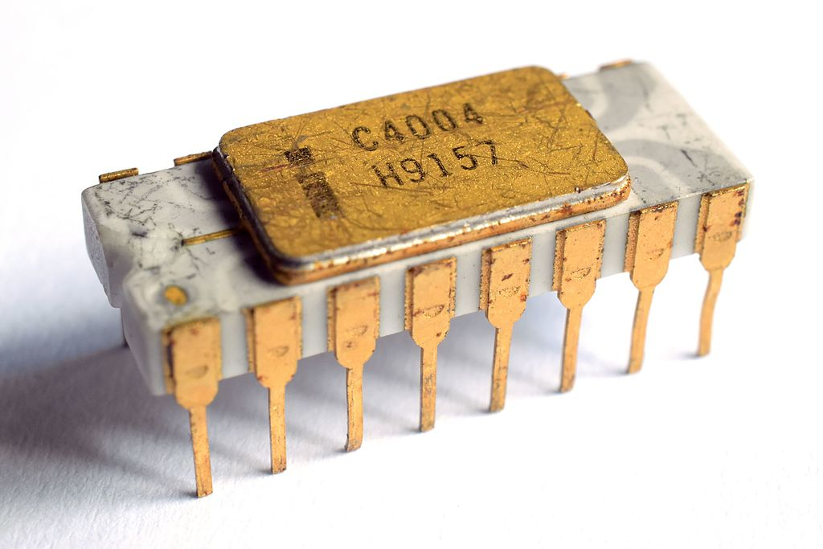
Figure 1.1 The Intel 4004 processor
Gradually, with the incredible development of semiconductor technology, processors come with a huge numerous of transistors, which in turn make them powerful. Modern processors are faster today. For instance, the Core i7 CPU – 9700K – can run at 4.9 GHz, and use the 64-bit instruction set.
How can processors be more powerful? – Processor Design. Concerning processor design, an engineer must do some researches on ISA and structure of a CPU, these things will be discussed in the following.
To have a deep understand of processors, this proposal is about some popular techniques using in this field, and design of a new one.

Literature review

The demand of ISA
ISA, as known as Instruction Set Architecture, is defined as the set of instructions that a processor can understand. Spending a lot of time designing an ISA is not a good choice, now that there are a large number of commercial ISAs. Therefore, reusing one of them would help engineer avoid some bugs and cost of porting software to the new one.
There are two key philosophies of design of ISA: complex (CISC) and reduced (RISC).
The first term stands for “Complex Instruction Set Computer”, it is rooted in the computing history. A command is an instruction, and an instruction is a compound of several “micro-instruction”. As a result, decoding an instruction of CISC is complicated. An instruction of CISC takes several cycles – two to ten machine cycles - to be executed. In this kind of ISA, instruction pipelining is not easily implemented. The most notable CISA ISAs are Motorola 68k and Intel x86 architecture.
The other stands for “Reduced Instruction Set Computer”. As a opposite side of CISC, most of its instructions are performed in only one machine cycle. Beside this, decoding its instructions is easy, since the instruction is modest and simple. That is crucial for pipelining the CPU to reach the best performance. ARM, MIPS, PowerPC… are the most well-known of RISC ISAs.
The table below shows the comparison of several ISAs.
Table 1.1 Summary of several ISAs
 | MIPS | SPARC | Alpha | ARMv7 | ARMv8 | OpenRISC | 80x86
Free and Open |  | Yes |  |  |  | Yes
64-bit Address | Yes | Yes | Yes |  | Yes | Yes | Yes
Compressed  Instructions | Yes |  |  | Yes |  |  | Partial
Separate Privileged ISA |  |  | Yes
Position-Indep. Code | Partial |  |  | Yes | Yes |  | Yes
IEEE 754-2008 |  |  |  |  | Yes |  | Yes
Classically Virtualizable | Yes | Yes | Yes |  | Yes
The world is now in a trend, called “open-source”. That makes engineer and even companies take a look on the giant advantages of “open-source ISAs”. When they are open, all engineer and companies in the world would work on them together, make them more and more powerful.
However, look at the table 1.1, Open-RISC and SPARC lack of some crucial features. Fortunately, a free and open ISA was created in the Computer Science Division of the EECS Department at the University of California, Berkeley. It is RISC-V. This ISA is used to design the CPU in this thesis.

Design of processor in reality
The world is facing the depression of Moore’s Law. The law states that the number of transistors per square inch on integrated circuits had doubled every year since the integrated circuit was invented.
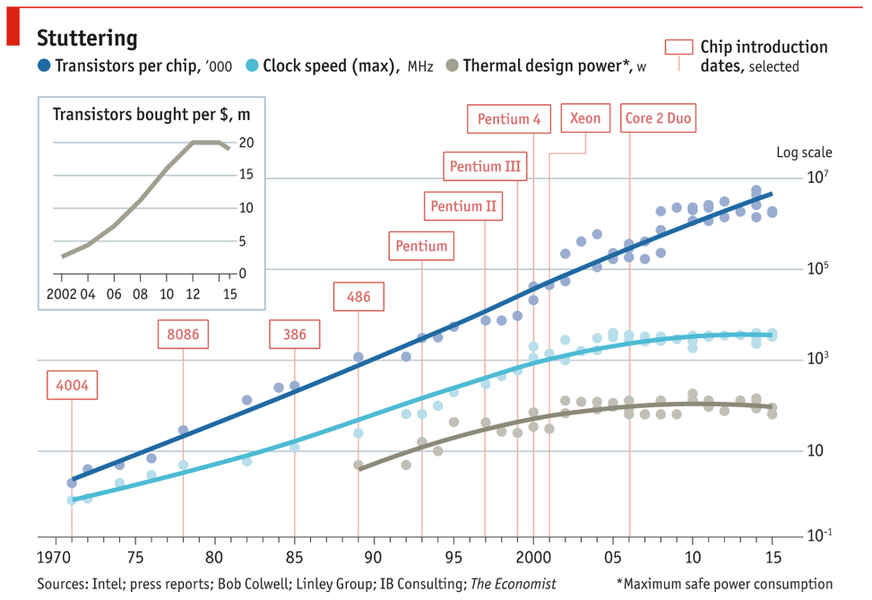
Figure 1.2 Moore's Law
Because of the limitation of physical design, transistors are now reaching the limit of size. It is impossible to make them smaller, since the power to cool down them are larger than the power already passed them.
As a result, thinking another way to improve the performance of IC, CPU… is the wisest choice since reducing the size of transistors is impossible. In terms of processor design, one of the easiest ways to make the CPU faster is pipeline. This technique is also used in this thesis.

Thesis purpose
With these above discusses, this thesis is about:
Design of a 32-bit RISC-V processor with these requirements:
- Processor - RV32IF.
- The pipeline technique with BTB and RAS.
- At least 1 AMBA buses.
- Interrupt is optional.
This processor is for academic purpose, helping students understand how a CPU operates.
In addition, with a lot of work on it, the author hopes it becomes one of the good choices of processors to use in reality. Beside this, designing core using RISC-V ISA, may it contribute to the incredible growth of “open-source” hardware.

CONTENT OF THE THESIS
To reach the best result, the following tasks must be completed:
- Understand the RISC-V ISA: RV32IF.
- Understand the basic of System Verilog language.
- Understand the pipelining method.
- Understand the BTB, RAS principle.
- Understand the work of interrupt.
- Understand the work of AMBA bus protocol.
- Design of a 32-bit processor.
- Implement the design on an FPGA kit – DE10.

SOLUTIONS

RISC-V ISA
RISC-V (pronounced “risk-five”) is a new ISA, designed by the University of California, Berkeley. Originally, it was designed for research and education, but with its considerable
benefits, the creators hope it will become a standard free and open architecture for industry
implementations.
What benefits are RISC-V bringing?
- Separate the ISA into a small base ISA and optional extensions. When the base ISA is good enough to be used for educational purposes, optional extensions are for some specialized purposes.
- Not only 32-bit address space, but also 64-bit one is supported. That is vital for applications, operating system kernels, and hardware implementations. The creators also work on 128-bit address space.
- Support for highly-parallel multicore or many-core implementations, including heterogeneous multiprocessors.
- Optional variable-length instructions to both expand the encoding space of possible
custom instructions and improve performance.
- Support for modern standard, such as the revised 2008 IEEE-754 floating-point
standard.
- New privileged architecture designs.
The RISC-V Instruction Set Manual is the best resource to clearly understand this ISA.
Since this proposal is about design of RV32IF, understanding the I – Integer extension,
F – Single Precision Floating-Point, and Zicsr – Control and Status Register Access is needed.

SystemVerilog
When the gap between design language (VHDL, Verilog…) and verification language (C, C++…) is large, a language that inherited from Verilog and C++, like SystemVerilog, is one of the optimal solutions.
In fact, SystemVerilog is an extensive set of enhancements to the Verilog-2001 standard. Thanks to them, it is superset of Verilog.
The advantages of SystemVerilog over other HDLs:
Table 3.1 Comparison of three HDLs
 | VHDL | Verilog-2001 | SystemVerilog
Strong typing | Yes | No | Yes (not as strong as VHDL)
User-defined types | Yes | No | Yes
Dynamic memory  allocation | Yes | No | Partial
Physical types | Yes | No | No
Named events | No | Yes | Yes
Enumerated types | Yes | No | Yes
Records/Structs | Yes | No | Yes
Data packing | No | No | Yes
Conditional  statements | Yes  - If-then-else/elsif  - Case  - Selected assign  - Conditional assign  - No “don’t care” matching capability | Yes  - If-else  - Case  - Casex  - ? : | Yes  (Same as Verilog)
Iteration | Yes  - Loop  - While-loop  - For-loop  - Exit  - Next | Yes  - Repeat  - For  - While | Yes  (Same as Verilog)  - Do-While  - Break  - Continue
Assertions | Partial | No | Yes
In this proposal, SystemVerilog is used to design the processor.

The concept of pipelining
When the processor works correctly, the next step is dealing with time – reducing the execution time. However, decrease the time for instruction execution is impossible. As a result, increasing the number of instructions at a moment would solve this problem.
Pipelining is a technique where multiple instructions are overlapped in execution. The computer is divided in several stages. Each stage completes a part of an instruction in parallel. They are connected to one another to form a pipe. Instructions enter at the beginning stage, progress through the stages, and exit at the last stage.
Each stage will complete its job in a period of time called machine cycles. The length of cycles is the time required for the slowest stage. After a machine cycles, each of them will move its data to the next stage and receive the new data from the previous stage.
The figure 3.1 is an example for pipelining method.
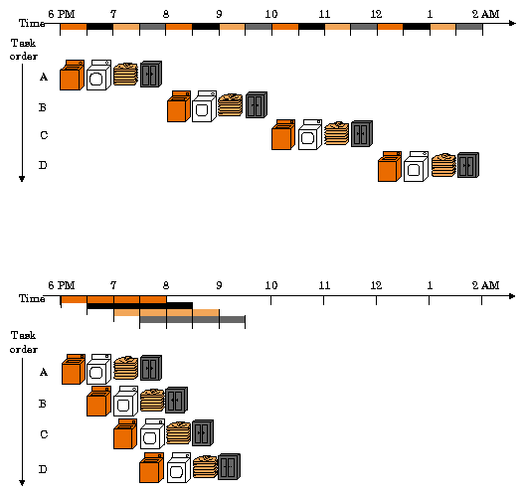
Figure 3.1 The laundry analogy for pipelining
DLX is one of the most famous architecture using pipeline. The core designed by DLX method is separated into five stages: IF – Instruction Fetch, ID – Instruction Decode, EX – Execute, MEM – Memory, WB – Write Back.
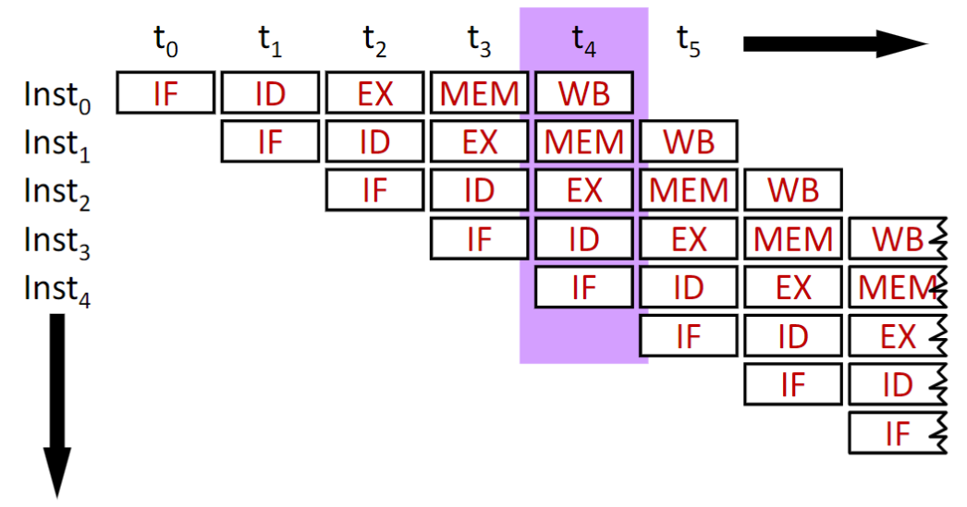
Figure 3.2 Illustrate pipeline operation
Nevertheless, this technique will make the programmer face some problems:
- Structural Hazards: They arise from resource conflicts when the hardware cannot support all possible combinations of instructions in simultaneous overlapped execution. For instance, when memory is only read and not written data at the moment and otherwise, read and write requests sent to memory at the same time will make a bug.
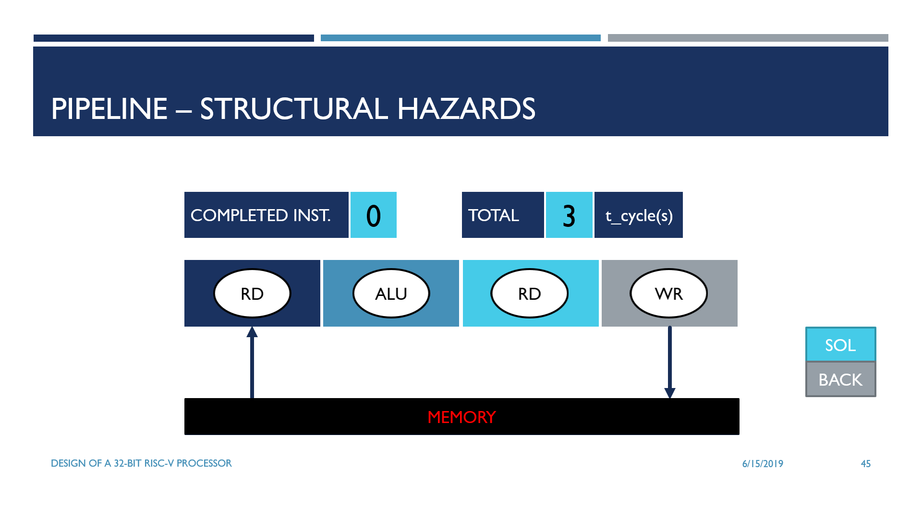
Figure 3.3 Example of structural hazards – Read and Write at the same time
  - Solution: Using nop (no operation).

- Data Hazards: They arise when an instruction depends on the result of a previous instruction in a way that is exposed by the overlapping of instructions in the pipeline. For example, since the previous operation is not completed, in other words, the previous result is not stored in register file, the present operation will produce wrong value if it is using the previous result.
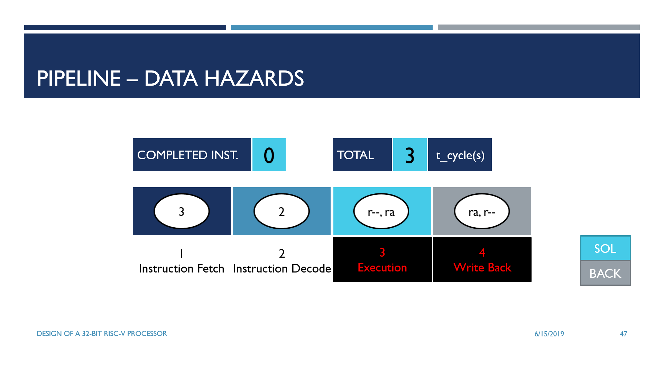
Figure 3.4 Example of data hazards – Read after Write
  - Solution: Forwarding data.
- Control Hazards: They arise from the pipelining of branches and other instructions that change the PC. In the example below, the branch instruction wants to jump to the “4” instruction. However, after it enters the next stage – Instruction Decode, the next instruction is not “4” but “1”.
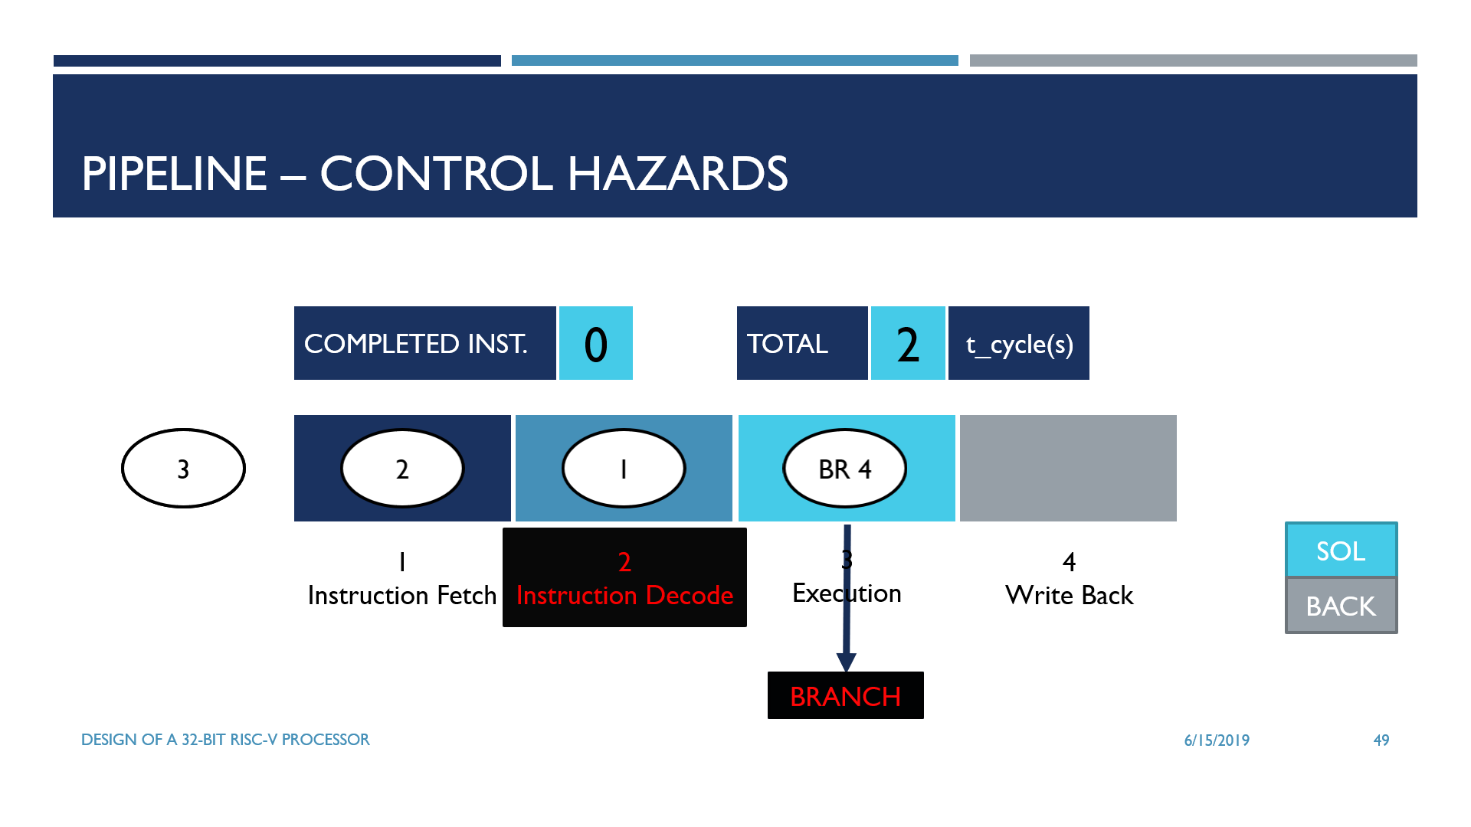
Figure 3.5 Example of control hazards – Branch instruction
  - Solution: Using BTB and RAS.

The concept of BTB, RAS
To solve the control hazards problem, BTB and RAS is one of the best approaches. The figure 3.3 is about Prefetch module, usually placed in the Instruction Fetch stage in order to predict the next PC and get instruction from Instruction Memory or Instruction Cache.
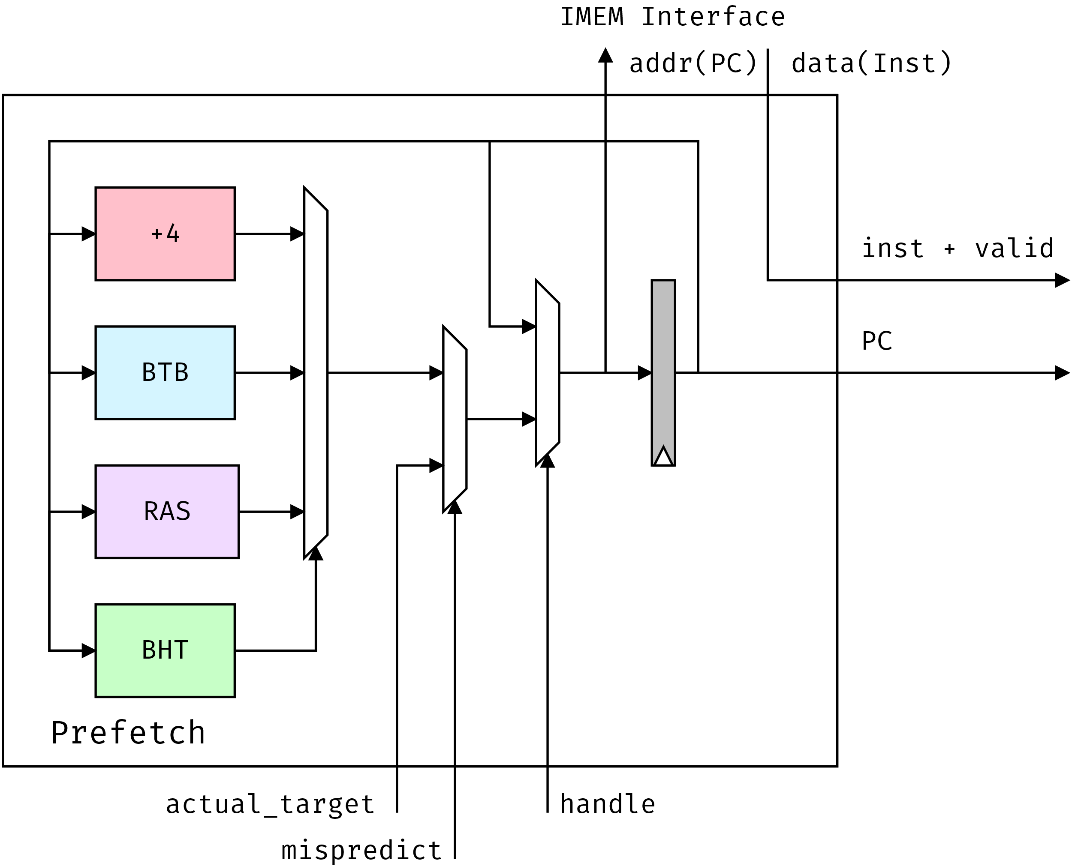
Figure 3.6 Prefetch diagram

BTB
BTB, as known as Branch Target Buffers, is a buffer that stores the branch address of
conditional branch instructions or jump address of unconditional jump instructions. This buffer usually comes with a buffer call BHT, Branch History Table, which predicts a branch/jump instruction will “taken” or “not taken.”
Why do we need BTB?

If the computer always executes control transfer instructions as “not taken”, it will cost 4.8 machine cycles per a control transfer instruction.
If the computer always executes control transfer instructions as “taken”, it will cost 2.14
machine cycles per a control transfer instruction.
However, with BTB and BHT, the time of execution control transfer instructions will be less than 1.57 machine cycles per a control transfer instruction.
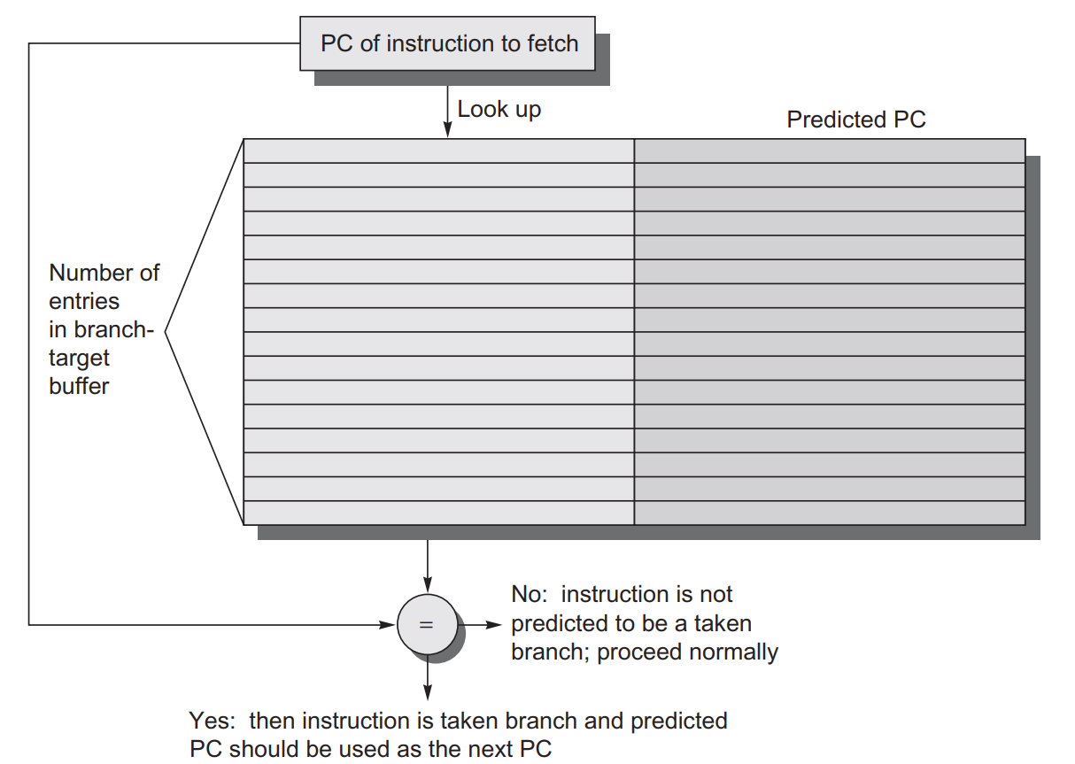
Figure 3.7 A Branch-Target Buffer
Basically, the PC is divided into two part, the first one is called “tag”, the other is “index”. With 32-bit address, there are $2^{32-2}=1073741824$ available instructions stored in Instruction Memory. It is too wasted to save all of them.
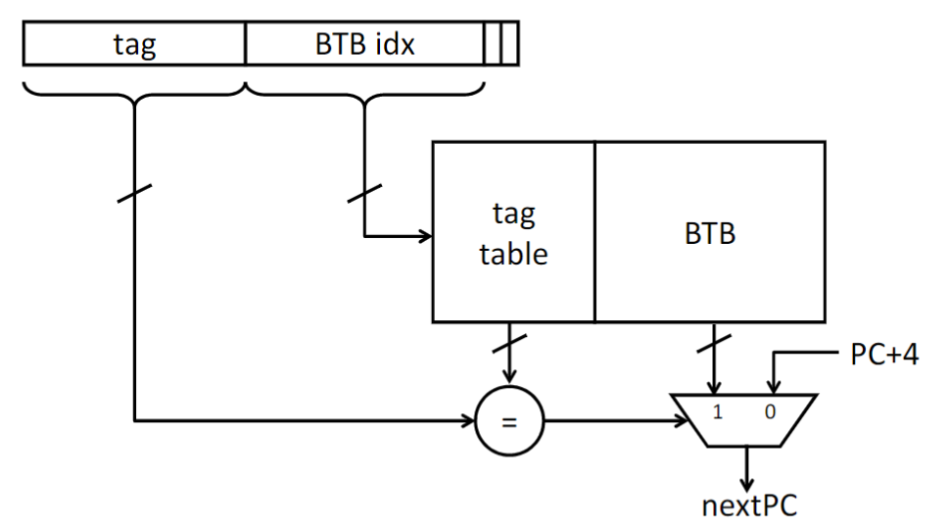
Figure 3.8 Tagged BTB
Two least significant bits are always 2’b00, so they could be eliminated. N bits of “BTB idx” called “N-bit PC”; the BTB has $2^{N}$ entries. As the core conforms that an instruction is control transfer instruction, BTB gets the index from “BTB idx” of its PC, and then saves its “tag” and its “target”, address that PC jumps to, if the result of the instruction is “taken”. For instance, if the BTB is “8-bit PC”, this buffer has $2^{8}=256$ entries in total. However, there are $2^{32-2-8}=4194304$ address that have the same “BTB idx”. For that case, updating the “target” and “tag” is necessary, that is trade-off.
The BHT plays a role as branch-prediction. It generates a signal called “taken”.
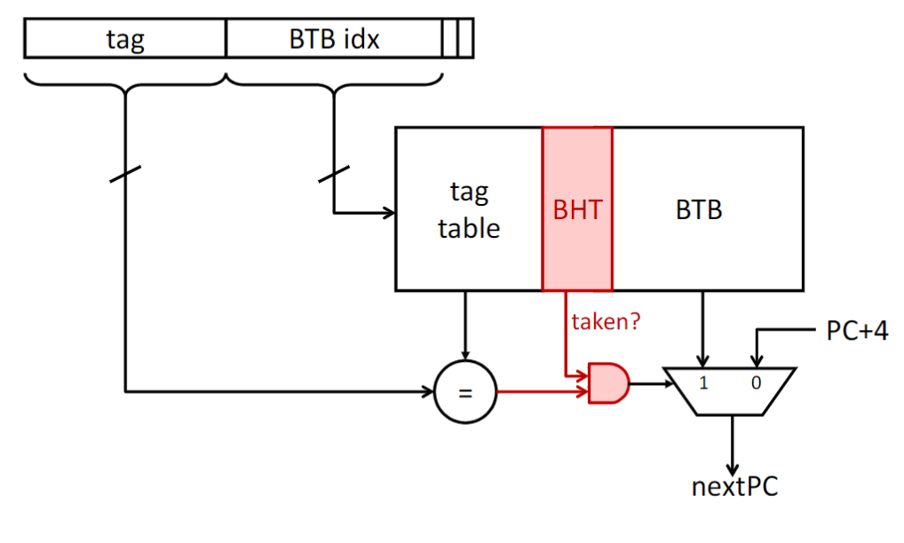
Figure 3.9 BTB and BHT
When BTB receives an address, it will compare its tag and the tag stored in BTB idx. If they are the same value, generating “hit” signal. Only when are “taken” and “hit”, the next address stored in BTB is used.
To generate the “taken”, in this proposal, BHT uses the 2-bit counter. The scheme of this
approach is show below.
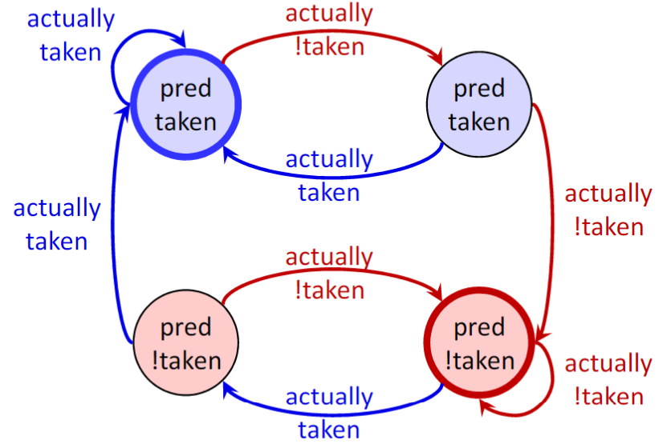
Figure 3.10 2-bit counter scheme
If the BHT predicts wrong, a signal called “mispredict” will be produced and the core will fix
the mistake.
In the chapter 4 of this proposal, two more “design of BHT” are under test to compare their performance with the strategy above.
- Always “taken”
- Always “not taken”

RAS
RAS stands for Return Address Stack. It is fixed size stacks of return address. When the program calls a function, the next PC, PC+4, will be pushed onto RAS. As it finishes the work of the function, it will return to PC+4. RAS will pop this address off the stack.
Since RAS always return to the last procedure call instruction, RAS are highly accurate.
Inasmuch as RAS only generates predictions for return instructions, do not using RAS
without BTB.

Interrupt
Sometimes, between two instructions of a running program, the processor has to stop its work and do something immediately. For example: bad pointer, divide by zero.... These immediate attentions are called interrupts.
When an interrupt occurs, the processor will execute the instructions at a specific address
instead of the next address as normal.
There are two types of interrupts: internal interrupts and external interrupts.

AMBA bus protocol
In the field of digital circuit design, especially design of microcontrollers, to transfer data from a module to another, engineers usually use buses. It is nothing to say that two modules with the same clock, data type… communicated with each other. However, if they are not the same clock or data type, it is another story. Buses are the key of this issue.
Sometimes, a transfer failed because of data error or busy slaves. When this case occurs, AMBA will tackle it by waiting or some methods.
This proposal uses two kind of AMBA buses, APB and AHB-lite.

APB
APB, Advanced Peripheral Bus, provides a low-cost interface, so it is used for low-power peripherals. The simplicity of this protocol contributes to reducing the interface complexity.

AHB-lite
AHB-lite, Advanced High-Performance Bus Lite, supports a single bus master and provides high-bandwidth operations. It is used for high-frequency and high-performance systems.

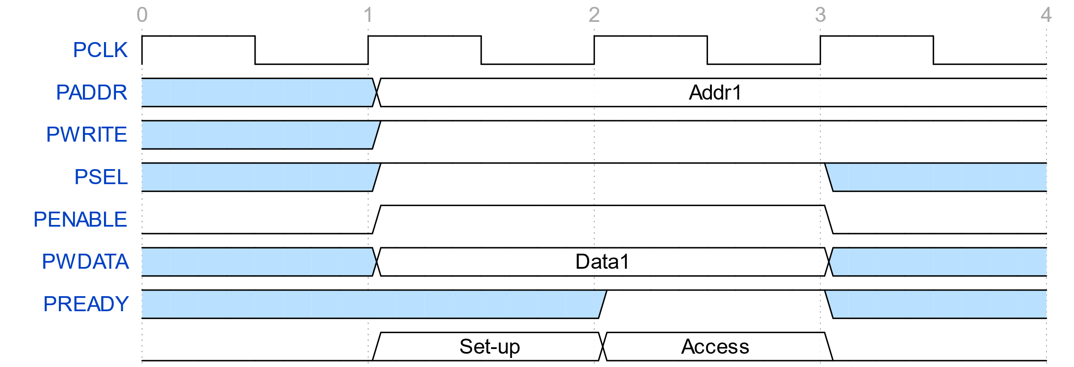  Figure 3.11 APB – Write transfer | 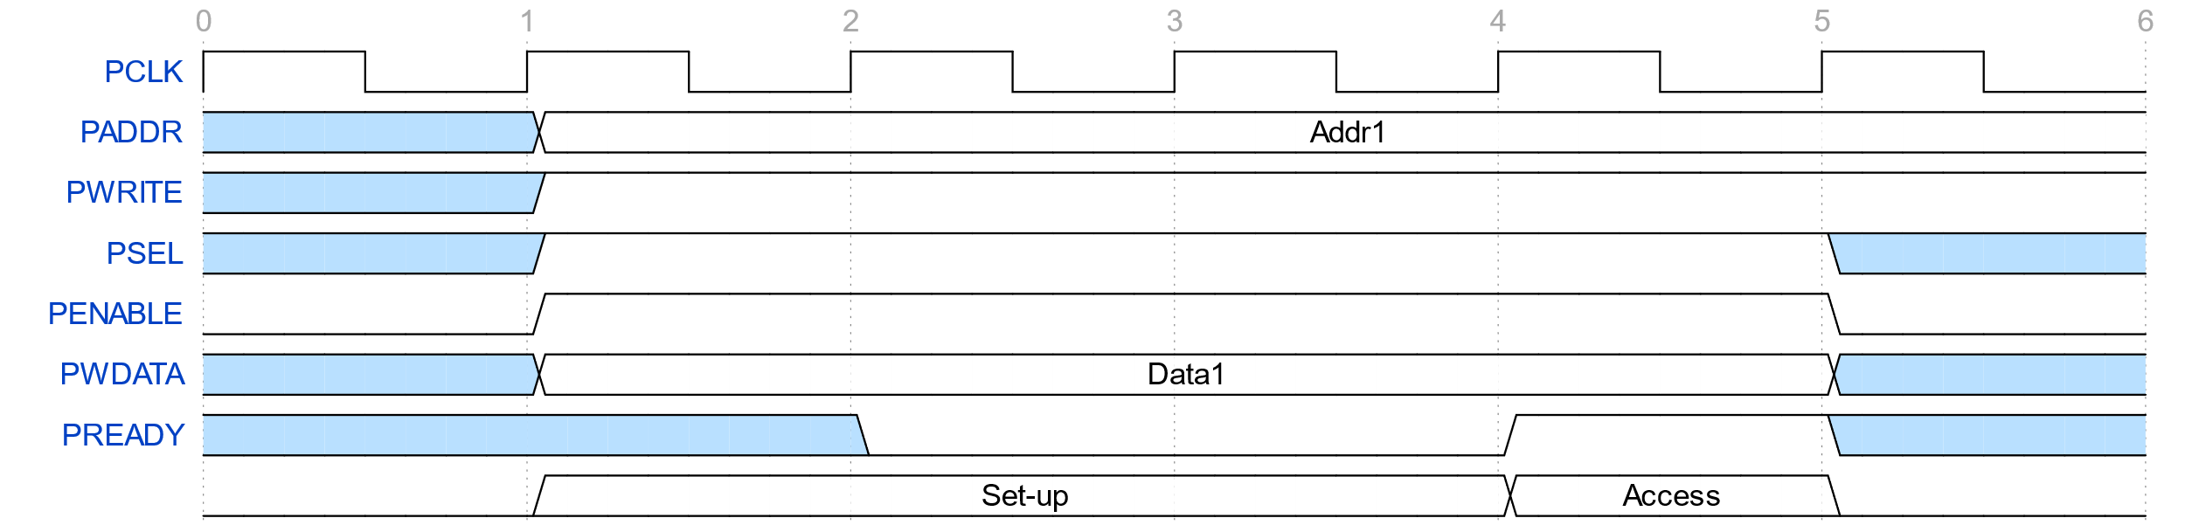  Figure 3.12 APB – Write transfer with wait states
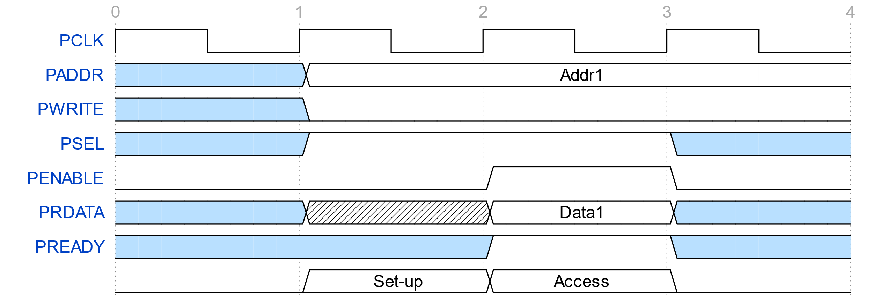  Figure 3.13 APB – Read transfer | 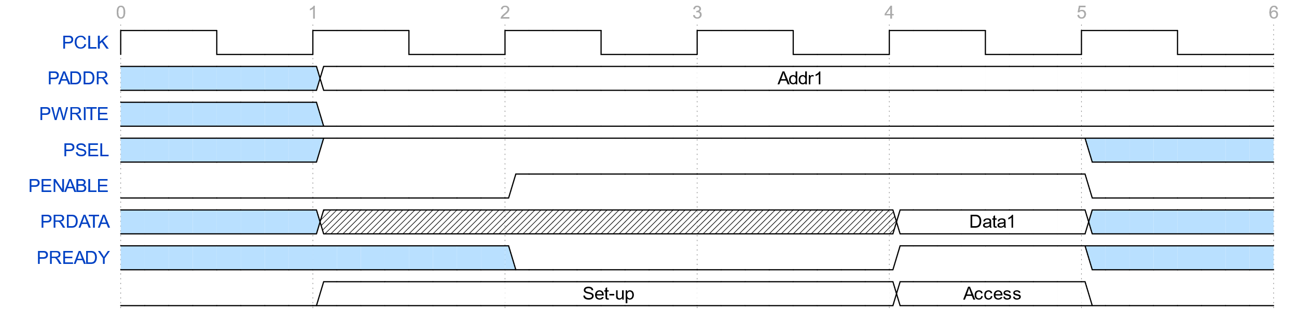  Figure 3.14 APB – Read transfer with wait state
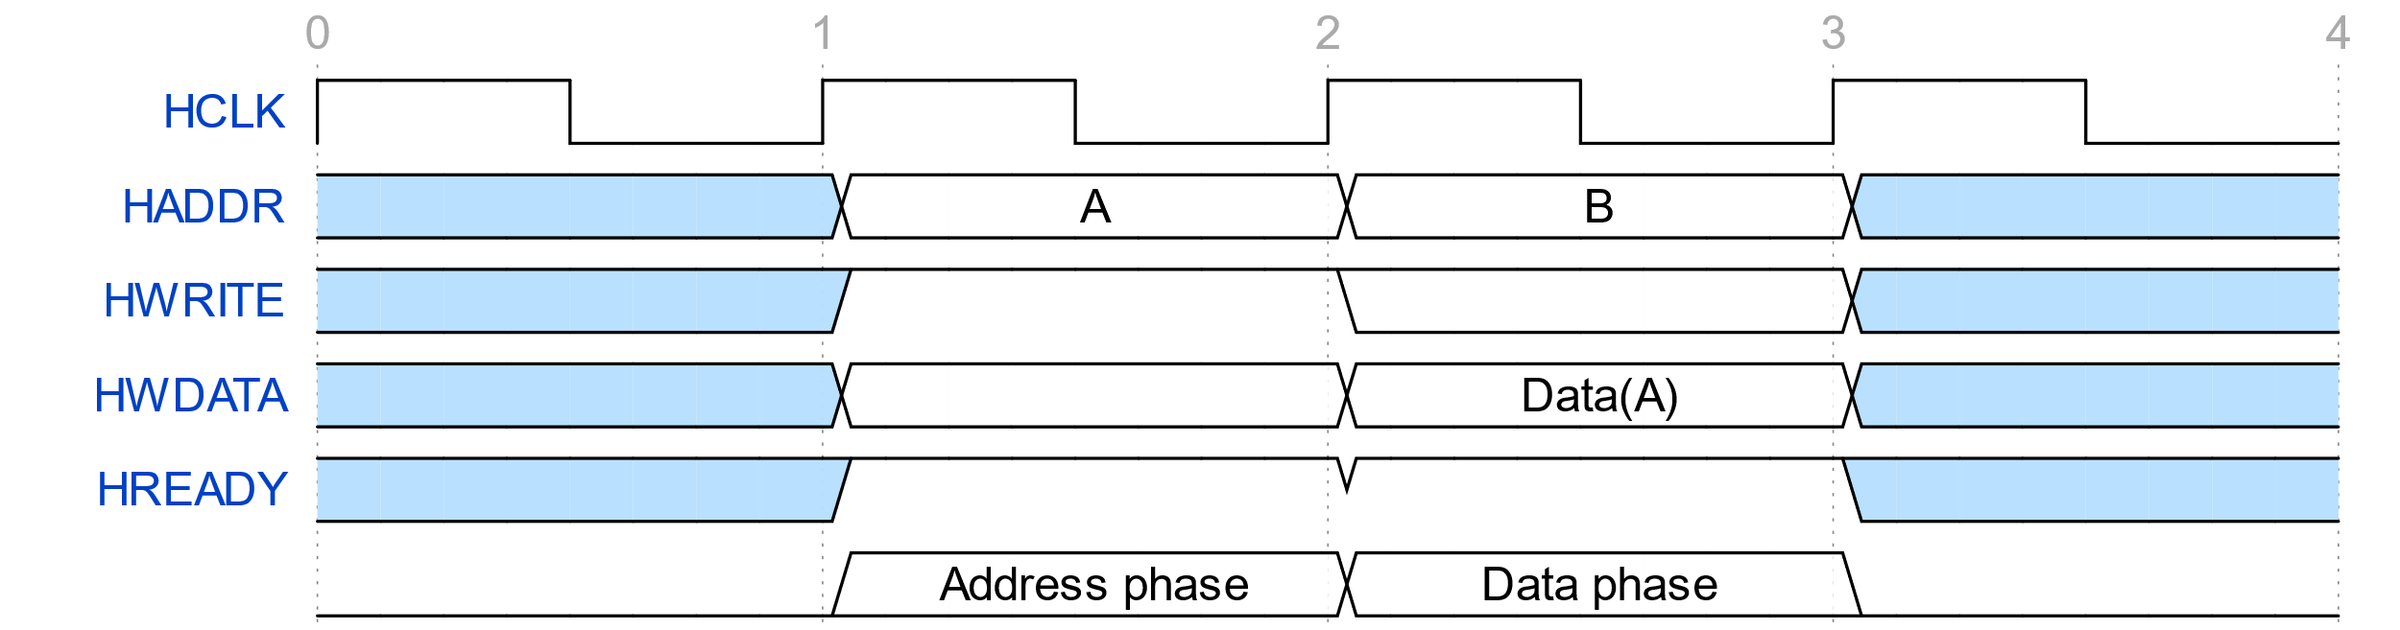  Figure 3.15 AHB-lite– Write transfer | 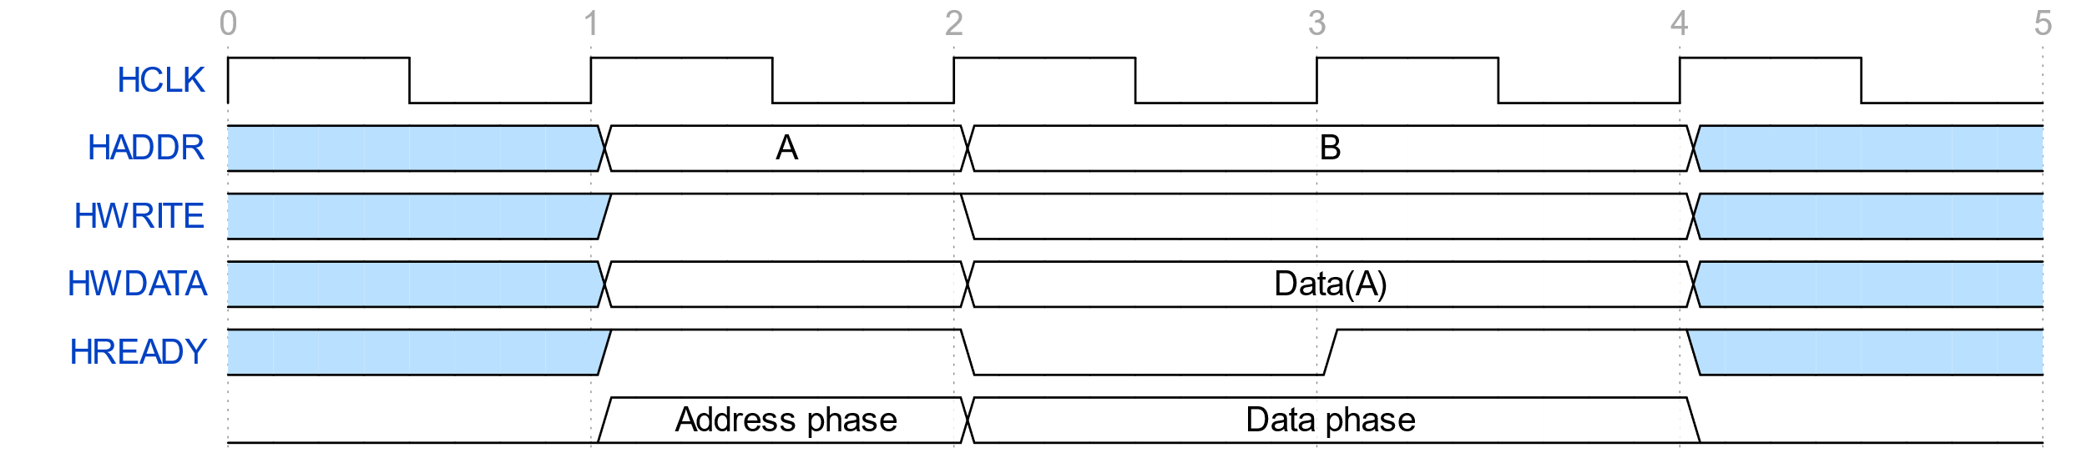  Figure 3.16 AHB-lite– Write transfer with wait states
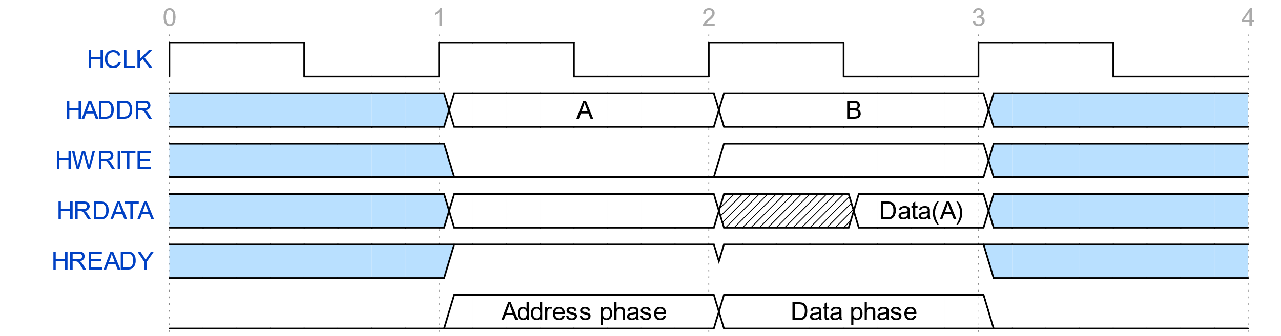  Figure 3.17 AHB-lite – Read transfer | 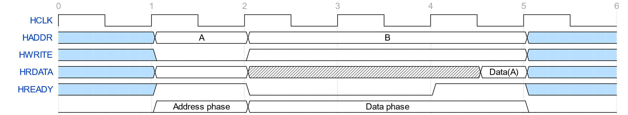  Figure 3.18 AHB-lite – Read transfer with wait state

Design of a 32-bit processor
The processor in this writing is named AQUA. It contains three separated parts showed in the figure below.
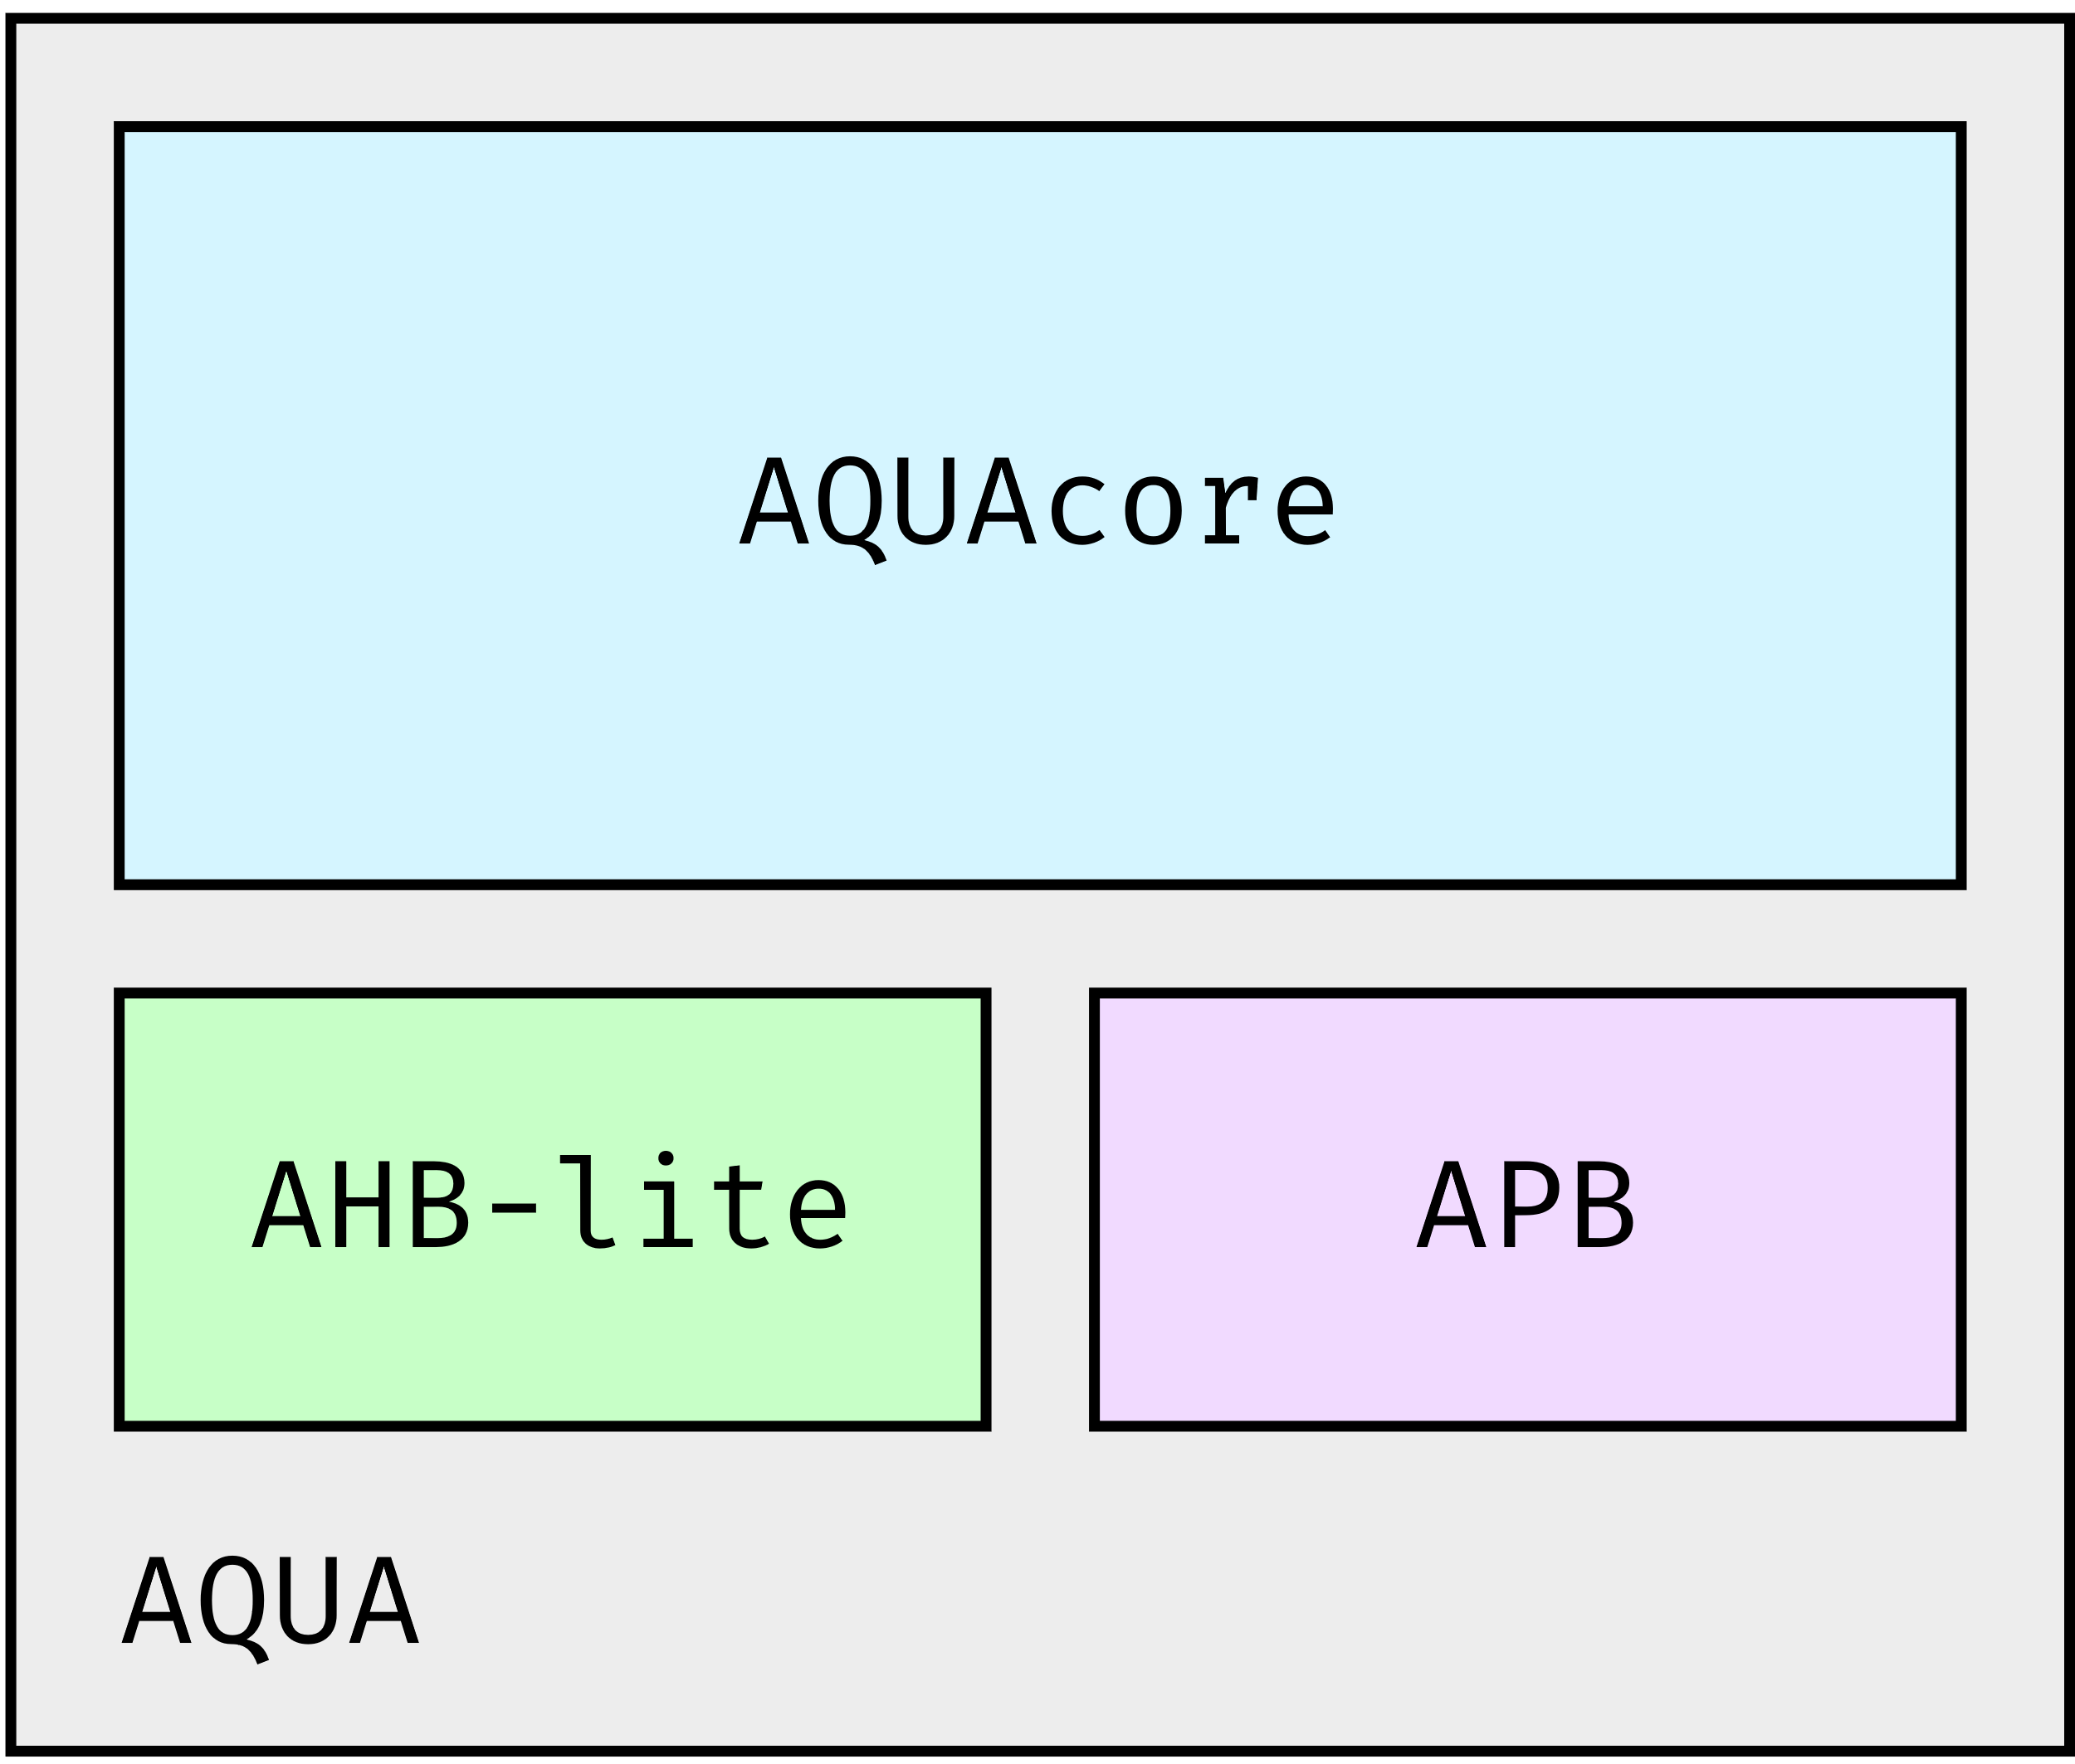
Figure 3.19 AQUA processor
Speaking of AQUA, it has AQUAcore, RV32IF, and two AMBA protocol in order to communicate with other peripherals. The specification of AQUAcore is in table 3.2.
Table 3.2 AQUAcore specification
Name | AQUA – RISCV
32-bit/64bit address | 32-bit address
ISA | RISC-V
Base ISA | I
Extensions | F, Zicsr (implies by F extensions)
Pipeline | 4
Branch Prediction | BTB – 1K entries, 8-bit PC  RAS – 8 deep circular stacks (32-bit)
Language | SystemVerilog

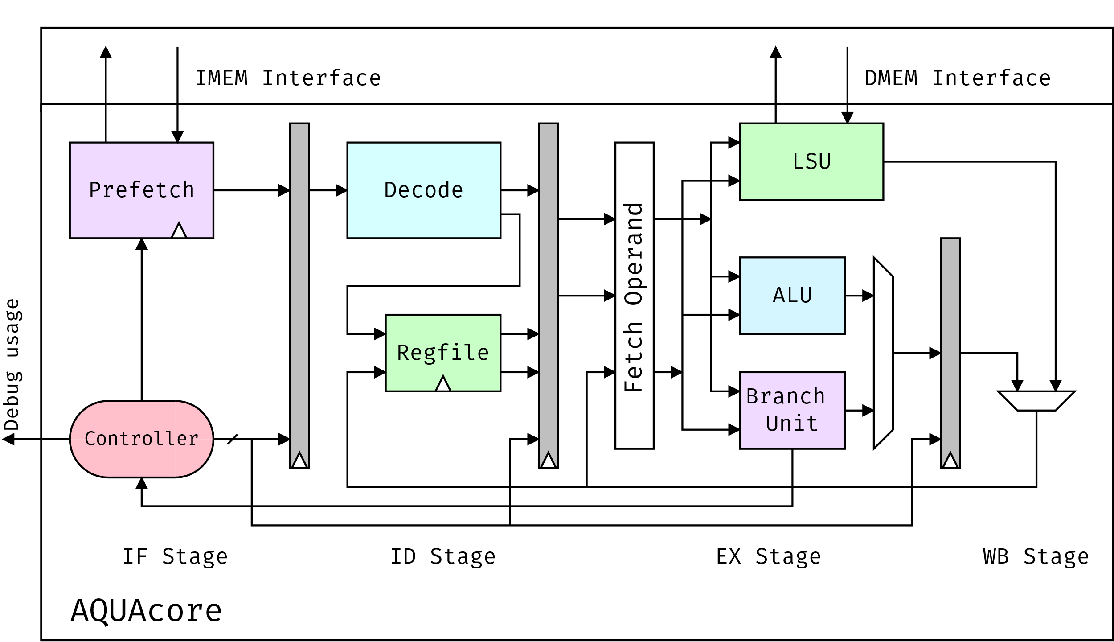
Figure 3.20 Datapath of AQUAcore (in progress)

The figure 3.12 above is the datapath of AQUAcore (in progress), the AQUA-top and two memory units is used for testing AQUAcore. AQUAcore is divided into four stages:
- IF stage: Instruction Fetch
- ID stage: Instruction Decode
- EX stage: Execute
- WB stage: Write Back
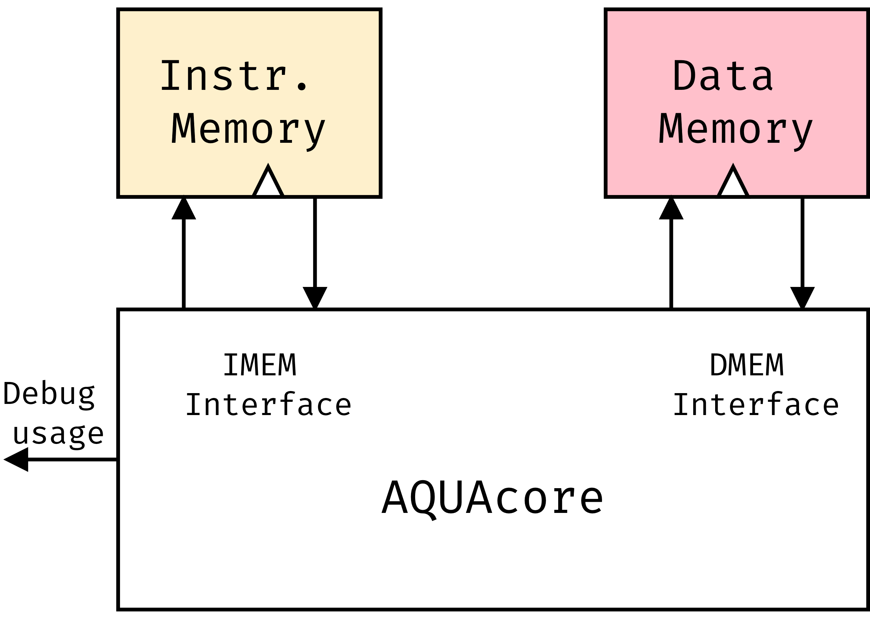
Figure 3.21 AQUAcore with two memories
Due to the incomplete of cache, works like a buffer, AQUAcore uses two external memories.
Each of the stages produces only one data and its valid signal. Its data is a user-defined type. By using this type, each stage has its own data-type, so the code is clear, simple and easy to debug. Making each stage produce one data and its valid signal well will help programmer easy to debug, like UNIX’s philosophy: “Make each program do one thing well”.
Because of that, a controller is added to control all of the stages. It also has some test signal, like handle, for debug demand.
One more thing, every pipelining stage only depends on the right neighbor, not the left one. Thanks to that, it will finish its work, no matter how the left is stall or not. If the right is ready (ready signal is high), it can do it work unless it is busy or not enable by controller. Controller also generate the flush signals. When it is needed to flush, controller sends them to each stage. If a stage is flush, its data is now not valid, in other words, valid signal is low. Two figures below explain these ideas.
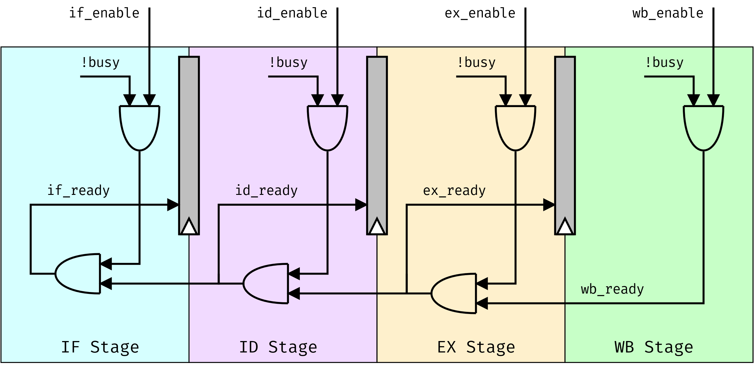
Figure 3.22 Enable signal and ready-structure of AQUA
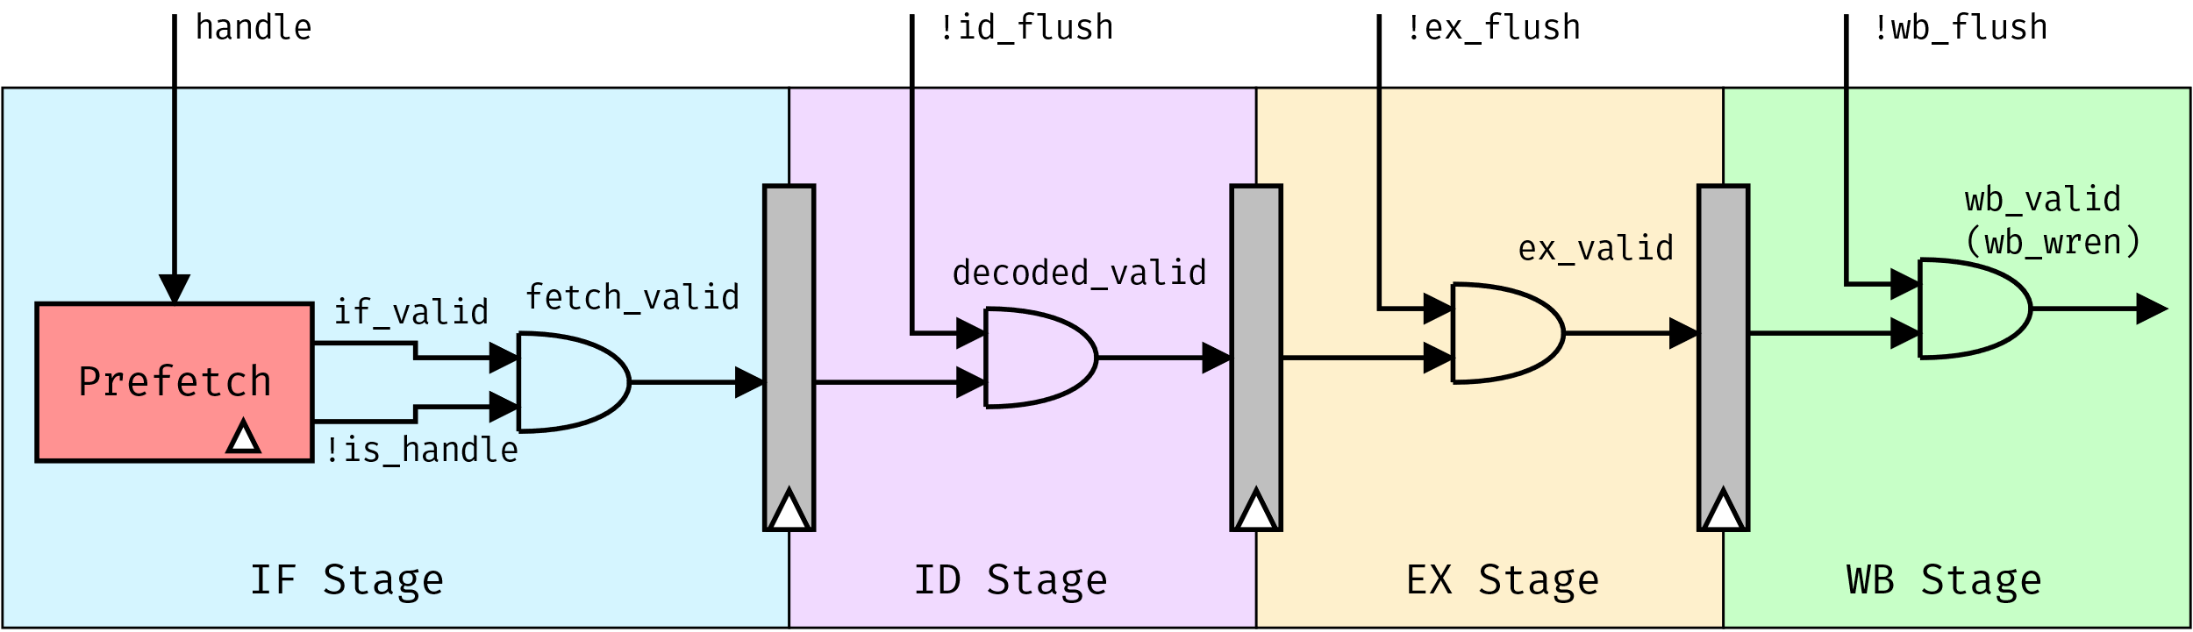
Figure 3.23 The relationship of flush signal and valid signal
Description of all units:
- ALU – Arithmetic Logic Unit: Execute the arithmetic or logic operation.
- Branch Unit: Calculate the next PC, if the branch prediction predicts wrong, mispredict signal will be high.
- Controller: Control the core, such as enable stages, insert flush signal. It also forwards some signal outside the core for test.
- Decoder: Decode the instruction.
- Fetch Operand: Receive decoded data from Decode, data from Regfile, and data from WB stage, forwarding them to 3 (4 in future) unit: LSU, ALU, Branch Unit.
- LSU – Load/Store Unit: Communicate with Data Memory in order to execute load, store instructions.
- Memory: Instruction Memory stores program, Data Memory stores data.
- Prefetch: Get instructions from Instruction Memory, it also contains BHT and BTB (and RAS in future).
- Regfile: 32 32-bit registers.
To design AQUA, the author uses:
- Coding: SublimeText 3.
- Simulation and verification: QuestaSim 10.4e and Verilator.
- Synthesis: Quartus Prime v18.1 Lite Edition.

DE10 – FPGA kit
The DE10-Standard Development Kit presents a robust hardware design platform built around the Intel System-on-Chip (SoC) FPGA, which combines the latest dual-core Cortex-A9 embedded cores with industry-leading programmable logic for ultimate design flexibility. Users can now leverage the power of tremendous re-configurability paired with a high-performance, low-power processor system. Altera’s SoC integrates an ARM-based hard processor system (HPS) consisting of processor, peripherals and memory interfaces tied seamlessly with the FPGA fabric using a high-bandwidth interconnect backbone. The DE10-Standard development board includes hardware such as high-speed DDR3 memory, video and audio capabilities, Ethernet networking, and much more…
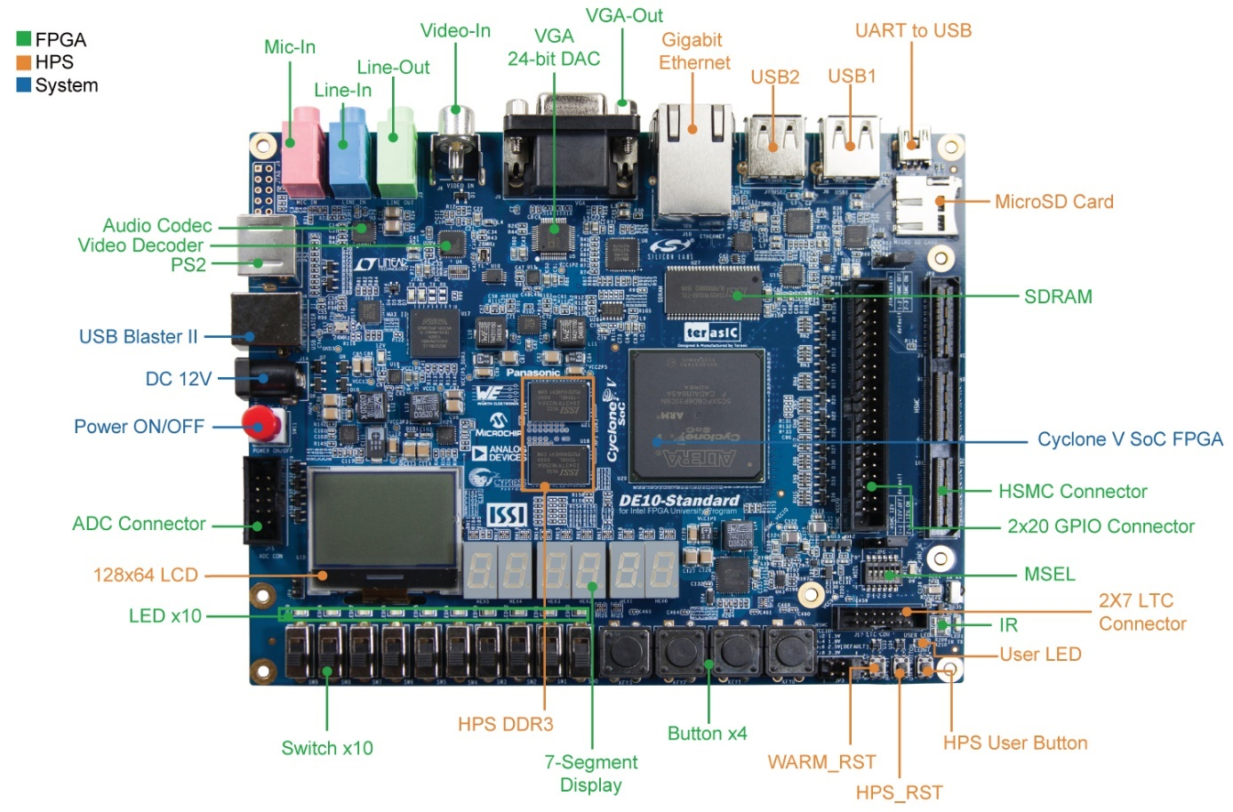
Figure 3.24 The top-layout of DE10
The specification of DE10 is in Appendix B.

EXPECTED RESULTS

Preliminary results
This table is the progress log of AQUA.
Table 4.1 AQUA Progress log
Name |  | Status
AQUAcore | ALU | ● |  | ● | Completed
 | Branch Unit | ● |  | ◐ | In progress
 | BTB, BHT | ● |  | ◍ | Not started yet
 | Cache | ◍
 | Controller | ◐
 | Decoder | ●
 | Fetch Operand | ●
 | FPU | ◍
 | LSU | ●
 | Memory | ●
 | Prefetch | ●
 | Reg-file | ●
 | RAS | ◐
AMBA | APB | ◍
 | AHB-lite | ◍
Interrupt |  | ◍

Even though FPU and interrupt are not completed, AQUAcore now works as an RV32I.
To proof the work of the present-AQUAcore, a testbenches is built. They also return the percentage of “wrong-prediction”. The testbench is sorting an array of numbers in Data Memory in ascending order.

Testbench
A number array has n entries (n is the value of M[0x0]), saved in Data Memory (the beginning
address: 0x10). Sort them in ascending order (signed number) and save the new one, the beginning address is 0x10.
There are a lot of arithmetic to solve this problem, in this proposal, bubble sort arithmetic is used. The code of testbench are in Appendix A.
The figure below is about the Data Memory before and after run the code.
Before:
// memory data file (do not edit the following line - required for mem load use)
// instance=/test/aquaTop/dataMemory/mem
// format=hex addressradix=h dataradix=h version=1.0 wordsperline=8
@0 00000010 00000000 00000000 00000000 00000000 00000000 00000000 00000000
@8 00000000 00000000 00000000 00000000 00000000 00000000 00000000 00000000
@10 ffffffe0 0000003f 00000060 ffffffb5 0000011c ffffff3f 00000015 0000001e
@18 0000003a ffffffd5 00000079 ffffffeb 00000061 fffffff8 0000008f fffffece
@20 0000000 00000000 00000000 00000000 00000000 00000000 00000000 00000000
vv HEX to DEC vv
0: 16 0 0 0 0 0 0 0
8: 0 0 0 0 0 0 0 0
10: -32 63 96 -75 284 -193 21 30
18: 58 -43 121 -21 97 -8 143 -306
20: 0 0 0 0 0 0 0 0
After:
// memory data file (do not edit the following line - required for mem load use)
// instance=/test/aquaTop/dataMemory/mem
// format=hex addressradix=h dataradix=h version=1.0 wordsperline=8
@0 00000010 00000000 00000000 00000000 00000000 00000000 00000000 00000000
@8 00000000 00000000 00000000 00000000 00000000 00000000 00000000 00000000
@10 fffffece ffffff3f ffffffb5 ffffffd5 ffffffe0 ffffffeb fffffff8 00000015
@18 0000001e 0000003a 0000003f 00000060 00000061 00000079 0000008f 0000011c
@20 00000000 00000000 00000000 00000000 00000000 00000000 00000000 00000000
vv HEX to DEC vv
0: 16 0 0 0 0 0 0 0
8: 0 0 0 0 0 0 0 0
10: -306 -193 -75 -43 -32 -21 -8 21
18: 30 58 63 96 97 121 143 284
20: 0 0 0 0 0 0 0 0
Figure 4.1 Data in Data Memory
The array is now sorted.

In the Transcript windows of QuestaSim, the rate of predicted wrong is stated.
#
# *************************************************************************
# *************************************************************************
# ** xXXXXx xXXXXx XX XX xXXXXx **
# ** XX XX XX XX XX XX XX XX xxxx xxxx xxxx xxxx **
# ** XX XX XX XX XX XX XX XX xx xx xx xx xx xx **
# ** XXXXXXXX XX XX XX XX XX XXXXXXXX xx xx xx xx xx x **
# ** XX XX XXXXXX XXXXXX XX XX xxxx xxxx xx xxxxx **
# ** XX **
# *************************************************************************
# ** Author: HAI Cao Xuan **
# ** Project: risc-aqua **
# *************************************************************************
# *************************************************************************
#
# @ Begining of testing DUT
#
# Mispredict 105 time(s). CT instr. 788 instr.(s) => 13.32% predicted wrong.
#
# @ End of testing DUT
#
# ** Note: $finish : D:/Project/risc-aqua/questasim-test/test.sv(113)
# Time: 4694 ns Iteration: 1 Instance: /test

Figure 4.2 The result of the testbench in Transcript window
The branch prediction, BTB and BHT, did its job well. In theory, the accuracy rate of this kind of branch prediction is 94%. In other words, it is only 6% predicted wrong. Therefore, in reality, the rate, 13.32%, is good enough for a small program, such as this testbench.
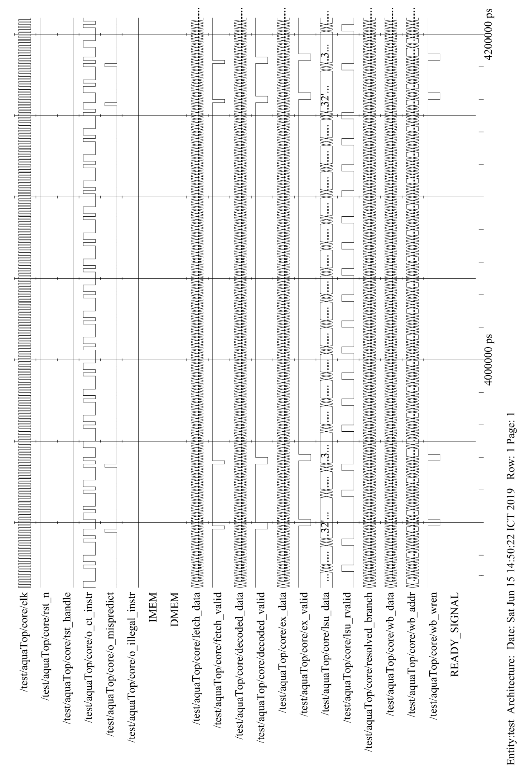
Figure 4.3 The waveform of bubble sort testbench

Expected result
In summary, AQUAcore is now, at the end of the course Thesis Proposal, a complete RV32I.
However, it is not the end. To transform this core into a RV32IF, it will take a lot of works. Because the processor lacks of FPU, RAS, cache, two AMBA buses and interrupt (optional). Moreover, it has to be embedded in an FPGA KIT, DE-10.

PROCEDURE
As discussed in the end of chapter 4, some researches and work with SystemVerilog have to be done to create an RV32IF. Adding F-extension to the core is one of the most important tasks.
After that, AQUAcore will be embedded in DE10.
Finally, building APB and AHB-lite protocol for it to communicate with some peripherals.
The total time to complete all of the above tasks is four months.
Table 5.1 The procedure for the other works of thesis
Content |  | Sep 2019 | Oct 2019 | Nov 2019 | Dec 2019
Add RAS, F-ext in AQUAcore |  | 🗸 | 🗸
1 | Add RAS | 🗸
2 | Add Z-icsr and config Decode | 🗸
3 | Add F-ext and test |  | 🗸
Embed AQUAcore |  |  |  | 🗸 | 🗸
Build AMBA protocol |  |  | 🗸 | 🗸
1 | Do researches |  | 🗸
2 | Design and test |  | 🗸 | 🗸

APPENDIX A. TESTBENCH SORTING AN ARRAY
 | PC | Label | Assembly code | Machine code (hex)
 | 0x24  0x28  0x2c  0x30  0x34  0x38  0x3c  0x40  0x44  0x48  0x4c  0x50  0x54  0x58  0x5c  0x60  0x64  0x68  0x6c | larger_loop:  smaller_loop:  inc_t1:  inc_t0:  exit: | lw s0, 0x0(zero)  addi s1, zero, 0x1  sub s1, s0, s1  add t0, zero, zero  bge t0, s0, exit  add t1, zero, zero  bge t1, s1, inc_t0  add a0, t1, zero  addi a1, t1, 0x1  lw a2, 0x10(a0)  lw a3, 0x10(a1)  blt a2, a3, inc_t1  sw a2, 0x10(a1)  sw a3, 0x10(a0)  addi t1, t1, 0x1  j smaller_loop  addi t0, t0, 0x1  j larger_loop  nop | 00002403  00100493  409404B3  000002B3  0282DC63  00000333  02935463  00030533  00130593  01052603  0105A683  00D64663  00C5A823  00D52823  00130313  FDDFF06F  00128293  FCDFF06F  00000013

APPENDIX B. DE10 SPECIFICATION
FPGA Device
- Cyclone V SX SoC—5CSXFC6D6F31C6N
- 110K LEs, 41509 ALMs
- 5,761 Kbits embedded memory
- 6 FPGA PLLs and 3 HPS PLLs
- 2 Hard Memory Controllers
ARM-Based Hard Processor System (HPS)
- 925 MHz, Dual-Core ARM Cortex-A9 MPCore Processor
- 512 KB of Shared L2 Cache
- 64 KB of Scratch RAM
- Multiport SDRAM Controller with Support for DDR2, DDR3, LPDDR1, and LPDDR2
- 8-Channel Direct Memory Access (DMA) Controller
Configuration and Debug
- Serial Configuration Device – EPCS128 on FPGA
- On-Board USB Blaster II (Normal Type B USB Connector)
Memory Device
- 64MB (32Mx16) SDRAM on FPGA
- 1GB (2x256Mx16) DDR3 SDRAM on HPS
- MicroSD Card Socket on HPS
Communication
- Two USB 2.0 Host Ports (ULPI Interface with USB Type A Connector) on HPS
- USB to UART (Micro USB Type B Connector) on HPS
- 10/100/1000 Ethernet on HPS
- PS/2 Mouse/Keyboard
- IR Emitter/Receiver
Connectors
- One 40-pin Expansion Header (Voltage Levels: 3.3V)
- One HSMC Connector (Configurable I/O Standards 1.5/1.8/2.5/3.3V)
- One 10-Pin ADC Input Header
- One LTC Connector (One Serial Peripheral Interface (SPI) Master, One I2C and One GPIO Interface) on HPS
Display
- 24-bit VGA DAC
- 128x64 Dots LCD Module with Backlight on HPS
Audio
- 24-bit CODEC, Line-in, Line-out, and Microphone-In Jacks
Video Input
- TV Decoder (NTSC/PAL/SECAM) and TV-In Connector
ADC
- Sample Rate: 500 KSPS
- Channel Number: 8
- Resolution: 12 bits
- Analog Input Range: 0 ~ 4.096 V
Switches, Buttons and Indicators
- 4 User Keys (FPGA x4)
- 10 User Switches (FPGA x10)
- 11 User LEDs (FPGA x10; HPS x 1)
- 2 HPS Reset Buttons (HPS_RST_n and HPS_WARM_RST_n)
- 7-Segment Display x6

Sensors
- G-Sensor on HPS
Power
- 12V DC Input
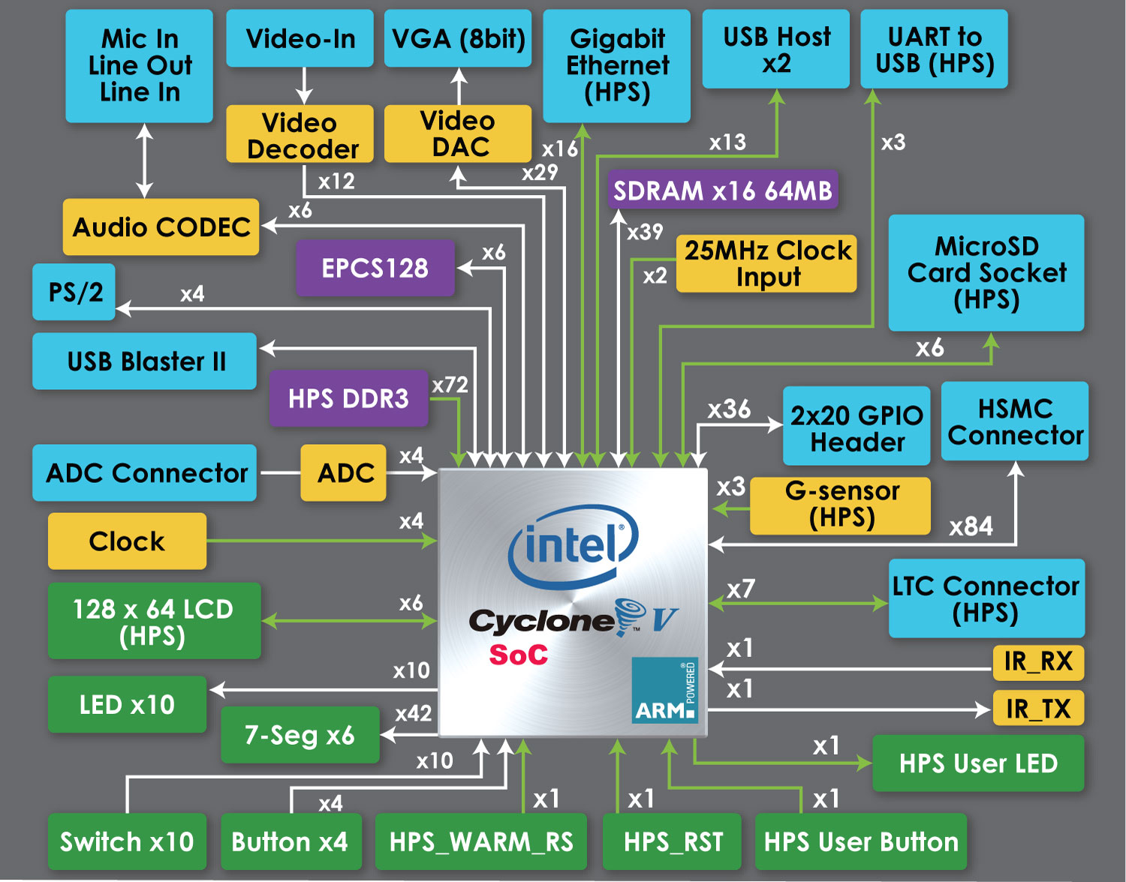
Figure B.0.1 Block Diagram of the DE10-Standard Board

REFERENCES

[1] | D. A. P. John L. Hennessy, Computer Architecture - A Quantitative Approach, 6th Edition, Morgan Kaufmann, 2017.
[2] | J. L. H. David A. Patterson, Computer Organization and Design RISC-V Edition, 1st Edition, Morgan Kaufmann, 2017.
[3] | "SystemVerilog 3.1a Language Reference Manual," [Online]. Available: http://www.ece.uah.edu/~gaede/cpe526/SystemVerilog_3.1a.pdf.
[4] | RISC-V, "RISC-V Instruction Set Manual," [Online]. Available: https://github.com/riscv/riscv-isa-manual.
[5] | A. Waterman, "Design of the RISC-V Instruction Set Architecture," Berkeley, 2016.
[6] | J. C. Hoe, "18-447 Introduction to Computer Architecture, Spring 2019," [Online]. Available: https://users.ece.cmu.edu/~jhoe/doku/doku.php?id=18-447_introduction_to_computer_architecture.
[7] | ARM, "Documentation," [Online]. Available: https://developer.arm.com/docs.

