AI IDEAS HUB
End-to-End Requirements Document
A centralised workspace to capture, develop and track the team's AI ideas and initiatives
Version 0.1 (Draft for team review)
Prepared by: Trung Vo · 3 July 2026
Audience: Support team (10–30 users)

Contents

1. Executive summary
Today, the team's AI ideas and initiatives are tracked manually across a Confluence page list and Trello boards. Ideas are hard to discover, engagement is invisible, ownership is unclear, and there is no single view of progress. This document defines the requirements for the AI Ideas Hub: a centralised workspace where any team member can submit an AI idea through a structured form, browse and support other ideas, join initiative teams in defined roles, receive Slack/email notifications, and where the team lead can monitor the full pipeline through a dashboard.
The recommended delivery approach is phased: build an MVP on a low-code platform and graduate to a lightweight custom web app only if the team outgrows it. Both options are assessed in Section 10.

1.1 Objectives
- Create a single source of truth for all AI ideas and initiatives, replacing the Confluence list and Trello boards.
- Lower the barrier to contribution: any team member can submit, like, comment on, or join an idea in under two minutes.
- Make ownership and roles explicit for every initiative (Project Lead, Initiator, AI Design, Form Design, etc.).
- Notify the team automatically via Slack and email when ideas are submitted or change status.
- Give the team lead a live dashboard of pipeline progress, engagement, and outcomes.

1.2 Success metrics (first 2 quarters)
Metric | Baseline | Target
Team members who have engaged (submitted, liked, commented or joined) | n/a (not measurable today) | ≥ 70% of team
New ideas submitted per quarter | ~2–3 (ad hoc) | ≥ 8
Ideas with a named lead and team | Unclear | 100% of approved ideas
Median time from submission to review decision | Weeks (untracked) | ≤ 7 days
Ideas launched into real use | Untracked | ≥ 2 per half-year

2. Background and problem statement
The current process relies on a manually curated Confluence page and Trello lists. This creates five recurring problems:
- Ideas are scattered and duplicated across tools; there is no canonical list.
- There is no structured intake, so ideas vary wildly in quality and completeness (missing context, benefits, or effort estimates).
- Engagement is invisible: no way to see which ideas the team supports or wants to help build.
- No notifications: people only find out about ideas if they happen to open the page.
- No progress tracking or reporting: the lead cannot answer 'what is the status of our AI initiatives?' without manual chasing.
The AI Ideas Hub addresses all five with structured intake, social engagement, role-based teams, automated notifications, and a leader dashboard.

3. Scope

3.1 In scope
- Idea board (browse, search, filter, sort) visible to all team members.
- Structured 'New Idea' form with required and optional fields, plus draft saving.
- Engagement: likes, requests/comments with follow-up status, and 'Join the team' with role selection.
- Idea lifecycle workflow with defined statuses and transition rules.
- Slack (#ai-ideas channel) and email notifications with deep links back to the idea.
- Leader dashboard: pipeline, engagement, categories, attention flags, contributor insights.
- Basic administration: manage categories, roles, members, and archive ideas.

3.2 Out of scope (for MVP)
- Building or hosting the AI solutions themselves (the Hub manages ideas, not the tools built from them).
- Company-wide rollout beyond the team (design should not prevent it later).
- Budget/cost approval workflows and formal business-case templates.
- Anonymous submissions and external (non-employee) access.
- Native mobile app (responsive web is sufficient).

4. Users, roles and permissions
Roles apply at two levels: workspace roles (what you can do in the Hub) and initiative roles (your function on a specific idea's team). One person can hold different initiative roles on different ideas.

4.1 Workspace roles
Role | Description | Who
Admin / Project Lead | Full control: configure categories and roles, review and approve ideas, change any status, access dashboard, archive ideas. | Trung (+1 backup)
Member | Submit ideas, like, comment/request, join teams, follow ideas, edit own submissions while in Draft/New. | All team members
Viewer (optional) | Read-only access for stakeholders outside the team (e.g. other departments, leadership). | By invitation

4.2 Initiative (per-idea) roles
Role | Responsibility on the idea | Cardinality
Initiator / Idea Lead | Owns the idea: refines scope, responds to requests, updates status and progress, reports at review checkpoints. | Exactly 1
AI Design | Designs the AI approach: prompts, model/tool selection, evaluation criteria, guardrails. | 0–2
Form / UX Design | Designs intake forms, screens, and the user experience of the resulting solution. | 0–2
Data / Ops | Sources and prepares data, builds integrations and automations (e.g. n8n, DevRev, Slack). | 0–2
Tester / Pilot user | Validates outputs against real work, provides structured feedback during pilot. | 1+ before Pilot
Observer | Follows along to learn; receives updates but has no delivery responsibility. | Unlimited

4.3 Permission rules
- Everyone in the team can view every idea (full transparency by default).
- Only the Idea Lead and Admin can edit an idea's core content after submission; others contribute via requests.
- Only Admin can move an idea into Approved, On Hold, or Archived; the Idea Lead moves it through delivery statuses (In Progress → Pilot → Launched) with Admin visibility.
- Joining a team in a non-Observer role requires Idea Lead acceptance (one click).

5. Idea lifecycle
Every idea moves through a defined lifecycle. Statuses drive board filters, notifications, and dashboard metrics.
Status | Meaning & entry criteria | Owner of transition
Draft | Started but not submitted; visible only to the author. | Author
New / Submitted | Form completed with all required fields; visible to all; Slack notification fires. | Author (submit)
In Review | Admin/lead is assessing feasibility, value and fit. Review SLA: 7 days. | Admin
Approved | Green-lit; team forming against requested roles; target time frame confirmed. | Admin
In Progress | Team assembled and actively building. | Idea Lead
Pilot | Solution in trial with real users/tickets; success criteria being measured. | Idea Lead
Launched | In regular use; benefits tracked; moves to light-touch maintenance. | Idea Lead + Admin
On Hold | Paused with a recorded reason and revisit date. | Admin
Archived / Declined | Closed with a recorded reason; remains searchable for future reference. | Admin
Transition rules: New → In Review → (Approved | On Hold | Declined); Approved → In Progress → Pilot → Launched. Any status can move to On Hold or Archived with a mandatory reason. Every status change is timestamped and triggers a notification to followers and team members.

6. Functional requirements
Priority: M = Must have (MVP), S = Should have, C = Could have (later phase).

6.1 Idea board (central space)
ID | Requirement | Priority
FR-01 | All team members can view a board of all ideas as cards showing: name, status, category, short summary, like/request/member counts, and team avatars. | M
FR-02 | Board supports search by keyword and filters by status, category, and initiator; sort by newest, most liked, most active. | M
FR-03 | A pipeline strip/summary shows the count of ideas per status at a glance. | S
FR-04 | 'My Ideas' view: ideas I initiated, joined, or follow. | S
FR-05 | Archived ideas are hidden by default but searchable via a filter. | S

6.2 Idea submission form
ID | Requirement | Priority
FR-10 | A 'Submit New Idea' form is available from anywhere in the workspace. | M
FR-11 | Required fields: Idea Name; Category; Context; Pain Points; Expected Benefit; Expected Time Frame. | M
FR-12 | Optional fields: AI Capability type; Estimated Effort; Roles Needed (multi-select); Attachments/links (Confluence, Loom, files); Related ideas. | M
FR-13 | Form validates required fields before submission and supports saving as Draft. | M
FR-14 | On submission the author automatically becomes Initiator/Idea Lead and the idea gets a unique ID (e.g. IDEA-007). | M
FR-15 | Duplicate hint: while typing the Idea Name, similar existing ideas are suggested to reduce duplicates. | C

6.3 Engagement and collaboration
ID | Requirement | Priority
FR-20 | Any member can Like an idea (one like per person, toggleable); like counts are visible on cards and detail pages. | M
FR-21 | Any member can post a Request/Input on an idea; the Idea Lead is notified and can mark each request Accepted, Under discussion, or Declined (with reply). Requesters are notified of outcome. | M
FR-22 | Any member can 'Join the team' by selecting an open or general role; the Idea Lead accepts or declines with one click. | M
FR-23 | Any member can Follow an idea to receive its updates without joining the team. | S
FR-24 | Idea Lead can post Progress Updates (short notes) that appear on the idea timeline and notify followers. | M
FR-25 | @mentions in requests/updates notify the mentioned person. | S

6.4 Notifications (Slack and email)
ID | Requirement | Priority
FR-30 | New idea submission posts a rich message to the #ai-ideas Slack channel: name, initiator, category, target time frame, and a deep link to the idea. | M
FR-31 | Slack message includes quick actions (or clearly linked equivalents): View, Like, Request, Join. | S
FR-32 | Status changes notify followers and team members via Slack DM or email (user-selectable preference). | M
FR-33 | Requests and their outcomes notify the relevant parties (lead ← request; requester ← outcome). | M
FR-34 | A weekly digest (Slack + email) summarises new ideas, status changes and top-engaged ideas. | S
FR-35 | Users can configure notification preferences (all / following only / digest only). | S

6.5 Leader dashboard
ID | Requirement | Priority
FR-40 | KPI tiles: total ideas, active ideas, launched count, team participation %, estimated hours saved per week. | M
FR-41 | Pipeline funnel: idea counts and conversion by status. | M
FR-42 | Breakdown of ideas by category with engagement levels. | S
FR-43 | 'Needs attention' flags: review SLA breaches, stale ideas (no update in N days), on-hold items past revisit date. | M
FR-44 | Engagement table: likes, requests, members and target per idea; sortable. | M
FR-45 | Contributor view: participation per person (ideas, requests, memberships) to recognise contributors and spot non-engagement. | S
FR-46 | Filter dashboard by quarter/date range; export as image/PDF for leadership updates. | C

6.6 Administration
ID | Requirement | Priority
FR-50 | Admin can manage the lists of categories, AI capability types, time frames and initiative roles. | M
FR-51 | Admin can add/remove members and assign workspace roles. | M
FR-52 | Admin can archive/decline ideas with a mandatory reason. | M
FR-53 | All status changes and key actions are recorded in an audit trail on the idea. | S

7. Data model (core entities)
Entity | Key attributes
Idea | id (IDEA-###); name; category; ai_capability; context; pain_points; expected_benefit; time_frame (enum: Sprint 2–4 wks / Quarter 8–12 wks / Half-year); effort (S/M/L); status; created_by; created_at; target_date; attachments[]; related_ideas[]
Membership | idea_id; user_id; initiative_role; state (requested/accepted); joined_at
Engagement | idea_id; user_id; type (like/follow); created_at
Request | id; idea_id; author; body; state (open/accepted/under_discussion/declined); lead_reply; resolved_at
Update | id; idea_id; author; body; created_at (progress notes shown on timeline)
StatusChange | idea_id; from; to; reason; changed_by; changed_at (drives audit trail and cycle-time metrics)
User | id; name; email; slack_id; workspace_role; notification_preference

8. Integrations
- Slack — primary notification channel via a dedicated #ai-ideas channel and DMs; delivered through Slack API/webhooks (MVP can use n8n workflows already available to the team).
- Email — secondary channel for status changes and the weekly digest, for members who prefer email.
- n8n — automation backbone for MVP: form-submission triggers, notification routing, digest scheduling, and SLA/stale-idea checks.
- Confluence — one-way links: ideas can attach Confluence pages; optionally auto-publish a read-only summary page per launched idea.
- DevRev / Linear (later) — when an approved idea becomes an engineering-backed build, create a linked Linear project or DevRev issue and mirror status. Explicitly a Phase 3 candidate.

9. Non-functional requirements
Area | Requirement
Access & security | SSO with company Google accounts; access restricted to invited team members; no customer data stored in ideas (policy note on the form).
Usability | Submitting an idea takes < 2 minutes; liking/joining takes 1 click; fully usable on mobile browsers.
Performance | Board and dashboard load in < 3 seconds for up to 500 ideas and 50 users.
Reliability | Notification delivery within 2 minutes of the triggering event; failed notifications retried.
Data & portability | All idea data exportable to CSV; the team owns the data regardless of platform choice.
Localisation | English UI; content may be written in English or Vietnamese.
Auditability | Status changes and admin actions logged with actor and timestamp.

10. Platform options and recommendation
Two candidate approaches were assessed, per the project brief: a low-code build and a custom web app.
Criterion | Option A — Low-code (e.g. Notion/Airtable + n8n + Slack) | Option B — Custom web app (internal)
Time to MVP | 2–4 weeks | 6–10 weeks
Build effort/cost | Low; configuration over code | Medium–high; needs dev capacity
Form & board UX | Good, some template constraints | Fully tailored to the mock-ups
Likes / join-team flows | Achievable with light workarounds (reaction fields, linked records) | Native, exactly as designed
Slack/email notifications | Strong via n8n + Slack API | Strong via same APIs
Dashboard | Good (built-in charts + n8n digests) | Fully custom insights
Maintenance | Very low | Ongoing ownership required
Scale beyond team | Fine to ~100 users | Unlimited; company-wide ready

10.1 Recommendation: phased hybrid
- Phase 1 (MVP, weeks 1–4): build on low-code + n8n + Slack. Validate the workflow, field set, and engagement behaviours with the real team at near-zero build cost.
- Phase 2 (weeks 5–8): refine based on usage — tune fields, notification frequency, dashboard metrics; add weekly digest and SLA flags.
- Phase 3 (decision gate, end of quarter): if adoption targets are met and low-code constraints bite (custom join flows, richer dashboard, cross-team rollout), commission the custom web app using this document and the mock-ups as the build spec; migrate data via CSV export.
This de-risks the investment: the requirements in Section 6 are written to be platform-neutral so nothing is wasted if/when the team graduates to Option B.

11. Delivery plan and team
Phase | Key activities | Indicative timing
Setup | Confirm requirements with team; finalise categories, roles, field lists; create #ai-ideas channel. | Week 1
MVP build | Configure workspace, form, board and statuses; wire n8n → Slack/email notifications; seed 3–5 existing ideas from Confluence/Trello. | Weeks 2–3
Pilot | Whole-team launch session; each member submits or engages with ≥ 1 idea; collect feedback. | Week 4
Iterate | Dashboard v1, weekly digest, SLA/stale flags; tune based on feedback. | Weeks 5–8
Review gate | Assess metrics vs Section 1.2 targets; decide on Phase 3 (custom app) or continue. | End of quarter
Suggested build team: Project Lead (Trung) — sponsor, reviewer, dashboard owner; 1 builder for workspace configuration and n8n flows; 1 form/UX designer for the intake form and board layout; 2–3 pilot champions to seed ideas and model engagement. This doubles as a live example of the initiative roles defined in Section 4.2.

12. Proposed dashboard insights (beyond the brief)
In addition to per-idea progress, the following insights are proposed for the leader dashboard:
- Estimated hours saved per week from launched ideas — the headline value story for leadership.
- Pipeline conversion rates (submitted → approved → launched) to spot where ideas stall.
- Review SLA and staleness flags so nothing sits unattended (e.g. in review > 7 days, no update in 14 days).
- Team participation rate — % of members who engaged this quarter; useful for nudging quiet members.
- Contributor recognition — top initiators and helpers, feeding shout-outs and performance conversations.
- Category heat map — which problem areas attract the most ideas and engagement, informing where to invest.
- Idea ageing — time in current status per idea, surfacing bottlenecks in the lifecycle.

13. Sample mock-ups
The following mock-ups illustrate the target experience. They are indicative designs to align the team, not final visual specifications.
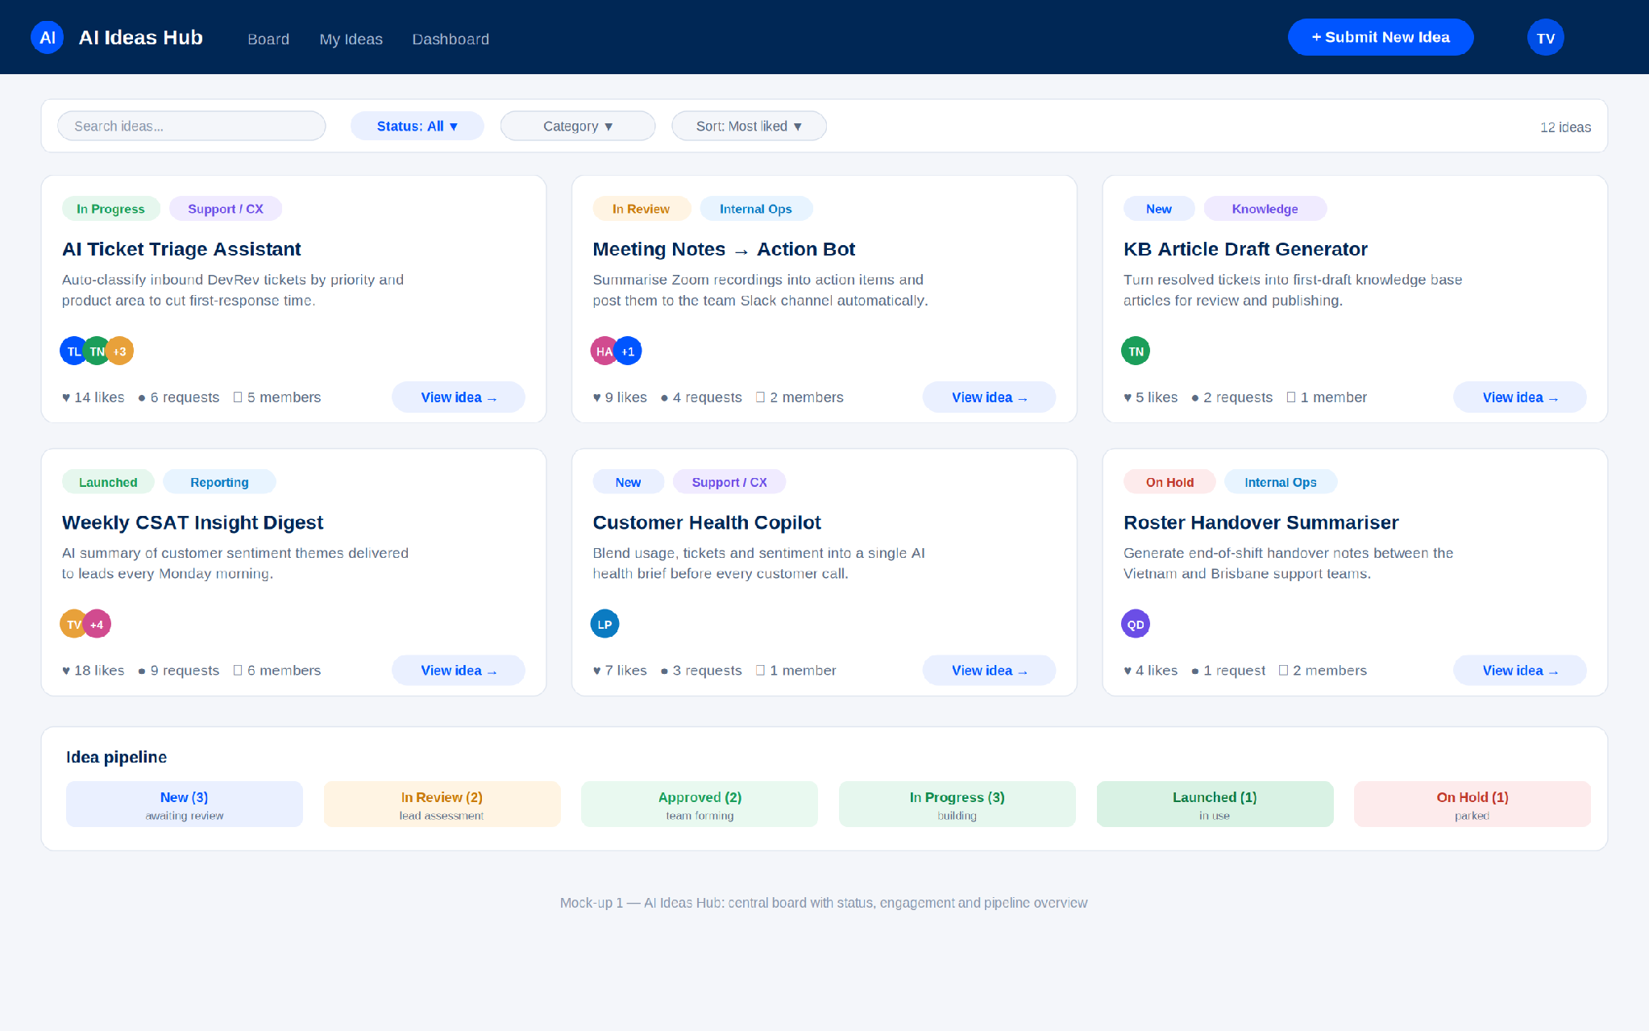
Mock-up 1 — AI Ideas Hub board: cards with status, category, engagement counts, team avatars, and a pipeline summary.

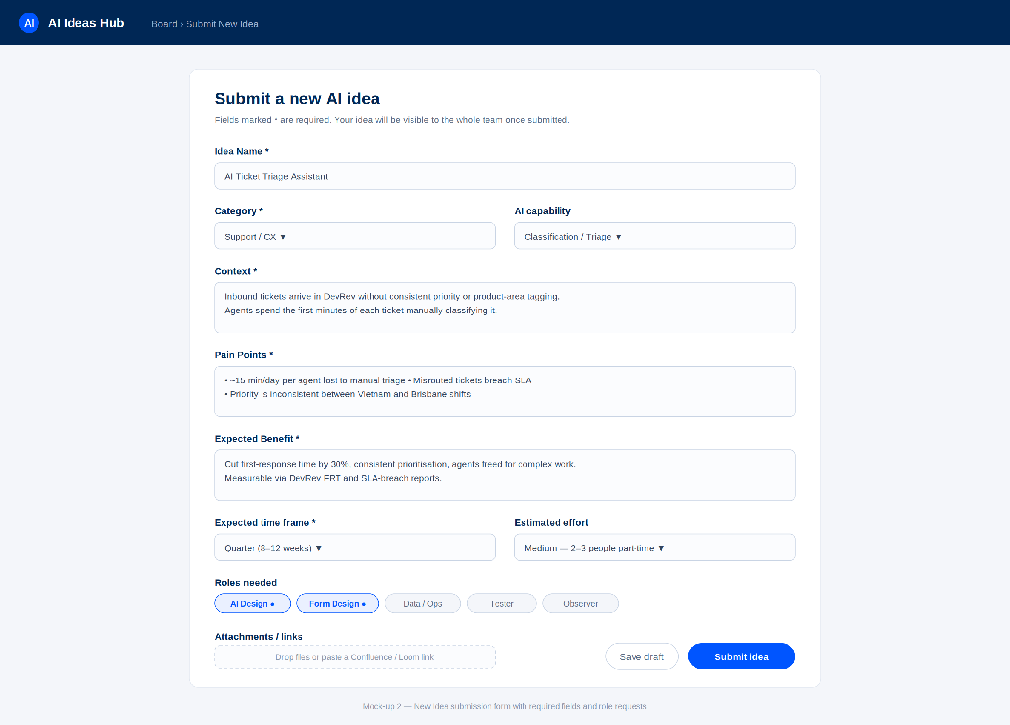
Mock-up 2 — Submit New Idea form: required fields (name, category, context, pain points, benefit, time frame), role requests and attachments.

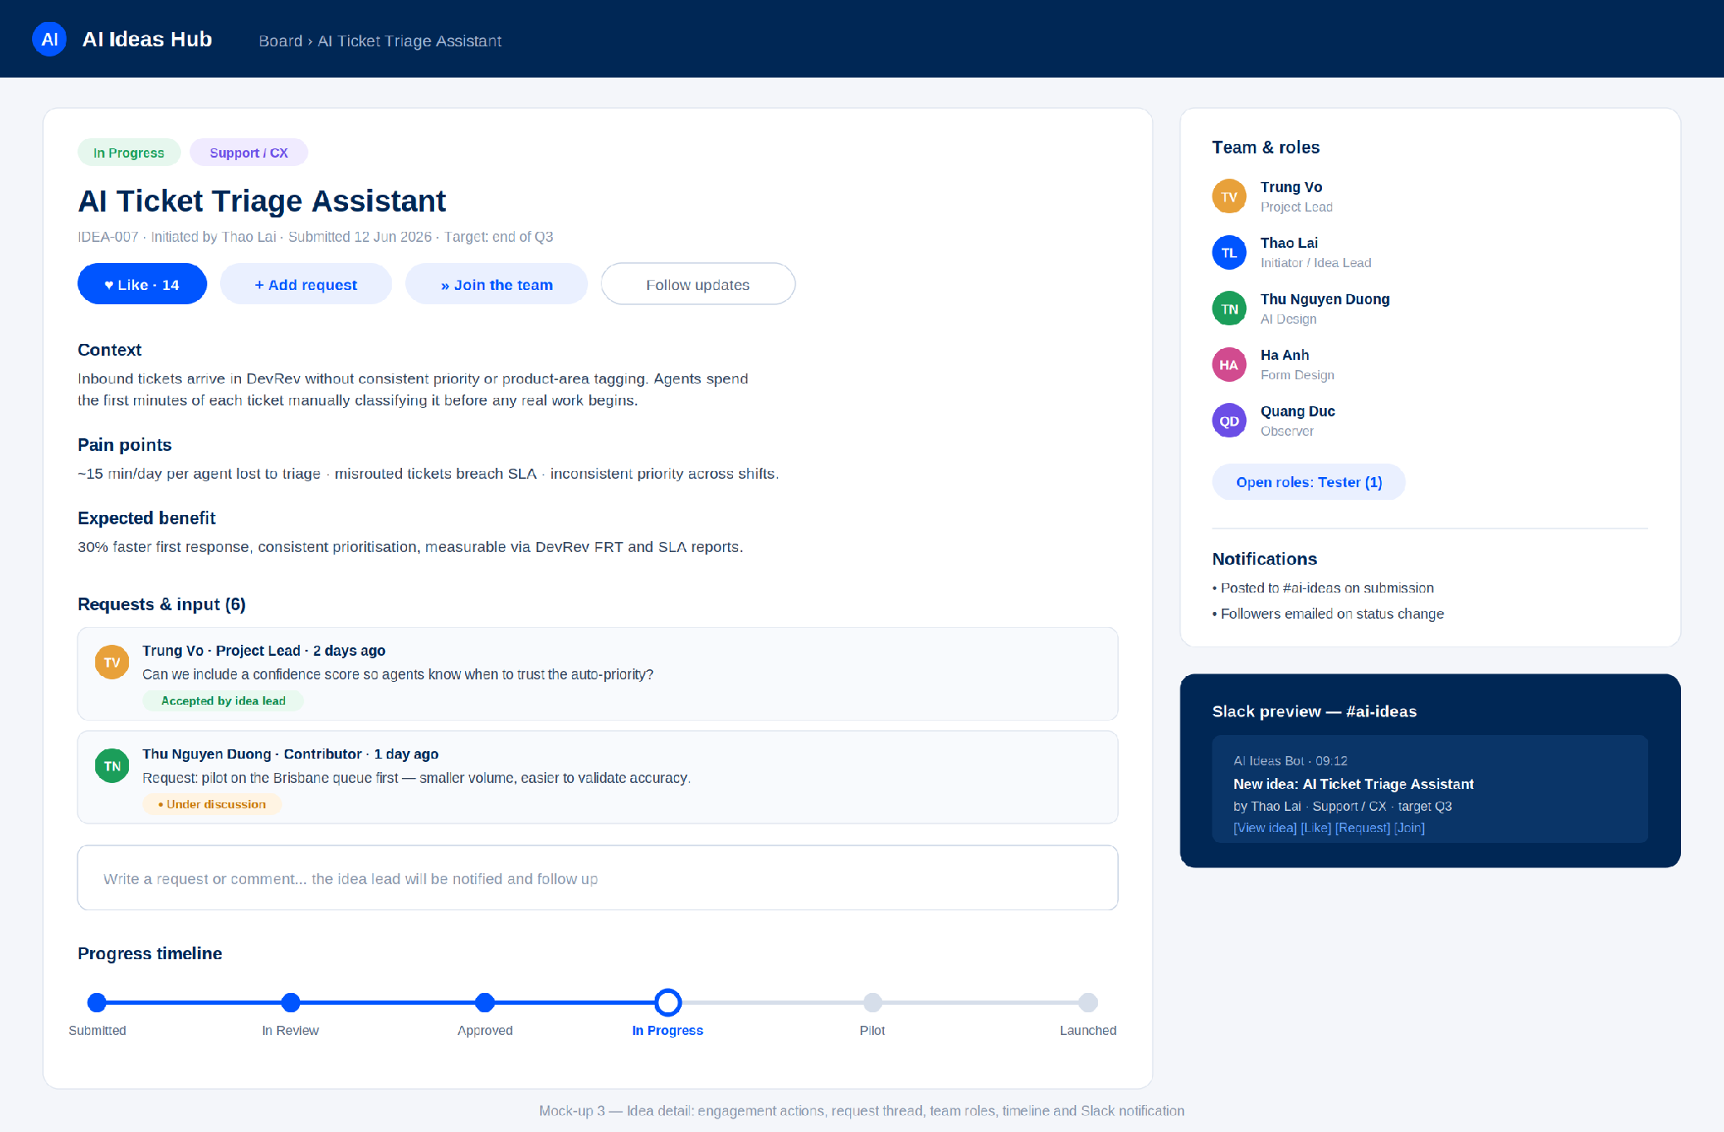
Mock-up 3 — Idea detail: like / request / join actions, request thread with follow-up status, team roles, progress timeline and Slack notification preview.

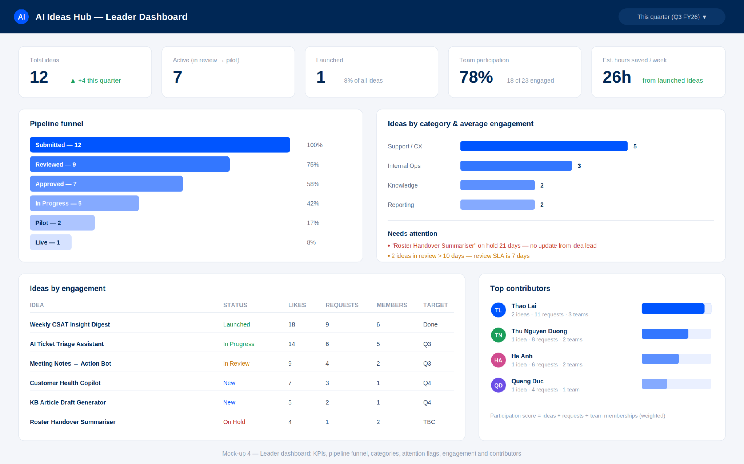
Mock-up 4 — Leader dashboard: KPI tiles, pipeline funnel, category breakdown, attention flags, engagement table and top contributors.

14. Open questions and next steps

14.1 Open questions for the team
- Categories: confirm the starting list (proposed: Support/CX, Internal Ops, Knowledge, Reporting — plus Other).
- Review cadence: single reviewer (lead) or a small review group? Weekly review slot?
- Notification default: all submissions to everyone, or digest-first with instant alerts opt-in?
- Low-code platform choice: Notion vs Airtable vs alternative — decide in Week 1 spike.
- Should Viewers (outside the team) be included from day one?

14.2 Next steps
- Circulate this document for team feedback (async, 3 working days).
- Confirm platform choice and build team in the next team meeting.
- Create #ai-ideas Slack channel and seed the first ideas from the existing Confluence/Trello lists.
- Kick off Phase 1 build per Section 11.

