1. The problem  
   Given an image of a dog or a class, the machine learning model will classify that whether the picture contain a dog or a cat
2. Dataset used  
   The dataset used in this assignment was the Kaggle‘s Cats and Dogs Dataset. The dataset contains 25.002 images with 12.501 cat images and 12.501 dog images.
3. Method  
   A deep neural network model is used to perform the classification task

Model structure is illustrated below:  
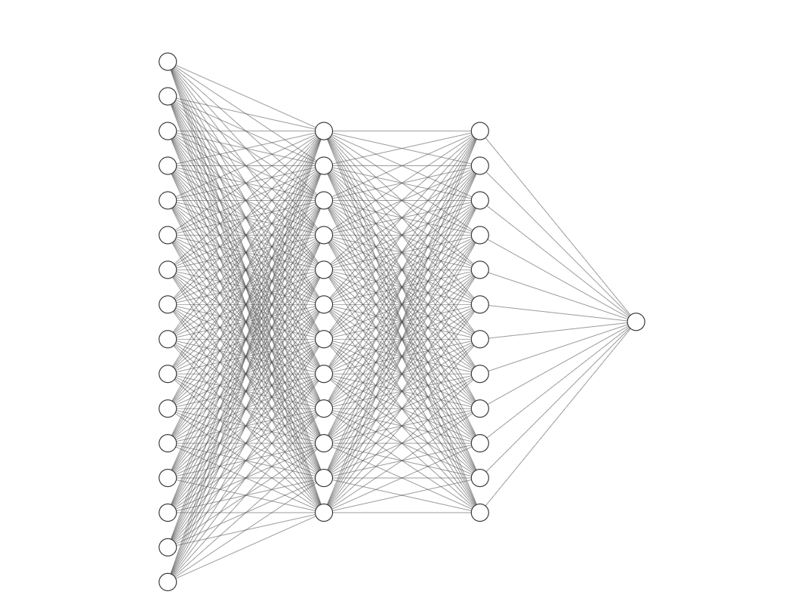

Output layer: 1 neuron

2 hidden layers: 128 neurons each

Input layer: 2500 neurons

|  |  |
| --- | --- |
| Layer | Number of neurons |
| Input layer | 2500 |
| Hidden layer 1 | 128 |
| Hidden layer 2 | 128 |
| Output layer | 128 |

The images will be resized to 50 x 50 pixels and then convert to numpy array. After that the arrays will be flatten and then feed to the model. The activation function for every layers is the sigmoid activation function:  
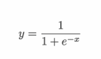

Following 2 hidden layer with 128 neurons each, the output layer will have a single neuron that return a value between 0 and 1.

The layer class will have 2 common functions:

* forward: This is the forward propagation process that feed the input data forward through the network. Each layers accepts the input data, processes it as per the activation function and passes to the successive layer.
* backward: This is the backward propagation process. It will compute the gradients in each node and update the weights of that layer based on the loss value of returned to the layer, and then return the loss value to the layer before it.

To calculate loss, we used the logistic cost function or binary crossentropy loss:

  
Where

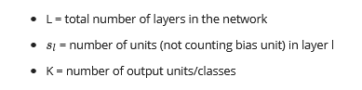

1. Training and result  
   We will train our model using 3 different learning rate to find out which one yield the best result. Here are the results:  
   Learning rate = 0.01

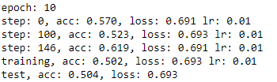  
Learning rate = 0.001  
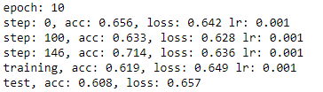  
Learning rate = 0.0001

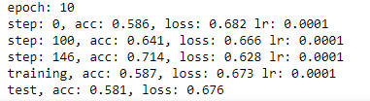

As seen from the output, at learning rate 0.001 the model produces the best result with test accuracy at 0.608. So we will use the model with learning rate 0.001 to predict cat and dogs picture. Here are some results:

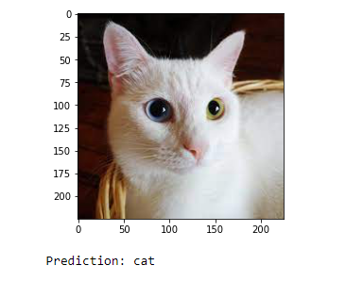

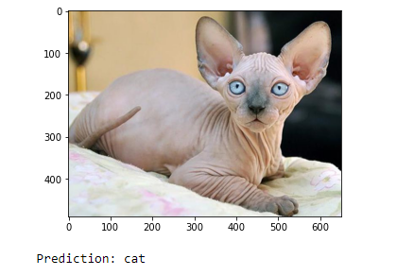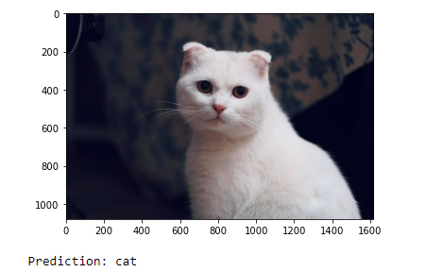

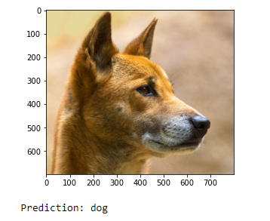

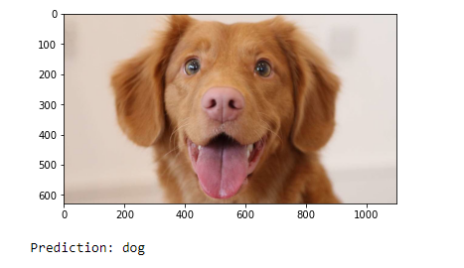

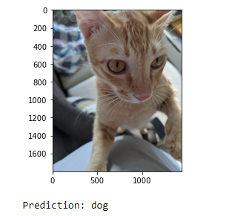

As can be seen from the results, our model still makes some wrong predictions. This is expected since the accuracy of our model is only at 60%. The reason for our low accuracy is because our model is still simple. To extract more features from the training images a more complex model like CNN can be implemented, which then can yield better results.