Contents

I. INTRODUCTION 2

1. Describe the problem: 2

2. Management objective: 2

II. ENTITY – RELATIONSHIP – ER 2

1. Definition entity - Attribute 2

2. Set up entity – relationship 2

III. DATA DICTIONARY 5

A. Create database AssignmentDBI 5

B. CREATE TABLE PLAYER 5

C. CREATE TABLE COACH 6

D. CREATE TABLE TEAM 6

E. CREATE TABLE SEASON 7

F. CREATE TABLE CONTRACT 7

IV. ENTITY RELATIONSHIP DIAGRAM (ERD) 8

A. Player 8

B. Coach 8

C. Team 9

D. Season 10

1. INTRODUCTION
2. Describe the problem:

eSports is becoming huge in the world. The global eSports audience will reach 380 million this year, made up of 165 million dedicated eSports fans and 215 million occasional viewers. League of Legends is one of the highest view eSport in the world with many Tournaments. Because of that, a database to manage these tournaments is essential. This assignment aims to design such a database to manage teams of each regions.

1. Management objective:

Manage team and members of team.

Manage matches of each season.

Manage penalty (if any) of each player in the tournament.

**Important output:**

Total points of each team in the season

1. ENTITY – RELATIONSHIP – ER
2. Definition entity - Attribute

* Player: **id**, name, gender, role
* Coach: **id**, name, gender, yearExperience
* Team: **id**, name, owner, status, **coachID**
* Season: **year**, monthBegin, monthEnd
* Achievement: **teamID**, **seasonId**, point
* Contract: **playerID**, **teamID**, DateSign, EffectiveYear

1. Set up entity – relationship

* Some symbols used in the model

**Attibute**

|  |  |
| --- | --- |
| * Key / identifier attribute |  |
| * Attribute description / description | **ENTITY**  Attribute |
| * Entity | **WEAK ENTIRY** |
| * Weak entity | *Relationship* |
| * Relationship |  |
| * Connectivity (force) = 1 |  |
| * Connectivity = N |  |

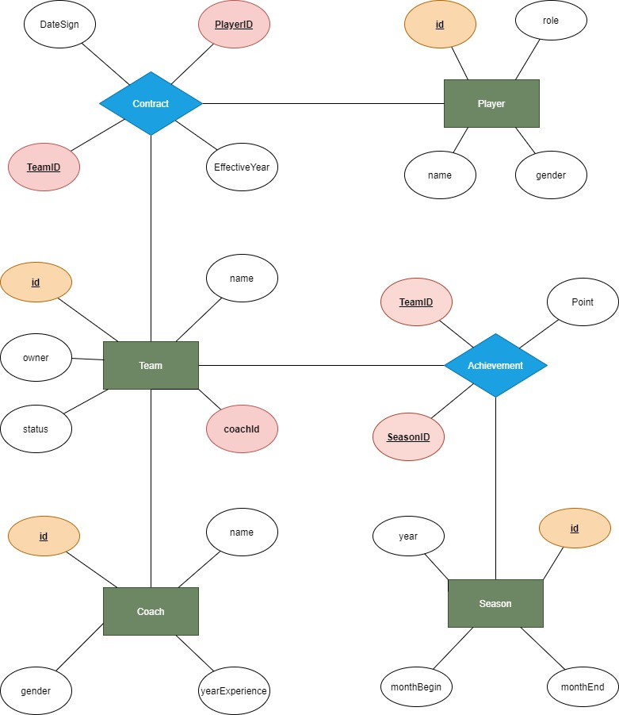

1. DATA DICTIONARY
2. Create database AssignmentDBI

-create database

CREATE DATABASE PROJECTDBI202

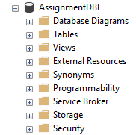

1. CREATE TABLE PLAYER

| Column Name | Data Type | Default | Check | Key/ Index/ Constraint |
| --- | --- | --- | --- | --- |
| ID | CHAR(8) |  | KORP+number | unique |
| Name | NVARCHAR(100) |  |  | Not null |
| Gender | NVARCHAR(1) |  | ‘M’ or ‘F’ | Not null |
| Role | NVARCHAR(255) |  |  | Not null |

Code:

CREATE TABLE Player(

id CHAR(8) PRIMARY KEY NOT NULL CHECK(id LIKE 'KORP[0-9][0-9][0-9][0-9]'),

name NVARCHAR(100),

gender CHAR(1) DEFAULT 'M' CHECK(Gender IN('F','M')) NOT NULL,

role NVARCHAR(10)

)

Example:

| ID | Name | Gender | Role |
| --- | --- | --- | --- |
| KORP0001 | Lee "Faker" Sang-hyeok | M | Mid |
| KORP0002 | Kim"Roach" Kang-hui | M | Top |
| KORP0003 | Moon "Cuzz" Woo-chan | M | Jungle |
| KORP0004 | Park "Teddy" Jin-seong | M | ADC |
| KORP0005 | Ryu "Keria" Min-seok | M | Support |

1. CREATE TABLE COACH

| Column Name | Data Type | Default | Check | Key/ Index/ Constraint |
| --- | --- | --- | --- | --- |
| ID | CHAR(8) |  | KORC+number | unique |
| Name | NVARCHAR(100) |  |  | Not null |
| Gender | NVARCHAR(1) |  | ‘M’ or ‘F’ | Not null |
| YearExperience | INT |  |  |  |

Code:

CREATE TABLE Coach(

id CHAR(8) PRIMARY KEY NOT NULL CHECK(id LIKE 'KORC[0-9][0-9][0-9][0-9]'),

name NVARCHAR,

gender CHAR(1) DEFAULT 'M' CHECK(Gender IN('F','M')) NOT NULL,

yearExperience INT,

)

Example:

| ID | Name | Gender | yearExperience |
| --- | --- | --- | --- |
| KORC0001 | Kim Jeong-soo | M | 3 |
| KORC0002 | Song Chang-geun | M | 5 |
| KORC0003 | Kang Dong-hoon | M | 7 |
| KORC0004 | Lee Chang-seok | M | 4 |
| KORC0005 | Kang Tae-su | M | 2 |

1. CREATE TABLE TEAM

| Column Name | Data Type | Default | Check | Key/ Index/ Constraint |
| --- | --- | --- | --- | --- |
| ID | INT |  |  | unique |
| Name | NVARCHAR(100) |  |  | Not null |
| Status | BIT |  |  | Not null |
| Owner | NVARCHAR(100) |  |  | Not null |
| coachID | CHAR(8) |  |  | FOREIGN KEY REFERENCES Coach(ID) |

Code:

CREATE TABLE Team(

id INT PRIMARY KEY,

name NVARCHAR(100),

Owner NVARCHAR(100),

Status BIT,

coachId CHAR(8) UNIQUE NOT NULL

FOREIGN KEY (coachId) REFERENCES Coach(id)

)

Example:

| Id | Name | Owner | Status | CoachID |
| --- | --- | --- | --- | --- |
| 1 | T1 | SK Telecom | 1 | KORC0001 |
| 2 | Sandbox Gaming | Sandbox Network | 0 | KORC0002 |
| 3 | KT Rolster | KT | 0 | KORC0003 |
| 4 | Griffin | STILL8 | 1 | KORC0004 |

1. CREATE TABLE SEASON

| Column Name | Data Type | Default | Check | Key/ Index/ Constraint |
| --- | --- | --- | --- | --- |
| Id | INT |  |  | Not Null |
| Year | INT |  |  | not null |
| monthBegin | INT |  | 1-12 | Not null |
| monthEnd | INT |  | 1-12 | Not null |

Code:

CREATE TABLE Season(

id INT PRIMARY KEY,

year INT NOT NULL,

monthBegin INT CHECK (monthBegin BETWEEN 1 AND 12),

monthEnd INT CHECK (monthEnd BETWEEN 1 AND 12)

)

Example:

| Id | Year | monthBegin | monthEnd |
| --- | --- | --- | --- |
| S01 | 2019 | 1 | 4 |
| S02 | 2019 | 5 | 8 |
| S03 | 2020 | 1 | 4 |
| S04 | 2020 | 5 | 8 |

1. CREATE TABLE CONTRACT

| Column Name | Data Type | Default | Check | Key/ Index/ Constraint |
| --- | --- | --- | --- | --- |
| playerId | Char(8) |  |  | FOREIGN KEY REFERENCES PLAYER(ID) |
| Teamid | INT |  |  | FOREIGN KEY REFERENCES TEAM(ID) |
| DateSign | DATE |  |  | Not null |
| effectiveYear | INT |  |  | Not null |

Code:

CREATE TABLE Contract(

PlayerID CHAR(8),

TeamID INT,

DateSign DATE,

effectiveYear INT,

FOREIGN KEY (PlayerID) REFERENCES Player(id),

FOREIGN KEY (TeamID) REFERENCES Team(id),

PRIMARY KEY (PlayerID, TeamID)

)

Example:

| PlayerID | TeamID | DateSign | effectiveYear |
| --- | --- | --- | --- |
| KORP0001 | 1 | 01/01/2010 | 10 |
| KORP0002 | 2 | 15/07/2018 | 5 |
| KORP0003 | 3 | 29/06/2014 | 8 |
| KORP0004 | 4 | 28/07/2019 | 4 |

1. ENTITY RELATIONSHIP DIAGRAM (ERD)
2. Player

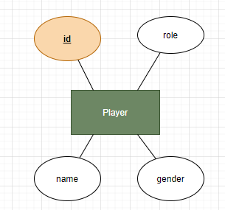

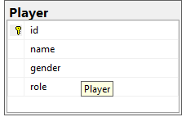

This is Player entity, the root of the diagram. This entity has 4 attributes. The attributes id is the primary key of this entity. Each player has a name, role and gender

1. Coach

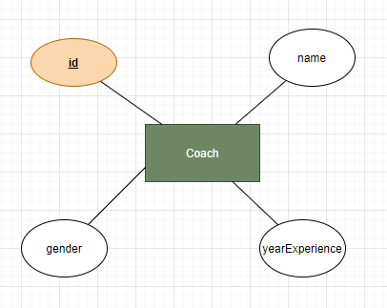

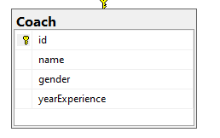

This is the coach entity. This entity has 4 attributes. The attributes id is the primary key of this entity. Each coach has a name, role and gender

1. Team

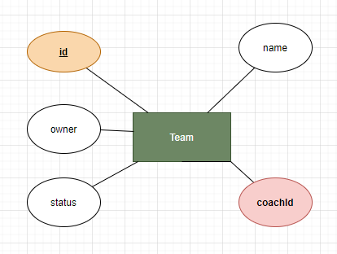

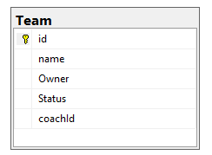This is Team identity. This has 5 attributes. Each team has id which is the primary key. Name is the name of the team. Each team is owned by an owner. Team status is whether team is full or not. Lastly, each Team has a coach so coachId is a foreign key which refernces id in Coach table.

1. Season

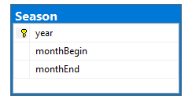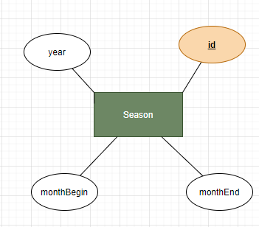

This is season entity. Season entity has 4 attributes. The id is the primary key, year is the year of the season. Each season has begin month and end month