**Phần 1: Các lệnh cơ bản thao tác với Docker**

1. docker –version

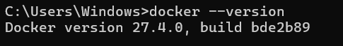

1. docker run hello-world

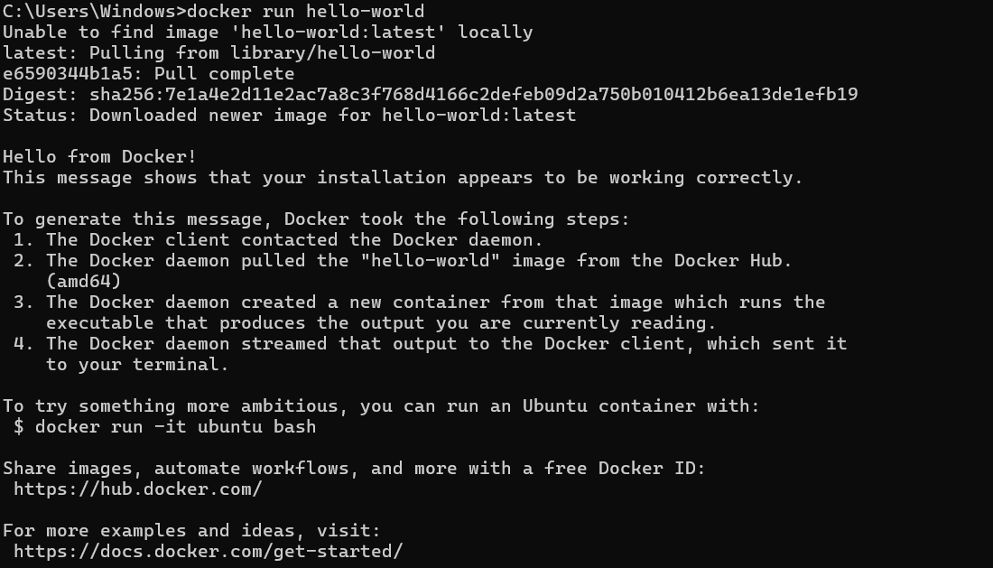



1. docker pull nginx

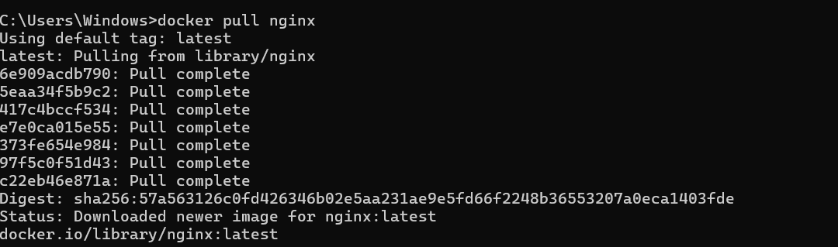



1. docker images

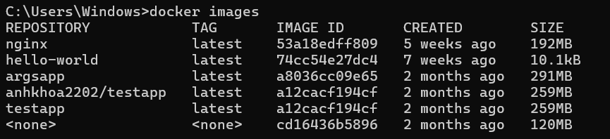

1. docker run -d nginx





1. docker ps



1. docker ps -a

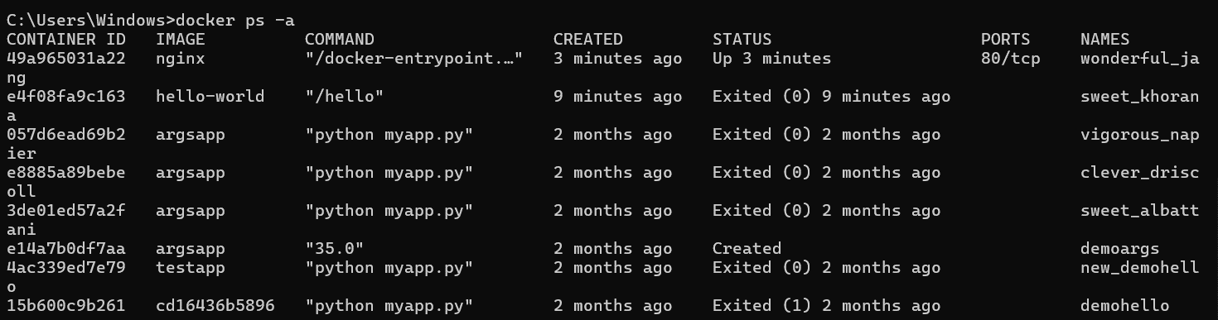

1. docker logs <container_id>

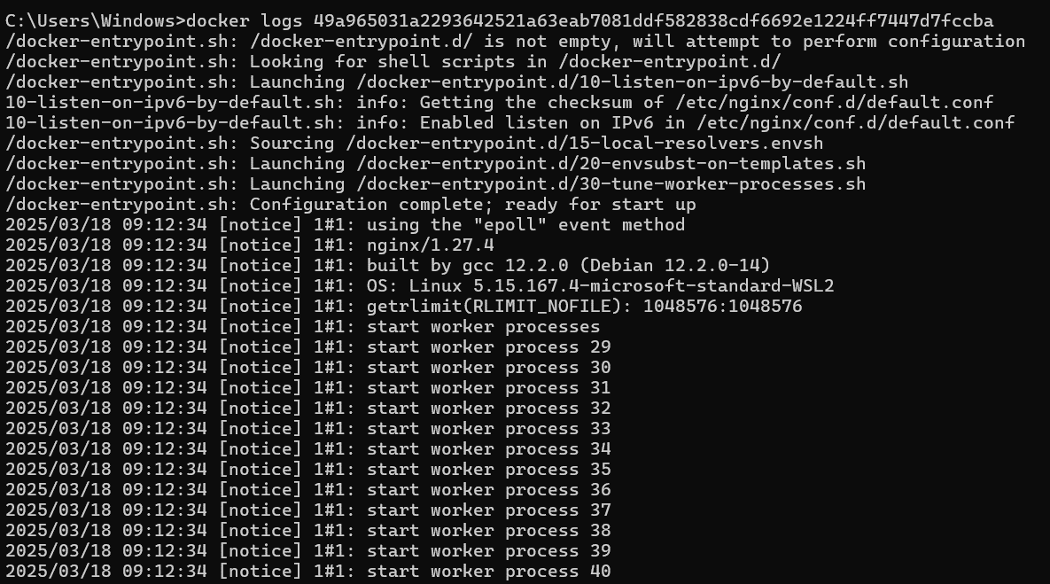

1. docker exec -it <container_id> /bin/sh
2. docker stop <container_id>





1. docker restart <container_id>





1. docker rm <container_id>

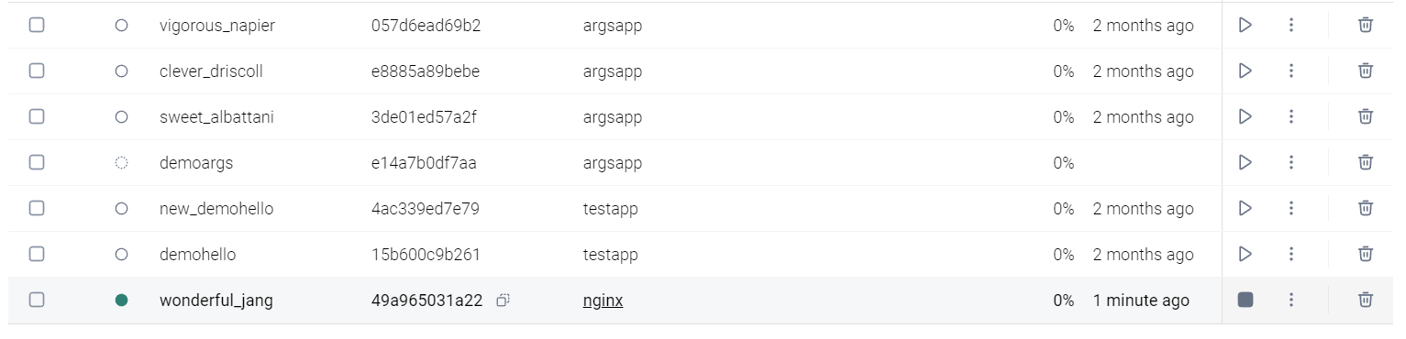



1. docker container prune

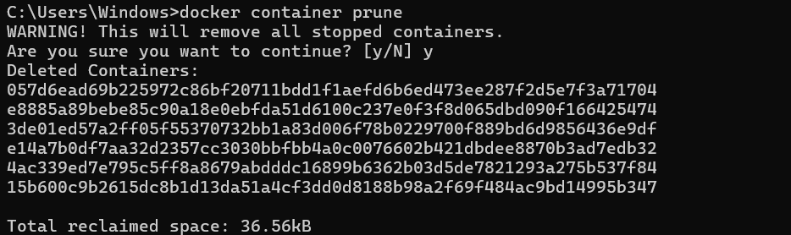

1. docker rmi <image_id>

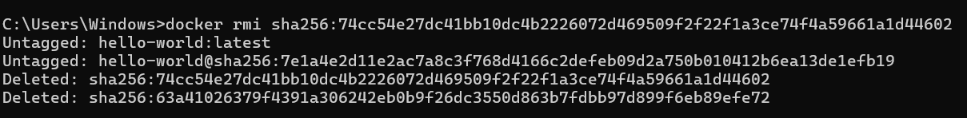

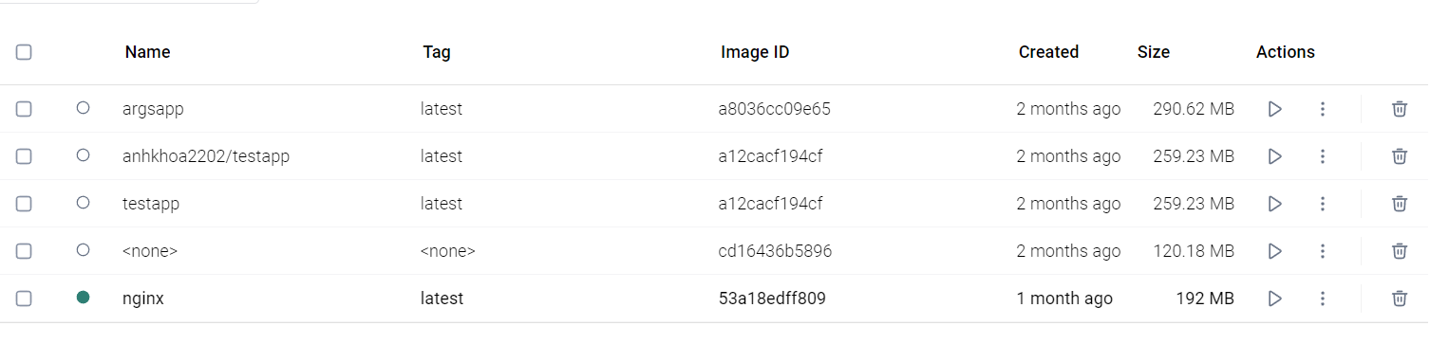

1. docker image prune -a

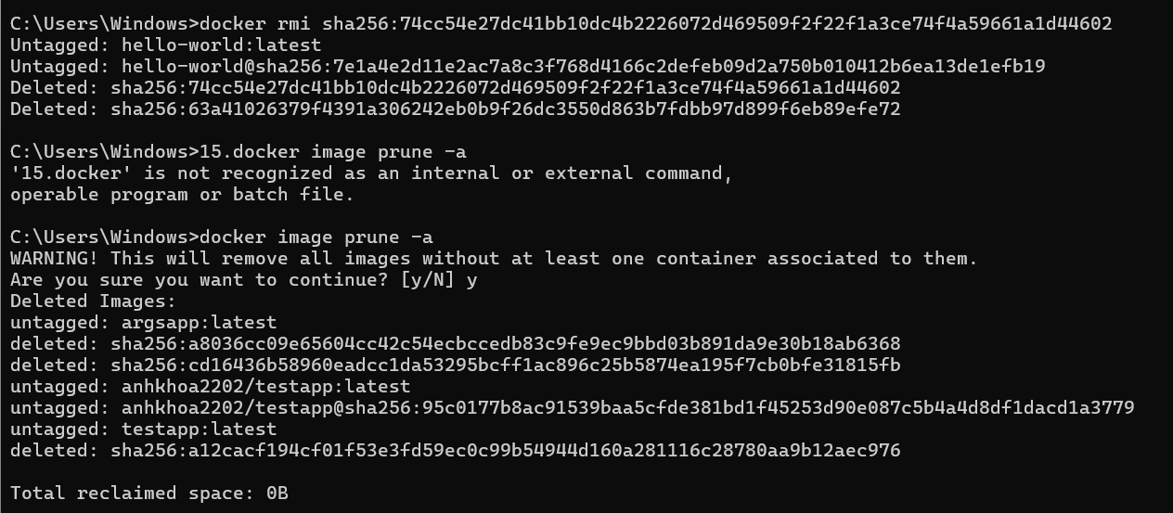

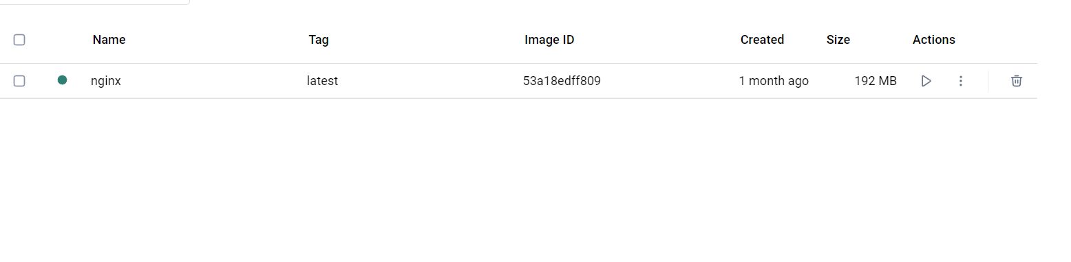

1. docker run -d -p 8080:80 nginx

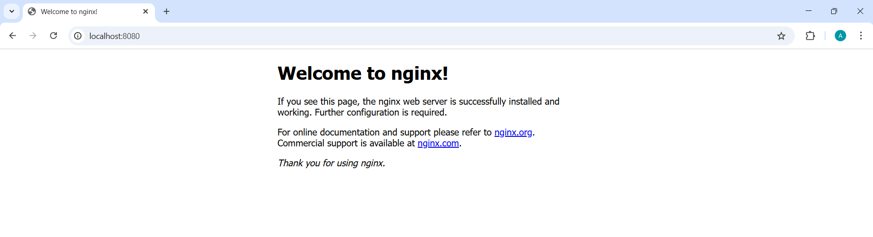



1. docker inspect <container_id>

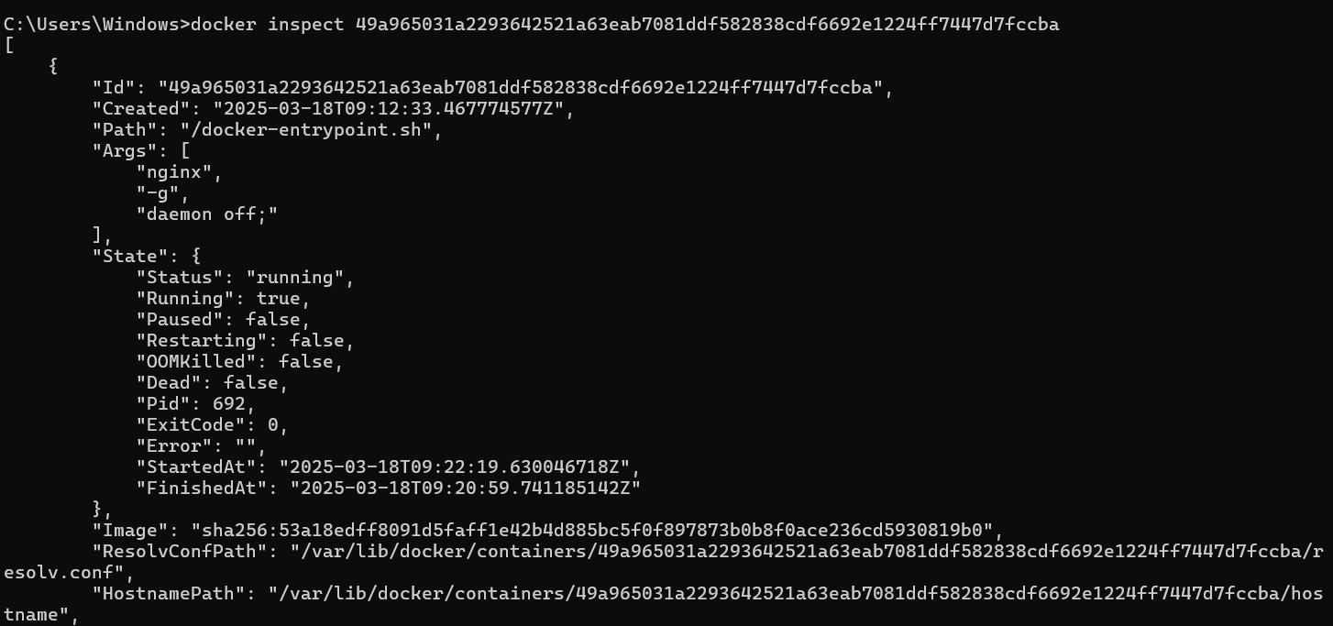

1. docker run -d -v mydata:/data nginx





1. docker volume ls

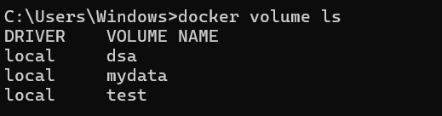

1. docker volume prune

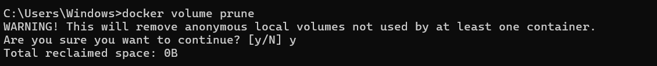



1. docker run -d --name my_nginx nginx



1. docker stats

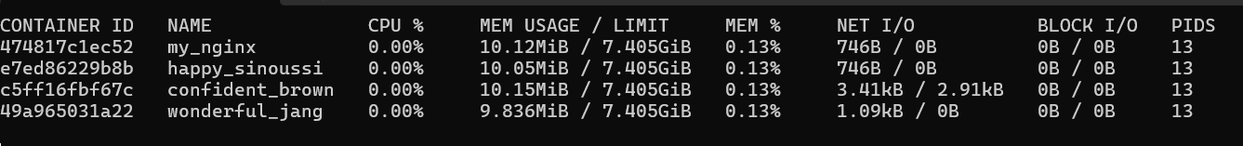

1. docker network ls

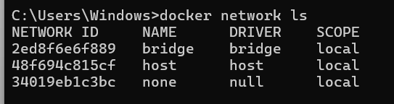

1. **docker network create my_network**



1. **docker run -d --network my_network --name my_container nginx**



1. **docker network connect my_network my_nginx**



1. **docker run -d -e MY_ENV=hello_world nginx**



1. **docker logs -f my_nginx**

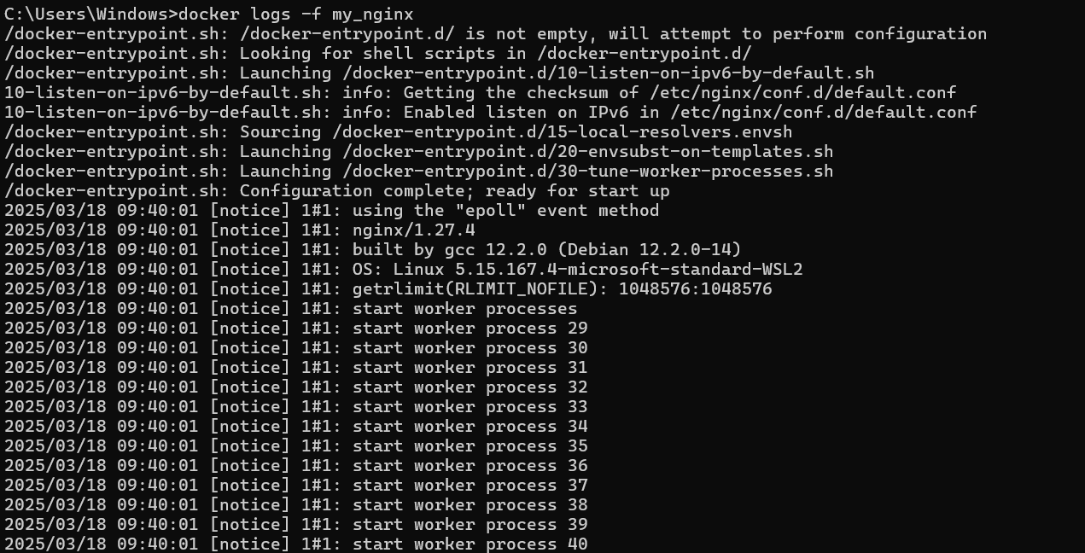

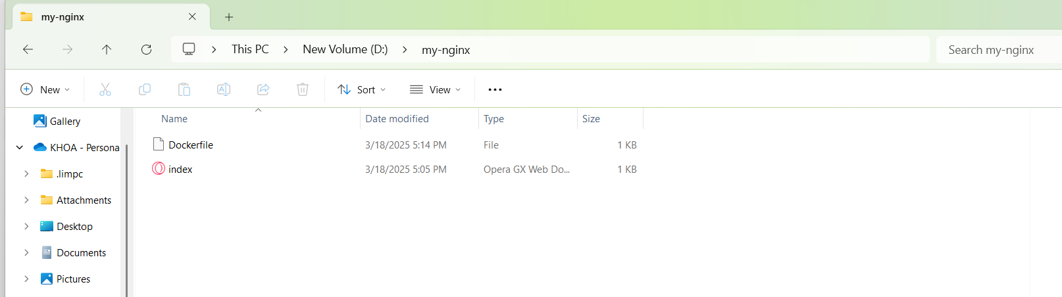

1. docker build -t my_nginx_image .

