**INTERNATIONAL UNIVERSITY**

**VIETNAM NATIONAL UNIVERSITY – HO CHI MINH CITY**

**School of Computer Science and Engineering**

**-----***-----**

**PROJECT REPORT**

**STORE MANAGER**

**Advisor: Dr Tran Thanh Tung and Thai Trung Tin**

**Course: ALGORITHMS AND DATA STRUCTURES**

|  |  |  |
| --- | --- | --- |
| No. | Full Name | Student’s ID |
| 1 | Đỗ Thanh Bảo Anh | ITDSIU22175 |
| 2 | Đào Ngọc Lan Hồng | ITDSIU21088 |
| 3 | Phạm Tuấn Đăng Khoa | ITITIU22087 |
| 4 | Nguyễn Thị Ngọc Mai | ITDSIU21098 |
| 5 | Trần Triệu Như | ITDSIU21029 |

**CHAPTER 1: INTRODUCTION**

1. **Objectives**

The goal of the project is to develop a system that analyzes Java source code using advanced data structures and algorithms. The key objectives are as follows:

* **Efficient Data Handling**: The system is designed to utilize suitable data structures, such as trees and linked lists, to effectively manage and organize the data under analysis. By employing a tree structure, it facilitates quick retrieval and storage of information related to products and purchase records.
* **Optimized Searching and Sorting**: A focus on implementing algorithms that enhance the speed of searching and sorting operations is paramount. The use of sorted linked priority queues enables efficient management and retrieval of data based on specific criteria, ensuring rapid access to relevant information.
* **Robust Exception Handling**: It is essential for the system to incorporate effective exception handling, particularly when managing file operations and user inputs. This capability guarantees that the analysis process remains reliable and robust, allowing for meaningful feedback even in the event of errors.
* **Scalability**: The algorithms and data structures are crafted to scale effectively with the increasing size of data. As the volume of the codebase or analyzed data expands, the system will maintain its performance without significant degradation.
* **User-Friendly Interaction**: By structuring data and algorithms to support clear outputs and interfaces, the system aims to enhance user interaction. This includes providing detailed explanations of code functionality and structure, thereby simplifying the interpretation of analysis results for developers.

1. **The Tools Used**

* IDE for programming and debugging: IntelliJ, VSCode.
* Design: Piskel, Simple2DTileEditor.
* Java Development Kit: 21.
* Mean of code version management: GitHub.
* Means of contacting: Facebook

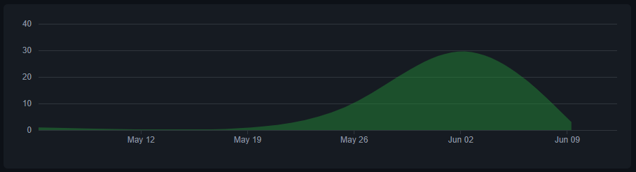

Figure 1: GitHub statistics

**CHAPTER 2: TIME COMPLEXITY**

1. **List of Time Complexity**

|  |  |  |  |  |
| --- | --- | --- | --- | --- |
| Algorithm / DataStructure | Best Time Complexity | Average Time Complexity | Worst Time Complexity | Worst Space Complexity |
|  |  |  |  |  |
|  |  |  |  |  |
|  |  |  |  |  |
|  |  |  |  |  |

*Table 1: List of class and responsibility*

**CHAPTER 3: DATA STRUCTURE**

1. **Player**
2. **Enemy**

**CHAPTER 4: ALGORITHM**

1. **Asset**

**CHAPTER 5: GAME DESIGN**

1. **Game Rule**

**CHAPTER 6: DEMO**

[Click here to view:](https://drive.google.com/file/d/1CLsoQxugP8uQHXMjLca8d3_UI-HAwY3w/view?usp=sharing" \o "Click here to view) https://drive.google.com/file/d/1CLsoQxugP8uQHXMjLca8d3_UI-HAwY3w/view?usp=sharing

**CHAPTER 7: CONCLUSION AND FUTURE WORKS**

1. **Conclusion**

The development of the game is still ongoing. In the final phase, the team has gained a deeper understanding of the four core principles of Object-Oriented Programming (OOP) and the SOLID principles. This knowledge has significantly enhanced our proficiency in OOP for both game development and post-release programming, introducing novel features compared to the original version. The project classes have covered encapsulation extensively. Inheritance, abstraction, and polymorphism have been most frequently applied within the enemies’ and player packages. Consequently, Saving Mrs Nghia was meticulously developed using the fundamental concepts of OOP, and the game code embodies all four key OOP features and a design pattern learned from class. The extensive knowledge gained from this experience is a testament not only to our collective expertise but also to the innovative spirit that has driven us to push the boundaries of game development.

1. **Future works**

For the timeline and restricted skills , we cannot do all plans that we have in mind. These features could enhance the player’s abilities, special attack, and the new experiences for players including teleport, throwing firearms, and allowing players to customize their character with various skins, outfits, anh jewelries. In technical improvements, performance optimization will be updated to ensure smooth gameplay on various devices. This includes reducing load times, optimization asset usage, and improving frame rates. In content expansion, storyline enhancements will be committed, this would expand the game’s narrative with additional storyline, quests, or side missions.

1. **Acknowledgment**

We would like to convey our deepest appreciation to our instructor and individuals who assisted us in reaching the goals of this project:

* Dr. Tran Thanh Tung and MSc. Thai Trung Tin
* Original code from RyiSnow (https://youtu.be/om59cwR7psI?si=xngu7Kg2FalNV_4J)

**REFERENCES**