Crack the Code  Match each note to its key and write the letter in the box. | Name: ______________

Treble clef key  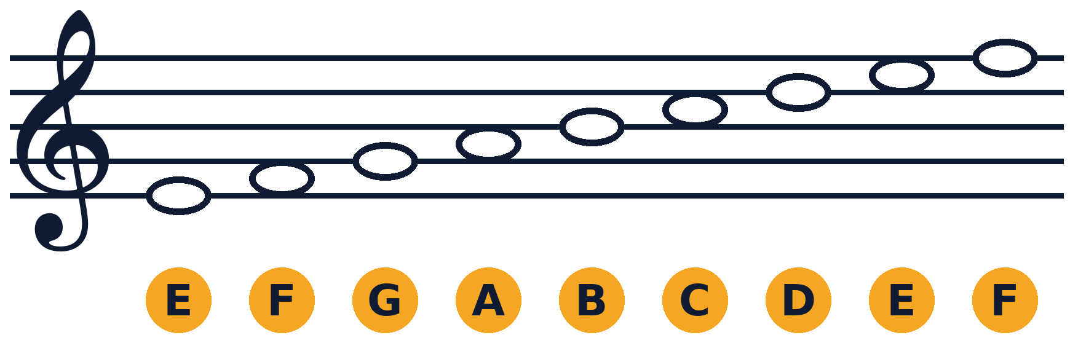 | Bass clef key  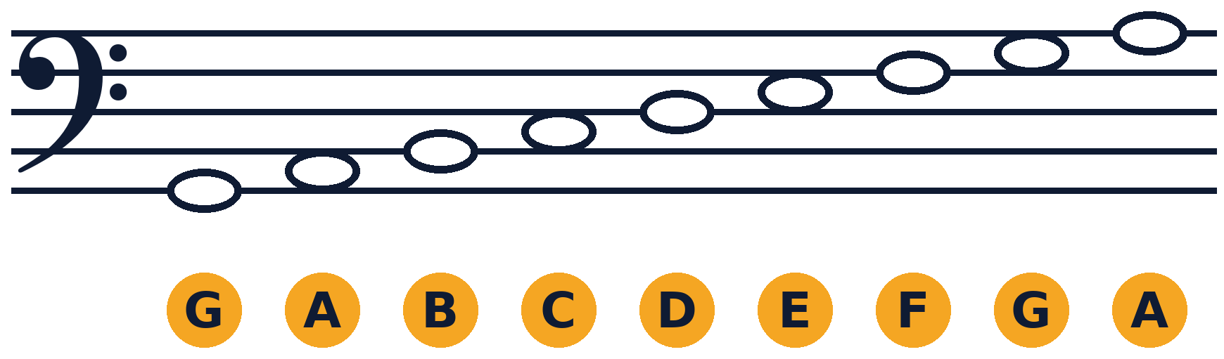

Treble 1  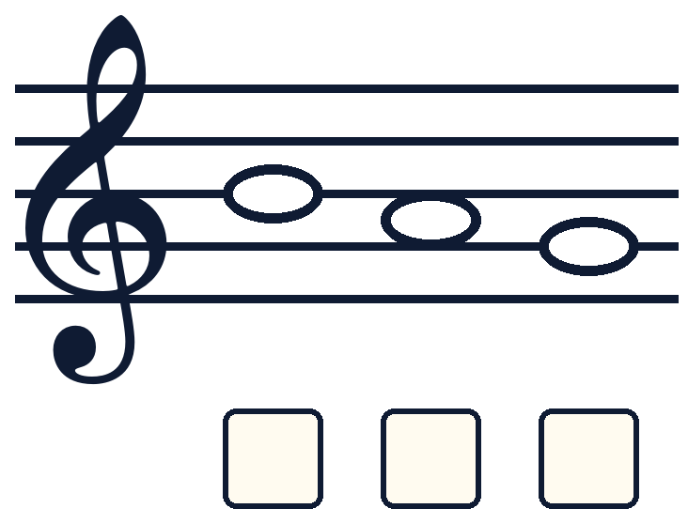 | Treble 2  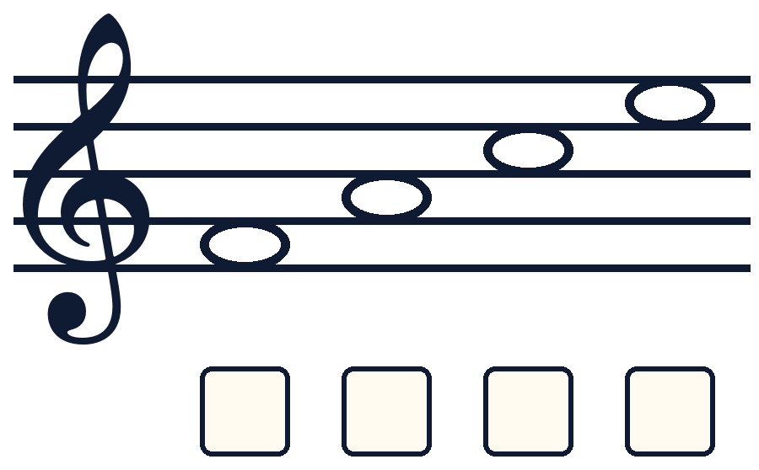 | Treble 3  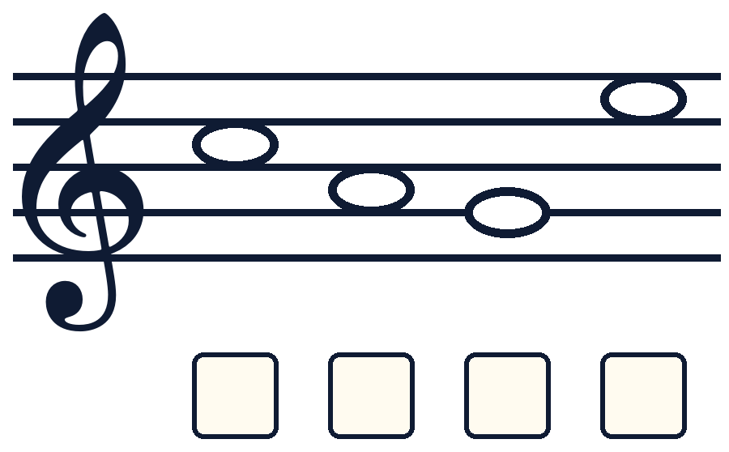
Treble 4  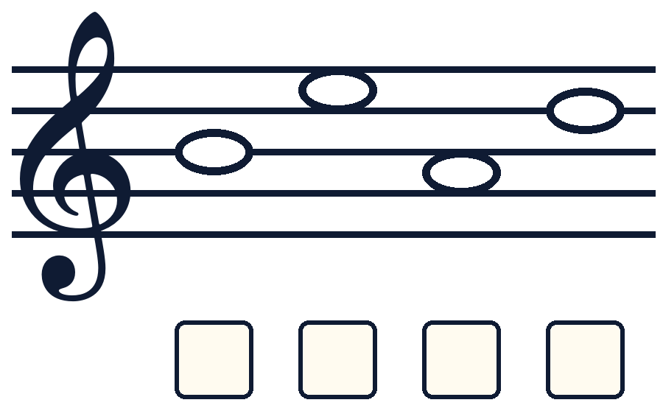 | Treble 5  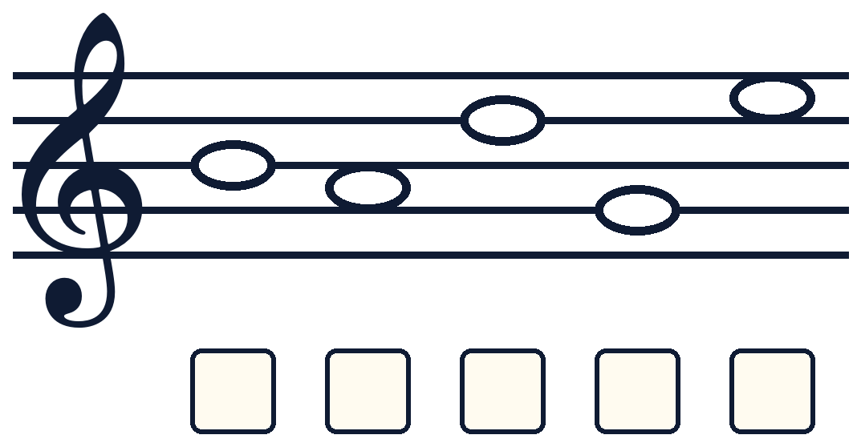 | Treble 6  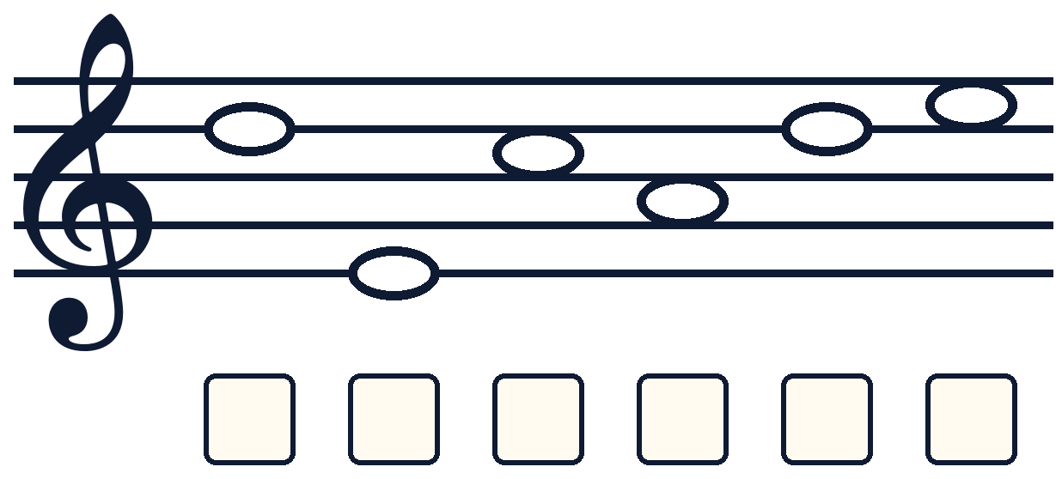

Crack the Code  Bass clef, then mixed clefs. In the mixed codes the clef changes halfway! | Name: ______________

Bass 1  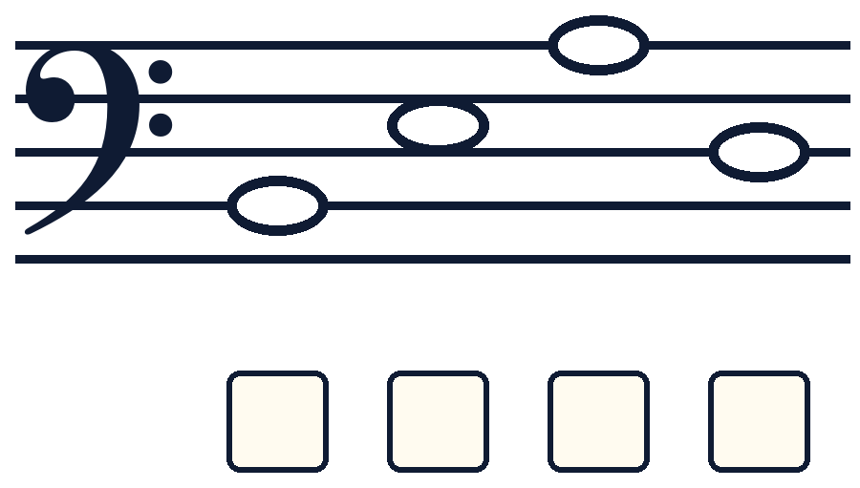 | Bass 2  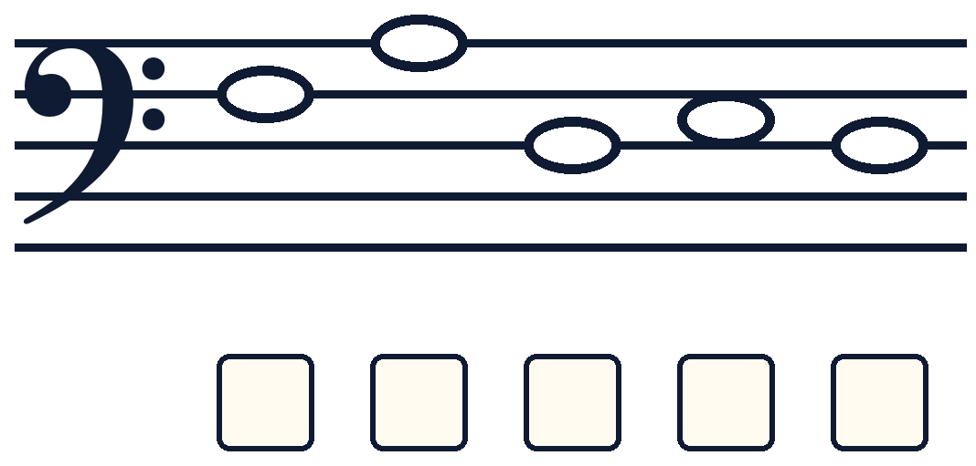
Mixed 1  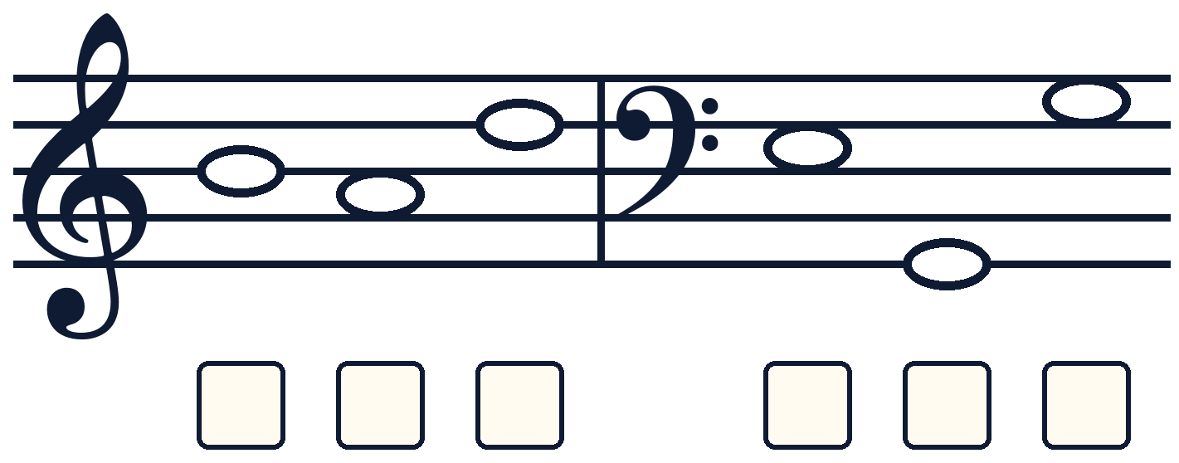 | Mixed 2  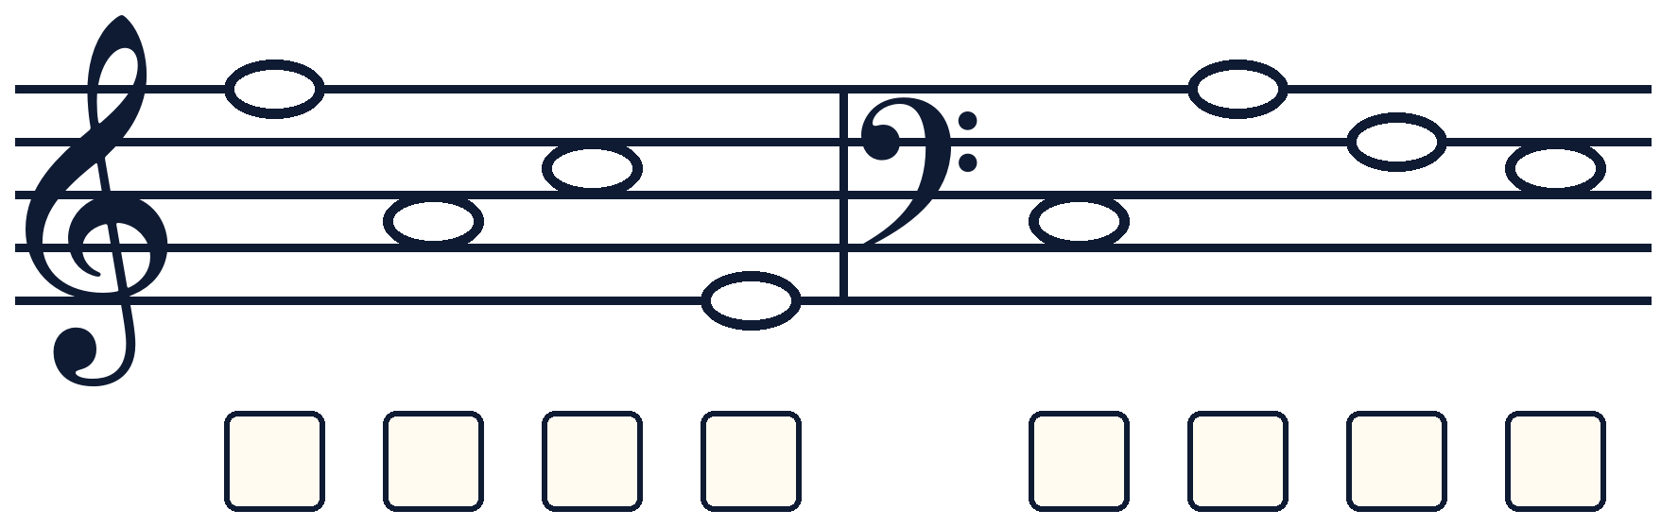
Mixed 3  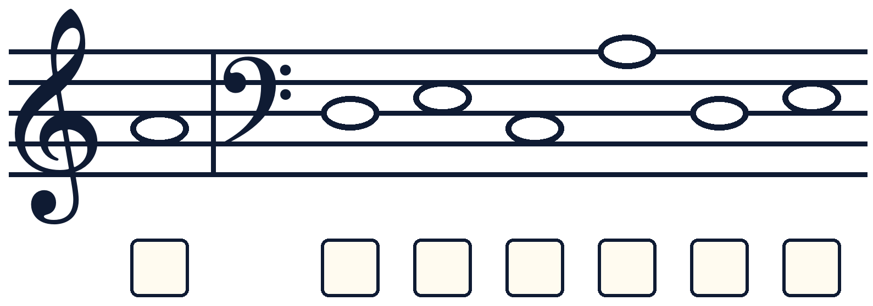 | Key reminder  Treble key: lines E G B D F | spaces F A C E  Bass key: lines G B D F A | spaces A C E G

