|  |  |
| --- | --- |
| Data Structure Final Project  Eng. Mahmoud Ouf Team Members: Ahmed Saad, Eslam Gamal, Nada ElBayoumy, Salma Gaber | **OS 01** |

A simulation project for database engine with the basic functionality

Statement of Work

|  |  |  |
| --- | --- | --- |
| Date | Services Performed By: | Services Performed For: |
| December 8, 2016 | Data Structure Final Project | Eng. Mahmoud Ouf  Team Members: Ahmed Saad, Eslam Gamal, Nada ElBayoumy, Salma Gaber |

# The project will perform the following features:

1. Create table
   1. Postponed:
      1. Alter table
2. Insert into table
   1. All columns
   2. Certain columns
3. Delete from table where one column is equal to certain value.
   1. Postponed:
      1. Delete from table with condition from multiple columns (ex. Delete from students where name = “Ahmed” and city = “Alexandria”.
4. Update record of certain table.
   1. Postponed:
      1. Update record with multiple columns condition (ex. Update students set name = “ABC” where city = “Alexandria” and track = “OS” )
5. Select from certain table all data
   1. Postponed:
      1. Select certain columns from one table.
      2. Select one record from one table with condition on one column.

# 1) Create Table

int create(table name , 2d array with three columns) //takes two arguments

{

* //First argument “table name”:
* is to create two text files (A) a text file with table name as file name with extension .txt
* //and (B) is a text file called tablename_details with extension .txt to fill it with the column details of the table.
* //Second argument “2d array”:
* // the first column of the 2d array contains the column names.
* // these column names will be the first row written into the first file ex. “Students.txt” separated by comma as a delimiter.
* // the 2d array will be the content of the second file ex.”Student_details.txt” each row of the 2d array will be row in this file with comma delimiter.
* // the return type is an integer returns positive value if file created and zero if file not created.

}

Steps in other words:

1. Create file with name sent as first parameter.
2. Create another file with name sent in first parameter concatenated with underscore “details” to be the columns details about the table.
3. Write into the first file the content of the first column in the 2d array sent as the second parameter horizontally in the file separated with comma delimiter.
4. Write into the second file the 2d array content separated with comma delimiter each column name with datatype and size.

Sample input:

1. “Students” -> first argument
2. “2d array” -> second argument

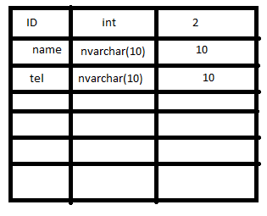

Sample output:

1. “Students.txt”

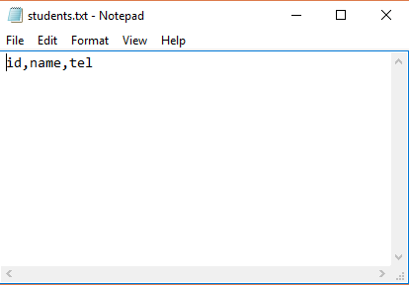

1. “Students_details.txt”

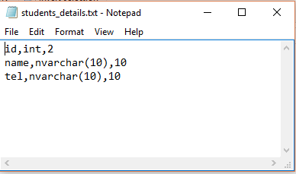

# 2) Insert Into Table (All columns)

Int insertAllColumns (“Table Name”, char * all values) //takes two parameters and return an integer

{

* // open file named “table name” from the first parameter with extension .txt
* //find the first empty column in the file.
* // insert the values in the second parameter comma separated.
* //returns the integer positive value in success case and zero if insert failed.

}

# 3) Select All data from table

Char *Select all (“table name”) //takes one argument

{

* // find the file with name “table name” with extension .txt
* // print the first row values as the header to the user.
* // loop through all the file to print the output to the user separated with tab delimiter instead of comma delimiter to make the output more user friendly.

}

Sample input

1. “students”

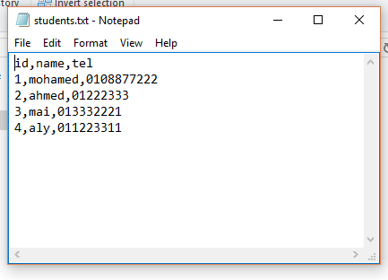

Sample output

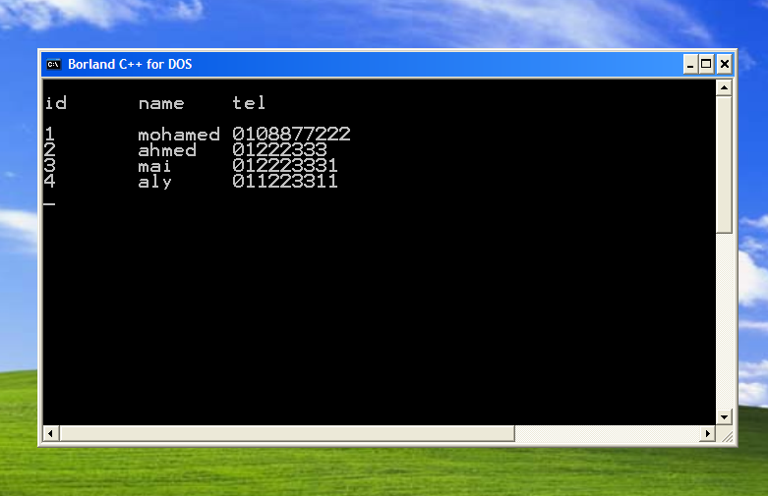

# 4) Delete from table

Int DeleteFromTable(“Table name”, “Column Name”, “Value” )//takes 3 arguments and returns an integer

{

//open file with name “table name” from the first parameter with extension .txt

//search into the first row to find the column number from the second parameter.

// after getting the column name and number search into this columns values compared to the value in parameter list (third parameter) and if found delete the current row from the file.

}

# Project Schedule

The project will be delivered on Thursday the 8th of December, 2006.

| Item Description | Responsible | Delivery date |
| --- | --- | --- |
| Implementation of read and write into text file | Ahmed saad, Salma Gaber, Eslam Gamal, Nada El Bayoumy | 1.12.2016 |
| Create table | Ahmed Saad | 2.12.2016 |
| Insert into table | Nada El Bayoumy | 2.12.2016 |
| Select all | Salma Gaber | 2.12.2016 |
| Delete from table | Eslam Gamal | 2.12.2016 |

# Assumptions

|  |  |
| --- | --- |
|  | List any assumptions that are specific to this project. |