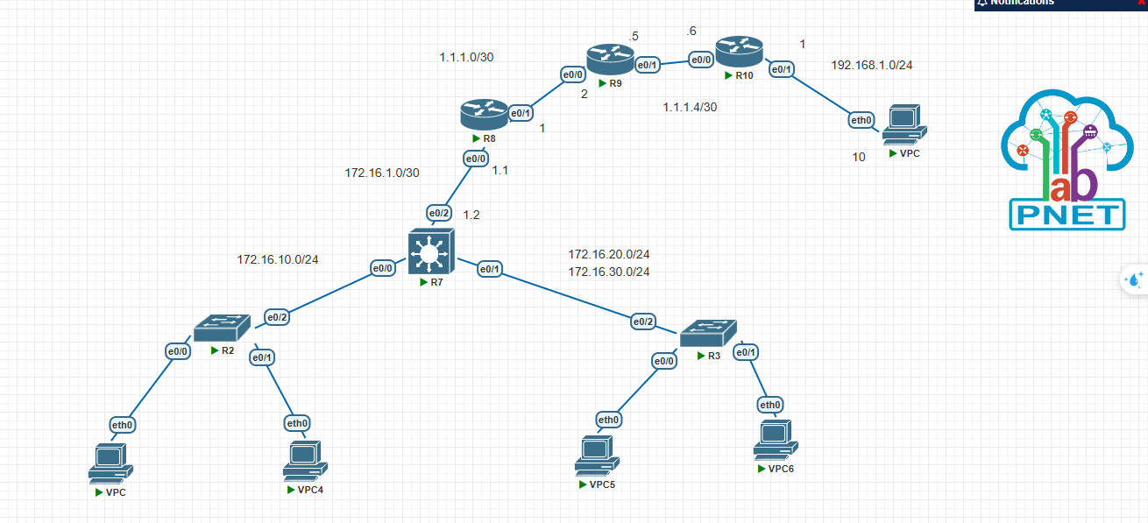

Sw1_layer 2:

Ena

Conf t

Host SW1

Int range e0/0-1

Sw mode acc

Sw acc vlan 10

Int e0/2

Sw trunk encap dot1q

Sw mode trunk

SW2_layer2

Ena

Conf t

Host SW2

Int e0/0

Sw mode acc

Sw acc vlan 20

Int e0/1

Sw mode acc

Sw acc vlan 30

Int e0/2

sw trunk encap dot1q

sw mode trunk

SW_layer3 (R7)

Ena

Conf t

Int range e0/0-1

Sw trunk encap dot1q

Sw mode trunk

Exit

Vlan 10

Vlan 20

Vlan 30

Exit

Int vlan 10

No shut

Ip add 172.16.10.1 255.255.255.0

Int vlan 20

No shut

Ip add 172.16.20.1 255.255.255.0

Int vlan 30

No shut

Ip add 172.16.30.1 255.255.255.0

Int e0/2

No sw

No shut

Ip add 172.16.1.2 255.255.255.252

Exit

Ip route 0.0.0.0 0.0.0.0 172.16.1.1

2, cấu hình nat

Tren r8:

Ena

Conf t

Int e0/0

No shut

Ip add 172.16.1.1 255.255.255.0

Int e0/1

No shut

Ip add 1.1.1.1 255.255.255.252

Exit

Ip route 0.0.0.0 0.0.0.0 1.1.1.2

Ip access-list extend NAT

10 deny ip 172.16.10.0 0.0.0.255 192.168.1.0 0.0.0.255

20 permit ip any any

Ip nat inside source list NAT int e0/1 overload

Int e0/0

Ip nat inside

Int e0/1

Ip nat outside

Exit

Ip route 172.16.10.0 255.255.255.0 172.16.1.2

Ip route 172.16.20.0 255.255.255.0 172.16.1.2

Ip route 172.16.30.0 255.255.255.0 172.16.1.2

Tren r9

Ena

Conf t

Int e0/0

No shut

Ip add 1.1.1.2 255.255.255.252

Int e0/1

No shut

Ip add 1.1.1.5 255.255.255.252

Tren r10

Ena

Conf t

Int e0/0

No shut

Ip add 1.1.1.6 255.255.255.252

Int e0/1

No sh

Ip add 192.168.1.1 255.255.255.0

Exit

Ip route 0.0.0.0 0.0.0.0 1.1.1.5

Ip Access-list extend NAT

10 deny ip 192.168.1.0 0.0.0.255 172.16.10.0 0.0.0.255

20 permit ip any any

ip nat inside source list NAT int e0/0 overload

int e0/1

ip nat inside

int e0/0

ip nat outside

3, ip sec VPn site to site

Trên R8

Mode conf t;

**Crypto isakmp policy 10**

**Encry 3des**

**Hash sha**

**Group 2**

**Authe pre-share**

**Ex**

**Crypto isakmp key 6 cisco address 1.1.1.6**

**Crypto ipsec transform-set TEST esp-3des esp-md5-hmac**

**Ex**

**Ip access-list extend** VPN

10 permit ip 172.16.10.0 0.0.0.255 192.168.1.0 0.0.0.255

Crypto map VPN1 10 ipsec-isakmp

Set peer 1.1.1.6

Set transform-set TEST

Match address VPN

Ex

Int e0/1

Crypto map VPN1

Trên R10:

Mode conf t;

**Crypto isakmp policy 10**

**Encry 3des**

**Hash sha**

**Group 2**

**Authe pre-share**

**Ex**

**Crypto isakmp key 6 cisco address 1.1.1.1**

**Crypto ipsec transform-set TEST esp-3des esp-md5-hmac**

**Ex**

**Ip access-list extend** VPN

10 permit ip 192.168.1.0 0.0.0.255 172.16.10.0 0.0.0.255

Crypto map VPN1 10 ipsec-isakmp

Set peer 1.1.1.1

Set transform-set TEST

Match address VPN

Ex

Int e0/0

Crypto map VPN1

4,

Cấu hình ssh cho R8

Host R8

Ip domain name cisco.com

User tranlongvu privi 15 secret 14122003

Ip ssh version 2

Crypto key generate rsa modulus 1024

Line vty 0 4

Transport input ssh

Login local