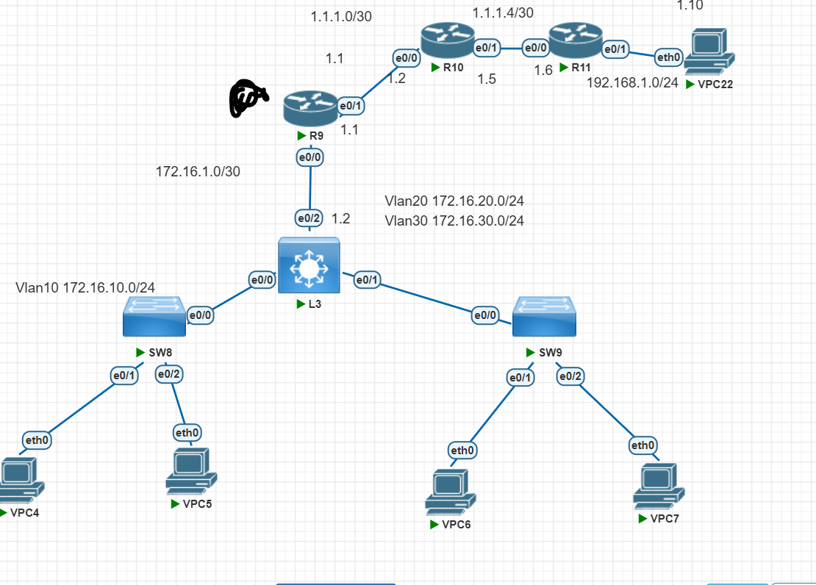

Int e0/0

Ip nat inside

Int e0/1

Ip nat outside

B2: Khai báo access list để cho phần tử nào ra ngoài internet

Access- list 1 permit 172.16.10.0 0.0.0.255

Ip nat inside source list 1 int e0/1 overload

Access- list 1 permit 172.16.20.0 0.0.0.255

Ip nat inside source list 1 int e0/1 overload

Access- list 1 permit 172.16.30.0 0.0.0.255

Ip nat inside source list 1 int e0/1 overload

* Để kiểm tra: show ip nat translations