PHONE BOOK MANAGEMENT SYSTEM
REPORT – TASK 5 AND TASK 6

1. Task 5 – Class Diagram (Stage 1)
The class diagram describes the main structure of the Phone Book Management System. It contains five classes: User, Group, Contact, ContactGroup, and PhoneNumber. Each class defines the information it stores (attributes) and the actions it performs (operations).
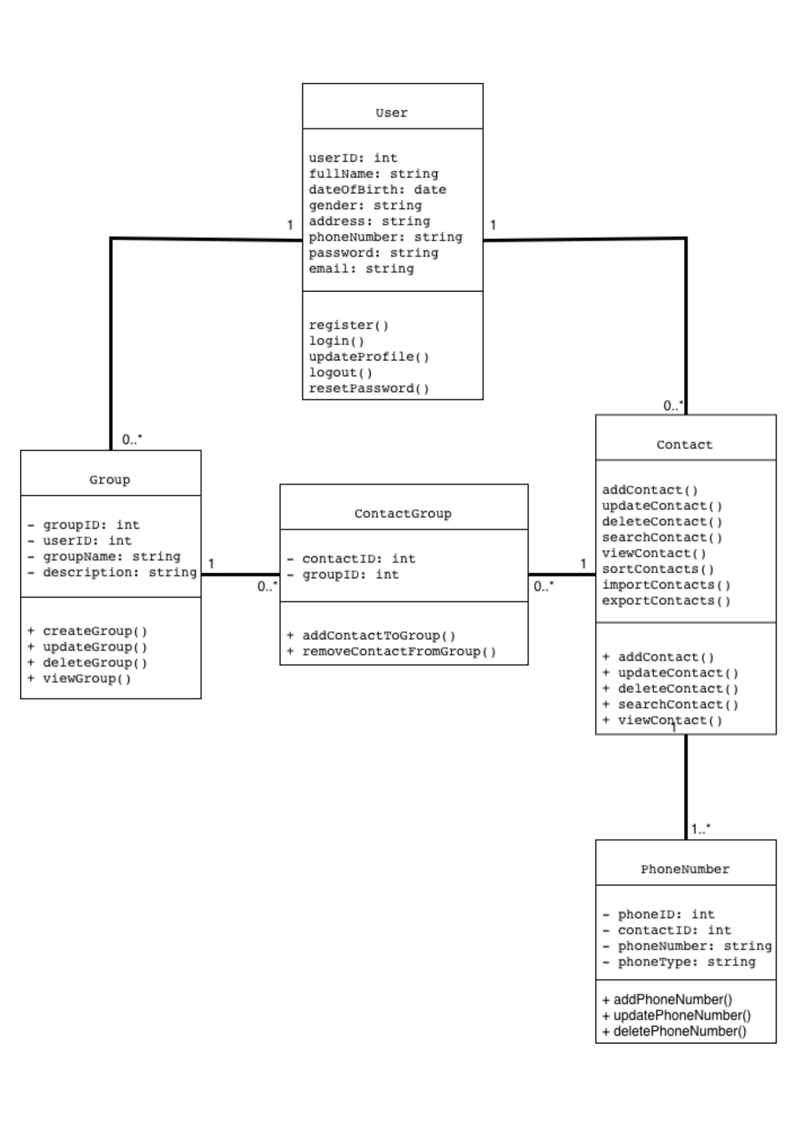
Figure 1. Class Diagram of the Phone Book Management System.

1.1 Class Descriptions

User
The User class represents a system account. Its attributes are userID, fullName, dateOfBirth, gender, address, phoneNumber, password, and email. Its operations are register(), login(), updateProfile(), logout(), and resetPassword().

Group
The Group class organizes contacts into groups. It contains groupID, userID, groupName, and description. Its operations are createGroup(), updateGroup(), deleteGroup(), and viewGroup().

Contact
The Contact class stores a person's details: fullName, email, address, and note, together with contactID and userID identifiers. Its operations are addContact(), updateContact(), deleteContact(), searchContact(), viewContact(), sortContacts(), importContacts(), and exportContacts().

ContactGroup
The ContactGroup class links contacts to groups. It contains contactID and groupID. Its operations are addContactToGroup() and removeContactFromGroup().

PhoneNumber
The PhoneNumber class stores phone details for a contact. Its attributes are phoneID, contactID, phoneNumber, and phoneType. Its operations are addPhoneNumber(), updatePhoneNumber(), and deletePhoneNumber().

1.2 Class Relationships
The number 1 means exactly one related object. The notation 0..* means zero or many, and 1..* means one or many.
- User – Group: one User can have zero or many Groups; each Group belongs to one User.
- User – Contact: one User can have zero or many Contacts; each Contact belongs to one User.
- Group – ContactGroup: one Group can be linked to zero or many ContactGroup records.
- Contact – ContactGroup: one Contact can be linked to zero or many ContactGroup records.
- Contact – PhoneNumber: each Contact must have one or more PhoneNumber records (1..*); each PhoneNumber belongs to one Contact. This reflects the requirement that a contact must have at least one phone number.

2. Task 6 – Data Model / Database Schema (Stage 2)
The database schema translates the class design into five relational tables: USERS, CONTACTS, PHONE_NUMBERS, GROUPS, and CONTACT_GROUPS. Primary keys (PK) identify records, while foreign keys (FK) connect related tables.
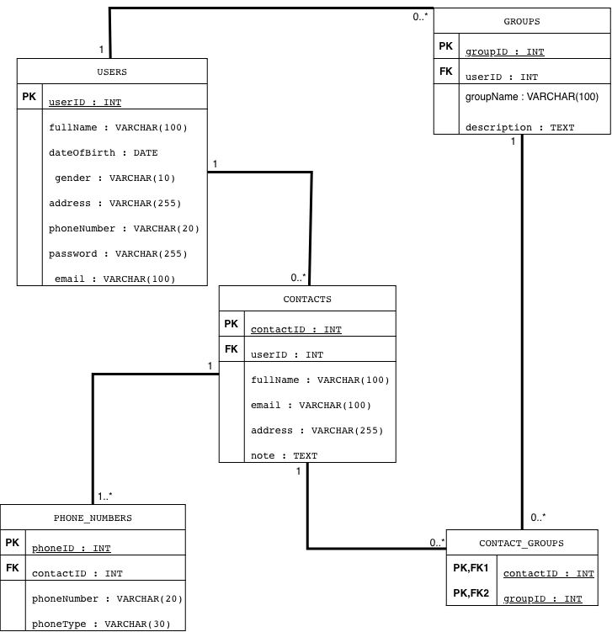
Figure 2. Database Schema of the Phone Book Management System.

2.1 Table Descriptions

USERS
Stores user account information. It includes userID INT (PK), fullName VARCHAR(100), dateOfBirth DATE, gender VARCHAR(10), address VARCHAR(255), phoneNumber VARCHAR(20), password VARCHAR(255), and email VARCHAR(100).

CONTACTS
Stores contacts owned by users. It includes contactID INT (PK), userID INT (FK), fullName VARCHAR(100), email VARCHAR(100), address VARCHAR(255), and note TEXT.

PHONE_NUMBERS
Stores phone numbers for contacts. It includes phoneID INT (PK), contactID INT (FK), phoneNumber VARCHAR(20), and phoneType VARCHAR(30).

GROUPS
Stores groups created by users. It includes groupID INT (PK), userID INT (FK), groupName VARCHAR(100), and description TEXT.

CONTACT_GROUPS
Connects contacts and groups. It contains contactID and groupID, and both fields are PK and FK. Together, they form a composite primary key.

2.2 Keys and Table Relationships
A Primary Key (PK) uniquely identifies each record in a table. A Foreign Key (FK) references a key in another table and maintains the relationship between records. In CONTACT_GROUPS, contactID and groupID together form a composite primary key.
- CONTACTS.userID references USERS.userID.
- GROUPS.userID references USERS.userID.
- PHONE_NUMBERS.contactID references CONTACTS.contactID.
- CONTACT_GROUPS.contactID references CONTACTS.contactID.
- CONTACT_GROUPS.groupID references GROUPS.groupID.
The database relationships follow the class diagram: one user may own many contacts and groups; one contact may have one or more phone numbers; and ContactGroup records connect contacts with groups.

3. Conclusion
Task 5 defines the five classes, their attributes, operations, and relationships. Task 6 represents the same system structure through five database tables, using primary and foreign keys to connect the data. The class diagram and database schema are aligned and provide a foundation for implementing the Phone Book Management System.

