SOFTWARE ENGINEERING GROUP PROJECT
STAGE 1 & STAGE 2 DELIVERABLE
Phone Book Management System
Requirement Specification & Design Document
Version 1.2 | SPECIFICATION & DESIGN
Document Revision History (Bảng ghi nhận thay đổi tài liệu)
Date | Version | Description | Author / Role
20/10/2026 | 1.0 | Initial Requirement Specification & MVC Architecture (Section 1 & Section 2) | Nguyễn Đăng Khôi (Team Leader)
23/10/2026 | 1.1 | Added Data Flow Diagrams (Section 3) & Use Case Specification (Section 4) | Dư Quốc Hưng & Nguyễn Lâm Phúc Hậu
26/10/2026 | 1.2 | Completed Class Diagram (Section 5), Data Model (Section 6) & GUI Design (Section 7) | Dương Nguyễn Hồng Phúc & Đặng Nguyễn Minh Châu
Document Structure Overview (7 Standard Sections)
Contents
1. Functional Requirements 3
2. Non-Functional Requirements 6
3. Data Flow Diagram 8
4. Use Case Diagram 10
5. Class Diagram 25
6. Data Model 28
7. Interface Design Description 32

- 1. Functional Requirements: Describes system overview, business rules in natural language, glossary, and 14 structured functional requirements (FR-01 to FR-14).
- 2. Non-Functional Requirements: Specifies supplementary quality attributes (Usability, Reliability, Performance, Security), design constraints, and the MVC Software Architecture Design.
- 3. Data Flow Diagram (DFD): Illustrates the Context Diagram (0-Level DFD) and Top-Level Diagram (1-Level DFD) with data stores and data flows.
- 4. Use Case Diagram: Presents the overall Use Case Diagram, Actor/Use Case catalogs, and full specifications for all 20 use cases following the FaceShop specification template.
- 5. Class Diagram: Defines the object-oriented domain model across 5 core entity classes (User, Contact, PhoneNumber, Group, ContactGroup) with attributes, operations, and multiplicities.
- 6. Data Model (Database Design): Transforms the domain classes into 5 relational database tables (USERS, CONTACTS, PHONE_NUMBERS, GROUPS, CONTACT_GROUPS) with primary and foreign keys.
- 7. Interface Design Description: Provides the Figma graphical user interface (GUI) mockups, component breakdowns, and use-case mappings across all core screens.

1. Functional Requirements
1.1. System Overview (Mô tả tổng quan hệ thống)
Following the natural-language specification format of the reference document (FaceShop Specification), the Phone Book Management System is designed to store, organize, and manage personal contact books for registered users with the following core capabilities:
• Browse and Search Contacts (Xem và tìm kiếm danh bạ):
- Users can browse the entire contact list belonging to their personal account or filter contacts by specific contact groups (e.g., Family, Friends, Work). The contact list supports pagination (up to 30 contacts per page) and alphabetical sorting by full name (ascending A–Z or descending Z–A).
- Users can search for contacts across their personal phone book by entering a keyword (matching either the contact's full name or phone number). The system dynamically returns and displays all matching contact records.
• Contact and Group Management (Quản lý liên hệ và nhóm danh bạ):
- Each contact record stores a unique contact ID, full name (mandatory), one or more phone numbers with phone types (mandatory), email address, residential/work address, assigned contact group(s), and personal notes.
- When viewing the contact list or search results, users can select any contact to view its complete details, add a new contact, edit an existing contact's information, or delete a contact after confirming the action on a warning dialog.
- Users can organize their address book by creating custom contact groups (e.g., Gia Đình, Bạn Bè, Công Việc), renaming groups, deleting groups, and assigning or removing contacts from groups.
• Import and Export Contact Data (Nhập và xuất dữ liệu danh bạ):
- Users can export their current contact list to standard external files (.csv or .vcf vCard format) for offline backup or migration, and import multiple contacts simultaneously from valid .csv or .vcf files into their personal database.
• Account Registration, Authentication & Administration (Quản lý tài khoản & Quản trị):
- Unregistered guests can register a new account by providing their full name, date of birth, gender, address, phone number, password, and email address (used as the unique login identifier and for password recovery).
- Logged-in users can update their personal profile information (excluding their registered email) and securely log out. If a user forgets their password, the Reset Password function generates a new random password and sends it to their registered email.
- System administrators can view the list of registered user accounts and delete or deactivate violating user accounts.
1.2. Glossary (Bảng chú giải thuật ngữ)
No. | Term | Definition
1 | Contact (Liên hệ) | An individual entry stored in a user's personal phone book containing name, phone number(s), email, address, and notes.
2 | Contact Group (Nhóm danh bạ) | A user-defined category (e.g., Family, Friends, Work) used to classify and filter contacts. One contact may belong to multiple groups.
3 | CSV / vCard (.vcf) | Standardized file formats used for importing and exporting address book records across different platforms and devices.
4 | Composite Primary Key | A primary key made up of two or more columns (e.g., contactID + groupID in CONTACT_GROUPS) that uniquely identifies a many-to-many link.

1.3. Detailed Functional Requirements Specification
1.3.1. Account & Authentication
- FR-01: The unregistered user shall be able to register a new account on the system by providing their full name, date of birth, gender, address, phone number, password, and email address.
- FR-02: The system shall uniquely identify each user account using a unique userID and a non-duplicated email address.
- FR-03: The registered user shall be able to log into the system using their registered email address and password.
- FR-04: The logged-in user shall be able to view and update their personal profile information (except for the email address used as the login username).
- FR-05: The system shall automatically generate a new random password and send it via email when the user requests password recovery.
1.3.2. Browse & Search Contacts
- FR-06: The user shall be able to view the entire list of contacts belonging to their account or filter the contact list by specific contact groups.
- FR-07: The system shall allow the user to sort the contact list alphabetically by full name (ascending A–Z or descending Z–A).
- FR-08: The user shall be able to search for contacts across their personal phone book by entering a keyword (full name or phone number) into the search bar.
- FR-09: The system shall display the full detailed information of a contact (contact ID, full name, phone number, email, address, contact group, notes) when the user selects to view that contact.
1.3.3. Contact & Group Management
- FR-10: The user shall be able to add a new contact to the system with mandatory fields being a valid Full Name and Phone Number.
- FR-11: The user shall be able to edit information or delete an existing contact from the phone book after confirming the deletion action on the system's warning dialog.
- FR-12: The user shall be able to create a new contact group (e.g., Family, Friends, Work), rename a group, delete a group, and assign contacts to the respective groups.
1.3.4. Import & Export Data
- FR-13: The system shall allow the user to export the existing contact list to standard .csv or .vcf (vCard) format files.
- FR-14: The system shall allow the user to import a list of contacts from a valid .csv or .vcf file into their personal phone book database.

2. Non-Functional Requirements
2.1. Supplementary Specification (Đặc tả bổ sung)
ID | Category | Requirement Description
NFR-01 | Usability (Goal) | The system should be easy to use for regular users and consistently laid out to minimize user operational errors.
NFR-02 | Usability (Testable) | New users shall be able to proficiently use all phone book management functions after a maximum of 15 minutes of training/familiarization; after this time, the average number of user errors shall not exceed 2 errors per hour of use.
NFR-03 | Reliability & Availability | The Phone Book Management System shall be available to users during standard operating hours (Monday - Sunday, 00:00 - 24:00); unexpected downtime shall not exceed 5 seconds in any single working day (availability > 99.9%).
NFR-04 | Performance (Response Speed) | The system shall process search, filter, and display contact list queries with a response time not exceeding 1.0 second per action when the database stores up to 10,000 contacts.
NFR-05 | Space & Capacity | The system shall support pagination displaying a maximum of 30 contacts/page and have the capacity to store a minimum of 100,000 contact records across the entire system.
NFR-06 | Authentication Policy | System users shall authenticate themselves using a valid email account and password before performing any contact data retrieval or manipulation operations.
NFR-07 | Design Constraints | The system shall be implemented following the Model–View–Controller (MVC) architectural pattern using Python (with FastAPI and pytest for unit testing) or C++ (with Google Test for unit testing), coupled with a relational database (MySQL/SQLite), Figma for GUI design, and Git/GitHub for source code version control.
NFR-08 | Privacy & Security | Each user shall only be permitted to access and manipulate their own phone book. User passwords stored in the database shall be encrypted using a secure hash algorithm (SHA-256, minimum 160 bits), and database queries shall use Prepared Statements to prevent SQL Injection and XSS vulnerabilities.

2.2. Software Architecture Design (Stage 2)
The Phone Book Management System applies the MVC (Model – View – Controller) architectural pattern to separate the internal representation of data and business rules from the ways information is presented to and accepted from the user.
- Model (UserModel, ContactModel, GroupModel): Manages the data structure, state, and business logic. It directly performs CRUD (Create, Read, Update, Delete) operations with the Database.
- View (LoginView, ContactListView, ContactFormView): Defines and manages how contact and group data is presented (displayed) to the user via the graphical user interface.
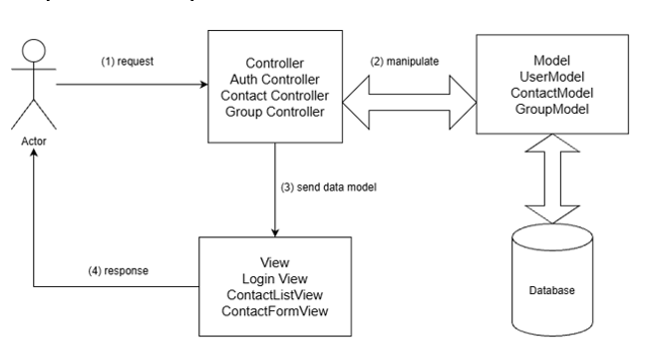
- Controller (AuthController, ContactController, GroupController): Receives user requests (1), calls the Model to manipulate data (2), and sends the updated data model to the View (3) to render the response (4) back to the user.
Architectural Evaluation (Pros & Cons)
- Pros: Concurrent development allows multiple team members to work on the Model, View, and Controller simultaneously. High Cohesion & Loose Coupling allow logical grouping of related actions in a Controller while maintaining low dependency between the data (Model) and the interface (View). Easy to modify the user interface or upgrade features in Stage 3 and Stage 4 without affecting the entire system.
- Cons: Increases initial programming complexity and file management overhead, requiring team members to strictly adhere to the directory structure.

3. Data Flow Diagram
3.1. Context Diagram (0-Level DFD)
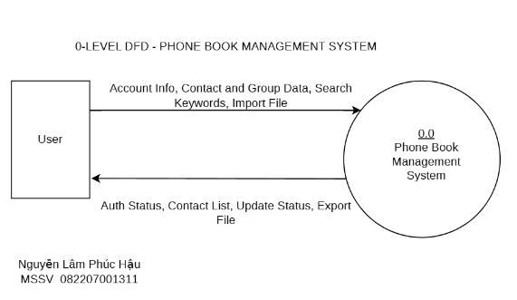
The Context Diagram (Level 0 DFD) represents the entire Phone Book Management System as a single central process (0.0) interacting with the external entity (User, which generalizes Guest, authenticated User, and Admin roles). The User submits credentials, account details, search keywords, contact/group inputs, and import files, and receives authentication status, contact/group lists, update notifications, and exported contact files.
3.2. Top-Level Data Flow Diagram (1-Level DFD)
The 1-Level DFD decomposes the central system into four primary functional processes (1.0 to 4.0) and three persistent relational data stores (D1: USERS, D2: CONTACTS, and D3: GROUPS):
- Process 1.0 – Manage Account: Receives Account Info (registration, login, profile updates, and administrative account actions) from the User, verifies or updates User Data in data store D1: USERS, and returns Auth Status to the User.
- Process 2.0 – Search, View Contacts: Receives Search Keywords or view/filter requests from the User, retrieves matching Contact Info (along with associated phone numbers and group classifications) from D2: CONTACTS, and returns the formatted Contact List to the User.
- Process 3.0 – Manage Contacts, Groups: Receives Contact and Group data from the User, writes Updated Contact records to D2: CONTACTS and Updated Group Data to D3: GROUPS, and returns Update Status to the User.
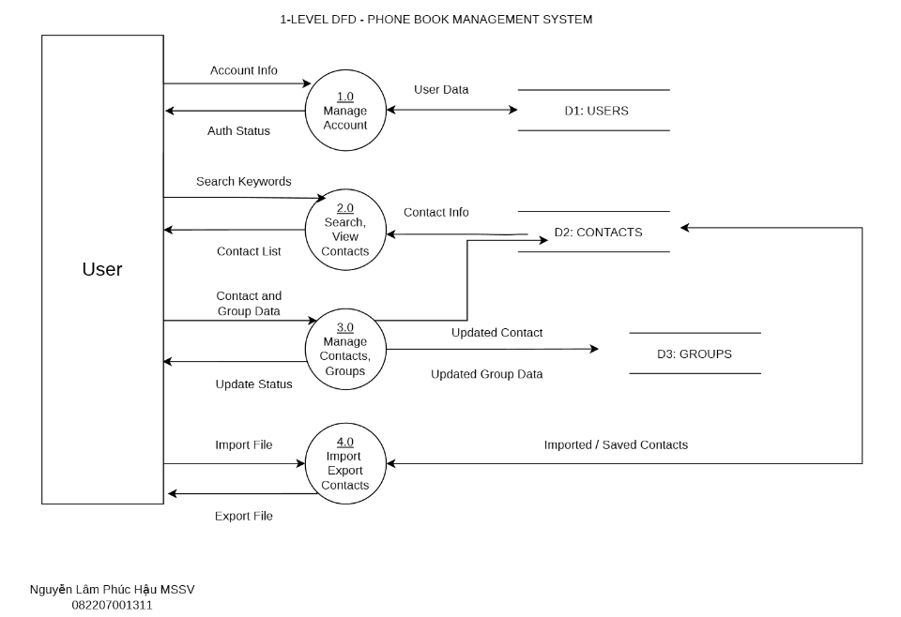
- Process 4.0 – Import Export Contacts: Processes external Import Files from the User to store Saved Contacts in D2: CONTACTS, and reads contact records to generate Export Files (.csv / .vcf) for the User.

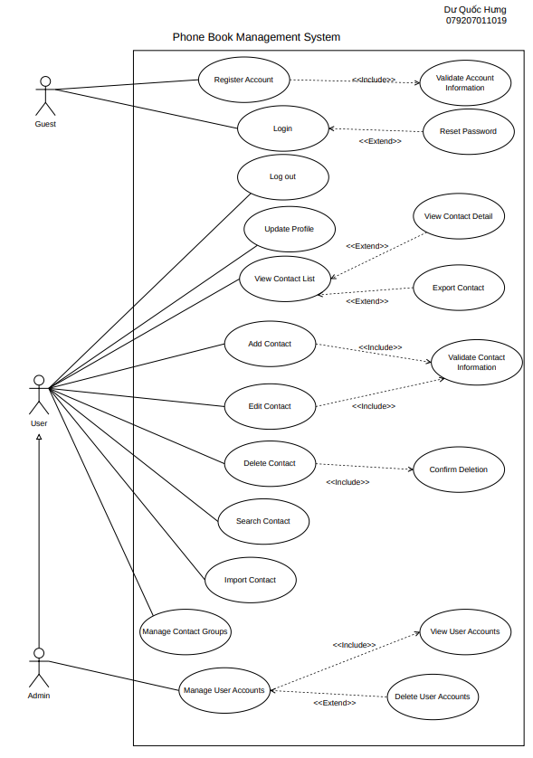
4. Use Case Diagram
4.1. Overview Use Case Diagram (Sơ đồ tổng quan)
The Use Case Diagram below illustrates the actors (Guest, User, Admin) and all 20 use cases of the Phone Book Management System, including <<include>> and <<extend>> relationships.
4.2. List of Actors (Danh sách các Actor)
SN | Actor | Meaning / Description
1 | Guest | Unauthenticated visitors who have not yet logged into the system (can Register Account, Login, or Reset Password).
2 | User | Authenticated members who have registered an account and logged into the system to manage their personal phone book.
3 | Admin | System administrators with privileges to oversee and manage registered user accounts (inherits User capabilities).

4.3. List of Use Cases (Danh sách các Use-case)
SN | Use Case Name | Meaning / Description | Primary Actor
1 | Register Account | Allows new users to create an account by providing the required registration information. | Guest
2 | Validate Account Information | Checks whether the provided account information is complete, valid, and meets the system's requirements. | Included UC
3 | Login | Allows registered users to access the system by entering their username/email and password. | Guest
4 | Reset Password | Allows a user to securely reset their forgotten password via email to regain account access. | Guest
5 | Log Out | Allows users to securely exit their current account and end their active session. | User
6 | Update Profile | Allows users to view and modify their personal account information. | User
7 | View Contact List | Displays the paginated list of contacts saved in the user's account. | User
8 | View Contact Detail | Allows users to view detailed information about a selected contact. | User
9 | Export Contact | Allows a user to export their contact list to an external file (.csv/.vcf) for backup. | User
10 | Add Contact | Allows users to create and save a new contact with name, phone number, email, and address. | User
11 | Edit Contact | Allows users to modify the information of an existing contact. | User
12 | Validate Contact Information | Checks whether the contact information is complete and valid before saving it to the system. | Included UC
13 | Delete Contact | Allows registered users to permanently remove a contact from their address book. | User
14 | Confirm Deletion | Prompts a confirmation dialog before any contact is permanently deleted. | Included UC
15 | Search Contact | Provides a search function to find specific contacts using name or phone number keywords. | User
16 | Import Contact | Allows a user to import multiple contacts simultaneously from a supported external file. | User
17 | Manage Contact Groups | Allows users to create, rename, and delete custom groups and assign contacts to groups. | User
18 | Manage User Accounts | Allows an administrator to oversee and manage system user profiles. | Admin
19 | View User Accounts | Displays the complete list of registered user accounts on the administrative dashboard. | Included UC
20 | Delete User Accounts | Allows an administrator to delete or deactivate an existing user account. | Admin

4.4. Detailed Use Case Specifications
4.4.1. Use-case 1: Register Account
• Summary (Tóm tắt): Allows an unauthenticated visitor (Guest) to create a new account in order to use the system's contact-management features.
• Flow of Events (Dòng sự kiện):
Main Flow (Dòng sự kiện chính):
1. The use case begins when the Guest selects the Register Account function.
2. The system displays the registration form and requests the required account information (Full Name, Date of Birth, Gender, Address, Phone Number, Password, Email).
3. The Guest enters the information and submits the registration request.
4. The system invokes Validate Account Information to verify the submitted data.
5. If the information is valid, the system creates the new account, stores the encrypted password, and displays a success message.
Alternative Flows (Các dòng sự kiện khác):
- 4.4.1.1. Existing Email Address: If the Guest enters an email address that already exists in the system, the system displays an error notification and allows the Guest to re-enter or cancel.
- 4.4.1.2. Missing Mandatory Fields or Invalid Password: If required fields are missing or the password is shorter than 6 characters, the system displays a validation error message.
• Special Requirements (Các yêu cầu đặc biệt): Account information must be validated before storage. User passwords must be hashed using SHA-256 (minimum 160 bits).
• Pre-conditions (Trạng thái hệ thống trước khi thực hiện): The Guest is not logged into the system.
• Post-conditions (Trạng thái hệ thống sau khi thực hiện): If successful, the new user account is saved in the database. Otherwise, system state remains unchanged.
• Extension / Inclusion Points (Điểm mở rộng): Includes Use-case Validate Account Information.
4.4.2. Use-case 2: Validate Account Information
• Summary (Tóm tắt): Validates the completeness, format, and uniqueness of the information provided by a Guest during account registration.
• Flow of Events (Dòng sự kiện):
Main Flow (Dòng sự kiện chính):
1. The use case is invoked when the Guest submits the registration form in Register Account.
2. The system receives the submitted registration fields.
3. The system checks mandatory fields and data formats (valid email syntax, valid phone number format, password length).
4. The system queries the USERS table to check whether the email identifier already exists.
5. The system returns the validation result to Register Account.
Alternative Flows (Các dòng sự kiện khác):
- If required data is missing, improperly formatted, or duplicated, the system returns specific error messages to Register Account for user correction.
• Special Requirements (Các yêu cầu đặc biệt): Validation must be enforced on the server/controller side to ensure data integrity.
• Pre-conditions (Trạng thái hệ thống trước khi thực hiện): Register Account is in progress and registration input data has been submitted.
• Post-conditions (Trạng thái hệ thống sau khi thực hiện): The validation result (valid/invalid) is returned to the calling use case; no database records are written by this use case.
• Extension / Inclusion Points (Điểm mở rộng): None.
4.4.3. Use-case 3: Login
• Summary (Tóm tắt): Allows a registered user to authenticate and gain access to their personal Phone Book Management System.
• Flow of Events (Dòng sự kiện):
Main Flow (Dòng sự kiện chính):
1. The use case begins when the Guest selects the Login function on the initial screen.
2. The system prompts the user to enter their registered Email and Password.
3. The user enters their credentials and clicks the Login button.
4. The system verifies the submitted email and password hash against stored records in the USERS table.
5. If credentials are valid, the system creates an authenticated session and navigates to the Home (Contact List) screen.
Alternative Flows (Các dòng sự kiện khác):
- 4.4.3.1. Incorrect Email or Password: If the email or password is incorrect, the system displays an authentication error message. The user may retry from Step 1 or cancel.
- 4.4.3.2. Unauthorized/Deactivated Account: If the account is deactivated, the system denies access and displays a notification.
• Special Requirements (Các yêu cầu đặc biệt): Credentials must be processed securely using Prepared Statements to prevent SQL Injection.
• Pre-conditions (Trạng thái hệ thống trước khi thực hiện): The user is currently in an unauthenticated (not logged in) state.
• Post-conditions (Trạng thái hệ thống sau khi thực hiện): If successful, the user enters an authenticated state. Otherwise, system state remains unchanged.
• Extension / Inclusion Points (Điểm mở rộng): Use-case Reset Password: Extends Login when the user forgets their password.
4.4.4. Use-case 4: Reset Password
• Summary (Tóm tắt): Allows a user who has forgotten their password to generate a new random password sent to their registered email.
• Flow of Events (Dòng sự kiện):
Main Flow (Dòng sự kiện chính):
1. The use case begins when the user clicks the Forgot Password (Quên mật khẩu) link on the Login screen.
2. The system prompts the user to enter their registered email address.
3. The user enters the email address and submits the recovery request.
4. The system checks whether the email exists in the USERS table. If it exists, the system generates a new random password, updates the password hash, sends the new password to the user's email, and displays a confirmation message.
Alternative Flows (Các dòng sự kiện khác):
- 4.4.4.1. Email Does Not Exist: If the entered email is not found in the system, the system notifies the user and allows them to retry or exit.
• Special Requirements (Các yêu cầu đặc biệt): The new password must be randomly generated and hashed before updating the database.
• Pre-conditions (Trạng thái hệ thống trước khi thực hiện): The user is not logged into the system.
• Post-conditions (Trạng thái hệ thống sau khi thực hiện): If successful, the account password is updated. Otherwise, the existing password remains unchanged.
• Extension / Inclusion Points (Điểm mở rộng): Extends Use-case Login.
4.4.5. Use-case 5: Log Out
• Summary (Tóm tắt): Allows a logged-in User to securely terminate their active session and exit the system.
• Flow of Events (Dòng sự kiện):
Main Flow (Dòng sự kiện chính):
1. The use case begins when the authenticated User selects the Log Out option.
2. The system receives the logout request.
3. The system invalidates and terminates the current active session.
4. The system redirects the user back to the Login screen.
Alternative Flows (Các dòng sự kiện khác):
- If the session has already expired, the system immediately returns the user to the Login screen.
• Special Requirements (Các yêu cầu đặc biệt): Session tokens/states must be completely cleared upon logout.
• Pre-conditions (Trạng thái hệ thống trước khi thực hiện): The User is currently logged into the system.
• Post-conditions (Trạng thái hệ thống sau khi thực hiện): The active session is terminated and the user returns to an unauthenticated state.
• Extension / Inclusion Points (Điểm mở rộng): None.
4.4.6. Use-case 6: Update Profile
• Summary (Tóm tắt): Allows a logged-in User to view and modify their personal account profile information.
• Flow of Events (Dòng sự kiện):
Main Flow (Dòng sự kiện chính):
1. The use case begins when the User clicks the User Profile icon on the navigation bar and selects Update Profile.
2. The system displays the User's current profile details (Full Name, Date of Birth, Gender, Address, Phone Number, excluding Password).
3. The User modifies the desired fields (excluding the registered Email address).
4. The User clicks the Save/Update button.
5. The system validates the input fields, updates the USERS record, and displays a success message.
Alternative Flows (Các dòng sự kiện khác):
- 4.4.6.1. Cancellation: If the User cancels the operation, no changes are saved.
- 4.4.6.2. Invalid Input: If mandatory fields (Full Name, Phone Number, Gender, Address) are left blank or a new password is shorter than 6 characters, the system displays an error message.
• Special Requirements (Các yêu cầu đặc biệt): Users may only view and modify their own profile record.
• Pre-conditions (Trạng thái hệ thống trước khi thực hiện): The User must be logged into the system.
• Post-conditions (Trạng thái hệ thống sau khi thực hiện): If successful, the user profile is updated in the database. Otherwise, previous profile information is retained.
• Extension / Inclusion Points (Điểm mở rộng): None.
4.4.7. Use-case 7: View Contact List
• Summary (Tóm tắt): Allows a logged-in User to view, paginate, filter by group, and alphabetically sort all contacts in their personal phone book.
• Flow of Events (Dòng sự kiện):
Main Flow (Dòng sự kiện chính):
1. The use case begins when the User logs in or navigates to the Home (DANH BẠ) screen.
2. The system retrieves and displays up to 30 contacts per page belonging to the logged-in User.
3. If the User selects a sorting option (A–Z or Z–A by full name), selects a specific Contact Group filter, or navigates to another page, the system refreshes and displays the contact list matching the User's selection.
4. From this list, the User can select a contact to view details or trigger Export Contact.
Alternative Flows (Các dòng sự kiện khác):
- If the User's phone book has no contacts, the system displays an empty state message prompting the User to add or import contacts.
• Special Requirements (Các yêu cầu đặc biệt): Query response time must not exceed 1.0 second for up to 10,000 contacts, with pagination set to 30 records per page.
• Pre-conditions (Trạng thái hệ thống trước khi thực hiện): The User must be logged into the system.
• Post-conditions (Trạng thái hệ thống sau khi thực hiện): The contact list is displayed; no database records are modified.
• Extension / Inclusion Points (Điểm mở rộng): Use-case View Contact Detail and Use-case Export Contact extend View Contact List.
4.4.8. Use-case 8: View Contact Detail
• Summary (Tóm tắt): Allows a User to view complete detailed information for a specific contact selected from the contact list.
• Flow of Events (Dòng sự kiện):
Main Flow (Dòng sự kiện chính):
1. The use case begins when the User clicks on a contact entry in the View Contact List screen.
2. The system verifies that the selected contactID belongs to the logged-in User.
3. The system retrieves full contact information from CONTACTS, PHONE_NUMBERS, and CONTACT_GROUPS.
4. The system displays the contact details: Contact ID, Full Name, Phone Number(s) and Types, Email, Address, Assigned Group(s), and Notes.
Alternative Flows (Các dòng sự kiện khác):
- If the contact record no longer exists or does not belong to the User, the system displays an error notice and returns to the contact list.
• Special Requirements (Các yêu cầu đặc biệt): Strict data isolation: a User cannot view contact details belonging to another User account.
• Pre-conditions (Trạng thái hệ thống trước khi thực hiện): The User is logged in and viewing the Contact List.
• Post-conditions (Trạng thái hệ thống sau khi thực hiện): Detailed contact information is displayed; database state remains unchanged.
• Extension / Inclusion Points (Điểm mở rộng): Extends Use-case View Contact List.
4.4.9. Use-case 9: Export Contact
• Summary (Tóm tắt): Allows a User to export their personal contact list to a standard .csv or .vcf (vCard) file for backup or external use.
• Flow of Events (Dòng sự kiện):
Main Flow (Dòng sự kiện chính):
1. The use case begins when the User selects the Export Contact function from the contact list interface.
2. The system retrieves all contact records (or currently filtered records) belonging to the User's account.
3. The system formats the contact data into a standard .csv or .vcf file.
4. The system prompts the User to download/save the generated file locally and displays an export completion notification.
Alternative Flows (Các dòng sự kiện khác):
- If the User's phone book is empty, the system notifies the User that there are no contacts available to export.
• Special Requirements (Các yêu cầu đặc biệt): Exported files must strictly contain only contacts owned by the authenticated User.
• Pre-conditions (Trạng thái hệ thống trước khi thực hiện): The User is logged into the system.
• Post-conditions (Trạng thái hệ thống sau khi thực hiện): An external .csv or .vcf file is generated for the User; internal database records remain unchanged.
• Extension / Inclusion Points (Điểm mở rộng): Extends Use-case View Contact List.
4.4.10. Use-case 10: Add Contact
• Summary (Tóm tắt): Allows a logged-in User to create and save a new contact entry into their personal phone book.
• Flow of Events (Dòng sự kiện):
Main Flow (Dòng sự kiện chính):
1. The use case begins when the User selects the Add Contact function.
2. The system displays the Add New Contact form (THÊM LIÊN HỆ MỚI) with input fields for Full Name, Phone Number, Email, Contact Group, Address, and Note.
3. The User enters the contact details and clicks the Save (Lưu) button.
4. The system invokes Validate Contact Information to check mandatory fields (Full Name, Phone Number) and data formats.
5. If valid, the system inserts the new record into CONTACTS, PHONE_NUMBERS, and CONTACT_GROUPS (if a group is selected) and displays a success message.
Alternative Flows (Các dòng sự kiện khác):
- 4.4.10.1. Invalid or Missing Mandatory Data: If Full Name or Phone Number is missing/invalid, the system displays an error message and highlights the fields for correction.
- 4.4.10.2. User Cancellation: If the User clicks Cancel (Hủy), the system discards the input and returns to the Home screen.
• Special Requirements (Các yêu cầu đặc biệt): Each contact must be linked to the authenticated User's userID and have at least one PhoneNumber record (1..*).
• Pre-conditions (Trạng thái hệ thống trước khi thực hiện): The User must be logged into the system.
• Post-conditions (Trạng thái hệ thống sau khi thực hiện): If successful, a new contact and its phone number/group links are saved in the database. Otherwise, the database remains unchanged.
• Extension / Inclusion Points (Điểm mở rộng): Includes Use-case Validate Contact Information.
4.4.11. Use-case 11: Edit Contact
• Summary (Tóm tắt): Allows a logged-in User to update the information of an existing contact in their phone book.
• Flow of Events (Dòng sự kiện):
Main Flow (Dòng sự kiện chính):
1. The use case begins when the User selects an existing contact and chooses the Edit Contact function.
2. The system retrieves and populates the Add/Edit Contact form with the contact's current information.
3. The User modifies the desired fields (Name, Phone Number, Email, Group, Address, Note) and clicks Save (Lưu).
4. The system invokes Validate Contact Information to verify the updated data.
5. If valid, the system updates the corresponding records in CONTACTS, PHONE_NUMBERS, and CONTACT_GROUPS and notifies the User.
Alternative Flows (Các dòng sự kiện khác):
- If the updated data fails validation, the system displays an error message and prompts the User to correct it.
- If the User clicks Cancel (Hủy), the system aborts the update and preserves the existing contact data.
• Special Requirements (Các yêu cầu đặc biệt): Only the owner of the contact may edit its information.
• Pre-conditions (Trạng thái hệ thống trước khi thực hiện): The User is logged in and the target contact exists in their phone book.
• Post-conditions (Trạng thái hệ thống sau khi thực hiện): If successful, the contact's information is updated in the database. Otherwise, previous data remains intact.
• Extension / Inclusion Points (Điểm mở rộng): Includes Use-case Validate Contact Information.
4.4.12. Use-case 12: Validate Contact Information
• Summary (Tóm tắt): Verifies that contact input fields meet mandatory and format rules before database insertion or update.
• Flow of Events (Dòng sự kiện):
Main Flow (Dòng sự kiện chính):
1. The use case is invoked when the User submits the contact form in Add Contact or Edit Contact.
2. The system inspects the submitted contact fields.
3. The system verifies that Full Name and at least one Phone Number are non-empty, and checks that Phone Number and Email follow valid formats.
4. The system returns the validation status to the calling use case.
Alternative Flows (Các dòng sự kiện khác):
- If mandatory fields are blank or formats are invalid, the system returns an invalid status along with descriptive error messages.
• Special Requirements (Các yêu cầu đặc biệt): Validation rules must be applied consistently across both Add Contact and Edit Contact operations.
• Pre-conditions (Trạng thái hệ thống trước khi thực hiện): Add Contact or Edit Contact has captured user input.
• Post-conditions (Trạng thái hệ thống sau khi thực hiện): Validation result is returned to the caller; no database modifications occur directly within this use case.
• Extension / Inclusion Points (Điểm mở rộng): None.
4.4.13. Use-case 13: Delete Contact
• Summary (Tóm tắt): Allows a logged-in User to permanently delete a contact from their personal phone book after confirmation.
• Flow of Events (Dòng sự kiện):
Main Flow (Dòng sự kiện chính):
1. The use case begins when the User selects a contact and triggers the Delete Contact action.
2. The system identifies the target contact and invokes Confirm Deletion to display a warning dialog.
3. If the User confirms the deletion, the system deletes the contact's associated records in PHONE_NUMBERS, CONTACT_GROUPS, and CONTACTS.
4. The system displays a deletion success message and refreshes the contact list.
Alternative Flows (Các dòng sự kiện khác):
- If the User cancels or declines on the confirmation dialog, the deletion is aborted and the contact remains intact.
• Special Requirements (Các yêu cầu đặc biệt): Referential integrity must be maintained by removing child records in PHONE_NUMBERS and CONTACT_GROUPS when a contact is deleted.
• Pre-conditions (Trạng thái hệ thống trước khi thực hiện): The User is logged in and the selected contact belongs to their account.
• Post-conditions (Trạng thái hệ thống sau khi thực hiện): If confirmed, the contact is permanently removed from the database. Otherwise, system state remains unchanged.
• Extension / Inclusion Points (Điểm mở rộng): Includes Use-case Confirm Deletion.
4.4.14. Use-case 14: Confirm Deletion
• Summary (Tóm tắt): Prompts the User with an explicit warning dialog to confirm or cancel permanent contact deletion.
• Flow of Events (Dòng sự kiện):
Main Flow (Dòng sự kiện chính):
1. The use case is invoked by Delete Contact prior to executing database removal.
2. The system displays a confirmation dialog showing the contact's name and asking the User to confirm permanent deletion.
3. The User selects Confirm or Cancel.
4. The system returns the User's choice to Delete Contact.
Alternative Flows (Các dòng sự kiện khác):
- If the User closes the dialog or selects Cancel, a negative confirmation result is returned and deletion is halted.
• Special Requirements (Các yêu cầu đặc biệt): Prevents accidental data loss caused by unintentional clicks.
• Pre-conditions (Trạng thái hệ thống trước khi thực hiện): Delete Contact has been initiated on a valid contact.
• Post-conditions (Trạng thái hệ thống sau khi thực hiện): The confirmation decision is returned to Delete Contact; this use case does not modify database records directly.
• Extension / Inclusion Points (Điểm mở rộng): None.
4.4.15. Use-case 15: Search Contact
• Summary (Tóm tắt): Allows a logged-in User to search and filter their personal phone book by entering a name or phone number keyword.
• Flow of Events (Dòng sự kiện):
Main Flow (Dòng sự kiện chính):
1. The use case begins when the User clicks on the Search Bar (Tìm kiếm liên hệ...) on the top navigation bar.
2. The User types a search keyword (full name or phone number, e.g., 'Nghiêm').
3. The system queries the User's contacts in CONTACTS and PHONE_NUMBERS matching the keyword.
4. The system dynamically updates the screen to display only the matching contact records.
Alternative Flows (Các dòng sự kiện khác):
- If no contacts match the entered keyword, the system displays a 'No matching contacts found' message.
• Special Requirements (Các yêu cầu đặc biệt): Search queries must execute within 1.0 second for databases storing up to 10,000 contacts.
• Pre-conditions (Trạng thái hệ thống trước khi thực hiện): The User must be logged into the system.
• Post-conditions (Trạng thái hệ thống sau khi thực hiện): Matching contacts are displayed on screen; underlying contact data is not modified.
• Extension / Inclusion Points (Điểm mở rộng): None.
4.4.16. Use-case 16: Import Contact
• Summary (Tóm tắt): Allows a logged-in User to import multiple contacts from an external .csv or .vcf file into their phone book.
• Flow of Events (Dòng sự kiện):
Main Flow (Dòng sự kiện chính):
1. The use case begins when the User selects the Import Contact function.
2. The system opens a file selection dialog prompting the User to choose a .csv or .vcf file.
3. The User selects a file and confirms the import request.
4. The system validates the file format, parses each contact row, and checks mandatory fields (Full Name, Phone Number).
5. The system inserts valid contact records into the User's phone book database and displays an import summary report.
Alternative Flows (Các dòng sự kiện khác):
- If the file format is unsupported or corrupted, the system aborts the operation and displays an error message.
- If specific rows in the file are missing mandatory fields, the system skips the invalid rows and reports them to the User.
• Special Requirements (Các yêu cầu đặc biệt): Imported data must be sanitized and validated before insertion to prevent malformed records or injection attacks.
• Pre-conditions (Trạng thái hệ thống trước khi thực hiện): The User is logged in and possesses a valid .csv or .vcf contact file.
• Post-conditions (Trạng thái hệ thống sau khi thực hiện): If successful, valid contacts from the file are added to the User's database. Otherwise, existing contacts remain unchanged.
• Extension / Inclusion Points (Điểm mở rộng): None.
4.4.17. Use-case 17: Manage Contact Groups
• Summary (Tóm tắt): Allows a logged-in User to view, create, rename, and delete contact groups (e.g., Gia Đình, Bạn Bè, Công Việc) and manage group memberships.
• Flow of Events (Dòng sự kiện):
Main Flow (Dòng sự kiện chính):
1. The use case begins when the User clicks the Manage Groups (Quản lý nhóm) button on the navigation bar.
2. The system displays the list of existing groups belonging to the User along with the number of contacts in each group (e.g., Gia Đình (3), Bạn Bè (2), Công Việc (0)).
3. 4.4.17.1. Create Group: If the User clicks 'Thêm nhóm mới (+)', the system prompts for a group name and description, validates the input, and saves the new group to the GROUPS table.
4. 4.4.17.2. Rename/Update Group: If the User clicks 'Sửa' next to a group, the system displays the group's current details, allows the User to edit the name/description, and saves the changes.
5. 4.4.17.3. Delete Group: If the User clicks 'Xóa' next to a group and confirms, the system removes the group link in CONTACT_GROUPS and deletes the group from GROUPS (without deleting the contacts themselves).
Alternative Flows (Các dòng sự kiện khác):
- If the User enters an empty or duplicate group name, the system displays a validation error message.
- If the User cancels any add/edit/delete action, the group list remains unchanged.
• Special Requirements (Các yêu cầu đặc biệt): Deleting a group only removes the category and its CONTACT_GROUPS associations; the contacts themselves remain in the User's phone book.
• Pre-conditions (Trạng thái hệ thống trước khi thực hiện): The User must be logged into the system.
• Post-conditions (Trạng thái hệ thống sau khi thực hiện): If successful, group records in GROUPS and memberships in CONTACT_GROUPS are updated. Otherwise, system state remains unchanged.
• Extension / Inclusion Points (Điểm mở rộng): None.
4.4.18. Use-case 18: Manage User Accounts
• Summary (Tóm tắt): Allows a system Administrator to oversee registered user accounts, view the account list, and remove violating accounts.
• Flow of Events (Dòng sự kiện):
Main Flow (Dòng sự kiện chính):
1. The use case begins when the Admin logs in and selects Manage User Accounts.
2. The system verifies the Admin's administrative privileges and invokes View User Accounts to display the list of registered users.
3. The Admin selects a target user account to inspect or triggers Delete User Accounts to remove the account.
4. The system executes the selected administrative action and displays the result.
Alternative Flows (Các dòng sự kiện khác):
- If an unauthorized non-admin user attempts to access this function, the system denies access immediately.
• Special Requirements (Các yêu cầu đặc biệt): Administrative actions must strictly respect user privacy; Admins manage account status but do not manipulate private contact entries.
• Pre-conditions (Trạng thái hệ thống trước khi thực hiện): The Admin is logged into the system with administrative privileges.
• Post-conditions (Trạng thái hệ thống sau khi thực hiện): User account status is viewed or updated according to the selected action.
• Extension / Inclusion Points (Điểm mở rộng): Includes View User Accounts; extended by Delete User Accounts.
4.4.19. Use-case 19: View User Accounts
• Summary (Tóm tắt): Displays the paginated list of registered user accounts for system administration.
• Flow of Events (Dòng sự kiện):
Main Flow (Dòng sự kiện chính):
1. The use case is invoked when the Admin accesses Manage User Accounts.
2. The system retrieves registered user account records (userID, fullName, email, phoneNumber, dateOfBirth) from the USERS table.
3. The system displays the paginated account list to the Admin.
Alternative Flows (Các dòng sự kiện khác):
- If no user accounts exist, the system displays an empty list notification.
• Special Requirements (Các yêu cầu đặc biệt): User account lists must be paginated for performance, and password hashes must never be displayed on screen.
• Pre-conditions (Trạng thái hệ thống trước khi thực hiện): The Admin is logged in and accessing Manage User Accounts.
• Post-conditions (Trạng thái hệ thống sau khi thực hiện): The list of user accounts is displayed; no database records are modified.
• Extension / Inclusion Points (Điểm mở rộng): None.
4.4.20. Use-case 20: Delete User Accounts
• Summary (Tóm tắt): Allows an Administrator to delete or deactivate a selected user account from the system.
• Flow of Events (Dòng sự kiện):
Main Flow (Dòng sự kiện chính):
1. The use case begins when the Admin selects a user account in Manage User Accounts and clicks Delete.
2. The system displays a confirmation prompt showing the selected account's details.
3. The Admin confirms the account deletion.
4. The system removes the user account and its associated records from the database and displays a confirmation message.
Alternative Flows (Các dòng sự kiện khác):
- If the Admin cancels the confirmation dialog, the account is preserved and no changes are made.
• Special Requirements (Các yêu cầu đặc biệt): Cascading deletion or deactivation must maintain database referential integrity across all tables linked to userID.
• Pre-conditions (Trạng thái hệ thống trước khi thực hiện): The Admin is logged in with administrative privileges and a valid target user account is selected.
• Post-conditions (Trạng thái hệ thống sau khi thực hiện): If successful, the target user account is removed from the system. Otherwise, account data remains unchanged.
• Extension / Inclusion Points (Điểm mở rộng): Extends Use-case Manage User Accounts.

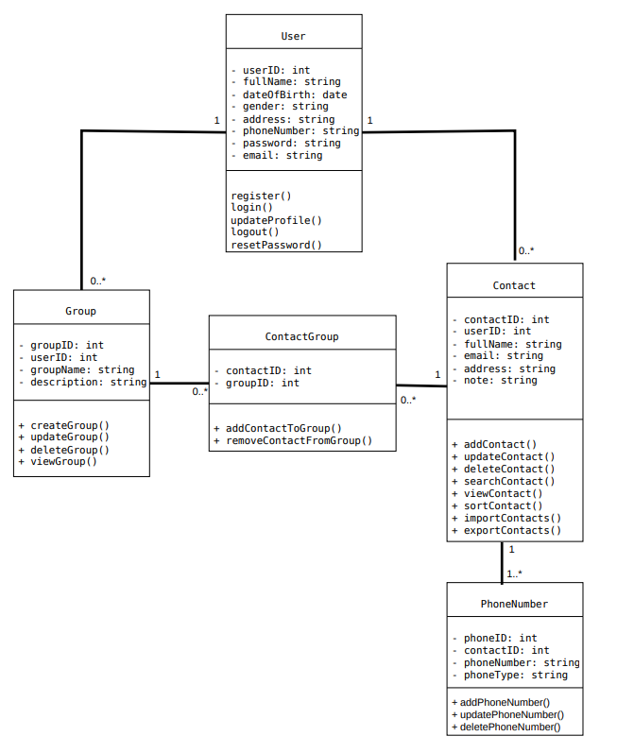
5. Class Diagram
5.1. Overview of Domain Class Diagram (Stage 1)
The Class Diagram describes the static object-oriented structure of the Phone Book Management System. It contains five core classes: User, Group, Contact, ContactGroup, and PhoneNumber. Each class defines the attributes it stores and the operations (methods) it performs.
5.2. Detailed Class Descriptions
Class Name | Attributes | Operations (Methods) | Responsibility
User | - userID: int  - fullName: string  - dateOfBirth: date  - gender: string  - address: string  - phoneNumber: string  - password: string  - email: string | + register()  + login()  + updateProfile()  + logout()  + resetPassword() | Represents a registered system account and handles user authentication, profile updates, and password recovery.
Group | - groupID: int  - userID: int  - groupName: string  - description: string | + createGroup()  + updateGroup()  + deleteGroup()  + viewGroup() | Represents a contact category created by a user (e.g., Family, Friends, Work) to organize contacts.
Contact | - contactID: int  - userID: int  - fullName: string  - email: string  - address: string  - note: string | + addContact()  + updateContact()  + deleteContact()  + searchContact()  + viewContact()  + sortContact()  + importContacts()  + exportContacts() | Stores personal details of an entry in the user's phone book and supports CRUD, search, sorting, and CSV/vCard import/export.
ContactGroup | - contactID: int  - groupID: int | + addContactToGroup()  + removeContactFromGroup() | Association class that resolves the many-to-many relationship between Contact and Group.
PhoneNumber | - phoneID: int  - contactID: int  - phoneNumber: string  - phoneType: string | + addPhoneNumber()  + updatePhoneNumber()  + deletePhoneNumber() | Stores one or more phone numbers and their types (Mobile, Home, Work) associated with a specific Contact.

5.3. Relationships and Multiplicities Between Classes
- User – Group (1 to 0..*): One User can own zero or many Groups (1 to 0..*); each Group belongs to exactly one User.
- User – Contact (1 to 0..*): One User can own zero or many Contacts (1 to 0..*); each Contact belongs to exactly one User.
- Group – ContactGroup (1 to 0..*): One Group can be linked to zero or many ContactGroup records (1 to 0..*); each ContactGroup record references one Group.
- Contact – ContactGroup (1 to 0..*): One Contact can be linked to zero or many ContactGroup records (1 to 0..*); each ContactGroup record references one Contact.
- Contact – PhoneNumber (1 to 1..*): Each Contact must have at least one or more PhoneNumber records (1 to 1..*), reflecting the mandatory phone number requirement in FR-10; each PhoneNumber belongs to one Contact.

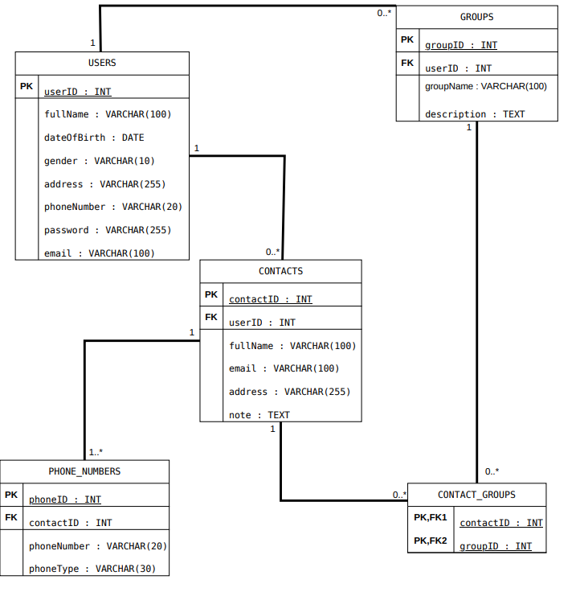
6. Data Model
6.1. Relational Database Schema (Stage 2)
The Data Model translates the object-oriented class design from Stage 1 into five normalized relational database tables: USERS, CONTACTS, PHONE_NUMBERS, GROUPS, and CONTACT_GROUPS. Primary keys (PK) uniquely identify records in each table, while foreign keys (FK) enforce referential integrity across related tables.
6.2. Data Dictionary & Table Specifications
6.2.1. Table: USERS
Stores registered user account credentials and personal profile information.
Column Name | Data Type | Key / Constraint | Description
userID | INT | PK, NOT NULL, AUTO_INCREMENT | Unique identifier for each registered user account.
fullName | VARCHAR(100) | NOT NULL | Full name of the user.
dateOfBirth | DATE | NULLABLE | User's date of birth.
gender | VARCHAR(10) | NULLABLE | User's gender.
address | VARCHAR(255) | NULLABLE | Residential address of the user.
phoneNumber | VARCHAR(20) | NOT NULL | User's personal phone number.
password | VARCHAR(255) | NOT NULL | SHA-256 encrypted password hash.
email | VARCHAR(100) | UNIQUE, NOT NULL | Registered email address used as login username.

6.2.2. Table: CONTACTS
Stores contact entries owned by each user.
Column Name | Data Type | Key / Constraint | Description
contactID | INT | PK, NOT NULL, AUTO_INCREMENT | Unique identifier for the contact record.
userID | INT | FK (USERS.userID), NOT NULL | Identifies the user who owns this contact.
fullName | VARCHAR(100) | NOT NULL | Full name of the contact person (Mandatory).
email | VARCHAR(100) | NULLABLE | Email address of the contact.
address | VARCHAR(255) | NULLABLE | Physical address of the contact.
note | TEXT | NULLABLE | Additional user notes about the contact.

6.2.3. Table: PHONE_NUMBERS
Stores one or more phone numbers associated with each contact.
Column Name | Data Type | Key / Constraint | Description
phoneID | INT | PK, NOT NULL, AUTO_INCREMENT | Unique identifier for the phone number entry.
contactID | INT | FK (CONTACTS.contactID), NOT NULL | References the parent contact.
phoneNumber | VARCHAR(20) | NOT NULL | Telephone number string (Mandatory).
phoneType | VARCHAR(30) | NULLABLE | Category of phone number (e.g., Mobile, Work, Home).

6.2.4. Table: GROUPS
Stores custom contact groups created by users.
Column Name | Data Type | Key / Constraint | Description
groupID | INT | PK, NOT NULL, AUTO_INCREMENT | Unique identifier for the contact group.
userID | INT | FK (USERS.userID), NOT NULL | References the user who created the group.
groupName | VARCHAR(100) | NOT NULL | Name of the group (e.g., Gia Đình, Bạn Bè, Công Việc).
description | TEXT | NULLABLE | Optional description of the contact group.

6.2.5. Table: CONTACT_GROUPS
Junction table connecting contacts and groups in a many-to-many relationship.
Column Name | Data Type | Key / Constraint | Description
contactID | INT | PK, FK1 (CONTACTS.contactID) | Part 1 of Composite PK; references CONTACTS.contactID.
groupID | INT | PK, FK2 (GROUPS.groupID) | Part 2 of Composite PK; references GROUPS.groupID.

6.3. Referential Integrity & Key Mapping
- CONTACTS.userID references USERS.userID (1 User owns 0..* Contacts).
- GROUPS.userID references USERS.userID (1 User owns 0..* Groups).
- PHONE_NUMBERS.contactID references CONTACTS.contactID (1 Contact has 1..* Phone Numbers).
- CONTACT_GROUPS.contactID references CONTACTS.contactID and CONTACT_GROUPS.groupID references GROUPS.groupID (Composite Primary Key enforcing unique contact-to-group assignments).

7. Interface Design Description
This section presents the Graphical User Interface (GUI) designed in Figma for the Phone Book Management System (Stage 2), detailing the visual layout, UI components, and corresponding use cases for each screen.
7.1. Login Screen
- Detailed Description:
- Input Fields: Two text boxes for Email and Password.
- Buttons: The Login button (Blue) to authenticate the user.
- Links: Forgot password? (to reset password) and Register new account (to navigate to the registration form).
- Corresponding Use-case:
- Use-case: Login
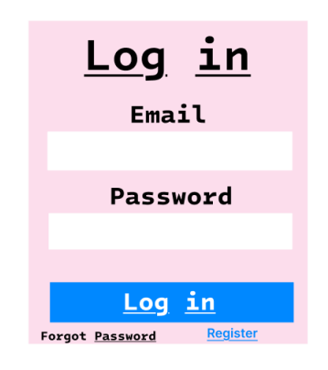
- Use-case: Reset Password
7.2. Register Screen
- Detailed Description:
- Input Fields: Text boxes for Email, Password, and Confirm your password.
- Buttons: The Register button (Blue) to create a new account.
- Corresponding Use-case:
- Use-case: Register Account
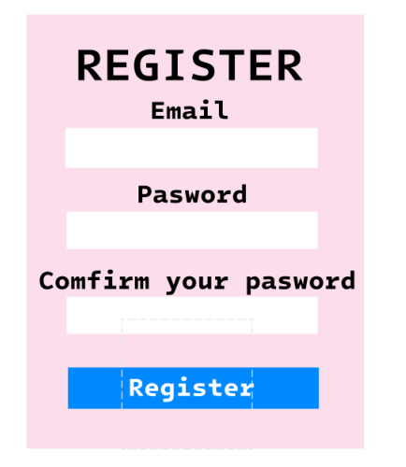
7.3. Personal Information Screen (Update Profile)

- Detailed Description:
- Purpose: Allows users to view and modify their own account information when they click on the User icon on the navigation bar.
- Avatar: Displays the user's profile picture with a Change picture option.
- Input Fields: Pre-filled text boxes for Full name, Phone number, Email, Address, and Note.
- Buttons: Update button (Blue) to save the modified information; Cancel or Logout button (Blue) to discard changes or exit the profile.
- Corresponding Use-case:
- Use-case: Update Profile

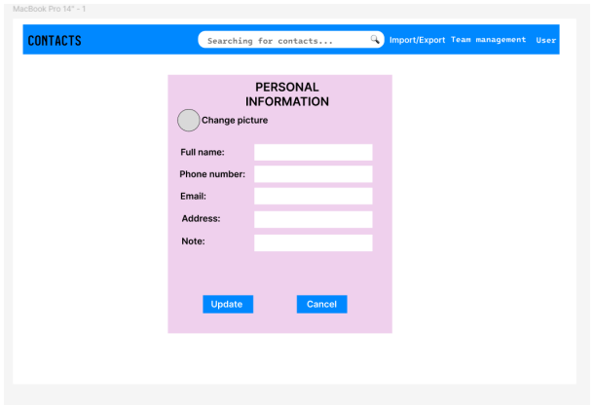

7.4. Home Screen (Contact List)
- Detailed Description:
- Navigation Bar: Includes the Logo, a Search bar, an Import/Export File button, a Group Management button, and a User profile icon.
- Filter & Sort: Located below the navbar, including a Sort A-Z button and a Filter by Group dropdown.
- Contact List: Displays contacts with Avatar, Name (bold), and Phone Number (gray).
- Floating Action Button: A circular + (Add) button at the bottom right corner to open the "Add New Contact" form.
- Corresponding Use-case:
- Use-case: View Contact List, Search, Sort, Filter, Import/Export Data.
- Use-case: Add New Contact
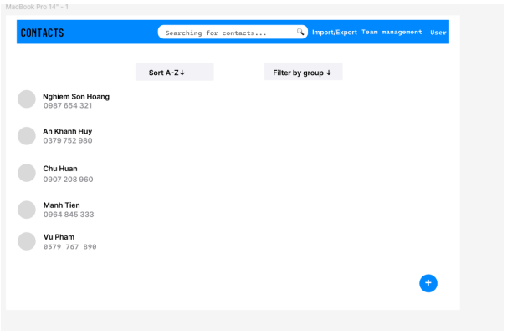

7.5. Search Screen
- Detailed Description:
- Search Bar: Located on the navigation bar. Users can type a keyword (e.g., "Nghiem") to search for contacts.
- Result List: The system automatically filters and displays only the contacts whose names or phone numbers match the keyword. In this example, only "Nghiem Son Hoang" is shown.
- Corresponding Use-case:
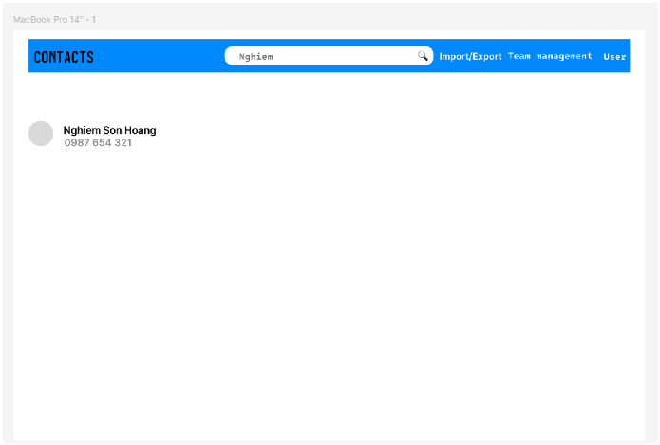
- Use-case: Search Contact
7.6. View Contact Detail Screen
- Detailed Description:
- Information Display: Shows the full details of the selected contact, including Avatar, Name, Phone Number, Email, Address, and Note (e.g., Work Contact, VIP Customer).
- Buttons: EDIT button (Blue) to navigate to the update form; DELETE button (Red) to remove the contact.
- Confirmation Popup (Required by FR-11): When the DELETE button is clicked, a confirmation dialog appears asking "Are you sure you want to delete this contact?" with Yes and No options.
- Corresponding Use-case:
- Use-case: View Contact Detail
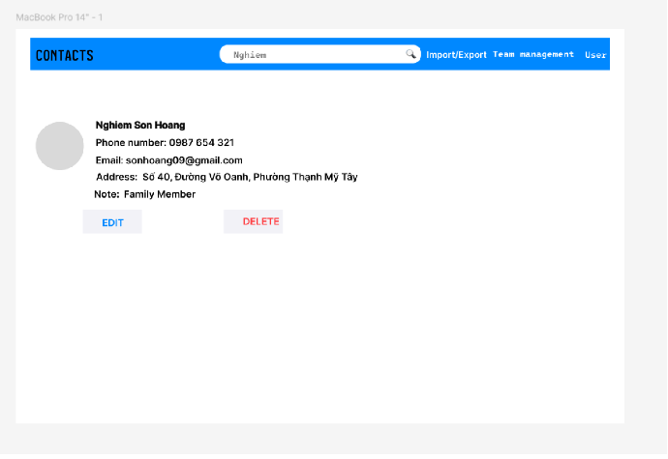
- Use-case: Delete Contact
7.7. Add/Edit Contact Form
- Detailed Description:
- Title: ADD NEW CONTACT (or "Edit Contact").
- Input Fields: Includes text boxes for Full name, Phone number, Email, Address, and Note.
- Dropdown Menu: Choose group (with a dropdown arrow to select from existing groups).
- Buttons: Save button (Blue) to confirm and store the new contact; Cancel button (Blue) to discard changes and return to the previous screen.
- Corresponding Use-case:
- Use-case: Add New Contact
- Use-case: Update Contact

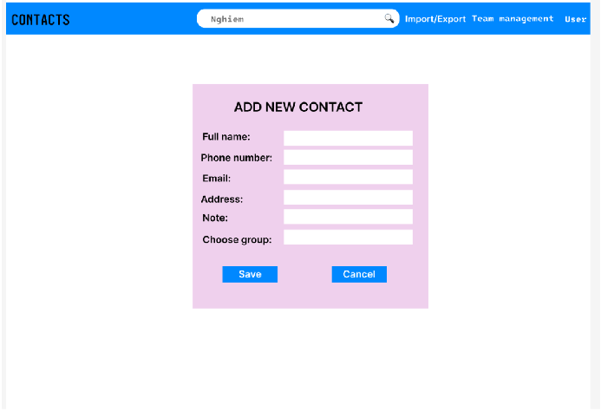
7.8. Group Management Screen
- Detailed Description:
- Title: GROUP MANAGEMENT
- Group List: Displays a list of existing contact groups (e.g., Family, Friend, Work) along with the number of members in each group.
- Action Buttons: Edit button (Blue) allows users to rename the group; Delete button (Red) allows users to remove a group from the system.
- Add Button: A prominent Add New Group (+) button (Blue) at the bottom to create a new group.
- Corresponding Use-case:
- Use-case: Manage Contact Groups (View, Add, Edit, Delete groups).


