PHONE BOOK MANAGEMENT SYSTEM
REPORT – TASK 5 AND TASK 6
2026

1. Introduction
The Phone Book Management System is designed to store and organize users’ contact information. It allows users to manage contacts, save phone numbers, and arrange contacts into groups. This report describes Task 5 – Class Diagram (Stage 1) and Task 6 – Data Model / Database Schema (Stage 2).

2. Task 5 – Class Diagram (Stage 1)

2.1 Overview
The class diagram presents the static structure of the system. It contains five classes: User, Group, Contact, ContactGroup, and PhoneNumber. Each class has a name, attributes, and operations. Attributes represent the data stored by the class, while operations represent the actions that the class can perform.
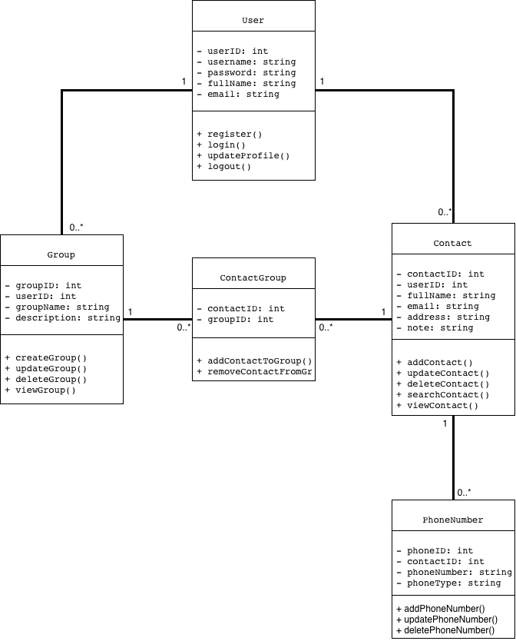
Figure 1. Class Diagram of the Phone Book Management System.

2.2 Class Descriptions

User
The User class represents a person who uses the system. Its attributes are userID, username, password, fullName, and email. Its operations are register(), login(), updateProfile(), and logout(). These operations support account registration, authentication, profile management, and ending a session.

Group
The Group class represents a collection used to organize contacts. Its attributes are groupID, userID, groupName, and description. Its operations are createGroup(), updateGroup(), deleteGroup(), and viewGroup(). A user can create and manage groups to organize their contacts.

Contact
The Contact class stores information about a person in the phone book. Its attributes are contactID, userID, fullName, email, address, and note. Its operations are addContact(), updateContact(), deleteContact(), searchContact(), and viewContact(). These operations allow users to manage contact information.

ContactGroup
The ContactGroup class connects contacts with groups. It contains contactID and groupID as attributes. Its operations are addContactToGroup() and removeContactFromGroup(). This class records which contacts belong to which groups.

PhoneNumber
The PhoneNumber class stores phone numbers associated with a contact. Its attributes are phoneID, contactID, phoneNumber, and phoneType. Its operations are addPhoneNumber(), updatePhoneNumber(), and deletePhoneNumber(). The phoneType attribute can distinguish different types of phone numbers.

2.3 Relationships Between Classes
An association is a relationship that connects two classes. The multiplicity written near an association indicates how many objects can participate in that relationship. In this design, 1 means exactly one, while 0..* means zero or many.
User – Contact: The multiplicity is 1 to 0..*. One user can have zero or many contacts. Each contact belongs to one user.
User – Group: The multiplicity is 1 to 0..*. One user can create zero or many groups. Each group belongs to one user.
Contact – PhoneNumber: The multiplicity is 1 to 0..*. One contact can have zero or many phone numbers. Each phone number belongs to one contact.
Contact – ContactGroup: The multiplicity is 1 to 0..*. One contact can be connected to zero or many ContactGroup records. Each ContactGroup record refers to one contact.
Group – ContactGroup: The multiplicity is 1 to 0..*. One group can be connected to zero or many ContactGroup records. Each ContactGroup record refers to one group.
The ContactGroup class acts as a linking class between Contact and Group. It supports the assignment of contacts to groups.

3. Task 6 – Data Model / Database Schema (Stage 2)

3.1 Overview
The database schema converts the system data into five relational tables: USERS, CONTACTS, PHONE_NUMBERS, GROUPS, and CONTACT_GROUPS. Each table stores information about one entity or a relationship. Primary keys identify records, while foreign keys connect records in different tables.
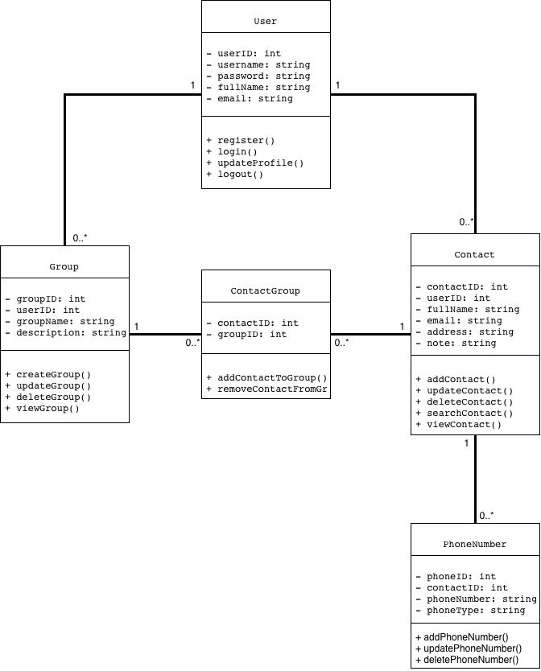
Figure 2. Database Schema of the Phone Book Management System.

3.2 Description of Database Tables

USERS
The USERS table stores account information. It contains userID INT as the primary key (PK), username VARCHAR(50), password VARCHAR(255), fullName VARCHAR(100), and email VARCHAR(100). The userID field uniquely identifies each user.

CONTACTS
The CONTACTS table stores the contacts owned by users. It contains contactID INT as the primary key (PK), userID INT as a foreign key (FK), fullName VARCHAR(100), email VARCHAR(100), address VARCHAR(255), and note TEXT. The userID field references USERS.userID.

PHONE_NUMBERS
The PHONE_NUMBERS table stores phone numbers for contacts. It contains phoneID INT as the primary key (PK), contactID INT as a foreign key (FK), phoneNumber VARCHAR(20), and phoneType VARCHAR(30). The contactID field references CONTACTS.contactID.

GROUPS
The GROUPS table stores groups created by users. It contains groupID INT as the primary key (PK), userID INT as a foreign key (FK), groupName VARCHAR(100), and description TEXT. The userID field references USERS.userID.

CONTACT_GROUPS
The CONTACT_GROUPS table connects contacts and groups. It contains contactID INT and groupID INT. Both fields are primary keys (PK) and foreign keys (FK). Together, they form a composite primary key. contactID references CONTACTS.contactID, while groupID references GROUPS.groupID.

3.3 Primary Keys and Foreign Keys
A Primary Key (PK) is a field, or a combination of fields, that uniquely identifies each record in a table. A primary key cannot contain duplicate values.
A Foreign Key (FK) is a field in one table that refers to a key in another table. It creates a relationship between tables and helps maintain referential integrity.
In the CONTACT_GROUPS table, contactID and groupID form a composite primary key. This means that the pair of values identifies one contact-to-group assignment. Each field is also a foreign key that references its corresponding parent table.

3.4 Relationships Between Database Tables
USERS and CONTACTS: One user can own zero or many contacts. Each contact references one user through CONTACTS.userID.
USERS and GROUPS: One user can own zero or many groups. Each group references one user through GROUPS.userID.
CONTACTS and PHONE_NUMBERS: One contact can have zero or many phone numbers. Each phone number references one contact through PHONE_NUMBERS.contactID.
CONTACTS and CONTACT_GROUPS: One contact can appear in zero or many records in CONTACT_GROUPS. The contactID field identifies the related contact.
GROUPS and CONTACT_GROUPS: One group can appear in zero or many records in CONTACT_GROUPS. The groupID field identifies the related group.

3.5 Mapping the Class Diagram to the Database
The five classes in Task 5 correspond to the five database tables in Task 6. User maps to USERS, Contact maps to CONTACTS, PhoneNumber maps to PHONE_NUMBERS, Group maps to GROUPS, and ContactGroup maps to CONTACT_GROUPS. Class attributes become table columns. Associations are implemented using foreign keys. This mapping keeps the object-oriented design and the database structure consistent.

4. Conclusion
Task 5 describes the system through five classes, their attributes, operations, and relationships. Task 6 transforms the design into five database tables and defines their primary and foreign keys. The class diagram explains how the system components interact, while the database schema explains how information is stored and connected. Together, they provide a foundation for implementing the Phone Book Management System.

