Use-case Diagram
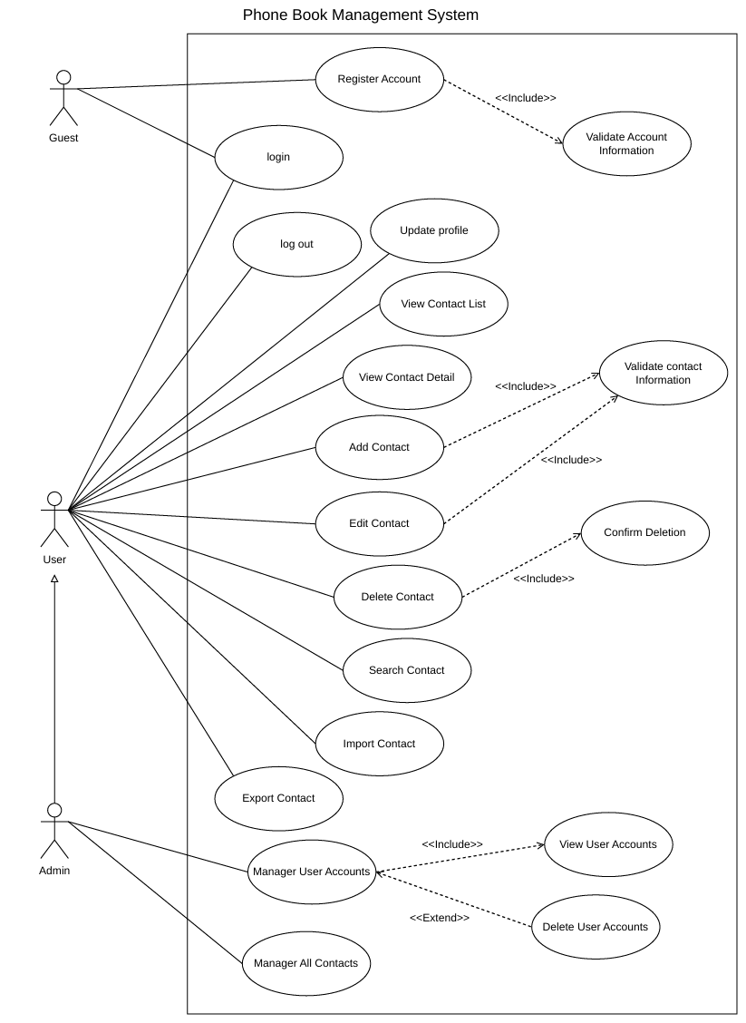
- Overview diagram
  - List of Actors
SN | Use-case | Meaning
1 | Admin | The person who control system
2 | User | Member, a user who already has an account and has logged into the system.
3 | Guest | Guests, users who haven't logged into the system

  - List of Use-case
SN | Use-case | Meaning | Note
1 | Register Account | Allows new users to create an account by providing the required registration information.
2 | Validate Account Information | Checks whether the provided account information is complete, valid, and meets the system's requirements.
3 | Login | Allows registered users to access the system by entering their username/email and password.
4 | Log out | Allows users to securely exit their current account and end their session.
5 | Update profile | Allows users to view and modify their personal account information.
6 | View Contact List | Displays the list of contacts saved in the user's account.
7 | View Contact Detail | Allows users to view detailed information about a selected contact.
8 | Add Contact | Allows users to create and save a new contact with information such as name, phone number, email, and address.
9 | Edit Contact | Allows users to modify the information of an existing contact.
10 | Validate Contact Information | Checks whether the contact information is complete and valid before saving it to the system.
11 | Delelet Contact
12 | Confirm Deletion
13 | Search Contact
14 | Import Contact
15 | Export Contact
16 | Manager User Accounts
17 | View User Accounts
18 | Delete User Accounts
19 | Manager All Contacts

- Use-case: Register Account
Actor: Guest
Summary: This use case allows an unauthenticated guest to register a new account to use the system.
2.1. Flow of Events
2.1.1. Basic Flow
The use case begins when the Guest selects the Register Account function.
The system displays the registration form and requests the Guest to enter the required account details.
The Guest enters the information and submits the registration request.
The system forwards the submitted information to the Validate Account Information function for verification.
If the information is valid, the system creates a new account and saves the user data.
The system notifies the result of the registration.
2.1.2. Alternative Flows
If the registration information is invalid, the system displays an error message and prompts the Guest to check and re-enter the information or cancel the registration.
If the Guest cancels the operation, the system does not create an account, and the use case ends.
2. Pre-conditions
The Guest is not logged into the system.
3. Post-conditions
Success: A new account is created and saved in the system.
Failure/Cancellation: Account data remains unchanged.

2. Use-case: Validate Account Information
Actor: Invoked by Register Account
Summary: This use case checks the validity of the information provided by the Guest during account registration.
1. Flow of Events
1.1. Basic Flow
The use case begins when Register Account sends registration information to the validation function.
The system checks mandatory fields and the format of the provided data.
The system checks whether the account identifier duplicates an existing account.
The system returns the validation result to Register Account.
1.2. Alternative Flows
If mandatory fields are missing, formats are incorrect, or the account identifier already exists, the system returns an invalid result along with the specific reasons so that the Guest can edit the input.
2. Pre-conditions
The Guest has entered and submitted registration details from Register Account.
3. Post-conditions
A valid or invalid validation result is returned to Register Account; this use case does not create accounts directly.

3. Use-case: Login
Actor: Guest / User / Admin
Summary: This use case allows users to log into the Phone Book Management System using their account credentials.
1. Flow of Events
1.1. Basic Flow
The use case begins when the user selects the Login function.
The system prompts the user to enter login credentials.
The user inputs credentials and submits the login request.
The system verifies the submitted credentials against stored account data.
If credentials are correct and the account is permitted access, the system creates a login session and grants entry to the system.
1.2. Alternative Flows
If credentials are incorrect, the system displays an error message. The user may re-enter credentials or cancel.
If the account is disabled or unauthorized, the system displays a notification and does not create a session.
2. Pre-conditions
The user is not logged into the system.
3. Post-conditions
Success: The user enters an authenticated state.
Failure: System state remains unchanged.

4. Use-case: Log out
Actor: User / Admin
Summary: This use case allows logged-in users to terminate their active session and log out of the system.
1. Flow of Events
1.1. Basic Flow
The use case begins when a logged-in user selects the Log out function.
The system receives the log-out request.
The system terminates the current active session.
The system returns the user to an unauthenticated state and displays the appropriate interface.
1.2. Alternative Flows
If the user cancels before confirming (if the UI requires confirmation), the session remains active.
2. Pre-conditions
The user is currently in a logged-in state.
3. Post-conditions
Success: The active session ends, and the user returns to an unauthenticated state.

5. Use-case: Update Profile
Actor: User / Admin
Summary: This use case allows users to view and update their account profile information.
1. Flow of Events
1.1. Basic Flow
The use case begins when a logged-in user selects the Update Profile function.
The system displays the user's current profile information.
The user modifies the desired fields.
The user submits a request to save changes.
The system validates the updated information.
If the information is valid, the system saves the changes and notifies the user.
1.2. Alternative Flows
If the information is invalid, the system displays an error message prompting the user to correct it.
If the user cancels the operation, changes are not saved.
2. Pre-conditions
The user must be logged into the system.
3. Post-conditions
Success: The user profile is updated.
Failure/Cancellation: Existing profile data is preserved.

6. Use-case: View Contact List
Actor: User / Admin
Summary: This use case allows users to view the list of contacts stored within their account.
1. Flow of Events
1.1. Basic Flow
The use case begins when the user selects View Contact List.
The system retrieves the contact list associated with the user's account.
The system displays the contact list.
The user can select a contact from the list to view detailed information.
1.2. Alternative Flows
If the contact list is empty, the system displays an empty contact list message.
If the list fails to load, the system displays an error message and allows the user to retry.
2. Pre-conditions
The user must be logged into the system.
3. Post-conditions
The contact list is displayed; contact data is not modified.

7. Use-case: View Contact Detail
Actor: User / Admin
Summary: This use case allows users to view detailed information of a selected contact.
1. Flow of Events
1.1. Basic Flow
The use case begins when the user selects a contact from the list.
The system identifies the selected contact.
The system retrieves detailed information for that contact.
The system displays the detailed contact information.
1.2. Alternative Flows
If the contact does not exist or does not belong to the user's access scope, the system notifies that the contact was not found or access is denied.
2. Pre-conditions
The user must be logged in and have selected a valid contact to view.
3. Post-conditions
Detailed contact information is displayed; data remains unchanged.

8. Use-case: Add Contact
Actor: User / Admin
Summary: This use case allows users to add a new contact to their address book.
1. Flow of Events
1.1. Basic Flow
The use case begins when the user selects the Add Contact function.
The system displays a contact input form.
The user fills in the details and submits the request to save.
The system forwards the data to Validate Contact Information for verification.
If valid, the system creates a new contact and saves it to the user's phone book.
The system notifies the user of the successful creation.
1.2. Alternative Flows
If data is invalid, the system displays an error message and prompts for corrections.
If the user cancels, no contact is created.
2. Pre-conditions
The user must be logged into the system.
3. Post-conditions
Success: A new contact is saved into the user's phone book.
Failure/Cancellation: Phone book contents remain unchanged.

9. Use-case: Edit Contact
Actor: User / Admin
Summary: This use case allows users to edit an existing contact's information in their address book.
1. Flow of Events
1.1. Basic Flow
The use case begins when the user selects a contact and requests Edit Contact.
The system displays current details of the selected contact.
The user edits contact information.
The user submits the update request.
The system forwards modified data to Validate Contact Information.
If valid, the system updates the contact and displays a success notification.
1.2. Alternative Flows
If data is invalid, the system displays error messages and prompts for correction.
If the user cancels, updates are discarded.
If the contact does not exist or is unauthorized, an error message is shown.
2. Pre-conditions
The user must be logged in, and the target contact must exist within their managed scope.
3. Post-conditions
Success: Contact details are updated.
Failure/Cancellation: Previous contact data is retained.

10. Use-case: Validate Contact Information
Actor: Invoked by Add Contact / Edit Contact
Summary: This use case verifies the validity of contact information before creation or updates.
1. Flow of Events
1.1. Basic Flow
The use case begins when Add Contact or Edit Contact sends contact details for verification.
The system checks provided data against field rules and mandatory flags.
The system determines whether data is valid.
The system returns validation results to the invoking use case.
1.2. Alternative Flows
If mandatory fields are missing or formats are wrong, an invalid result with details to fix is returned.
2. Pre-conditions
Add Contact or Edit Contact has captured data input by the user.
3. Post-conditions
Validation results are returned to the caller; contact data is not directly written by this use case.

11. Use-case: Delete Contact
Actor: User / Admin
Summary: This use case allows users to delete a contact from their address book.
1. Flow of Events
1.1. Basic Flow
The use case begins when the user selects a contact and triggers Delete Contact.
The system identifies the targeted contact.
The system requests user confirmation via Confirm Deletion.
If confirmed, the system removes the contact from the address book.
The system outputs a deletion confirmation message.
1.2. Alternative Flows
If the user does not confirm or cancels, the system leaves the contact intact.
If the contact does not exist or access is forbidden, an error message is shown.
2. Pre-conditions
The user must be logged in, and the contact to be deleted must exist under their management scope.
3. Post-conditions
Success: Contact is permanently removed from the phone book.
Failure/Cancellation: Phone book data remains unchanged.

12. Use-case: Confirm Deletion
Actor: Invoked by Delete Contact
Summary: This use case prompts for explicit user confirmation before deletion occurs.
1. Flow of Events
1.1. Basic Flow
The use case begins when Delete Contact calls for confirmation.
The system presents selected contact details and asks for explicit confirmation.
The user chooses to confirm or cancel.
The system passes the user's decision back to Delete Contact.
1.2. Alternative Flows
If the user selects cancel, the system returns a rejection result and terminates the deletion process.
2. Pre-conditions
The user selected a valid contact and initiated Delete Contact.
3. Post-conditions
Decision result (confirmed/cancelled) is passed to Delete Contact; this use case does not modify stored data directly.

13. Use-case: Search Contact
Actor: User / Admin
Summary: This use case allows users to search for contacts within their address book.
1. Flow of Events
1.1. Basic Flow
The use case begins when the user selects Search Contact.
The system provides a search input field.
The user enters keywords and submits the request.
The system searches contacts accessible to the user.
The system displays matching search results.
1.2. Alternative Flows
If no contacts match, a "No results found" message is displayed.
If the search term is empty or invalid, the system prompts the user to input valid criteria.
2. Pre-conditions
The user must be logged into the system.
3. Post-conditions
Matching contact results are displayed; contact data is not changed.

14. Use-case: Import Contact
Actor: User / Admin
Summary: This use case allows users to import contacts into their account from an external file.
1. Flow of Events
1.1. Basic Flow
The use case begins when the user selects Import Contact.
The system requests the user to upload/select a file containing contact entries.
The user chooses a file and submits the import command.
The system parses the file content and evaluates processable data.
The system appends valid contacts into the user's phone book.
The system reports the outcome of the import process.
1.2. Alternative Flows
If no file is selected or the user cancels, import is aborted.
If file reading fails or data is corrupted/unusable, an error is reported, and invalid rows are skipped/rejected.
2. Pre-conditions
The user must be logged in and possess an external file with contact data.
3. Post-conditions
Success: Valid entries are added to the phone book.
Failure/Cancellation: System contacts remain unchanged.

15. Use-case: Export Contact
Actor: User / Admin
Summary: This use case allows users to export their contacts into an external file for offline storage or external use.
1. Flow of Events
1.1. Basic Flow
The use case begins when the user selects Export Contact.
The system fetches contacts belonging to the user's account.
The system generates a file formatted with the contact details.
The system provides a download link/file prompt for the user to save locally.
The system displays an export completion status.
1.2. Alternative Flows
If the address book is empty, the system warns that there is no data to export.
If file generation encounters an issue, an error notice is displayed.
2. Pre-conditions
The user must be logged into the system.
3. Post-conditions
Success: A contact file is generated for local downloading; internal system data remains untouched.

16. Use-case: Manage User Accounts
Actor: Admin
Summary: This use case allows an Admin to manage user accounts in the system.
1. Flow of Events
1.1. Basic Flow
The use case begins when the Admin selects Manage User Accounts.
The system renders the user account list via View User Accounts.
The Admin picks a targeted account.
The Admin can request to view account details or proceed to delete the account via Delete User Accounts.
The system executes the selected task and displays execution status.
1.2. Alternative Flows
If there are no accounts registered, the system displays an empty list notification.
If the selected user does not exist, an error is shown.
If the Admin cancels, no state modifications occur.
2. Pre-conditions
The Admin must be logged in and hold administrative privileges over user accounts.
3. Post-conditions
Depending on administrative actions taken, accounts are viewed, updated, or removed. If action is aborted, account data remains intact.

17. Use-case: View User Accounts
Actor: Invoked by Manage User Accounts
Summary: This use case allows an Admin to view the complete list of system user accounts.
1. Flow of Events
1.1. Basic Flow
The use case begins when Manage User Accounts requests account listing.
The system fetches stored user account records.
The system presents the list of accounts to the Admin.
The Admin can select a specific user account to review administration info.
1.2. Alternative Flows
If no user accounts exist, the system shows an empty list or appropriate status.
If data retrieval fails, an error prompt is shown.
2. Pre-conditions
The Admin must be logged in with administrative privileges.
3. Post-conditions
User account list is rendered; underlying account records are unchanged.

18. Use-case: Delete User Accounts
Actor: Admin
Summary: This use case allows an Admin to remove a user account from the system.
1. Flow of Events
1.1. Basic Flow
The use case begins when the Admin selects an account inside Manage User Accounts and triggers delete.
The system highlights the selected account details and requests Admin confirmation.
The Admin confirms the account deletion.
The system deletes the specified user account from database.
The system notifies completion of deletion.
1.2. Alternative Flows
If the Admin cancels or rejects confirmation, the account is preserved.
If the targeted user account cannot be removed or is missing, an error notice is provided.
2. Pre-conditions
Admin logged in with administrative privileges; target user account exists.
3. Post-conditions
Success: User account is purged from system database.
Failure/Cancellation: Account records remain unchanged.

19. Use-case: Manage All Contacts
Actor: Admin
Summary: This use case allows an Admin to manage contacts across all user accounts in the system.
1. Flow of Events
1.1. Basic Flow
The use case begins when the Admin triggers Manage All Contacts.
The system fetches and renders all contact entries present across the entire system.
The Admin selects a contact entry to manage.
The system displays contact details.
The Admin applies appropriate management actions to the contact.
The system persists updates (if modified) and outputs results.
1.2. Alternative Flows
If system-wide contacts are empty, an empty list notification is presented.
If the selected contact record no longer exists, an error message is returned.
If the Admin cancels an edit operation, changes are abandoned.
2. Pre-conditions
The Admin must be logged in with system-wide contact administrative privileges.
3. Post-conditions
Success: System contact changes are updated and saved.
Read-only/Cancellation: Data remains unchanged.

