
MINISTRY OF TRANSPORT
HO CHI MINH CITY UNIVERSITY OF TRANSPORT
HIGH QUALITY TRAINING INSTITUTE
———& ———

REPORT
TOPIC:
BUILDING THE CHATTIES APP BASED ON DISCORD

INSTRUCTOR: Mai Ngọc Châu
SUBJECT: NETWORK PROGRAMMING
CLASS: 012012301309
Group 2:
1. Nguyễn Đăng Khôi - 079206030087
2. Trân Thanh Nhân - 080206012993
3. Đỗ Thiên Phúc - 075206003542
4. Đinh Thành Đạt - 072206000894
5. Trần Công Quốc - 049206006580
6. Pham Gia Khiêm - 074206004060

Ho Chi Minh City, June 2026
Table of Contents
CHAPTER 1. PROJECT INTRODUCTION 5
1.1 Introduction to the topic 5
1.2 Reason for choosing the topic 5
1.3 Project objectives 5
CHAPTER 2. THEORETICAL BASIS 6
2.1 Client – Server model 6
2.2 TCP protocol 6
2.3 Socket Programming 6
2.4 Boost.Asio library 7
CHAPTER 3. PROJECT IMPLEMENTATION PROCESS 7
3.1 Requirements analysis 7
3.2 Technologies used 7
3.3 Main functions of the system 8
Registration and login 8
Personal chat 8
Group chat 9
Sending files 10
Emoji and GIF 11
CHAPTER 4. RESULTS AND EVALUATION 11
4.1 Results achieved 11
4.2 Difficulties encountered 11
4.3 Knowledge and experience gained 12
4.4 Content completed 12
4.5 Content not yet completed 12
CHAPTER 5. LESSONS LEARNED 12
5.1 Professional experience 12
5.2 Teamwork experience 12
CHAPTER 6. CONCLUSION AND DEVELOPMENT DIRECTION 13
6.1 Conclusion 13
6.2 Development direction 13
References 13

Acknowledgements
The group would like to sincerely thank the Network Programming instructor for their dedicated guidance and support throughout the project. The instructor's knowledge and feedback were an important foundation that helped the group complete the topic. The group would also like to thank all members for working together, sharing tasks, and supporting one another to complete the product on schedule.

CHAPTER 1. PROJECT INTRODUCTION

1.1 Introduction to the topic
In the digital age, the demand for online information exchange has become increasingly popular and plays an important role in study, work, and daily communication. Messaging applications such as Discord, Messenger, and Telegram allow users to connect with each other in real time via the Internet, while also providing many supporting features such as personal chat, group chat, file sharing, and user status management.
In order to apply the knowledge learned in the Network Programming, the group chose to carry out the topic "Building the Chatties application based on Discord". The project is developed based on the Client–Server model, using the C++ programming language and the Boost.Asio library to handle network communication, along with SQLite for data management. Through building a real-time messaging application, the group had the opportunity to apply knowledge of network communication, Socket programming, asynchronous processing, and software system design.

1.2 Reason for choosing the topic
The topic was chosen based on its practicality and the ability to directly apply the knowledge from the course. Nowadays, online messaging applications are an indispensable part of life; however, building such a system requires combining a great deal of knowledge in computer networking, programming, and data management.
Through this project, the group aims to understand the operating principles of the Client–Server model, the way connections are established and maintained between devices via TCP Sockets, and to build a system capable of serving many users simultaneously. In addition, the project also helps the group practice skills in requirements analysis, system design, software development, and teamwork on a real-world project.

1.3 Project objectives
The objective of the topic is to build a real-time messaging application with a Client–Server architecture. The system allows users to register an account, log in, send and receive personal messages, create chat groups, transfer files, and manage online status.
In addition to meeting the basic functions of a chat application, the project also aims to build a system capable of operating stably, being easy to expand, and easy to maintain. Through the implementation process, the group hopes to reinforce its knowledge of network programming, improve its skills in using the Boost.Asio library, manage databases, and apply the software development process to a complete product.

CHAPTER 2. THEORETICAL BASIS

2.1 Client – Server model
The Chatties application is built based on the Client–Server model, one of the most common architectural models in network systems today. In this model, the Server acts as the central point that receives, processes, and manages all requests from Clients. Each Client is an application installed on a user's device, responsible for sending requests to the Server and displaying the response results.
For the Chatties system, all activities such as logging in, registering an account, sending messages, creating chat groups, or transferring files are performed through the Server. As a result, data is centrally managed, easily synchronized among many users, and convenient to scale as the number of users increases.

2.2 TCP protocol
To ensure data is transmitted accurately and stably, the system uses the TCP (Transmission Control Protocol) protocol. This is a connection-oriented protocol capable of ensuring that data reaches the correct destination in the correct order, while minimizing packet loss during transmission.
In the Chatties project, TCP is used for the entire data exchange process between the Client and the Server, including logging in, sending messages, transferring files, and updating user status. Choosing TCP helps the system operate stably and meet the requirements of a real-time messaging application.

2.3 Socket Programming
A Socket is a mechanism that allows two processes on different devices to communicate with each other over a computer network. In the Client–Server model, the Server creates a Socket to listen for connection requests, while the Client uses a Socket to establish connections and exchange data.
In the Chatties application, the Socket serves as the communication channel between the Client and the Server. Through the TCP Socket connection, users can send and receive messages, transfer files, and perform other operations continuously without needing to re-establish the connection after each data exchange.

2.4 Boost.Asio library
Boost.Asio is a library that supports network programming in C++, providing the necessary components to build network applications using both synchronous and asynchronous mechanisms. In the project, Boost.Asio is used to build the TCP Server and TCP Client, while also managing network connections among multiple users.
The group used functions such as async_accept(), async_read(), and async_write() to handle sending and receiving data asynchronously. As a result, the Server can serve multiple Clients simultaneously while still ensuring the system's performance and scalability.

CHAPTER 3. PROJECT IMPLEMENTATION PROCESS

3.1 Requirements analysis
Before building the system, the group analyzed the needs of an online messaging application and identified the core functions required. The system must allow users to create accounts, log in, and send and receive messages in real time, while also supporting the creation of chat groups and file sharing. In addition, the system needs to manage users' online status and ensure that data is stored to support later retrieval.
Based on these requirements, the group chose the Client–Server model as the system's main architecture. In this model, the Server is responsible for managing connections, processing requests from Clients, and storing data, while the Client handles interaction with the user through a graphical interface.

3.2 Technologies used
To meet the system's requirements, the group used a variety of technologies during the development process.
The C++ programming language was chosen to build the entire system due to its high performance and strong support for network programming. The Boost.Asio library was used to implement TCP communication asynchronously, allowing the Server to handle multiple connections from Clients simultaneously.
For data storage, the group used SQLite to manage account information, messages, and chat group data. This is a lightweight, easy-to-integrate database management system suitable for the scale of the project.
In addition, the group used Visual Studio 2022 as the main development environment, combined with GitHub to manage source code and coordinate among team members.

3.3 Main functions of the system
After the analysis and design process, the group implemented the main functions of the Chatties application as follows:

Registration and login
The system allows users to create a new account and log in to the application using a username and password. After a successful login, the user is connected to the Server and taken to the application's main interface.
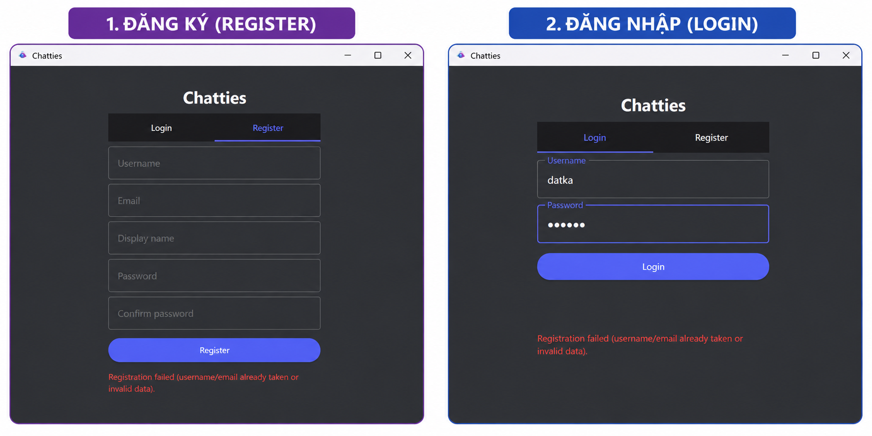
Figure 3.3.1 Registration and login interfaceRegistration and login

Personal chat
Users can select an account from their friends list to start a conversation. When a message is sent, the data is transmitted to the Server via the TCP protocol, and the Server then forwards it to the correct recipient if they are online, or stores it for synchronization when the recipient logs in.
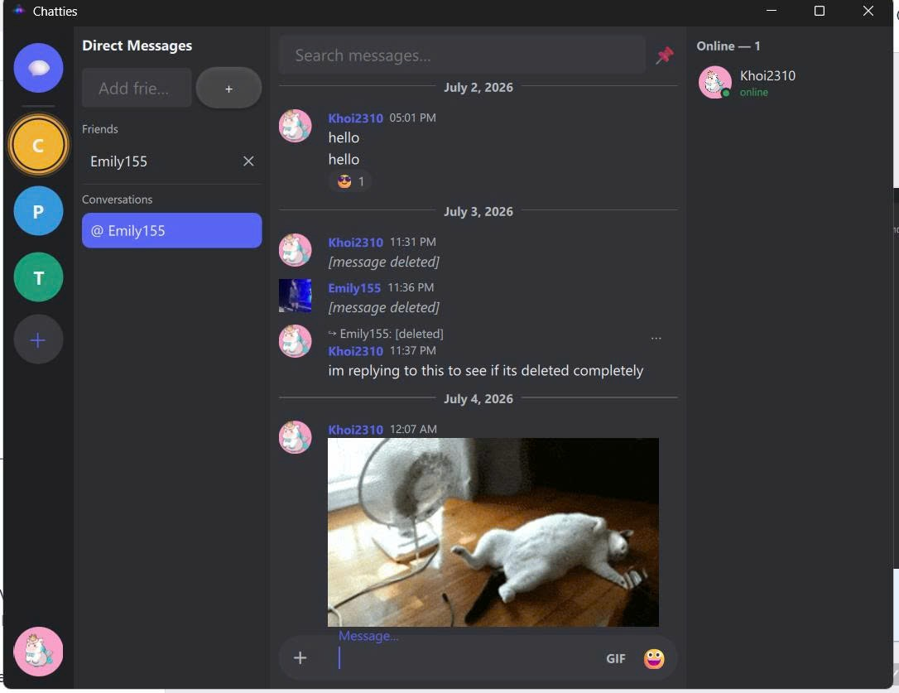
Figure 3.3.2 Personal chat interface

Group chat
The application supports creating chat groups with multiple members. Each message sent in a group is forwarded by the Server to all members who are online, allowing information exchange to happen simultaneously and conveniently.
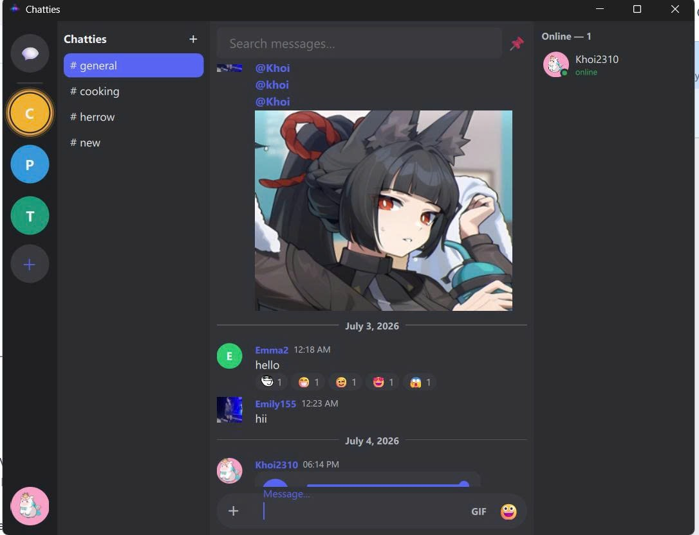
Figure 3.3.3 Group chat interface

Sending files
In addition to text messages, the system also supports sending images and files between users. When a user selects a file to send, the data is transmitted to the Server and then forwarded to the recipient via the TCP connection.
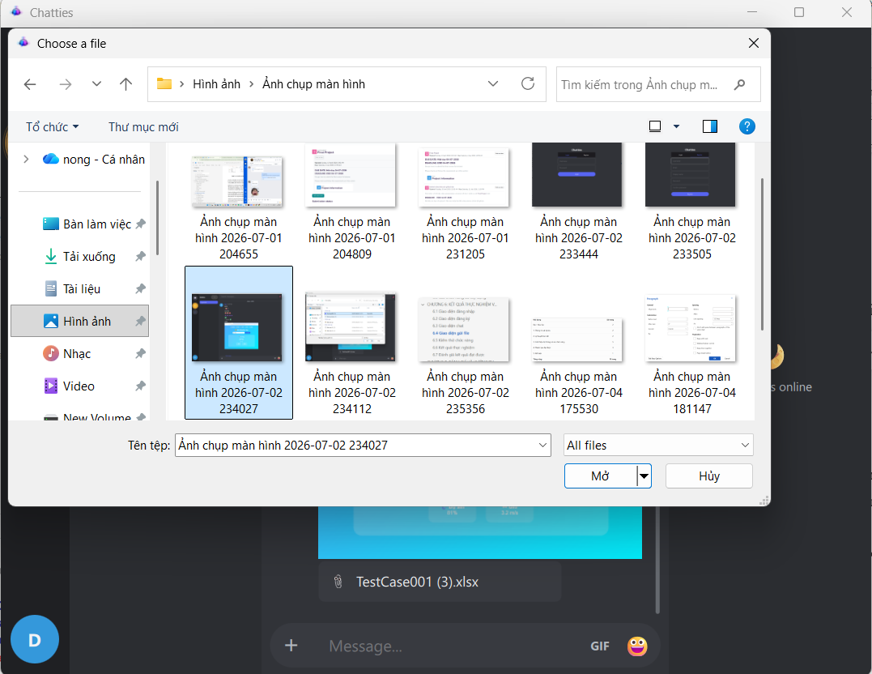
Figure 3.3.4 File sending interface

Emoji and GIF
The system supports sending Emoji and GIF to enhance visual expression during conversations. Users can select emoticons or search for animated images (GIFs) directly within the application interface to send to the recipient. Data is transmitted and displayed in real time, making conversations more lively and convenient.
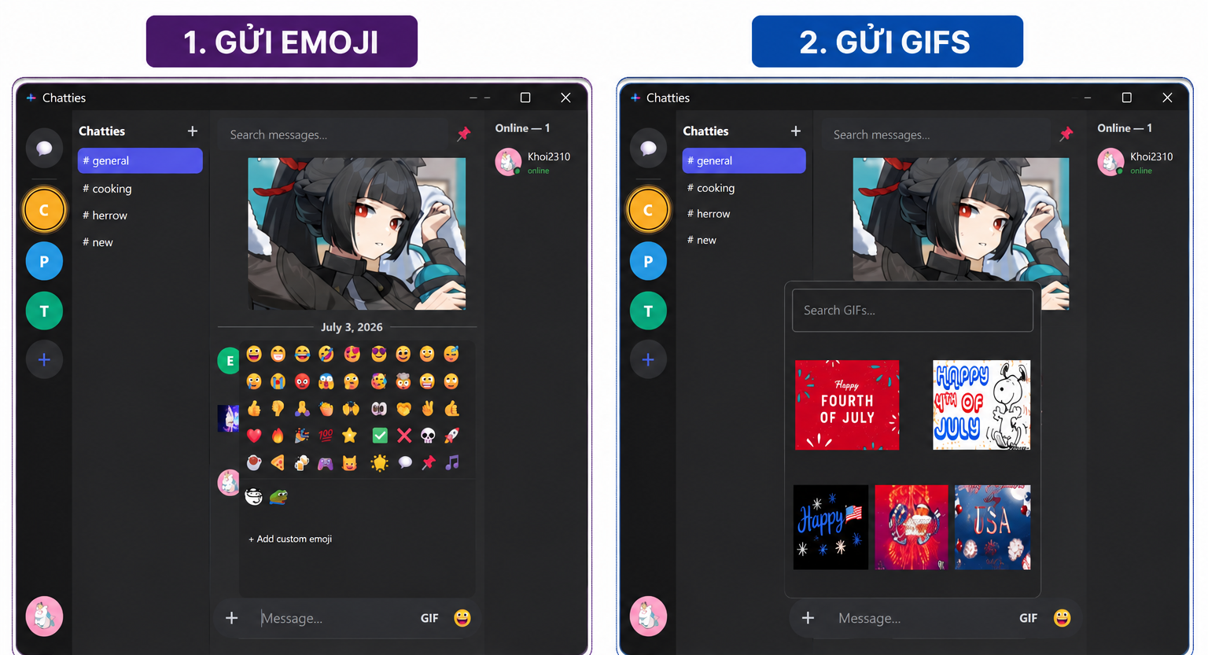
Figure 3.3 Emoji and GIF interface

CHAPTER 4. RESULTS AND EVALUATION

4.1 Results achieved
After the research and development process, the group successfully built the Chatties application operating on the Client–Server model. The system meets basic functions such as registration, login, personal messaging, group chat, file sending, and user status management.
Through testing in a local network environment, the functions operated stably, data was transmitted and received accurately via the TCP protocol, and was stored using SQLite to support user management and chat history.

4.2 Difficulties encountered
During implementation, the group encountered many difficulties in building an asynchronous architecture using Boost.Asio, handling multiple Client connections simultaneously, and ensuring real-time data transmission. In addition, designing the database, managing user permissions, and coordinating project development via GitHub also required the group to research and communicate frequently.

4.3 Knowledge and experience gained
Through the project, the group applied knowledge of the Client–Server model, the TCP protocol, Socket programming, and the Boost.Asio library to build a complete network application. At the same time, the group also improved its skills in database design, source code management using GitHub, and teamwork during software development.

4.4 Content completed
By the end of the project, the group had completed the following functions:
- Building the system based on the Client–Server model.
- Account registration and login.
- Real-time personal and group chat.
- Sending images and files.
- Managing users' online status.
- Support for Emoji and GIF.
- Data storage using SQLite.

4.5 Content not yet completed
Although the project has completed the core functions of a messaging application based on the Client–Server model, some content has not yet been implemented due to time and scope limitations of the course.
Currently, the system does not yet support real-time voice and video calling using the WebRTC protocol. In addition, End-to-End Encryption for private conversations has not yet been integrated. The system also has not yet applied a Content Delivery Network (CDN) to optimize loading speed for avatars and multimedia files as the number of users increases.
These features will continue to be researched and implemented by the group in future versions to improve performance, security, and user experience.

CHAPTER 5. LESSONS LEARNED

5.1 Professional experience
During the project, the group had the opportunity to apply the knowledge learned in the Network Programming course to a real-world product. Building the Chatties application helped the group better understand the operating principles of the Client–Server model, how to establish connections using the TCP protocol, and the process of transmitting and receiving data via Sockets.
In addition, the group also learned how to use the Boost.Asio library to build an asynchronous processing system, allowing the Server to serve multiple Clients simultaneously while still ensuring performance and stability. The process of database design, connection error handling, and system testing also helped the group improve its ability to analyze and solve problems that arise in practice.

5.2 Teamwork experience
During project development, the members divided tasks by stages such as interface design, Server building, Client development, and system testing. Using GitHub to manage source code helped members easily track changes to the program and coordinate work more effectively.
Through the project, the group found that frequent communication, agreeing on coding conventions, and regular code review are important factors that help reduce conflicts during software development and improve product quality.

CHAPTER 6. CONCLUSION AND DEVELOPMENT DIRECTION

6.1 Conclusion
The topic "Building the Chatties application based on Discord" achieved its goal of building a real-time messaging system based on the Client–Server model. The system uses the TCP protocol for data transmission, Boost.Asio for network communication, and SQLite for user data management.
The results achieved show that the system operates stably, meeting the basic functions of a messaging application such as registration, login, personal chat, group chat, file sending, and online status management. The project not only helped the group reinforce its knowledge of network programming but also improved its software development, database management, and teamwork skills.

6.2 Development direction
Although the main functions have been completed, the system still has great potential for further development. In the near future, the group plans to add features such as Voice Call, Video Call, screen sharing, and real-time notifications to improve the user experience.
In addition, the group will research and apply security mechanisms such as End-to-End Encryption, Two-Factor Authentication, and Server performance optimization so that the system can serve a large number of users. In addition, developing a mobile version is also an important direction to expand the project's practical applicability.

References
Referenced from the lecture slides of the course

