**GROUP 22 – OOP Project**

**Plants vs Zombies – PvZs**

**Members:**

**Đặng Đăng Khôi - ITCSIU22266**

**Nguyễn Văn Lạc Thiên - ITCSIU22245**

**Lê Nguyễn Thành Long - ITDSIU21097**

**Lê Tự Minh Kiên - ITDSIU21092**

**Nguyễn Minh Khoa - ITCSIU22267**

For the last project of Object-Oriented Programming class, we have produced a project which is using basic and kind of advantaged of OOP knowledge and normal library such as swing...

Java is an only programming language we have used in this project, a representative language in OOP. Besides that, we have used Swing, Socket for our display and networking.

In this report, we will give a detail description on our project. The structure of our report is outlined as follows:

Chapter I: Gameplay, Role play and instruction.

Chapter II: Details of Game technique.

Chapter III: UML class diagram.

Chapter IV: Evaluation.

# Chapter I - Gameplay, Role play and instruction.

## Gameplay

This is a type-based defensive game between plant and zombie in which players will have to click on a plant card like Peashooter, Sunflower or Wallnut… and put them on lane from number 1 to 5. Besides that, zombie will be random between types of zombie: Normal Zombie, Buckhead Zombie, Balloon Zombie, Conehead zombie. Each plant has personal skill, and the zombies are the same. Each skill has its own graphics, element type, and a set of combination of keys.

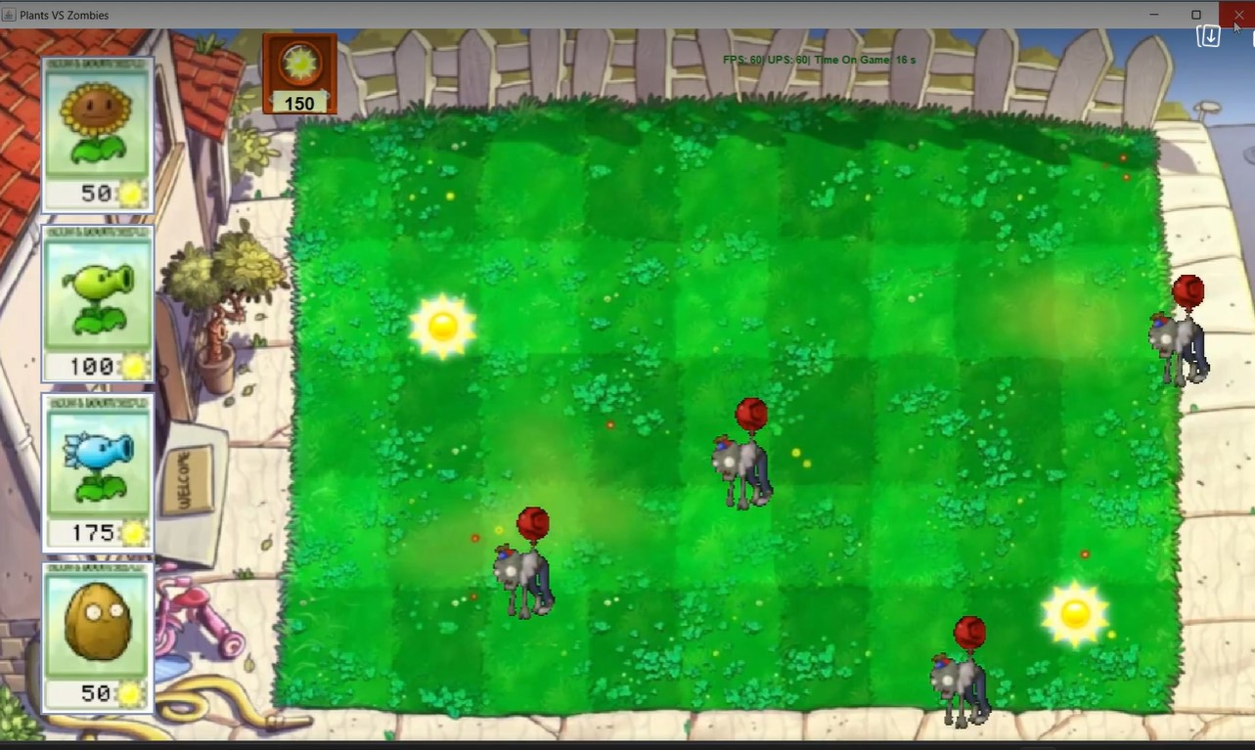

Figure : Several scenes of game

## Role Play:

* First, the player will have some capital to buy the Plant, and it is called "Sun". When the purchase is completed, the capital will be deducted. However, players can still earn them again throughout a game, when these sun icons will fall randomly in the screen. The player's task is to quickly click on those sun icons to collect, before they disappear.
* Then, when zombies begin to appear, from the right side of the screen, players will have to buy plants placed on the left side of the screen, in front of houses for protection. The player's task will calculate the most reasonable way to defend until the time of the mission success.
* If one of the houses is successfully invaded by zombies, the player will lose, the game will end.

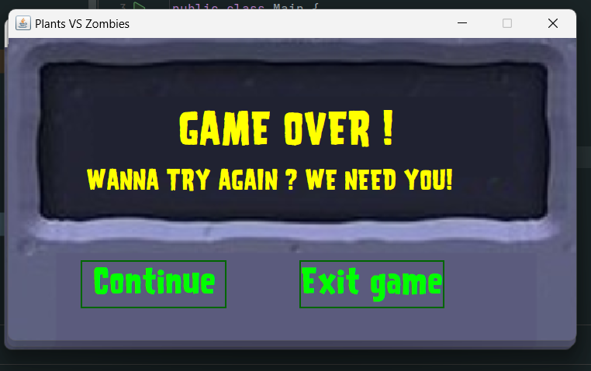

Figure : Playing Again

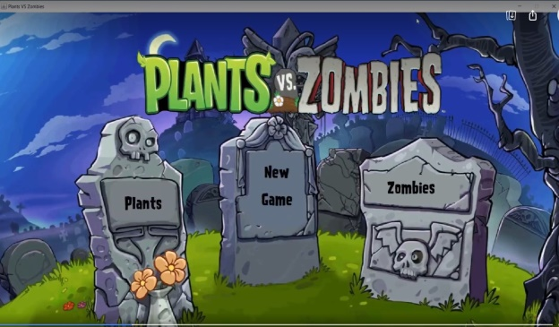

Figure : Main Menu

After running the game, the Main Menu will appear. There are three choice:

* If you choose New Game: the game will leads you to Game Mode menu.

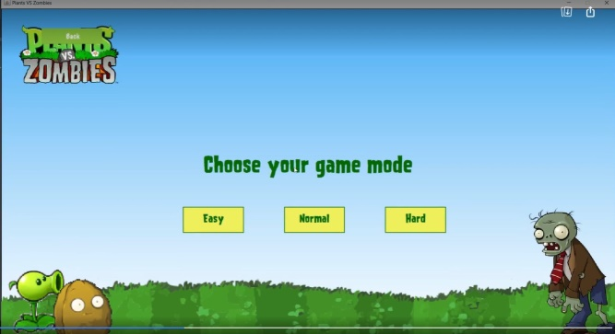

Figure : MenuMode

Easy Mode: your mission is to defend your house until you kill 50 zombies

Normal Mode: your mission is to defend your house until you kill 75 zombies

Hard Mode: your mission is to defend your house until you kill 100 zombies

* If you choose Plants: the Plants Menu will appear and you can see the details of each Plants.

Figure : Plants Menu

* If you choose Zombies: the Zombies Menu will appear and you can see the details of each Zombies.

## Chapter II: Details of game technique

## Introduction about function of used class:

Package Game:

_Game Panel class:

* Used for displaying graphics and game elements.
* Implements Runnable and Mouse for game flow, extends JFrame to display images.

_Game class:

* Used for storing game elements, such as array of pea, array of zombies.

Package GameElement:

_Collider class:

* Used for logic game, when the pea collides with the zombie in the lane

_Position class:

* Used for logic game, adjust the box and the lane for pea, also determine the where to draw images.

_LawnMower class:

* Used for logic game, if the zombie touch a position on the x-axis, without any defense, the lawnmower will destroy the zombie in that lane.

Package GameMode:

_EasyMode class:

* Used for logic game, the mission is to kill 50 zombies.

_NormalMode class:

* Used for logic game, the mission is to kill 75 zombies.

_HardMode class:

* Used for logic game, the mission is to kill 100 zombies.

Other packages and classes: for the game flow and game play

Resources

* The resource of game will be held in PvZs:
* Include:

+Image: Images use for the game.

+Font: The font use for displaying text.

+Sound: Sounds that trigger when the user open the game, such as background music or click sound.

+src: Game classes.

## Chapter III - UML Class Diagram

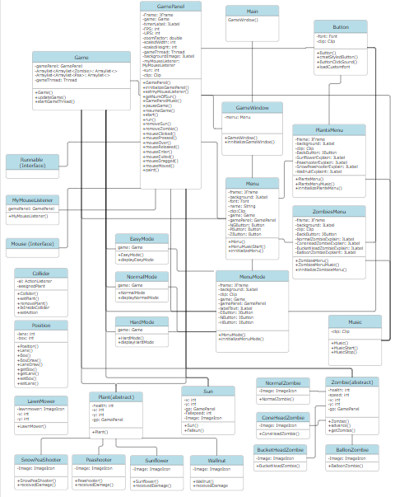

Figure 7: UML class diagram

## Chapter IV - Conclusion

* This project is designed and built for the simplest and flexible way that can expand and freely.
* Follow the structure of player, you can add many plants and play the game.
* Because of the game thread and paint component is overload to the frame, the plants and sun sometimes are seamless and lag.