Exercise Lab8 ITCSIU22266
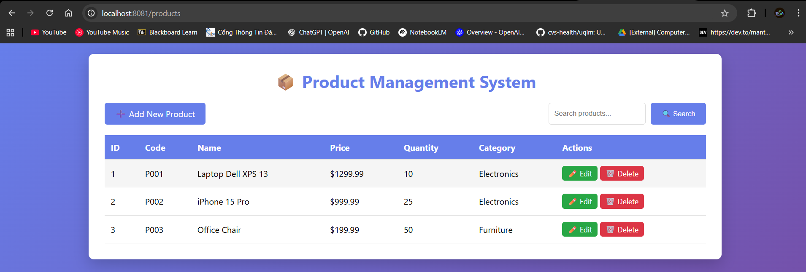
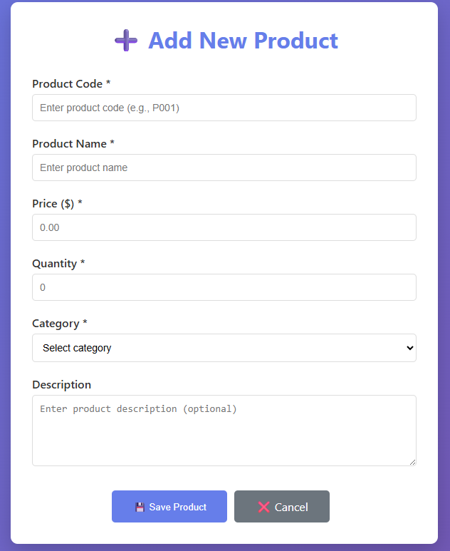
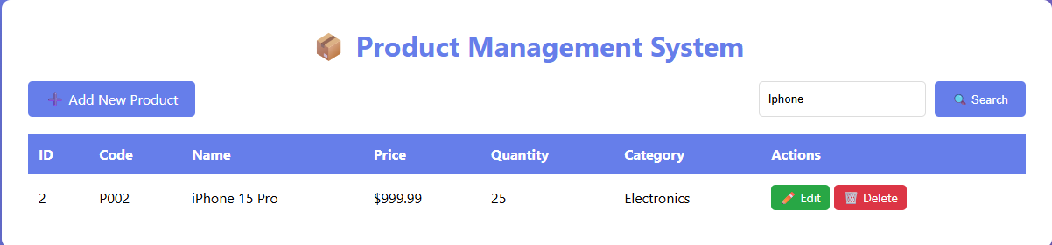
Entity:
Maps Java class to database table.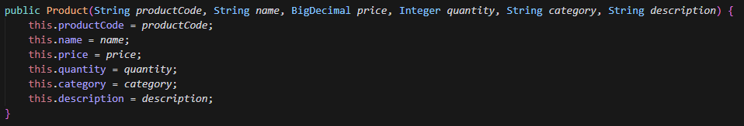
Repository:
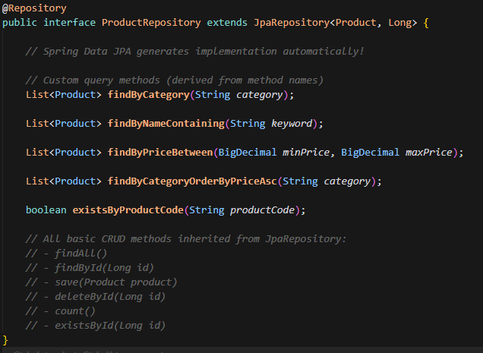
Extends JpaRepository<Product, Long> - gets free CRUD methods:
- findAll(), findById(), save(), deleteById()
Custom queries derived from method names (Spring Data JPA magic):
- findByCategory() -> SELECT * FROM products WHERE category = ?
- findByNameContaining() -> SELECT * FROM products WHERE name LIKE %?%
Service:
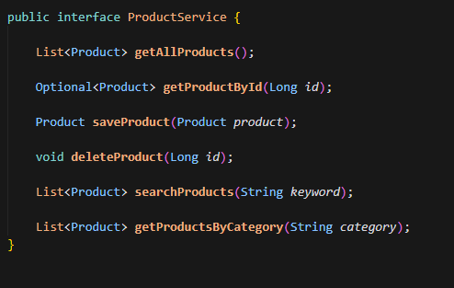
Business logic layer between controller and repository
DB connection:
