Report Exercise Lab4
1.1
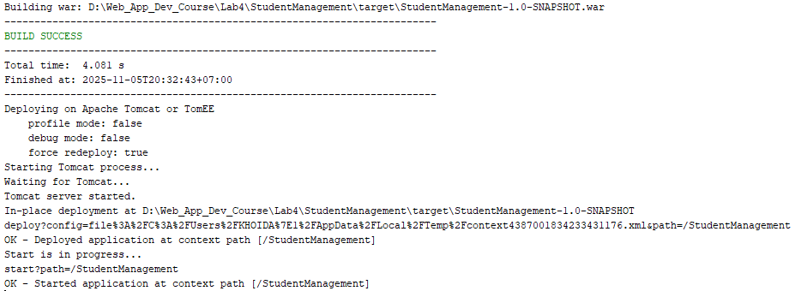
1.2
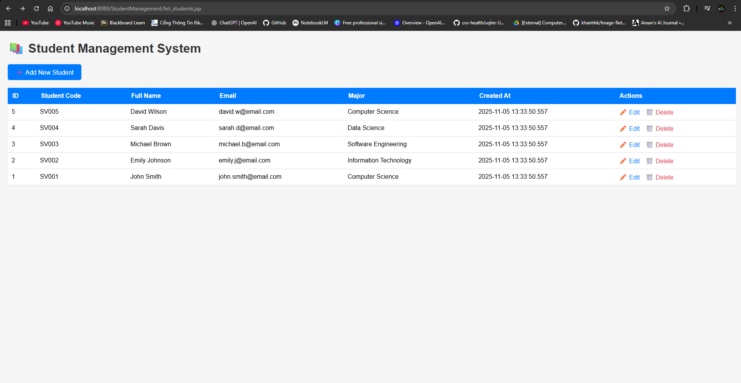
2.1
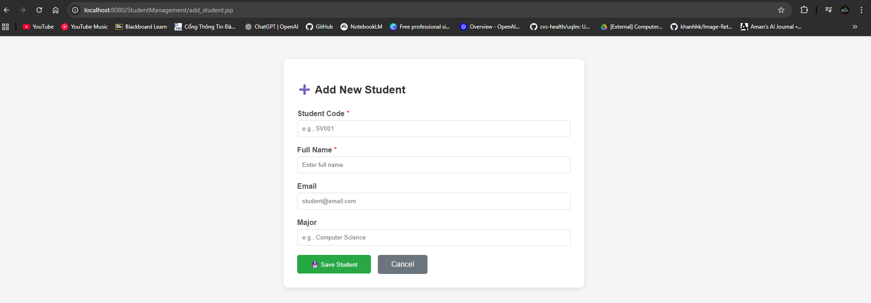
2.2
Add John Doe - Success
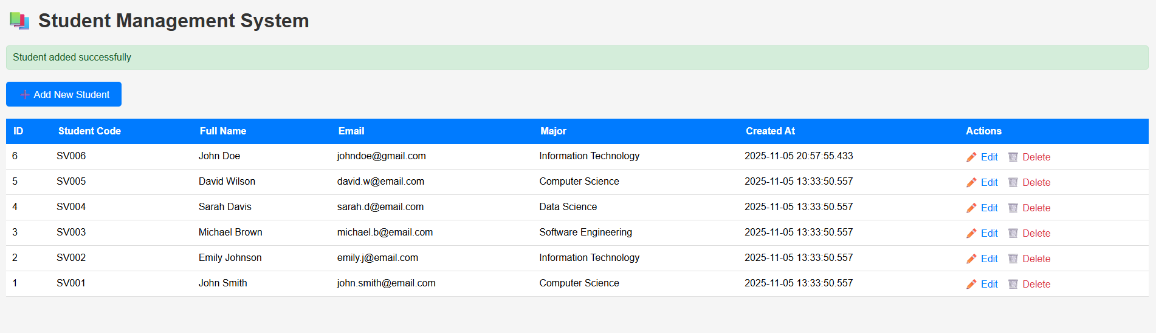
Empty field
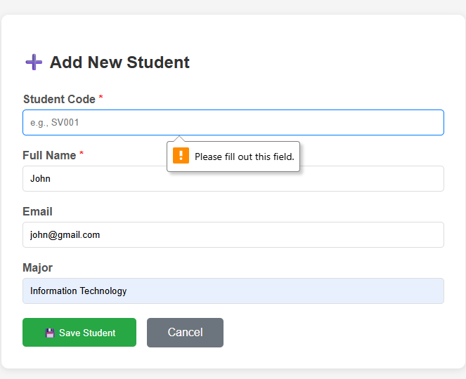
Duplicate student code
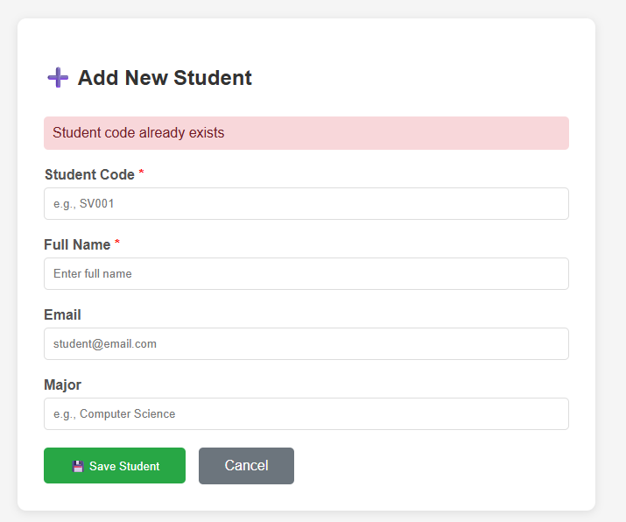
Flow explaination:
Client: User open and view form
Server: Sent plain html to client
Client: User fills fields, then click Save Student
Browser: Get all values in fields, and send a HTTP POST request, target is process_add.jsp as a server.
Server:
- GetParameter from the request, and store in Java variables.
- Load db driver and open a connection to student_management db.
- Execute INSERT query
- Get result from db, sucessful or SQL Exception
- If Success: Send HTTP response 302 redirect to Browser and make a request to list_students.jsp then display the success message
- If Failed: catch the error, Send HTTP response with the error to browser and make a request to add_student.jsp, then display failed error
3.1

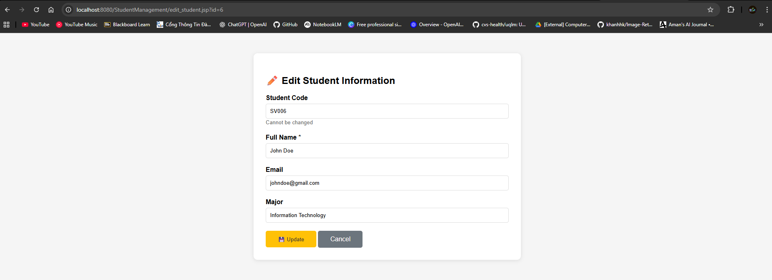
3.2
Update John Smith to John Doe
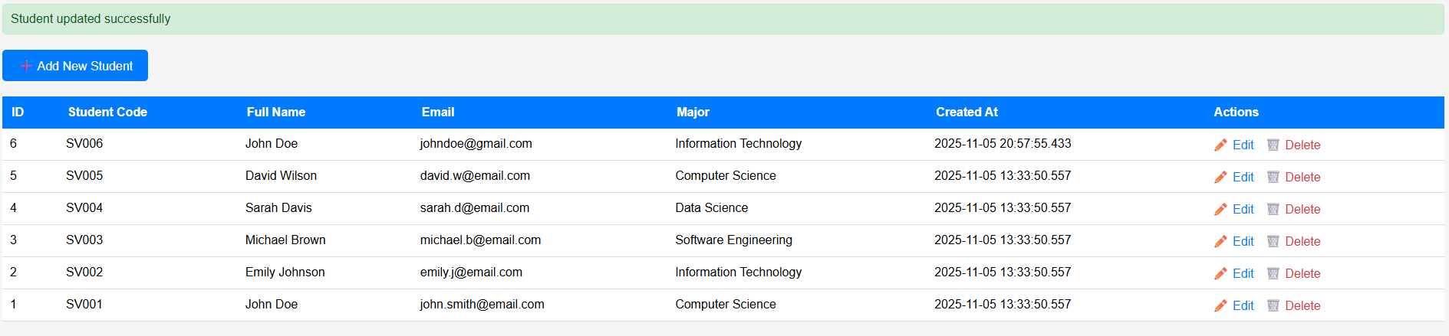
Access Student id 9999 – not found student
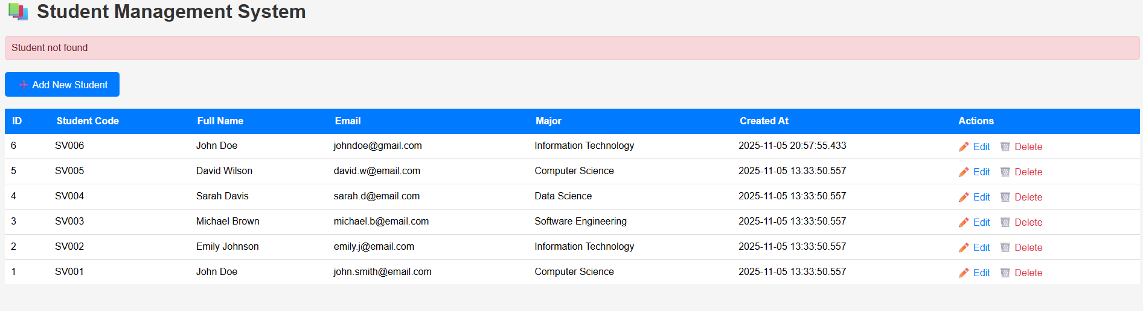
Missing name field
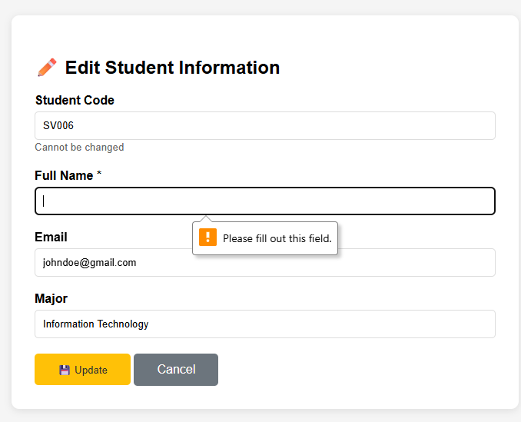
Flow explaination:
Phase 1: Seeing the Form
- Client: User is on the student list and clicks an "Edit" link.
- Browser: Sends an HTTP GET request to the server, targeting edit_student.jsp and passing the student's ID (like ...jsp?id=5).
- Server (edit_student.jsp):
  - GetParameter from the request to grab that id.
  - Load DB driver and open a connection to the student_management DB.
  - Execute a SELECT query to find that one student.
  - Get result from DB, and stuff that student's data (name, email...) into Java variables.
- Server: Sent plain HTML to client, but this time, the form fields are pre-filled with all the student's data.
- Client: User opens and views the form, seeing all the info they're about to edit.
Phase 2: Saving the Changes
- Client: User changes the name, fixes the email, etc., then clicks the Update button.
- Browser: Get all values in fields (the new ones, plus that hidden id), and send an HTTP POST request, target is process_edit.jsp as a server.
- Server (process_edit.jsp):
  - GetParameter from the request (for the id, full_name, etc.), and store in Java variables.
  - Load DB driver and open a connection to student_management DB.
  - Execute UPDATE query (using the id in the WHERE clause).
  - Get result from DB, successful (rowsAffected > 0) or SQLException.
  - If Success: Send HTTP response 302 redirect to Browser and make a request to list_students.jsp, then display the success message.
  - If Failed: catch the error, Send HTTP response with the error to browser and make a request back to edit_student.jsp (with the id), then display the failed error.
4.2
Delete Announcement
