# Challenges

## OpenCV Accuracy

Around 70% of the faces in all images got detected. Several are not.

Examples:

Face covered with some objects are not detected – False negative

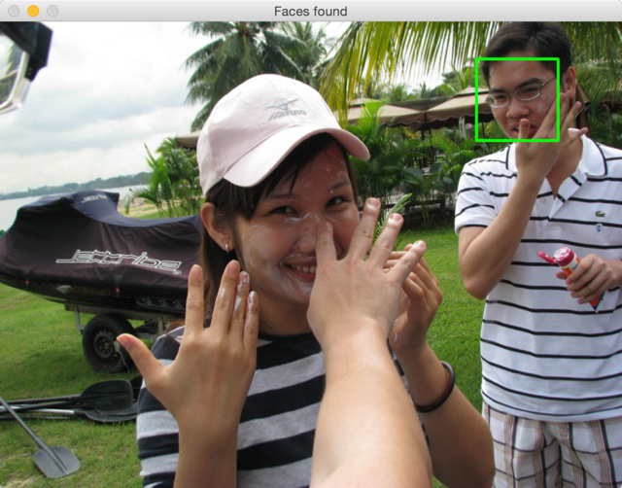

Obvious wrong detection – false positive

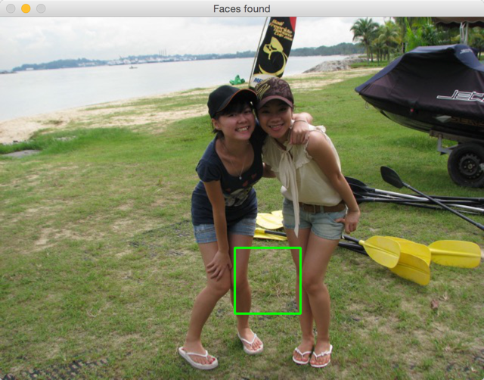

Non-human face detected – False positive

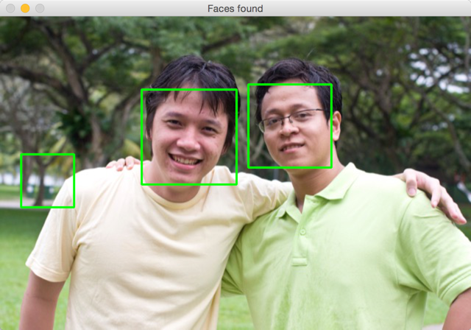

Unable to detect “non-straight head” – false negative

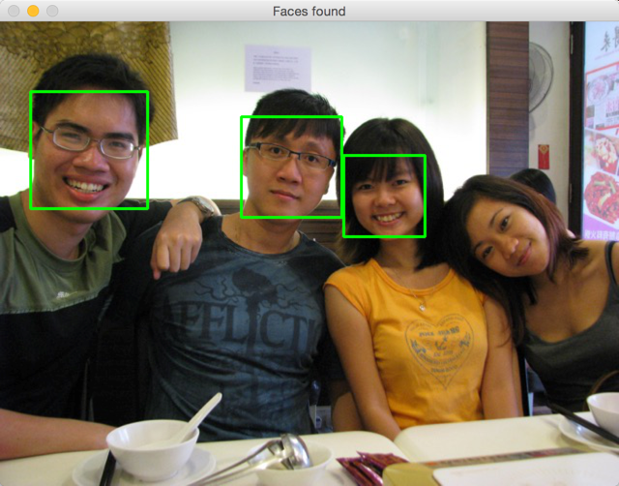

Many faces are missed out

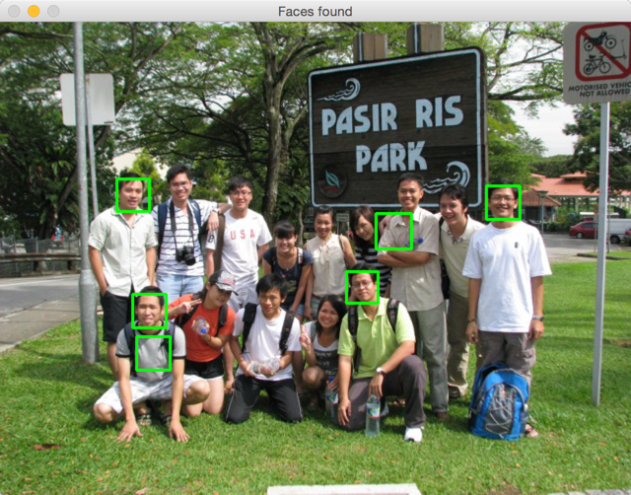

## Observation

Playing with these parameters improve or reduce detection quality:

* image size: resize image does help, better at 640 pixels on longest side
* scaleFactor: smaller scale factor introduces more false positive, bigger scale factor introduces more false negative

using facepy

using facebook photos as source of head shots trained data.

Using ConfigParser

Parse config file storing facebook ID, etc

Using Flask Oauth for oauth with Facebook