Name: Khola Rehman
Roll no: 24-ARID-931
BS CS (4C) - Evening
Computer Organization & Assembly Language
(COAL)
Assignment # 1

Types of Registers in Assembly
General Purpose Registers
AX (Accumulator Register)
Overview: Used for arithmetic, logic, and input/output operations.
Type: Processing / Input-Output
BX (Base Register)
Overview: Holds base address for memory access.
Type: Processing / Memory
CX (Count Register)
Overview: Used as loop counter and in shift/rotate operations.
Type: Processing
DX (Data Register)
Overview: Used in multiplication, division, and port addressing.
Type: Processing / Input-Output

Pointer Registers
SP (Stack Pointer)
Overview: Points to the top of the stack.
Type: Memory / Process
BP (Base Pointer)
Overview: Used to access data and parameters inside the stack.
Type: Memory / Process

Index Registers
SI (Source Index)
Overview: Points to source data in memory during string operations.
Type: Input / Memory
DI (Destination Index)
Overview: Points to destination data in memory.
Type: Output / Memory

Segment Registers
CS (Code Segment)
Overview: Stores address of program instructions.
Type: Processing
DS (Data Segment)
Overview: Stores address of program data.
Type: Input / Memory
SS (Stack Segment)
Overview: Stores address of stack memory.
Type: Memory / Process
ES (Extra Segment)
Overview: Extra memory segment used mainly in string operations.
Type: Memory / Output

Control Registers
IP (Instruction Pointer)
Overview: Holds offset address of next instruction to execute.
Type: Processing / Control
FLAGS Register
Overview: Stores status and condition flags of the CPU.
Type: Control / Processing

Examples & Implementation
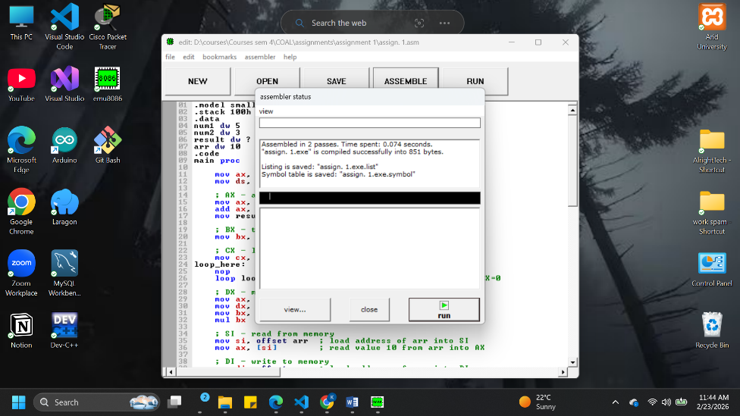
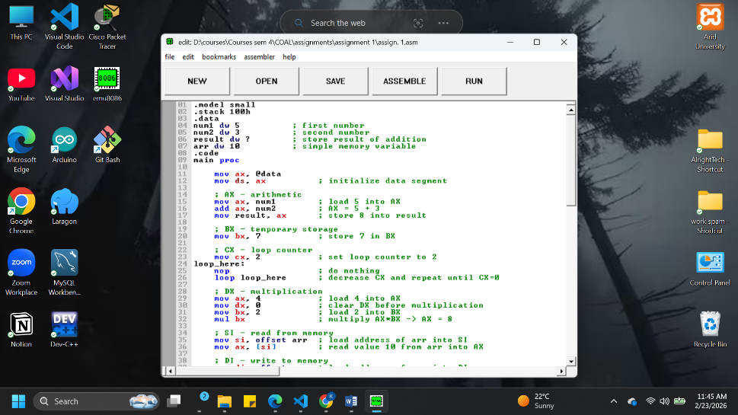
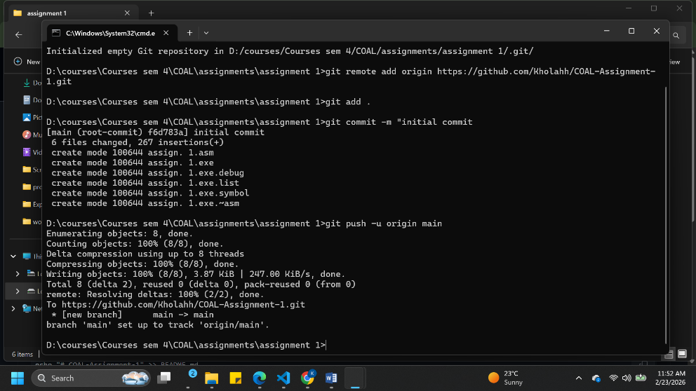
LINK: Github repository

