Online Retail II
Project Overview
For this project I wanted to build something outside of work that let me practice the full process end to end, improving my knowledge and skill, starting from messy, unstructured data and building up to a proper relational database. The goal was to combine SQL and Power BI in a way that actually shows judgement, not just technical execution, working through the same kind of decisions that come up in real client data, and documenting the reasoning behind each one properly.
The dataset I used is Online Retail II from the UCI Machine Learning Repository. It contains transactions from a UK based online retailer that sells gift and homeware items, covering December 2009 through December 2011. Many of its customers are wholesalers rather than individual shoppers, which turned out to matter later in the project. The data comes as two Excel sheets, one for each year, and is known to be genuinely messy rather than pre cleaned for teaching purposes.
Getting to Know the Data
Before touching anything, I spent time just profiling the data column by column in Power Query, using Power BI's column distribution and column quality tools. The 2009 to 2010 sheet had 525,461 rows and the 2010 to 2011 sheet had 541,910 rows, each with eight columns: Invoice, StockCode, Description, Quantity, InvoiceDate, Price, CustomerID and Country.
Two columns immediately showed mixed data types when I loaded them. Invoice contained both numbers and text, because cancelled orders in this dataset are marked with an invoice number that starts with the letter C. StockCode also mixed numbers and text, partly because some products have variant codes like 85183B, and partly because a handful of codes aren't products at all. I changed Invoice, StockCode and CustomerID to text type early on, mainly to stop Power Query from silently dropping the C prefix or reformatting IDs as decimals.
While checking StockCode more closely I noticed a stock code showing as a lowercase m, sitting apart from the much more common uppercase M. Filtering for each one directly confirmed it: M appeared 850 and 571 times in the two sheets and stood for manual adjustments, while lowercase m turned up 4 times and once, clearly the same code typed inconsistently. I uppercased the whole column to fix that.
That discovery made me want a complete, reliable list of every nonproduct code, rather than relying on scrolling and spotting things by eye. I built a check that extracted only the digits from each StockCode and filtered for rows where nothing was left, which surfaces every purely alphabetic code in one go. That returned sixteen codes in total: POST, DOT, BANK CHARGES, AMAZONFEE, M, D, B, ADJUST, S, GIFT, CRUK, PADS, DCGSSGIRL, DCGSSBOY, DCGSLBOY and DCGSLGIRL. None of these are real products. Some are shipping or service fees, some are internal adjustments, and a couple are charity or sample codes. I flagged these with a boolean column rather than deleting them, so revenue could still be reconciled with fees included if that was ever useful, while product level analysis could exclude them cleanly.
Cleaning the Data
With the structure understood, I worked through the data column by column, treating each issue as something to prove rather than assume. A few examples stood out.
Price contained both zero and negative values. The negative ones, only three and two rows across the two sheets, all shared the same StockCode, B, and the same description, Adjust bad debt, with no CustomerID attached. That was clearly an internal accounting entry rather than a sale, so I added B to the nonproduct code list. Zero price rows were a different story. There were 3,687 and 2,515 of them, spread across ordinary looking product codes rather than concentrated in one special code. Rather than deciding on a single blanket rule, I treated this as a decision that depends on what the number will be used for. For revenue analysis these rows contribute nothing either way, so excluding them avoids inflating order counts. For anything based on quantity or inventory, though, a free item still represents real stock leaving the warehouse, so I kept them for that purpose.
CustomerID was missing in about 21 percent of rows in the first year and 25 percent in the second. That's a large enough gap that dropping those rows would have thrown away a real chunk of revenue, and it also isn't something I can fix, since there's no way to recover a customer identity that was never recorded. I left it as a true null value and added a separate has_customer_id flag, rather than filling it with a placeholder like Guest, mainly because a placeholder ID risks being accidentally treated as one enormous customer in a group by query later on.
Description had a smaller but similar issue, missing in under one percent of rows, along with a few rows where the field held an operator's note like wrong invc instead of an actual product name. I also found that the same StockCode could carry several different descriptions over time, up to ten in one case, most often because a product had been renamed slightly at some point. Since a product table needs one description per StockCode, I resolved this by taking the most common description for each code, and left the original text untouched anywhere it still appeared row by row. I'm aware this is a simplification. If a product's name changed for a good reason, the more common older name might win out over a more current one, and a more thorough approach would track that history rather than collapsing it to a single value. For a project at this scale, though, picking the most frequent value and documenting the trade-off felt like the right level of effort.
Country turned out to be more interesting than expected. My first instinct was to treat it as a fixed attribute of each customer, but checking distinct country counts per CustomerID showed thirteen customers linked to two different real countries each, for example one customer tied to both Belgium and Spain. Given that a lot of this retailer's customers are wholesalers, that's plausible rather than a data error, a business could reasonably place orders attributed to more than one country. That meant Country had to live at the transaction level, not the customer level, and it changed how I designed the schema afterward.
I also checked for exact duplicate rows across every column, not just a couple of key fields, and found 6,865 and 5,268 of them in the two sheets. Removing those, along with a small number of test rows, TEST001 and TEST002, both literally described as test products, and 388 products that had never once been given a real description in either year, rounded out the cleaning pass.
Designing the Database
Once the data was in reasonable shape, I split it into three tables rather than keeping one large flat table, following the star schema pattern that's standard in data warehousing: one fact table holding the transactions, and separate dimension tables holding descriptive attributes about customers and products.
Customers ended up holding just the customer id, along with first purchase date, last purchase date and total number of distinct orders, all derived from the transaction data itself. Country was deliberately left out, for the reason above.
Products holds the stock code as its key, the cleaned description, and a flag marking whether the code represents a real product. Orders is the fact table, holding one row per original line item, referencing both Customers and Products by their keys, along with quantity, price, invoice date, country, and the cancellation, product code and has customer id flags. I removed the raw description column from Orders once Products existed, so that any query needing a product name has to join to Products rather than reading a copy sitting in the fact table. That's a deliberate constraint, not an oversight, since it keeps product names consistent in one place and forces proper use of joins, which is exactly the kind of thing this project was meant to practice.
Building and Loading the Database
I used PostgreSQL and pgAdmin locally on Windows rather than using a hosted service, mainly because I wanted to understand the actual server and tooling rather than just clicking through a managed dashboard. I wrote the create table statements by hand for all three tables, working through a handful of genuine syntax mistakes along the way, an unquoted reserved keyword used as a table name, a foreign key reference missing its data type, an unclosed parenthesis. Each one threw a clear error that pointed at the actual problem, which made fixing them a reasonable way to get comfortable with the syntax rather than something to be anxious about.
Getting the cleaned data out of Power Query and into PostgreSQL took more troubleshooting than I expected, and most of it came down to formatting rather than the underlying data being wrong. Exporting a table by dragging it into a Power BI visual turned out to silently split date columns into separate year, quarter, month and day columns because of Power BI's default date hierarchy, which broke the very first import attempt. Switching to DAX Studio and exporting directly from a query solved that, since it returns the raw column values with no hierarchy involved. A later import failed because the price column had been written out using a comma as the decimal separator, which traces back to Windows regional settings rather than anything in the data itself, and was fixed by changing that setting before re exporting. Another failure came from blank CustomerID values being exported as quoted empty text rather than a true empty field, which Postgres won't accept into a numeric column, solved by changing that column's type from text to whole number just before the final export.
One thing worth being honest about: partway through importing the Products table, the row count in Power Query showed 5,132 while Postgres showed 5,131, and for a while I assumed a row had been silently lost somewhere in the export. Rather than accepting that at face value, I built a small side by side comparison in SQL using EXCEPT in both directions, which turned up zero mismatches between the two lists of stock codes. That pointed to the 5,132 figure being a stale reading from Power Query's profiling tool rather than a real discrepancy, and reimporting confirmed the true count had been 5,131 all along. I'm including this because I think knowing how to chase down a number that looks wrong, rather than either panicking or shrugging it off, is as much a part of this project as the cleaning itself.
The final row counts loaded into PostgreSQL are shown below, with working foreign key constraints linking orders back to the other three tables.
Table | Row count | Role
customers | 5,942 | Dimension
products | 5,131 | Dimension
orders | 1,055,238 | Fact table
inventory_snapshot | 5,113 | Dimension (synthetic)

First Look at the Numbers
With the database built, I started on analysis with two simple queries, mainly to confirm the schema actually works the way it's meant to.
Total revenue, calculated as the sum of price multiplied by quantity across every row flagged as a real product, comes to 19,343,834.21. I didn't need to filter out cancellations separately here, since every cancelled row already carries a negative quantity, so the multiplication handles it on its own. Before trusting that number I tried a rough estimate using the dataset's average price and average quantity, which came out noticeably higher, and for a moment that looked like a problem with the query. It wasn't. Multiplying an overall average price by an overall total quantity isn't mathematically the same as summing each row's own price times its own quantity, especially once you consider that cheaper items in this data tend to be bought in much larger amounts than expensive ones. The row by row calculation is the correct one, and the mismatch was in my estimate, not the query.
Grouping revenue by month showed a fairly clear seasonal pattern, with November standing out as the strongest month in both years, which fits a gift focused retailer whose customers are partly stocking up ahead of the holiday season. December 2011 shows as a sharp drop in the same chart, but that's not a real decline. The dataset simply stops on the 9th of that month, so the figure only reflects nine days rather than a full one, and reading it as an actual fall in sales would be a mistake worth avoiding once this becomes part of a dashboard. The chart below was pulled straight from the SQL tool while I was working, query included, rather than redrawn afterward, since it's meant to show the actual work rather than a cleaned up version of it.
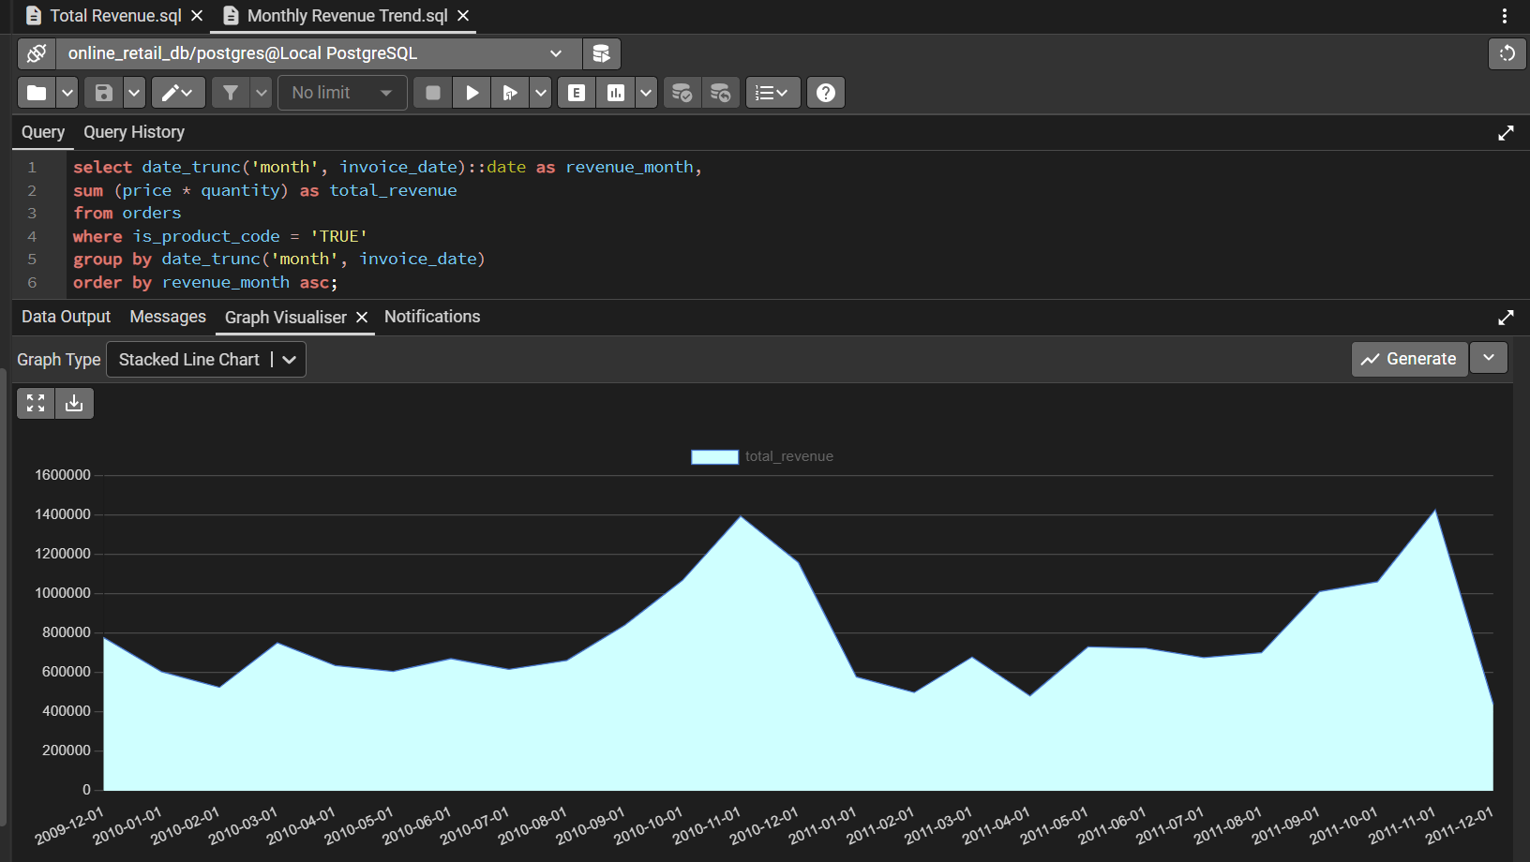
Monthly revenue, December 2009 to December 2011, taken directly from the query tool
Finding the Best and Worst Performers
With the basics confirmed, I moved into more specific questions, starting with which products actually drive revenue. The first pass used a plain group by with the list cut to ten using limit, and the result held together well, Regency Cakestand 3 Tier came out on top at 327,345.20, followed by White Hanging Heart T Light Holder at 257,371.21, then a mix of bags, ornaments and Christmas items filling out the rest. That mix lines up with the seasonal pattern already visible in the monthly figures.
I then rebuilt the same question using a window function instead, ranking every product with rank rather than cutting the list short. The first attempt at this actually caught a real mistake, DOTCOM POSTAGE showed up at rank two, meaning I had forgotten to reapply the filter that excludes non product codes on this particular query. Once that filter was back in place, the ranked list matched the original top ten exactly, row for row, a useful way to confirm two different methods agree.
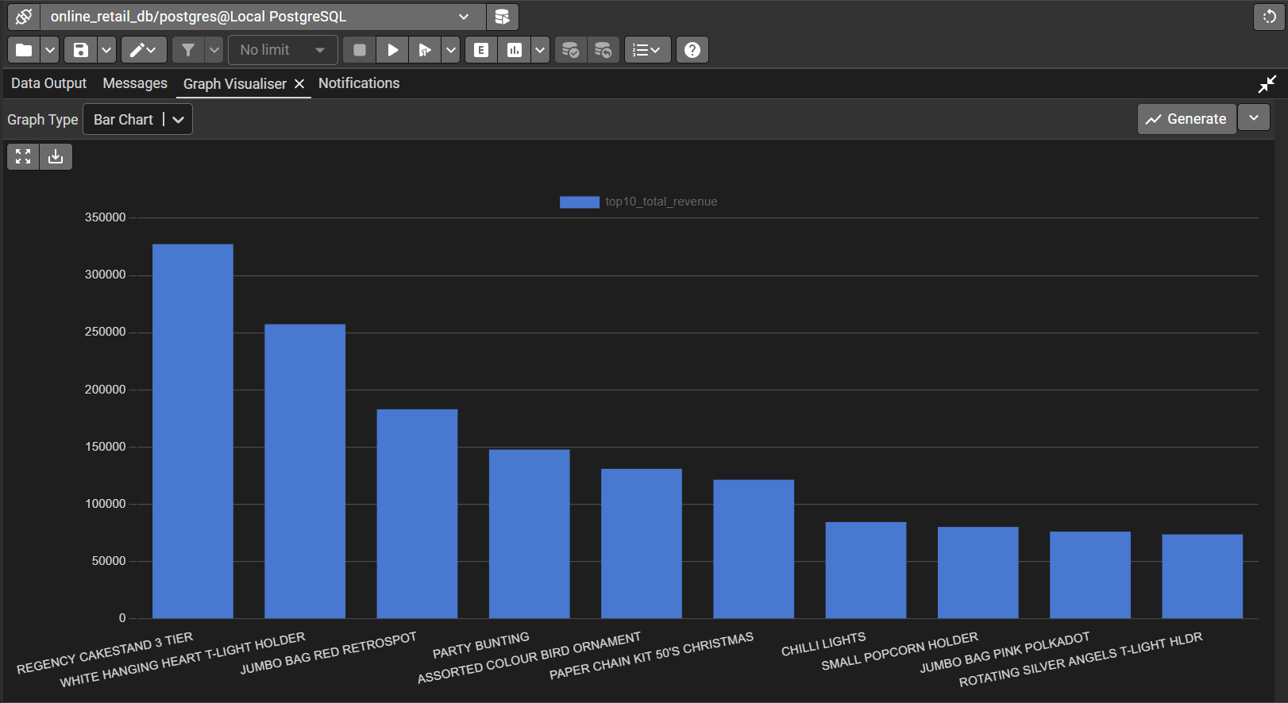
Top ten products by revenue
From there I asked a related but different question using a subquery rather than a named CTE, which products earn more than the average product does. The subquery works out that single average figure on its own, and the outer query compares every product against it. Out of roughly 5,113 real products, about 1,125 sit above that average, a little over one in five. That's a fairly typical shape for retail data, a smaller group of products doing most of the work and a longer tail doing less.
Tracking Growth Over Time
Next I looked at how revenue moved from one month to the next rather than just the raw monthly figures, using lag to pull the previous month's value into the same row as the current one. The pattern makes sense on its own terms, a drop of roughly fifty percent in January 2011 right after the November and December peak, a completely normal shape for a gift retailer once the holiday rush ends. December 2011 shows an even larger apparent drop, but that's the same partial month issue as before, not a real decline.
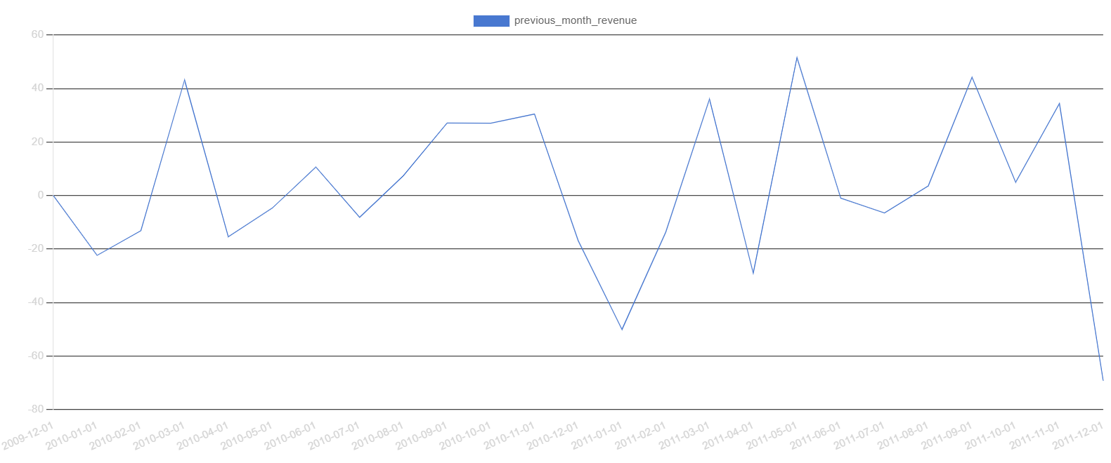
Month over month revenue growth, percentage change from the previous month
I also built a running total across the full two years, adding revenue up month by month using sum as a window function rather than a plain aggregate. This one works better as a demonstration of the technique than as an insight on its own, since a running total of revenue will almost always climb steadily, there isn't much of a surprise hiding in its shape. What it does confirm is that the final figure lines up exactly with the total revenue calculated at the very start, a simple but reassuring way to check the logic holds together.
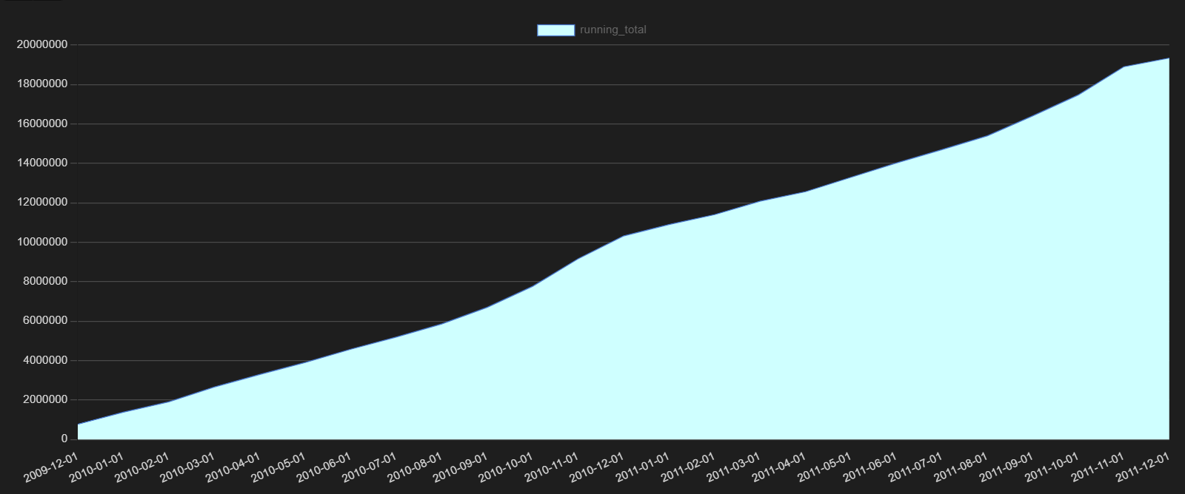
Running total of revenue, December 2009 to December 2011
Understanding the Customers
To look at customers rather than products, I built an RFM analysis, recency, frequency and monetary value, three separate signals combined into one picture of how engaged a customer actually is. Frequency and monetary needed calculating fresh, recency compared each customer's last purchase date against the most recent date in the whole dataset, since the data itself stops in December 2011 rather than running up to today.
One thing came up early that needed a decision. Joining customers to their calculated revenue dropped sixty five people entirely, and checking why showed these were customers whose only activity was things like postage charges or account adjustments, never an actual product. I chose to leave those sixty five out of the RFM table, since RFM is meant to describe buying behavior specifically, and a customer with nothing to measure doesn't really fit that purpose. It's a small number either way, about one percent of the customer base.
I also noticed a handful of customers with a negative monetary total, and checking one directly confirmed why, their cancelled or returned orders outweighed what they actually kept, net negative overall. Not an error, just an honest reflection of what happened.
Once the three raw numbers were in place, I split each one into four groups using ntile, higher recency, frequency and monetary each earning a higher score, then added the three scores together and labelled each customer High Value, Mid Value, Low Value or At Risk. The split came out fairly balanced, shown below.
Segment | Customers
Low Value | 1,797
Mid Value | 1,778
High Value | 1,731
At Risk | 571

The At Risk group in particular is something a real business could act on directly, a specific, named list of customers who haven't bought recently, buy rarely, or spend little, rather than a vague idea of churn. This one is earmarked for a proper chart once the dashboard stage begins, rather than a static image here.
Where the Revenue Comes From
Revenue by country confirmed something that made sense given the business itself, the United Kingdom accounts for roughly eighty five percent of all revenue, about 16.5 million out of 19.3 million total. That's expected for a UK based retailer, but it's large enough that including the UK in a country comparison chart would make every other country invisible next to it. I kept the full figures in the underlying query and stated the UK share here as a plain fact, but left the UK out of the chart itself so the rest of the world is actually readable. EIRE and the Netherlands lead everyone else by a clear margin, then a long tail of smaller markets trailing off from there.
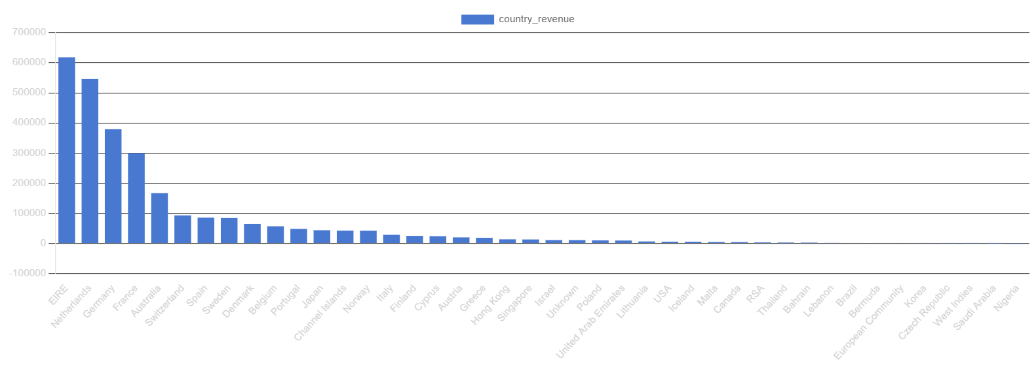
Revenue by country, United Kingdom excluded for readability
Estimating Demand and Building an Inventory Table
The dataset never records actual stock levels, only what was sold, so building an inventory table meant creating one from scratch, based on real selling patterns rather than a guess. The first step was average monthly demand per product, and checking the top of that list directly turned up something worth catching before building anything on top of it. The highest average demand belonged to a product that had only sold in four separate months, with nearly all of it coming from a single month, alongside two months where returns outweighed sales. Averaging across so few months let one unusual event look like a steady pattern, which would have badly overstated how much stock that product actually needs on hand.
Comparing that against a genuinely steady seller, active in all twenty five months with a fairly even spread throughout, made the difference obvious. So rather than treating every product the same way, I split them into two groups, steady sellers, active in twelve months or more, and everything else. Steady sellers get a starting stock of three months of their average demand, a reasonable enough buffer. Products with fewer than twelve active months instead get their total demand spread across the full twenty five month period, which naturally dilutes a single spike down to something more conservative. Either way, the result is never allowed to fall below zero, since a few products have more returns than sales overall and would otherwise come out negative.
This became a fourth table, inventory_snapshot, sitting alongside customers, products and orders, one row per product, all 5,113 of them, holding the average demand, how many months it was actually active, whether it counts as a steady seller, and the resulting starting stock. It's a synthetic table, not real inventory data, and I want to be upfront about that rather than let it read as something it isn't. But it's built on the actual selling patterns in the data, and it treats a genuinely different kind of product differently, rather than applying one formula everywhere and hoping it holds.
Building the Dashboard in Power BI
With the database finished, I moved into Power BI to turn the same analysis into something visual. Rather than pulling in flat files the way I had while cleaning the data, I connected Power BI directly to the PostgreSQL database this time, importing customers, products, orders and inventory_snapshot as they actually exist now. Power BI picked up all three foreign key relationships on its own, including the one-to-one link between products and inventory_snapshot, a good quiet confirmation that the schema itself is sound.
A few things needed rebuilding in DAX rather than SQL, since Power BI doesn't carry revenue as a ready-made column. I wrote a measure using SUMX and FILTER, the same logic as summing price times quantity filtered to real products and checked it against the total already established earlier in this report before trusting it anywhere else. I also added a calculated column rounding invoice date down to the first of its month, since the raw timestamp was treating every distinct time of day as its own point on a chart rather than grouping by month the way SQL's date_trunc already had. Once that was in place, the monthly trend matched the shape already documented earlier, including the same decision to leave the partial December 2011 out of the chart rather than let it read as a real decline.
For customer segmentation, I started out rebuilding the RFM scoring directly in DAX, recency and monetary as new calculated columns, then quartile scores using RANKX in place of NTILE, since DAX has no direct equivalent. Partway through I stepped back and asked whether that was actually the right call, given the same logic already existed, tested and correct, in Postgres. It wasn't. Duplicating a calculation that already works risks the two versions quietly drifting apart if the definition ever changes later. I saved the finished SQL logic as a view, customer_rfm, and brought that into Power BI directly instead, removing the half built DAX columns once the view was confirmed to match the original numbers.
The dashboard ended up split across two pages rather than one, since six visuals covering three different subjects, sales, customers and inventory, didn't sit well crammed onto a single screen even with more canvas space. One page covers the monthly trend, top products and country revenue. The other combines the customer segments with the two inventory charts, since customers alone didn't fill a page on its own. The inventory page also confirmed something worth stating plainly, of the 5,113 products, about 54 percent qualify as steady sellers under the twelve month threshold and about 46 percent don't, close enough to an even split that the two different treatments built into inventory_snapshot were genuinely necessary, not just a precaution for a handful of edge cases.
Closing Thoughts
With the dashboard built, this project is complete, a cleaned and validated database with four tables, a full set of SQL queries covering aggregation, joins, window functions, CTEs, a subquery and customer segmentation, a synthetic inventory table built on real demand patterns, and a two page Power BI dashboard connected directly to that same database. The report and the dashboard file are meant to be read together, this document for the reasoning behind each decision, the dashboard for the result those decisions led to. I've tried to be honest throughout about where a number needed a second look, where a choice was a judgement call rather than an obvious answer, and where something was simplified for the sake of a project at this scale. That's the part I'd want to stand behind in describing this work, not just the finished charts on their own.

