##1 - Choose a subject for a system of your preference, such as Amazon, Netflix, Tawakalna, or Absher.  
#2 – Select four tables related to the chosen subject."  
#4 – Create a database in DataGrip with the same name as the chosen system.  
#5 - create all table with attributes  
#6 – add constraints  
  
# DDL - Create  
create database nusuk;  
drop database nusuk;  
  
create table users (  
 userId varchar(10) primary key,  
 fullname varchar(40) not null,  
 email varchar(25) unique not null,  
 password varchar(20) not null,  
 birthdate date not null,  
 age int,  
 gender varchar(6) check(gender in ('male', 'female')),  
 phone_number varchar(15) not null  
);  
  
insert into users values('1103051031','Kholud Mohammed Almutairi','Kholud@gmail.com','wpf@2433622','2000-07-21',24,'female','0551243107');  
insert into users values('1022456780','Afnan faisal Algahdaty','Afnan@gmail.com','apf@2433622','1995-08-11',30,'female','0551569077');  
insert into users values('1110864346','Mohammed Ali Alshalahi','Mohammed@gmail.com','wpf@2433622','2005-04-21',18,'male','055669928');  
  
create table companions (  
 companionId int primary key ,  
 fullname varchar(40) not null,  
 birthdate date,  
 age int,  
 gender varchar(6) check(gender in ('male', 'female')),  
 relationship varchar(50),  
 userId varchar(10),  
 foreign key (userId) references users(userId)  
);  
  
insert into companions values('100456789','Fatmah Awid Almutairi','1970-07-21',65,'female','mother','1103051031');  
insert into companions values('1005632575','Reeham faisal Algahdaty','1996-07-21',31,'female','sister','1022456780');  
insert into companions values('1045479035','Saud Ali Alshalahi','1985-07-21',40,'male','father','1110864346');  
  
create table trips (  
 tripId int primary key ,  
 trip_type varchar(50) check(trip_type in('umrah', 'visiting the prophet’s mosque'))  
);  
  
insert into trips(tripId, trip_type) values (1, 'umrah');  
insert into trips(tripId, trip_type) values (2, 'visiting the prophet’s mosque');  
insert into trips(tripId, trip_type) values (3, 'umrah');  
  
create table bookings (  
 bookingId int primary key ,  
 userId varchar(10),  
 tripId int,  
 booking_date timestamp default *current_timestamp*,  
 trip_time varchar(10) check(trip_time in('morning', 'evening')),  
 foreign key (userId) references users(userId),  
 foreign key (tripId) references trips(tripId)  
);  
  
insert into bookings(bookingId, userId, tripId, trip_time) values (1, '1103051031', 1, 'morning');  
insert into bookings(bookingId, userId, tripId, trip_time) values (2, '1022456780', 2, 'evening');  
insert into bookings(bookingId, userId, tripId, trip_time) values (3, '1110864346', 3, 'evening');  
  
  
# DQL - Select  
select *from users;  
select *from bookings;  
select *from companions;  
select *from trips;  
  
  
  
# DML - Update  
update bookings  
set booking_date = '2024-03-21'  
where bookingId = '1';  
  
# DML - Delete  
delete from bookings  
where bookingId = '1';  
  
# DDL - Drop  
drop database Nusuk;  
drop table trips;  
  
  
# DDL - Alter  
alter table bookings add column trip_type varchar(50);  
  
  
# DDL - Truncate  
truncate table bookings;

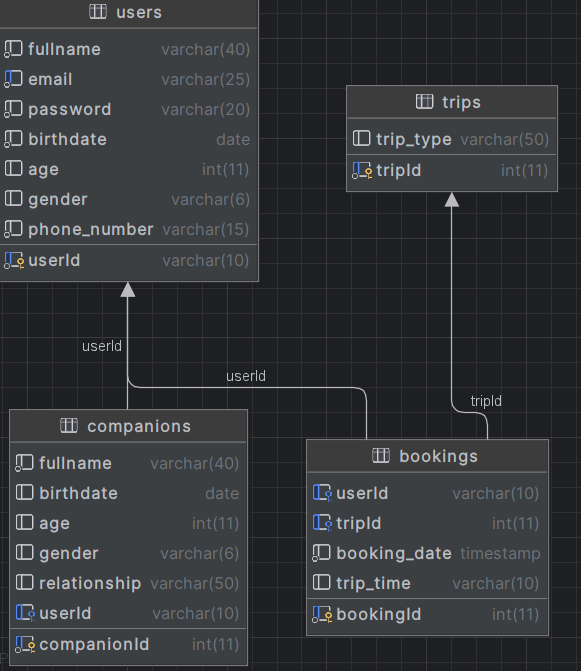

صورة تحتوي على نص, لقطة شاشة

تم إنشاء الوصف تلقائياً