**KIDS v.2.0 - KOOL INTRUSION DETECTION SYSTEM**

# **About**: Monitor the file system & folders change. Python API library and shell utilities to monitor file system events. A shell tool to run commands in response to directory changes.

# **Author**: Khondakar

# **Date**: 23/Oct/2020

**# MENU OPTIONS:**

**SCANNER OPTION:** There are 4 options in Scanner menu.

1. **Browse & Select folder:** Browse and select folder to monitor for file change.
2. **Start Scanner:** After selecting folder, it will start the scanner to monitor any change. If no folder being select from option (a) – scanner automatically choose current folder to scan by default.
3. **Stop Scanner:** To stop the scanner.
4. **Exit:** To exit from the KIDS tool.

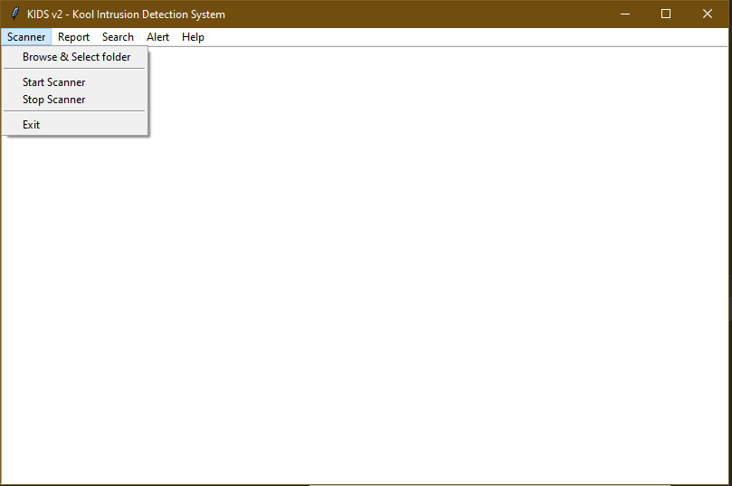

**REPORT OPTION:** There are 3 option available in this menu item.

1. **Main report:** This will show the whole report from the Log file.
2. **Collective report:** This will show collective report based on date and event type.
3. **Dashboard report:** This will display bar chart based on the collective data.

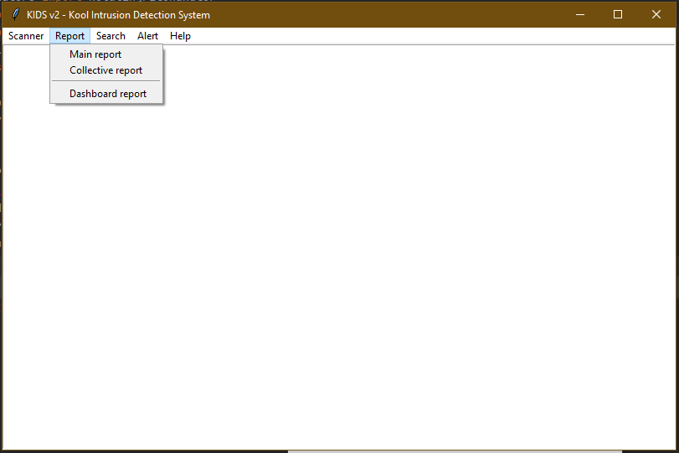

**SEARCH OPTION:** To search anything in the Log file, choose this option.

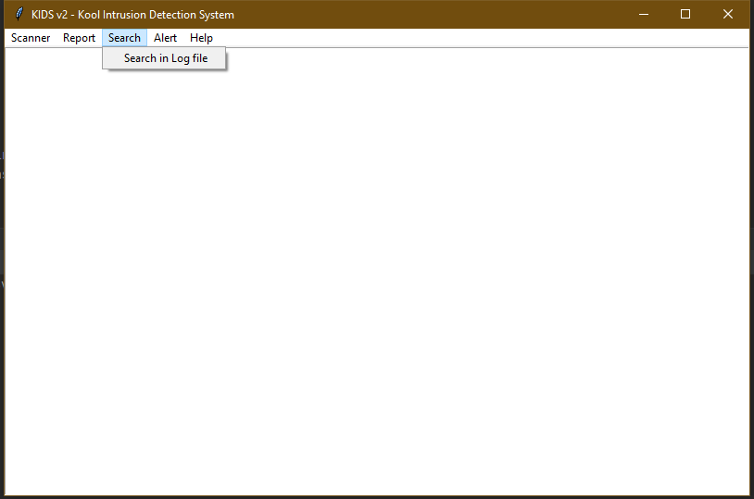

**ALERT OPTION:** This option is to send email alert manually. This will email *File Monitor Log* file as an attachment to predefined email address.

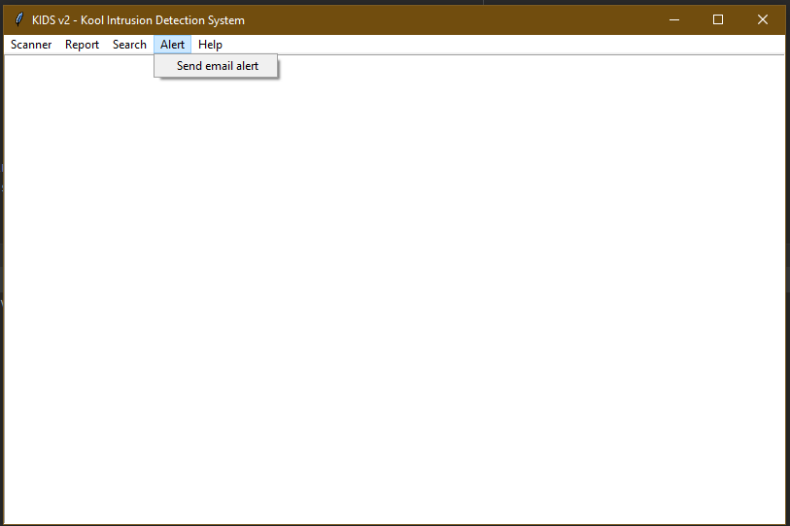

**HELP OPTION:** There are 2 options here

* 1. **Getting started:** This will open the instructions how to operate this KIDS tool.
  2. **About:** It will show the name and version of KIDS tool.

