UML Overview of Tailor Shop

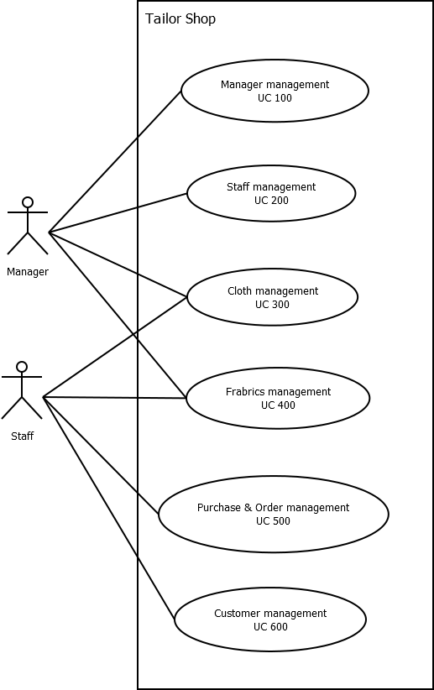

Use case Manager



Use case Staff



Use case Cloth

Use case Customer

