ISM 310 Semester Project
Flatt Falls College: Clubs Database
About the Project
This project will require you to design the table structure of a small-scale database.
- In the 1st phase you will, based on the descriptions and sample documents below, develop a pencil and paper conceptual data model in 3rd normal form using EER notation. Including designating the datatypes and lengths of all attributes and identifying all primary and foreign keys.
- In Phase 2 you will, after making any required changes to your graded Phase 1 submission, create a digital version of this conceptual model using Lucid Chart.

PHASE 1 (30 Points Possible)
Due at or before the beginning of class on Wed. Mar. 26
Based upon the description and documents below, create a pencil and paper Entity Relationship model of the set of database entities and their relationships required to capture the described data. Be sure that your tables are in 3rd normal form and make sure that your model indicates: the data type and length of each attribute, designates all Primary and Foreign keys, indicates whether attributes can be NULL, and shows the linkages between tables using crows foot notation and specifying whether each relationship is mandatory or optional in each direction. You may speak with or email Betsy Blomer (also known as Prof. Morgan) for any follow-up questions.
For any Generalization/Specialization hierarchies identified, use the notation shown in the Week6-1.pptx slide 4 and required for your In-Class Assignment # 5.
Summary of interview with Betsy Bloomer
I am Betsy Bloomer; you can call me Ms. Bloomer.
I have overseen the finances of all the clubs here at Flatt Falls for the past 4 years. I inherited a set of spreadsheet files that my predecessor Gert Trude had been using for years but am finding it difficult to maintain them with the necessary control and accuracy. I would like to have a small database created that would allow me to track this data more easily and accurately and avoid a lot of redundant entries that I am currently making.
All transactions involving clubs go through one account and through me and this will remain true for the foreseeable future.
The first area I deal with is club memberships and dues payments. You can see how this works from the sample Student Club Memberships spreadsheet I’ve given you. When a student joins a club, they must come to me to pay their annual dues.
I also, of course, record information about the student and the club they are joining. As you can see, I get the student’s ID Number, as assigned by the College, their name, and their campus address –nearly all of our students live on campus. I also enter the name of the club they are joining. Then I have to make sure that the correct amount of dues are charged. I do that by looking it up in the Clubs table that I’ll describe in a minute. Finally I enter the date that the dues were paid. All of our clubs have annual dues and memberships are good for 12 months.
I have included just a couple of prior year memberships in the sample data. Students can join and pay dues to the same club over multiple years.
I also keep a set of information about Clubs. As you can see from the sample I’ve given you, We keep a record of each club’s name, its type, which can be Honorary, Social, or Professional, the date the club was founded here at Flatt Falls College, the club’s annual dues and the club president’s name. Every fall each club reports to me the name of its president for that year and any changes in dues. Some clubs are affiliated with national organizations and pay annual dues to their parent organization, and some of the clubs have an individual or company that sponsors them and gives them an annual stipend. Finally, I need to keep a record of each club’s account balance. I debit or credit a club’s account manually each time a membership comes in or a payment charged to the club is made. This is an awkward way to handle these transactions, but, since all of the club transactions are run through a single college account, that is how it has been done. I would hope that the new system would support automatically adjusting the club account balances, which brings me to the last spreadsheet used in this area.
As you can see from the sample Club Expenditures spreadsheet, I record the club name, expense type and description, the amount paid, date the check was written, and the payee each time I make a payment. For each check I write, I require submission of a printed form with this information signed by the club’s president or a Faculty or Staff member.
Also, most of the Clubs have a faculty advisor. I’d like to have a simple table that would store the ID, Name, and Campus Phone Number of each Advisor that could be linked up to the Club or Clubs that they advise (some faculty advise more than one club). I’ve put together a sample list of Advisors and the clubs they advise in the Club Advisor list below. All club expenditures should be approved either by the club’s president or the faculty advisor and I’d like to start recording that information for each expenditure I approve.
Review of Betsy Bloomer Interview
After the Betsy Bloomer interview you decide that the StudentID can be used as the Primary Key of the Student entity. However, you decide to add a ClubID field as the internal identifier (Primary key) of the Club entity. Similarly you see that there is no good natural identifier of Club Expenditures and will add an internal identifier (ExpenseID) to serve as Primary key there. Finally, you notice that the external identifier for club memberships is a composite of the StudentID, the Club, and the DatePaid. To avoid this heavily composite key you will add a DuesPaymentID field as the Primary key for your entity covering ClubMemberships. The data about faculty Advisors will use the university supplied advisor code as its primary key and will be linked to the Club entity and your Club Expenditure data will include an attribute for authorization by a faculty advisor and an attribute for authorization by a club’s president (Where both allow nulls since either the club president or the Faculty Advisor can authorize an expenditure..
Phase 1 Requirements
Based on the interview description above, develop a pencil and paper conceptual data model of Ms. Bloomer’s requirements, in 3rd normal form, using EER notation. Including designating the datatypes and lengths of all attributes and identifying all primary and foreign keys. Your model should also include a generalization-specialization hierarchy with AffiliatedClubs and SponsoredClubs as specializations of the Club Entity.
Student Club Memberships
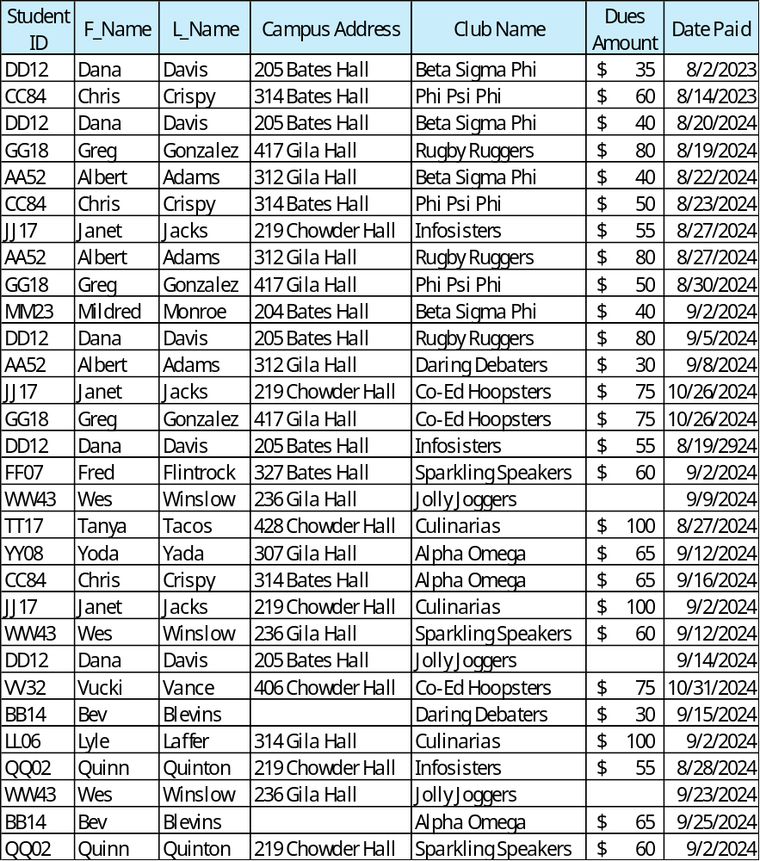
CLUBS
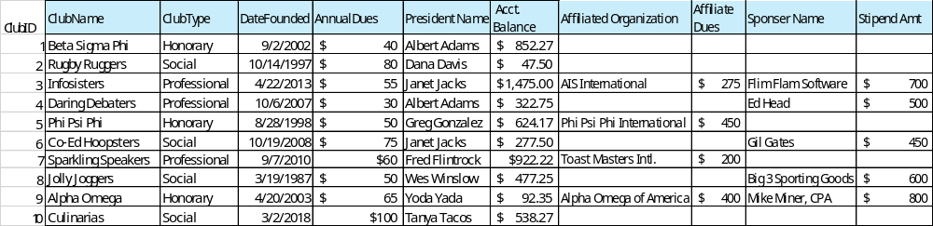
Club Advisor
Club Name | Advisor ID | Advisor Name | Campus Phone
Beta Sigma Phi | AJ12 | Alex James | 4-3627
Rugby Ruggers | BL14 | Bev Lumis | 3-1920
Infosisters | AJ12 | Alex James | 4-3627
Daring Debaters | CH7 | Chris Harris | 5-1847
Phi Psi Phi | DJ3 | Dawn Jones | 4-8213
Co-Ed Hoopsters
Sparkling Speakers | CH7 | Chris Harris | 5-1847
Jolly Joggers
Alpha Omega | RN5 | Rich Nixer | 3-2907
Culinarias | BB8 | Bob Brensen | 2-1038

