ISM 310 Data Modeling Semester Project Phase 3
Flatt Falls College: Clubs Database
Phase 3 (20 Points Possible, Due April 28)
The diagram below shows the Lucid Chart conceptual model of the clubs database that we will be using for this phase of the project. Hopefully, it is very similar to a portion of your Phase 2 drawing! (Note: Tables for the Advisor and for the AffiliatedClub and SponsoredClub sub-classes of club are not included here and thus not required for your submission.)
In this phase of the project, you will be creating some database tables with appropriate Key and attribute range restrictions, and then issuing a few insert statements to test your restrictions.
For this phase, you will need to save your successful CREATE TABLE statements to a notepad file. Submission of this file to Canvas will be required.
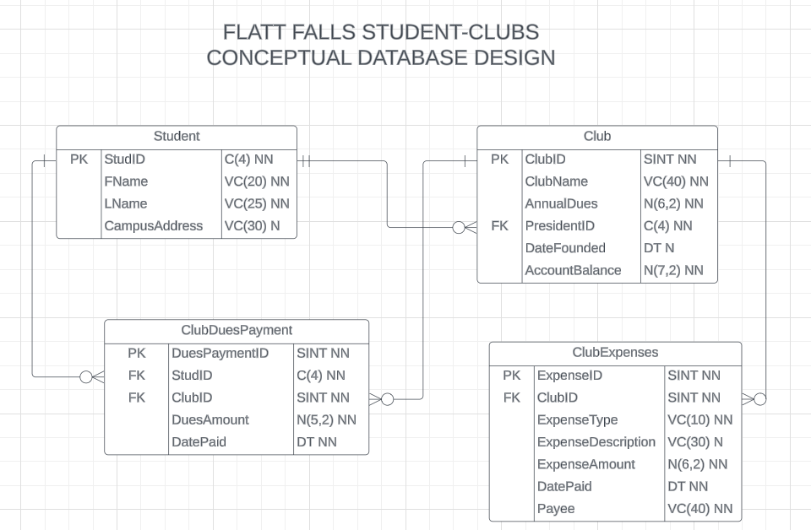
Create Table Specification Requirements
Use a set of DROP TABLE and CREATE TABLE statements as described in class to create the needed table structures. Be sure to include all PRIMARY KEY and FOREIGN KEY specifications appropriate for each table. Also use the data types and lengths indicated for the attributes, as well as NOT NULL designations where appropriate. In addition add the following CHECK constraints:
- The Type attribute of Club should only allow values of Honorary, Professional, or Social
- The ExpenseType attribute of ClubExpense should only be allowed to have values of Dues, Food, Travel, Supplies, or Misc.
- The Amount attribute of ClubExpense should not be allowed to be less than 0 or more than 1,000
Inserts Requirements
Here you are basically testing the constraints of your CREATE TABLE statements. You do not need to save these commands to your notepad file. They will be tested by your instructor.
- Insert a valid Student record with your Name and NAU ID.
- Try to Insert an additional Student record with your same ID number.
- Insert a Club record or your choice with a club ID of 1 and your NAU ID as the PresidentID.
- Try to Insert another Club record using a ClubID of 1
- Next try to insert a Club record with an ID of 2, but with a Type value of ‘Just for Fun’
- Now Insert an appropriate ClubExpense record with ExpenseID of 1 and then
- Test the ClubExpense table’s Primary Key and Foreign Key constraints with attempted inserts that violate these constraints.
- Now Insert a valid ClubDuesPayment record referencing the Student record you created in step 1 and the Club record created in step 3 using a DuesPaymentID value of 1 and finally,
- Test the ClubDuesPayment table’s Primary Key, Foreign Key, and attribute constraints with attempted inserts that violate these constraints.

