

**FACULTY OF COMPUTING AND INFORMATICS**

DPT5201

INDUSTRIAL TRAINING REPORT

JustSimple Digital Sdn. Bhd.

BY

1201203682

KHOO LAY HAN

DIPLOMA IN INFORMATION TECHNOLOGY

TRIMESTER 3 2022/2023

# Abstract

The Abstract is one of the most important parts of the report. It should not exceed **100** words, and you should include your objective and expectation. It is a very brief but clear description of what the report is all about, summarizing the work done and what you have achieved.

# Acknowledgement

Names of each person and organization that has contributed to the work appear in the Acknowledgments. Sometimes the nature of the contribution is described. (For example, permission for the use of equipment, facilities and documents.)

**TABLE OF CONTENTS**

**ABSTRACT i**

**ACKNOWLEDGEMENT ii**

**PART 1: THE COMPANY**

1.1 Background of the company..................................................................................... x

1.2 Organization structure.............................................................................................. x

1.3 Nature of businesses................................................................................................. x

1.4 Products or Services................................................................................................. x

**PART 2: COMPANY INFRASTRUCTURE**

2.1 Structure of Department attached to ...................................................................... xx

2.2 Network Infrastructure........................................................................................... xx

2.3 Hardware and Software…….................................................................................. xx

**PART 3: TASKS/PROJECTS ASSIGNED** (*student may add if their task is more than 3)

**3.1 Task/Project 1: [Name of the task/project]**

3.1.1 Description of project.......................................................................................... xx

3.1.2 Roles and responsibilities.................................................................................... xx

3.1.3 Screenshot ………….………............................................................................. xx

**3.2. Task/Project 2: [Name of the task/project]**

3.2.1 Description of project.......................................................................................... xx

3.2.2 Roles and responsibilities.................................................................................... xx

3.2.3 Screenshot…………….………........................................................................... xx

**3.3. Task/Project 3: [Name of the task/project]**

3.3.1 Description of task............................................................................................... xx

3.3.2 Roles and responsibilities.................................................................................... xx

3.3.3 Screenshot/Picture…........................................................................................... xx

**PART 4: TRAINING ANALYSIS**

4.1 Strengths and weaknesses ....................................................................................... xx

4.2 Knowledge/skills gained......................................................................................... xx

4.3 Suitability of placement....……….......................................................................... xx

4.4 Networking Skills………………........................................................................... xx

4.5 Jobs/Career Opportunities……….......................................................................... xx

4.6 Recommendations/ Suggestions............................................................................ xx

**PART 5: APPENDIX**

5.1 Self-evaluation form…........................................................................................... xx

5.2 Weekly logs.......……............................................................................................. xx

5.3 Attendance report……........................................................................................... xx

5.4 Source codes…………........................................................................................... xx

5.5 References…………............................................................................................. xx

**PART 1: THE Company**

* 1. **Background of the company**

This section gives a description of the company’s background such the history of the company that includes the startup year, founder, origin, location and branches available (wherever applicable). It is advisable that students will discuss with his/her supervisor prior to writing this section to avoid from possible breaching of information that are regarded as sensitive and classified to the organization.

* 1. **Organization structure**

This section gives a description of the company’s organization and environment. It includes the business functions of the organization and departments. It is advisable that students will discuss with his/her supervisor prior to writing this section to avoid from possible breaching of information that are regarded as sensitive and classified to the organization.

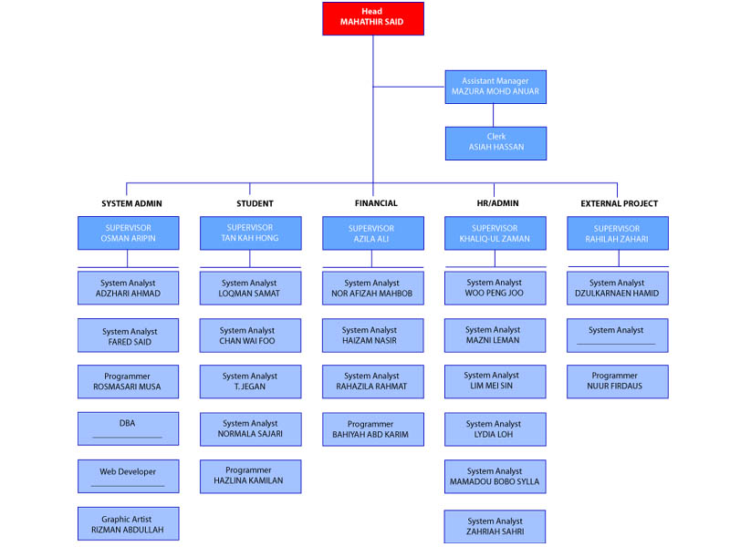

**Figure A.1:** *Organization structure (only for example)*

* 1. **Nature of businesses**

This section gives a description of product and services provided by the company. It is advisable that students will discuss with his/her supervisor prior to writing this section to avoid from possible breaching of information that are regarded as sensitive and classified to the organization.

**1.4 Product and Services**

This section gives a description of product and services provided by the company. It is advisable that students will discuss with his/her supervisor prior to writing this section to avoid from possible breaching of information that are regarded as sensitive and classified to the organization.

**PART 2: Company Infrastructure**

* 1. **Structure of Department attached to**

This section gives a description of the structure of department the student was attached to. Diagrams may be included to show the reporting structure of the department. It is advisable that students will discuss with his/her supervisor prior to writing this section to avoid from possible breaching of information that are regarded as sensitive and classified to the organization.

* 1. **Network Infrastructure**

This section gives a description of the network infrastructure. It is advisable that students will discuss with his/her supervisor prior to writing this section to avoid from possible breaching of information that are regarded as sensitive and classified to the organization.

* 1. **Hardware and Software**

This section gives a general description of different of hardware, servers, routers, switches, software (Application software, Operating System, DBMS, Web server, etc) use in the company.

**PART 3: TRAINING/PROJECT/TASK ASSIGNED**

* 1. **PROJECT/task 1: UPDATING WEBSITE [ Example]**
     1. **Description of project**

This section describes the project the student is involved in. Students may describe the project in terms of when it was initiated, how it began, requirements gathering, difficulty level, what the main objectives of the project are and etc. Describe the architecture, how many modules the project has, what are the hardware/software requirements of the system, etc, whichever that is applicable.

* + 1. **Roles and responsibilities**

Although all the sections need to be covered, emphasis should be given to the portion of the project the student was involved in this has to be highlighted. For *example*, students might be involved in one or more sections such as:

* Planning- Ex: Initiation/Feasibility studies, project management activities
* Analysis – Ex: Interviews with clients/users, research on current/proposed framework or technology, analyze documents, etc
* Design – Ex : Create diagrams pertaining to the design (ERD, DFD), layout of the website, design web templates, multimedia presentations
* Coding – Ex: Create web pages with back-end scripting (JAVA, PHP/ASP, etc) or front-end scripting (Javascript, JQuery, etc), or any other involvement of programming language (Python, Crystal Reporting, Visual Basic, etc) or scripting languages.
* Maintenance – Ex: Data entry, update documentation, modification to current system in terms of settings, colors, fixing bugs, troubleshooting.
  + 1. **Screen shot**  
       *only for example*

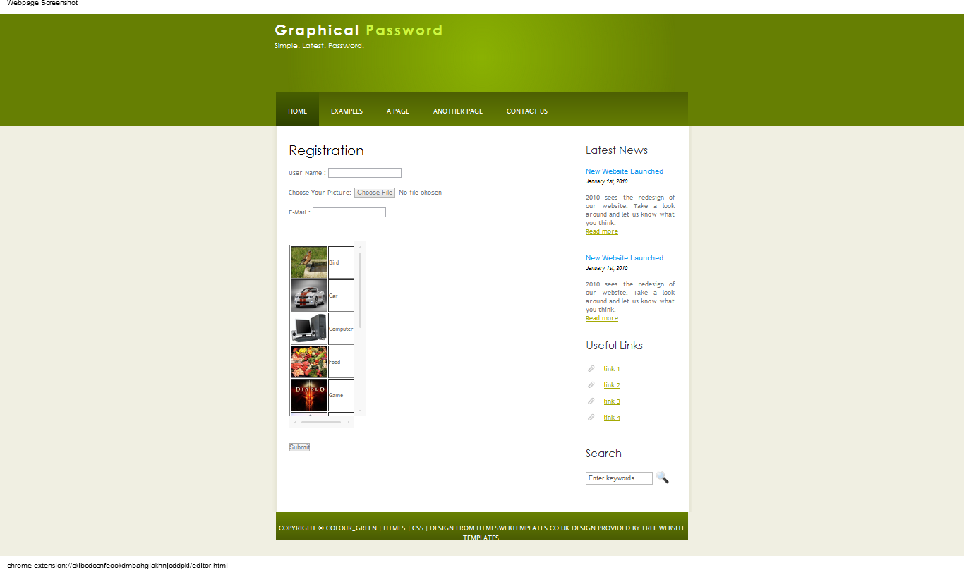

**Figure B.1:** *Brief description of the screenshot/interface.*

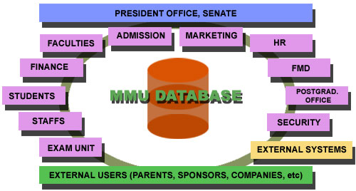

**Figure B.2:** *Brief description of the screenshot/interface. Only for example*

* 1. **PROJECT 2: MULTIMEDIA PRESENTATION [ Example]**
     1. **Description of project**

This section describes the project the student is involved in. Students may describe the project in terms of when it was initiated, how it began, requirements gathering, difficulty level, what the main objectives of the project are and etc. Describe the architecture, how many modules the project has, what are the hardware/software requirements of the system, etc, whichever that is applicable.

* + 1. **Roles and responsibilities**

Although all the sections need to be covered, emphasis should be given to the portion of the project the student was involved in this has to be highlighted. For *example*, students might be involved in one or more sections/areas of project such as:

* Planning- Ex: Initiation/Feasibility studies, project management activities
* Analysis – Ex: Interviews with clients/users, research on current/proposed framework or technology, analyze documents, etc
* Design – Ex : Create diagrams pertaining to the design (ERD, DFD), layout of the website, design web templates, multimedia presentations
* Coding – Ex: Create web pages with back-end scripting (JAVA, PHP/ASP, etc) or front-end scripting (Javascript, JQuery, etc), or any other involvement of programming language (Python, Crystal Reporting, Visual Basic, etc) or scripting languages.
* Maintenance – Ex: Data entry, update documentation, modification to current system in terms of settings, colors, fixing bugs, troubleshooting.
  + 1. **Screen shot**

*(Suitable snapshot of the developed system)*

**3.3 TASK 3: DOCUMENTATION/DATA ENTRY [ Example]**

* + 1. **Description of task**

This section describes the task the student is involve in (ex: How often the student work on the tasks, start date, end date) and any other area pertaining to the tasks such as what software/hardware is used, report format, etc.

* + 1. **Roles and responsibilities**

Describe main roles and responsibilities for the task. Although all the sections need to be covered, emphasis should be given to the portion of the task the student was involved in this has to be highlighted. For example, students might be involved partly of fully on the task.

* + 1. **Screen shot**

*(Suitable snapshot of the task)*

**PART 4: Training Analysis**

* 1. **Strength and weaknesses**

This section describes the self assessment of students’ strength and weaknesses and how they can improve themselves. Discuss subjects taught at the university which were helpful during the training. Discuss the problems you faced during the training.

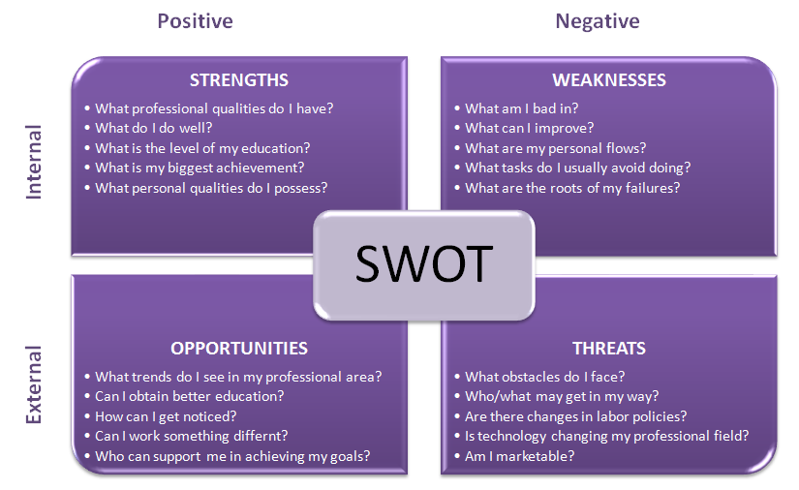

* 1. **Knowledge/skills gained**

This section describes new knowledge or skills learned during the training including communications skills, learning new software, setting up new hardware, troubleshooting, handling new products/technologies, or learning new programming languages.

* 1. **Suitability of placement**

In this section, students express their opinion about the company and how it helps students to improve themselves. Discuss about the suitability of the placement for students to prepare themselves in future working environment.

* 1. **Networking Skills**

This section requires student to interview their colleagues (in the same department or different department) and get their education background. If the colleague is an MMU graduate / MMU alumni, provide their details as below.

|  |  |  |  |  |  |  |
| --- | --- | --- | --- | --- | --- | --- |
| No. | Name | Contact Number | Email Address | Designation  (Department) | MMU Qualification/  Professional membership | Year of graduation |
| 1. |  |  |  |  |  |  |
| 2. |  |  |  |  |  |  |
| 3. |  |  |  |  |  |  |
| 4. |  |  |  |  |  |  |
| 5. |  |  |  |  |  |  |

* 1. **Jobs/Career Opportunities**

This section list the types of IT job positions in the company and what are the company future plans in recruiting IT graduates.

* 1. **Recommendation/ Suggestion**

Write about why did you choose the company and why should other students do the same. Students can give suggestion on what are the criteria for selecting a good company to do their industrial training and suggestion for industrial training in general. What other students should expect and how they should prepare themselves.

**PART 5: APPENDIX**

List of appendixes:

1: Self-Evaluation Form

2: Weekly Logs

3: Attendance report (signed and stamp by company’s supervisor)

4: Source code

5: Reference



STUDENT SELF-EVALUATION FORM

**To be attached in the training report (appendix)**

Instruction: Please tick ( **🗸** ) in the appropriate box.

The following questions will assist us in determining the effectiveness of the overall internship.

*Appraisal Rating Measurements:-*

5 Excellent

4 Very Good

3 Good

2 Satisfactory

1 Unsatisfactory

|  |  |
| --- | --- |
| **Student’s Assessment**  (Through my internship, I can see improvement in…. | How do you rate yourself? |
| 1.English communication skills | 1 2 3 4 5 |
| 2.Written skills | 1 2 3 4 5 |
| 3.Punctuality | 1 2 3 4 5 |
| 4.Leadership skills | 1 2 3 4 5 |
| 5.Critical thinking (ability to think clearly and rationally) | 1 2 3 4 5 |
| 6.Self-motivation/initiative | 1 2 3 4 5 |
| 7.Teamwork skills | 1 2 3 4 5 |
| 8.Working under pressure | 1 2 3 4 5 |
| 9.Problem-solving skills | 1 2 3 4 5 |
| 10. Understanding of appropriate codes of practise and industry standards. | 1. 2 3 4 5 |

**5.2 Weekly logs**

*All* ***3 months*** *weekly logs should be* ***signed and stamped*** *by company supervisor*

*\*please attach your original logs*

* 1. **Attendance report (must be signed and stamp by company’s supervisor)**

*Student may request help from HR department to prepare the attendance report or they can make their own (showing the date, time in and out for each day they come to work). It is very important to have the sign and stamp on the attendance report to validate the training.*

*Also, Student must realize that any MC / Leave taken should be replaced because of the need to fulfill industrial training hours.*

* 1. **Source code**

*Only for sample and is OPTIONAL (not needed if student didn’t do any coding or company do not allowed it to be in the report).*

<html>

<head>

<meta http-equiv="content-type" content="text/html;charset=iso-8859-1">

<title>Free Web Template 003 - templateHunter.com</title>

<link href="site.css" rel="stylesheet" media="screen">

</head>

<body bgcolor="#d3c0c7" leftmargin="0" marginheight="0" marginwidth="0" topmargin="0">

<div align="center">

<table width="750" border="0" cellspacing="0" cellpadding="0">

<tr>

<td background="images/header_bg.gif"><img src="images/logo.gif" alt="" height="95" width="385" border="0"></td>

</tr>

<tr>

<td>

<table width="750" border="0" cellspacing="0" cellpadding="0">

<tr>

<td><a href="products.html"><img src="images/maroon_but_products.gif" alt="" height="28" width="73" border="0"></a></td>

<td><a href="services.html"><img src="images/maroon_but_services.gif" alt="" height="28" width="66" border="0"></a></td>

<td><a href="news.html"><img src="images/maroon_but_news.gif" alt="" height="28" width="56" border="0"></a></td>

<td><a href="about.html"><img src="images/maroon_but_about.gif" alt="" height="28" width="67" border="0"></a></td>

<td><a href="contact.html"><img src="images/maroon_but_contact.gif" alt="" height="28" width="78" border="0"></a></td>

<td><a href="index.html"><img src="images/maroon_but_home.gif" alt="" height="28" width="45" border="0"></a></td>

<td><img src="images/maroon_but_spacer.gif" alt="" height="28" width="365" border="0"></td>

</tr>

</table>

</td>

</tr>

<tr height="240">

<td valign="top" bgcolor="white" height="240">

<h1>Headline</h1>

<h2>Subheadline</h2>

<p>This template uses a Cascading Style Sheet to control all formating like font, font color, link color, and more. This makes it very simple to change the look and feel of the site.</p>

<p>This free template is LinkWare. You MUST keep the link to our site on this template.</p>

</td>

</tr>

<tr>

<td>

<table width="750" border="0" cellspacing="0" cellpadding="0">

<tr>

<td><a href="products.html"><img src="images/gray_but_products.gif" alt="" height="28" width="73" border="0"></a></td>

<td><a href="services.html"><img src="images/gray_but_services.gif" alt="" height="28" width="66" border="0"></a></td>

<td><a href="news.html"><img src="images/gray_but_news.gif" alt="" height="28" width="56" border="0"></a></td>

<td><a href="about.html"><img src="images/gray_but_about.gif" alt="" height="28" width="67" border="0"></a></td>

<td><a href="contact.html"><img src="images/gray_but_contact.gif" alt="" height="28" width="78" border="0"></a></td>

<td><a href="index.html"><img src="images/gray_but_home.gif" alt="" height="28" width="45" border="0"></a></td>

<td><img src="images/gray_but_spacer.gif" alt="" height="28" width="365" border="0"></td>

</tr>

</table>

</td>

</tr>

<tr height="60">

<td align="center" bgcolor="#802043" height="60"><font color="#d3c0c7"><br>

</font></td>

</tr>

<tr height="20">

<td align="center" height="20">template designed by <a href="http://www.templatehunter.com/" target="_blank">templateHunter.com</a></td>

</tr>

</table>

</div>

</body>

</html>

* 1. **References**

*Only for sample*

*This is also optional.*

H.M Deitel, P. J. Deitel, T. R. Nieto, (2001). e-Business & e-Commerce How to Program (Fourth Edition), Prentice Hall, 885-914.