

Institute of Technology of Cambodia
Department of Information and Communication

Internet Programming
Group: I4-GIC-A

Name of Students ID of Students Score
1. KHORN VICTOR e20230078 ……….

Topic: Project Proposal
Lecturer: CHUN Thavorac

Academic year 2026-2027

Table of Contents
- Executive Summary
- Purpose and Scope
  - 2.1 Problem Statement
  - 2.2 Proposed Solution
  - 2.3 Target Audience
  - 2.4 Constraints, Assumptions, and Dependencies
- System Architecture & Technology Stack
- Data Management & Entity Design
  - 5.1 Data Entities & Relationships
  - 5.2 Database Schema
- Functional Requirements & User Stories
- Conclusion & Next Steps



1. Executive Summary
The Recipe Sharing Web Application (CookShare) is a full-stack web platform designed to facilitate culinary knowledge exchange among home cooks, culinary enthusiasts, and food creators. The platform allows users to create, document, publish, and explore structured recipes featuring comprehensive ingredient breakdowns, preparation times, difficulty levels, and step-by-step instructions.
To maintain high community standards and ensure content safety, the platform incorporates a role-based moderation system where users can flag inappropriate or hazardous submissions, and moderators can review and hide reported recipes.
The application is engineered strictly adhering to the requirements of the Internet Programming I course at the Institute of Technology of Cambodia (ITC), built with a decoupled architecture utilizing Vue 3 with TypeScript, Vite, and Pinia on the frontend, and NestJS 11 with Prisma ORM and PostgreSQL on the backend.
2. Purpose and Scope
2.1 Problem Statement
Culinary hobbyists frequently encounter disorganized cooking blogs cluttered with advertisements, lengthy personal anecdotes, unstructured ingredient lists, and unverified content. Furthermore, open communities frequently struggle with spam, off-topic posts, or unsafe cooking instructions. There is a need for a clean, structured, community-driven recipe application that emphasizes standardized recipe formatting, swift ingredient-based querying, and community moderation.
2.2 Proposed Solution
The CookShare web application provides:
- A standardized recipe composition interface (title, description, prep/cook time, difficulty, category, ingredients with units, and step-by-step instructions).
- Fast keyword search, category filtering, and paginated browsing.
- Secure, token-based authentication (JWT) with password hashing (bcrypt).
- A robust moderation pipeline: members can report problematic recipes with specific rationale, and moderators have dedicated controls to inspect reports and hide/unhide posts.
- A fully responsive, accessible Single Page Application (SPA) communicating over a typed RESTful API.

2.3 Target Audience
Home Cooks & Food Enthusiasts (Member): Individuals seeking to document their favorite dishes, discover new meal ideas, and share cooking techniques.
Administrators: Community curators responsible for inspecting reported content, enforcing guidelines, and keeping the platform clean.
2.4 Constraints, Assumptions, and Dependencies
Architectural Constraints:
- Frontend must be built with Vue 3, TypeScript, Vite, and Pinia.
- Backend must be built using NestJS 11 with TypeScript.
- Database PostgreSQL managed through Prisma ORM.
Dependencies:
- Node.js runtime (v20+ LTS recommended).
- PostgreSQL 15+ database instance.
- Automated testing tools: Jest, Supertest, and Vitest.

3. System Architecture & Technology Stack
The system follows a modern decoupled Client-Server architecture:
- Client Tier: Vue 3 Single Page Application (SPA) served via Vite. Handles UI rendering, local client-side validation, routing guards, and state management.
- Server Tier: NestJS 11 modular REST API. Implements business logic, request validation pipes, authentication guards, and role-based authorization.
- Data Tier: PostgreSQL relational database accessed exclusively through the Prisma ORM query engine and migration toolkit.

4. Data Management & Entity Design
4.1 Data Entities & Relationships
The application defines four core related entities satisfying and exceeding the course requirement of at least 3 related entities with 1:N relations:
- User: Represents registered members and moderators.
- 1:N with Recipe (Author)
- 1:N with RecipeReport (Reporter)
- 1:N with Review (Reviewer)
- 1:N with Favorite (Saved recipes)
- 1:N Self-Referencing with Follow (as follower and following)
- Recipe: Central entity of the platform.
- N:1 with User (Author)
- N:1 with Category (Normalized classification)
- 1:N with Ingredient (Itemized ingredients)
- 1:N with RecipeStep (Ordered step-by-step preparation)
- 1:N with RecipeTag (Many-to-Many junction with Tag)
- 1:N with Review (Feedback and ratings)
- 1:N with Favorite (Bookmark count)
- 1:N with RecipeReport (Moderation flags)
- Category: Formal recipe classification (e.g., "Soup", "Dessert", "Khmer Cuisine").
- 1:N with Recipe.
- Ingredient: Structured quantity, unit, and item linked to a recipe.
- N:1 with Recipe.
- RecipeStep: Sequenced instructions with ordered position numbers.
- N:1 with Recipe.
- Tag & RecipeTag: Cross-cutting dietary and lifestyle labels (e.g., "vegan", "spicy", "quick").
- M:N between Recipe and Tag via junction table RecipeTag.
- Review: Ratings (1–5) and optional text comments.
- N:1 with User and N:1 with Recipe (Unique compound constraint: 1 review per user per recipe).
- Favorite: Direct bookmarking junction.
- N:1 with User and N:1 with Recipe (Compound primary key).
- Follow: Social graph tracking follower-creator connections.
- N:1 with User (Follower) and N:1 with User (Following).
- RecipeReport: Content moderation tickets for inappropriate submissions.
- N:1 with Recipe and N:1 with User.
4.2 Database Schema
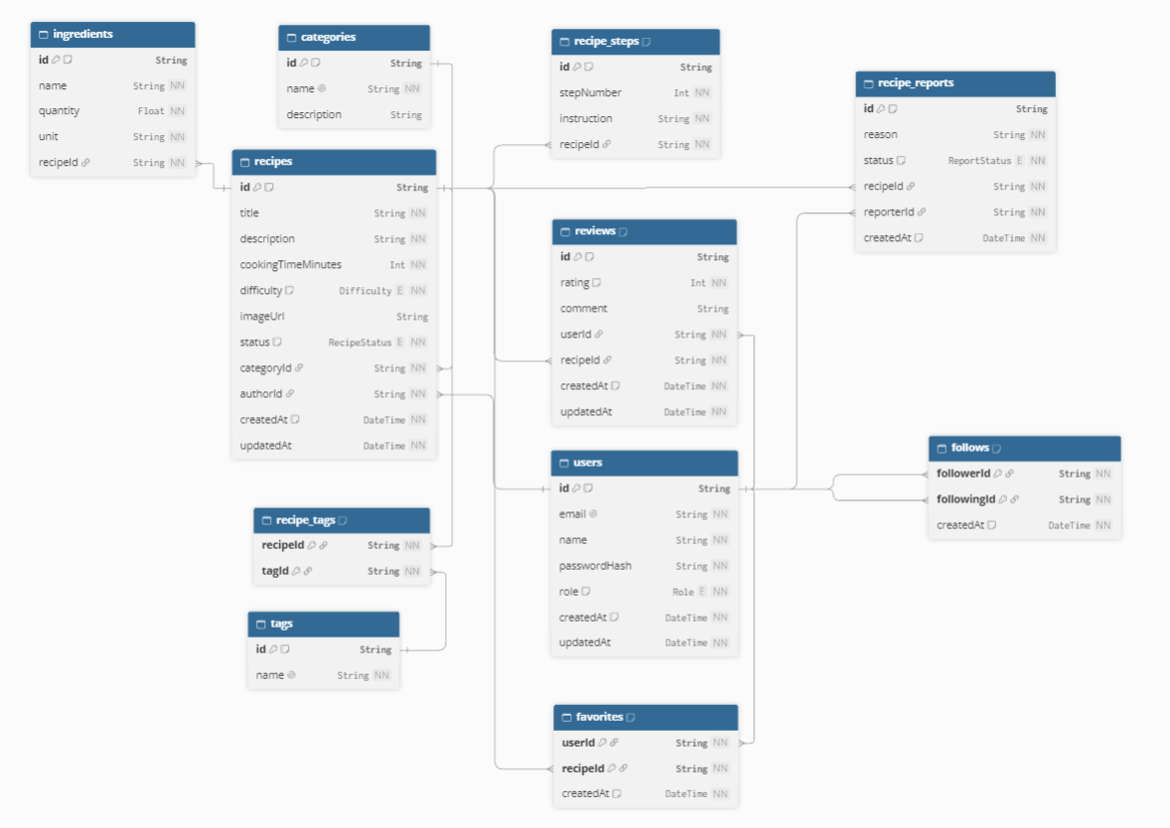
Reference: https://dbdiagram.io/d/RecipeSharing-6a13bd3eb62396d22c5d57c1

5. Functional Requirements & User Stories
Feature & Action | Guest | Member | Admin
Browse & Search Published Recipes | Allowed | Allowed | Allowed
Filter by Category & Tags | Allowed | Allowed | Allowed
View Recipe Details, Ingredients & Steps | Allowed | Allowed | Allowed
View Public Reviews & Ratings | Allowed | Allowed | Allowed
Register & Login | Allowed | N/A | N/A
Create New Recipe (with Steps & Ingredients) | Forbidden | Allowed | Allowed
Edit / Delete Own Recipe | Forbidden | Allowed | Allowed
Edit / Delete Other User's Recipe | Forbidden | Forbidden | Allowed
Assign Existing Tags & Category to Recipe | Forbidden | Allowed | Allowed
Create / Manage Master Categories & Tags | Forbidden | Forbidden | Allowed
Submit / Update Rating & Review (1 per recipe) | Forbidden | Allowed | Allowed
Delete Any User's Inappropriate Review | Forbidden | Forbidden | Allowed
Bookmark Recipe to Favorites (Add / Remove) | Forbidden | Allowed | Allowed
Follow / Unfollow Other Creators | Forbidden | Allowed | Allowed
Submit Inappropriate Recipe Report | Forbidden | Allowed | Allowed
View Moderation Report Queue | Forbidden | Forbidden | Allowed
Hide / Restore Reported Recipe | Forbidden | Forbidden | Allowed
Dismiss / Resolve Content Reports | Forbidden | Forbidden | Allowed

6. Conclusion & Next Steps
This project proposal establishes a complete, robust, and verifiable software requirements specification for the Recipe Sharing Web Application (CookShare). By uniting a modern, reactive user interface (Vue 3, Vite, Pinia) with an enterprise-grade backend architecture (NestJS 11, Prisma, PostgreSQL), the project fulfills all individual project criteria mandated by the Department of Information and Communication Engineering at ITC.
Github:
- Frontend: https://github.com/KhornVictor/ip1-e20230078/tree/frontend
- Backend: https://github.com/KhornVictor/ip1-e20230078/tree/backend

