CSV209:APPLICATION CONTAINERIZATION LAB

SUBMITTED BY - KHOSBAYAR BAATARSAIKHAN

SUBMITTED TO – UTKARSH AGARWAL

ASSIGNMENT NUMBER - 1

REGISTRATION NUMBER – 12222747

SECTION – K22XR

ROLL NUMBER – 17

**✅ 1. Docker Installation (10 Marks)**

**🔧 a. Install and Configure Docker (6 Marks)**

* I downloaded Docker Desktop from the official website and installed it on my Windows machine.
* Docker Desktop was launched successfully, and the whale icon appeared in the system tray showing “Docker is running.”

**Verification:**

* I used the following commands to verify Docker installation:

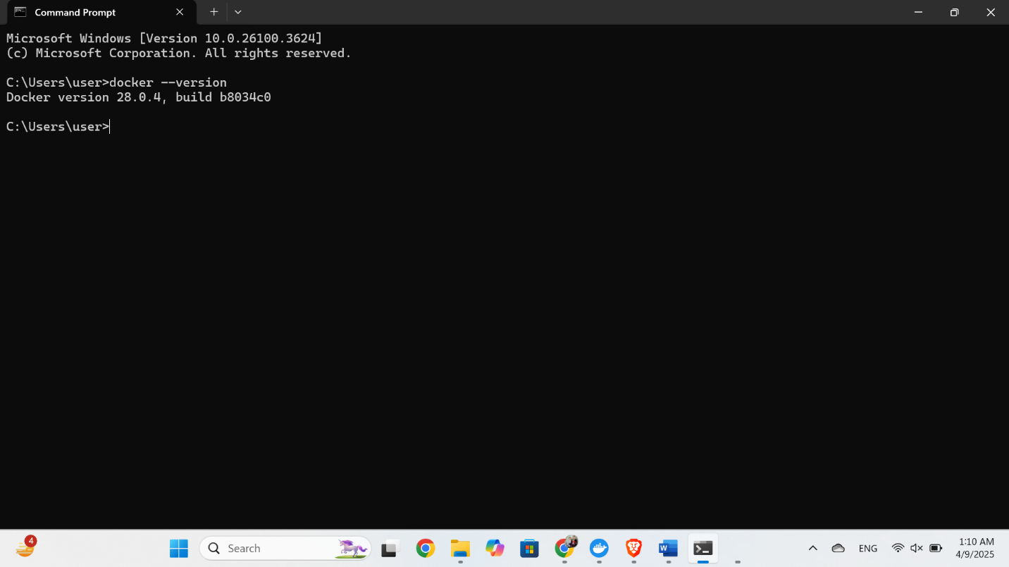

**b. Post-Installation Steps (4 Marks)**

* Docker Desktop does not require sudo on Windows.

**Issues Faced:**

* Initially received: Unable to find image 'hello-world:latest' locally.
* Docker then automatically pulled it from Docker Hub and ran successfully.

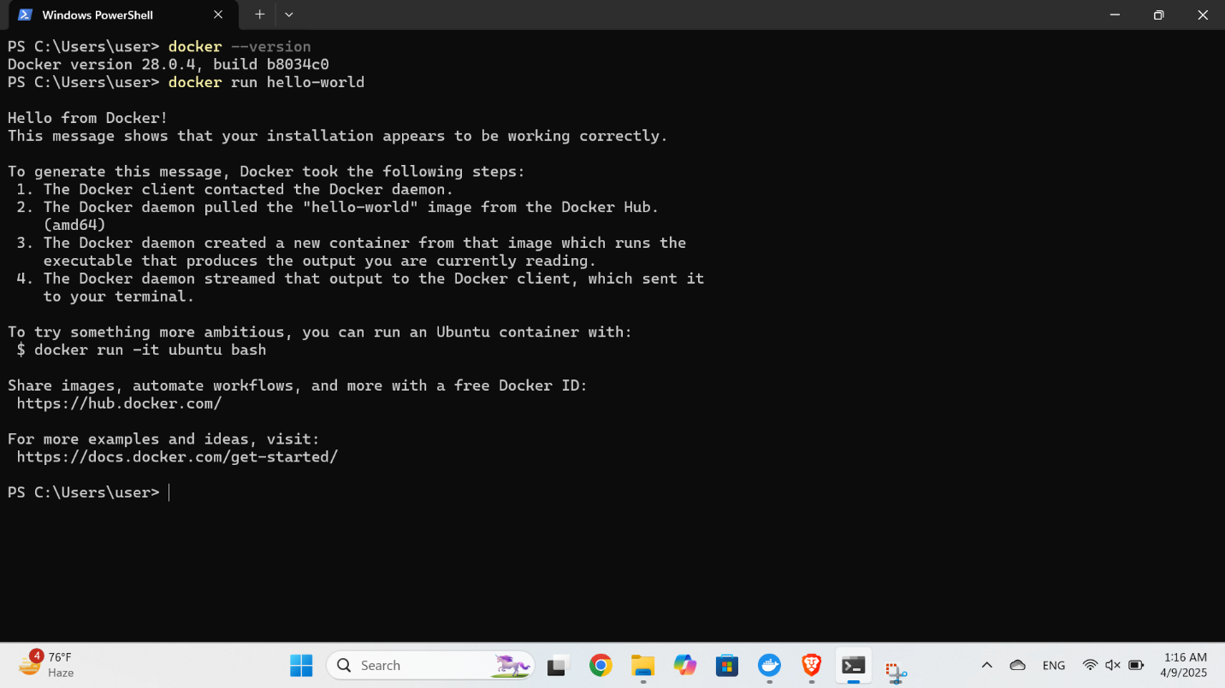

**✅ 2. Pulling and Running Docker Images (10 Marks)**

**📥 a. Pull a Base Image (4 Marks)**

* I pulled the official Ubuntu image using:

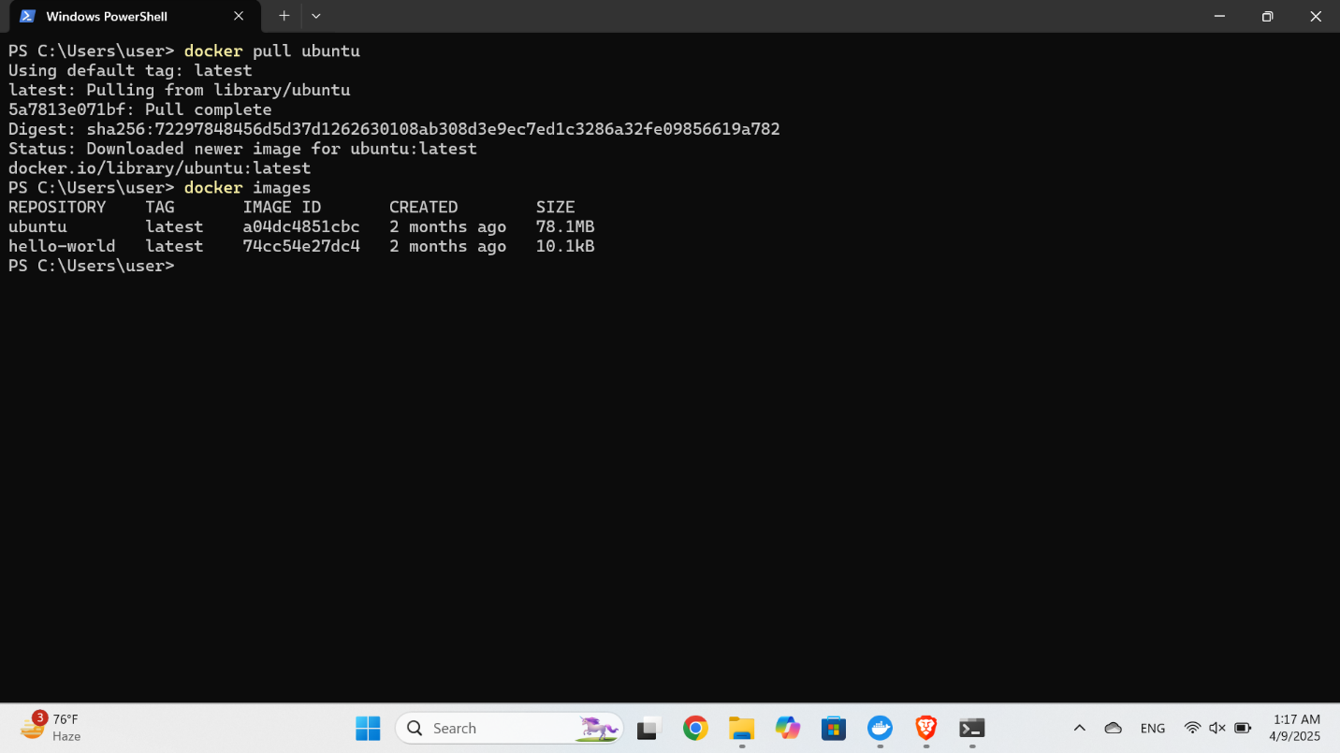

**🏃 b. Running Containers (6 Marks)**

* I started an interactive Ubuntu container with:

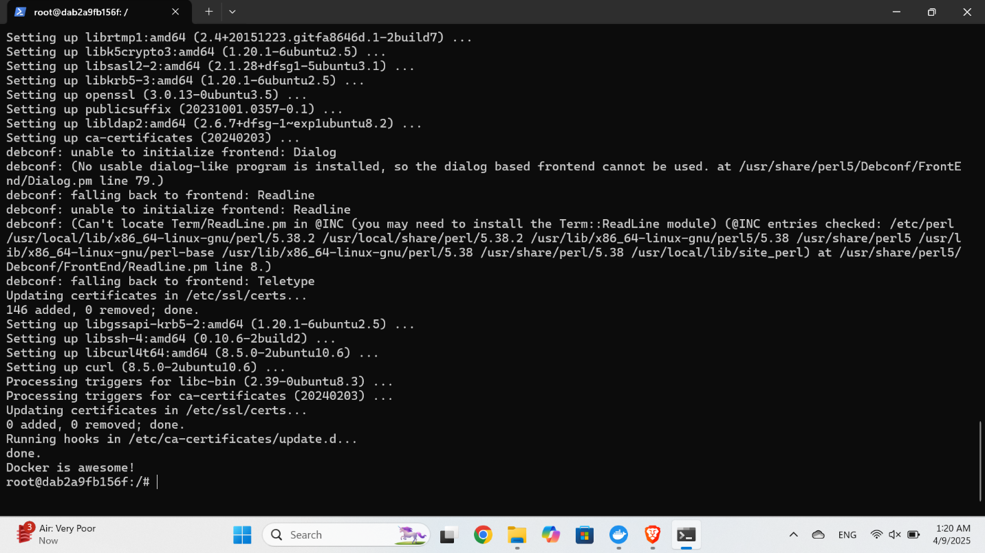

**✅ 3. Basic Container Management (10 Marks)**

**🔍 a. Inspecting Containers (5 Marks)**

* I listed running and all containers using:

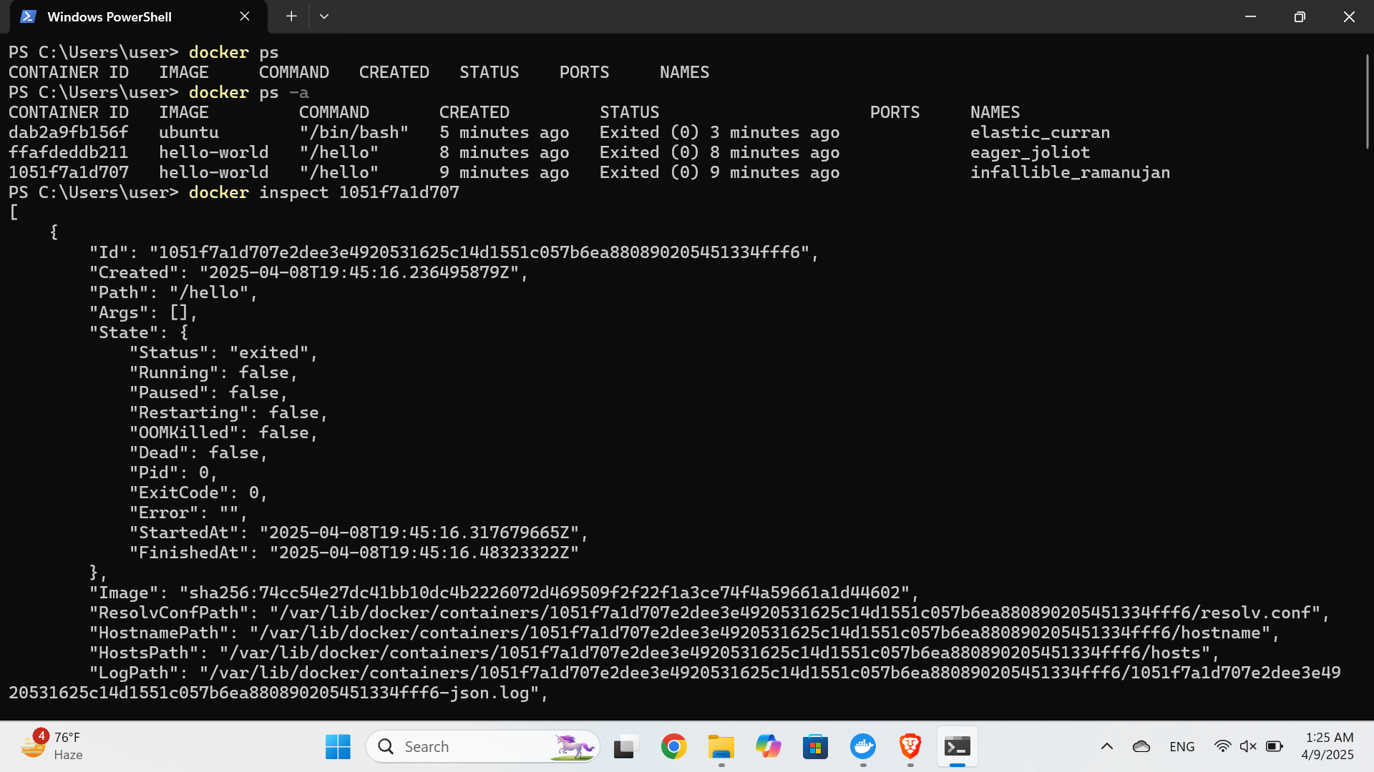

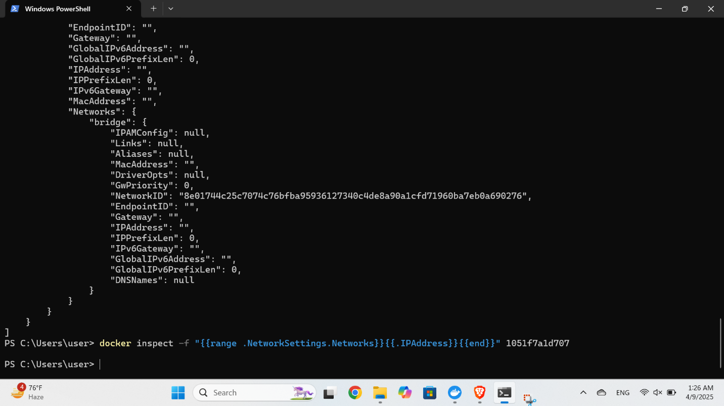

**🧹 b. Cleaning Up (5 Marks)**

* I removed unused containers and images using:

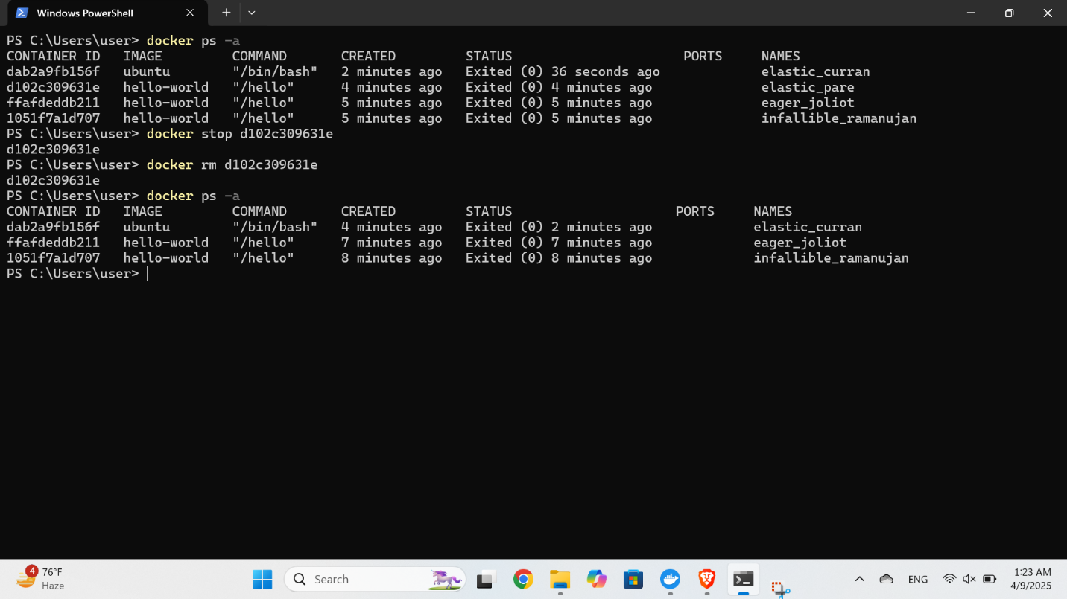

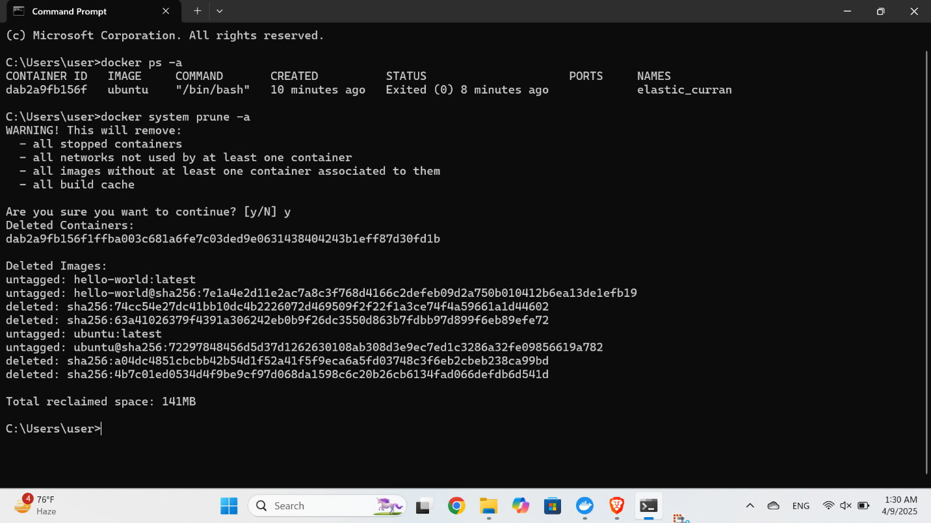

**📦 Final Notes**

This lab helped me understand:

* How to install Docker on Windows
* How to work with images and containers
* Basic Docker commands for container lifecycle management

📁 **Total Screenshots Included:** 8  
✅ **Assignment Completed Successfully**