CSV302:TEST AUTOMATION LAB

SUBMITTED BY - KHOSBAYAR BAATARSAIKHAN

SUBMITTED TO – UTKARSH AGARWAL

ASSIGNMENT NUMBER - 1

REGISTRATION NUMBER – 12222747

SECTION – K22XR

ROLL NUMBER – 17

The objective of this lab is to set up Selenium WebDriver and write a basic script to automate a web browser, interact with web elements, and verify functionality.

**2. Environment Setup**  
**2.1 Installation & Configuration**  
• Installed Python   
• Installed Selenium using pip: pip install selenium  
• Downloaded and configured ChromeDriver (matching browser version)  
• Used Visual Studio Code as IDE

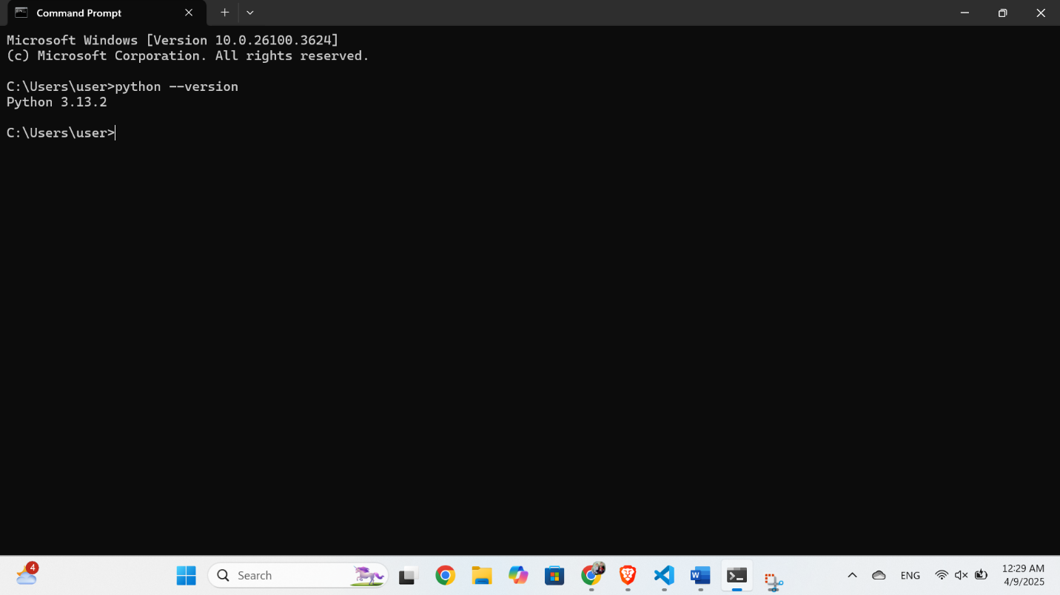

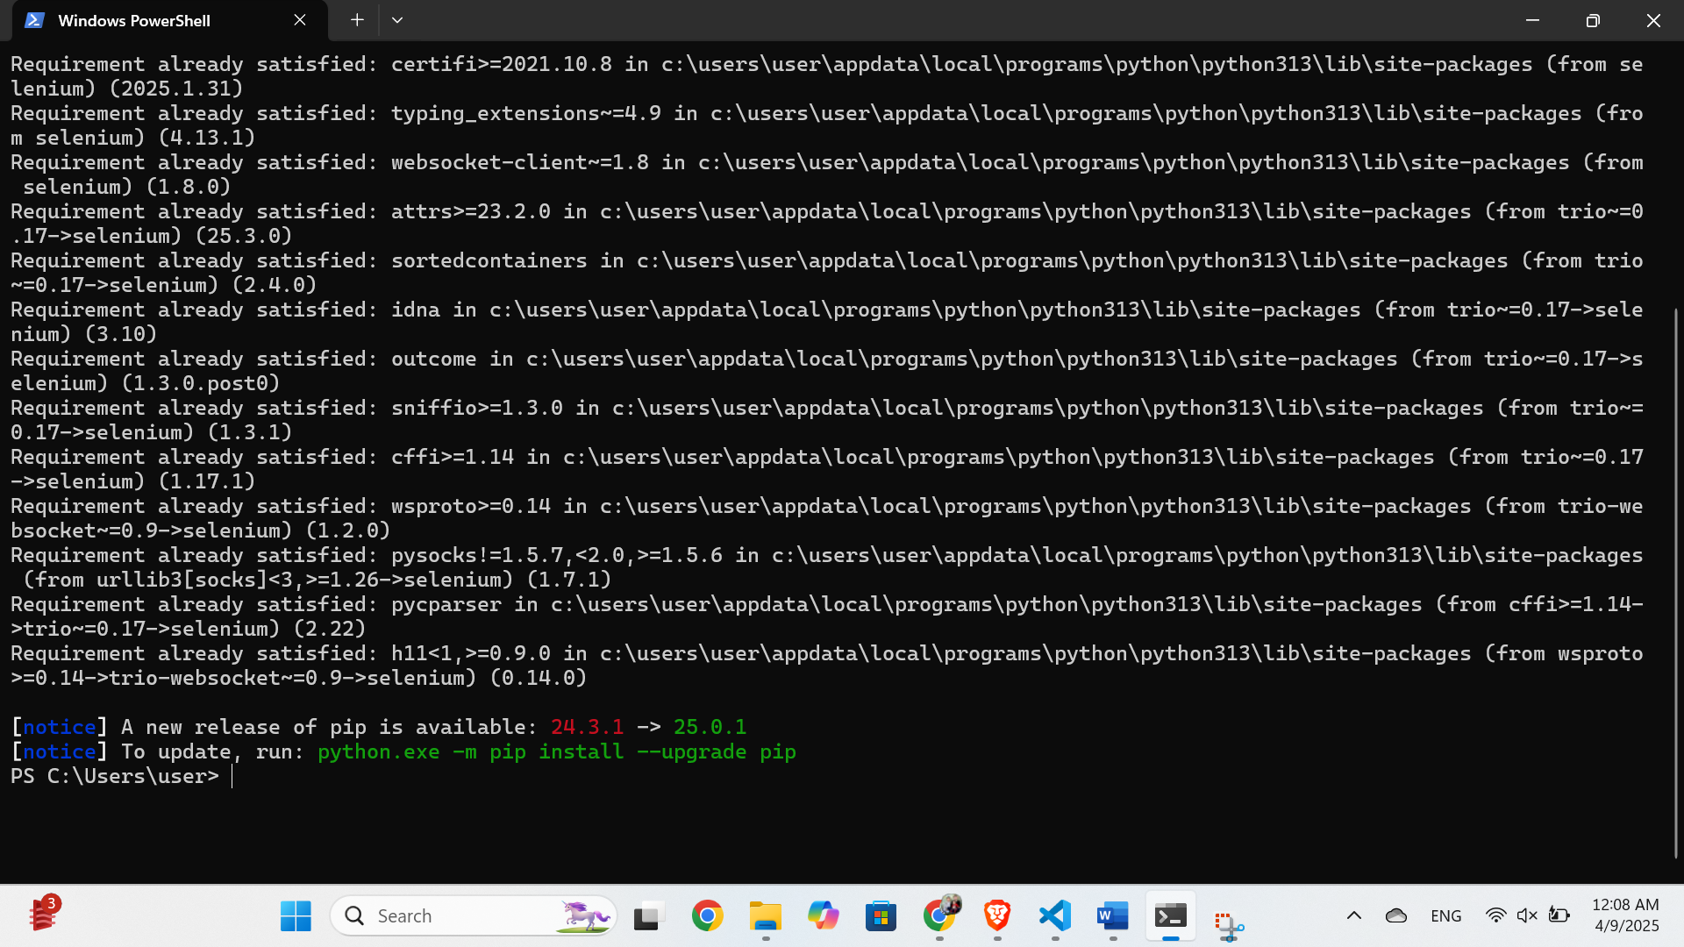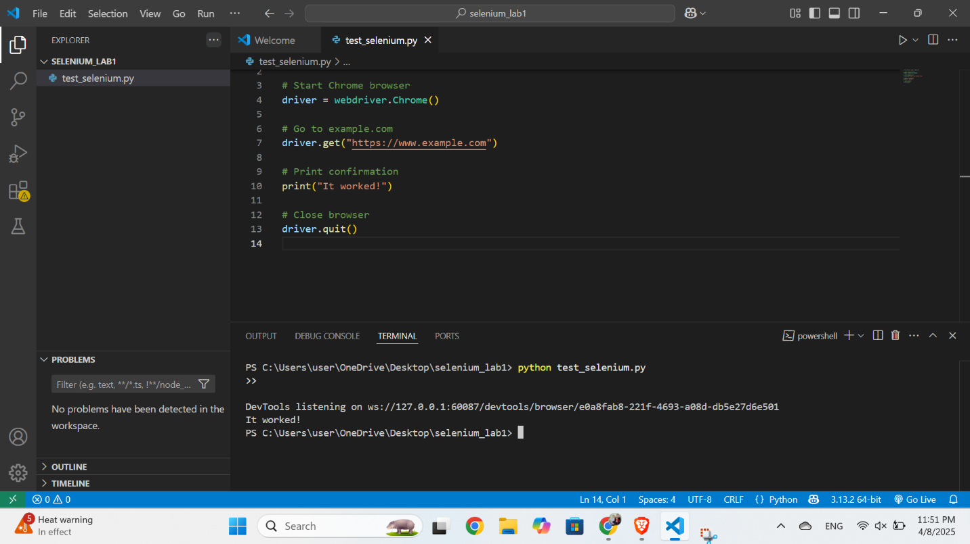

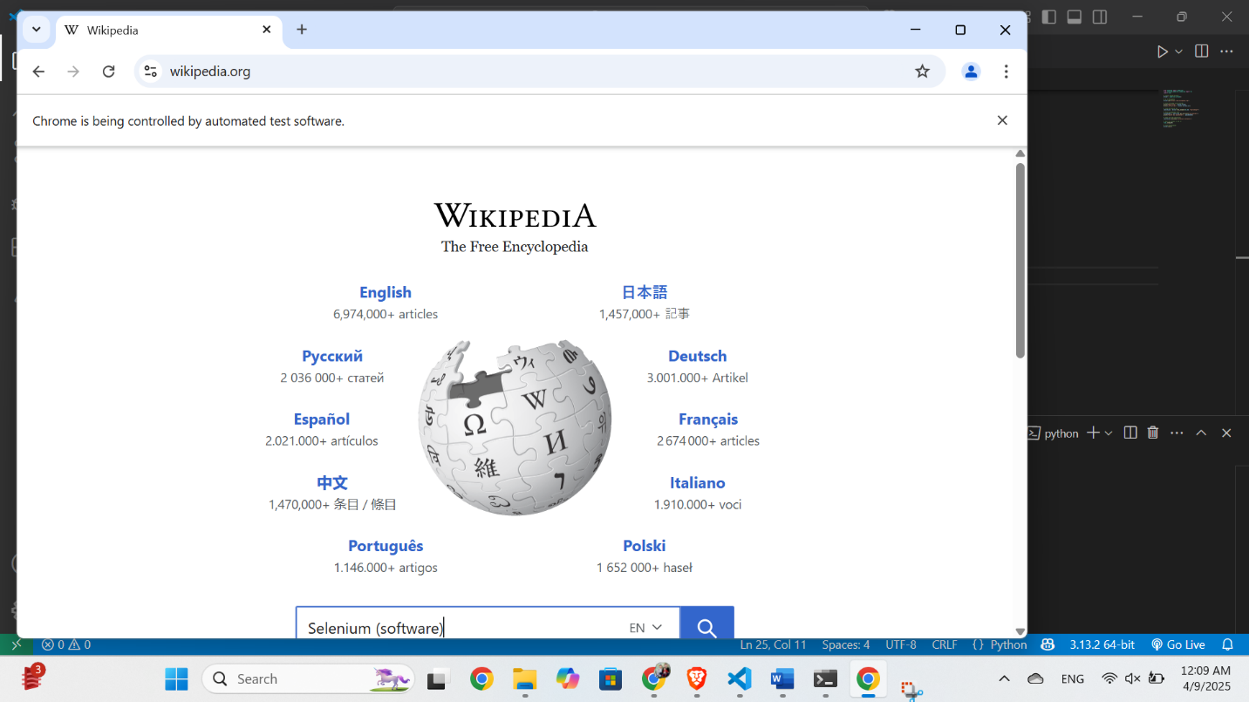

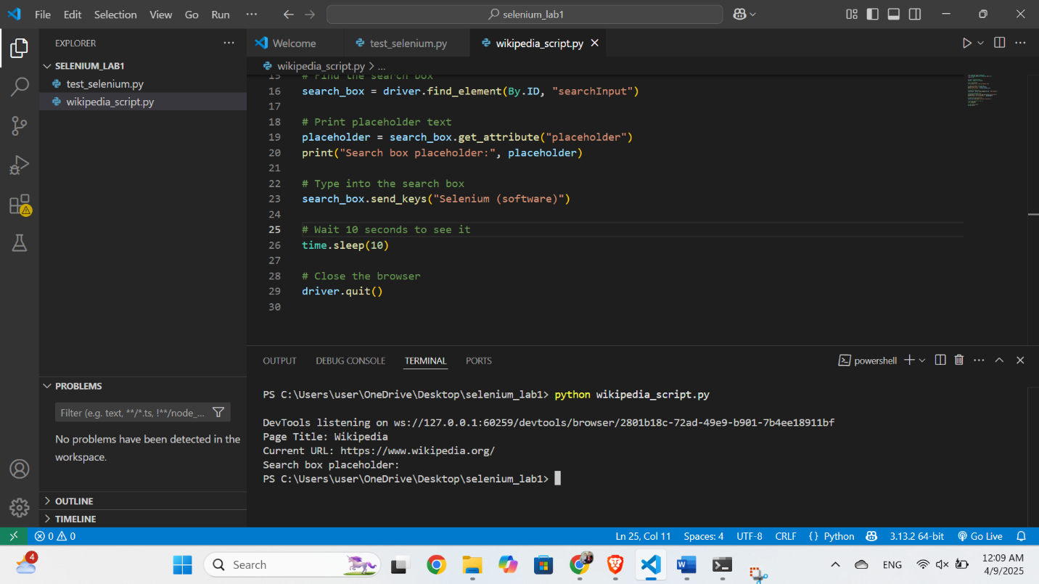

**5. Reflection & Challenges**

Initially, I faced issues with finding the correct version of ChromeDriver matching my browser version. After checking the version at chrome://version and downloading the correct driver, it worked. Locating elements with Selenium was also a bit tricky at first, but using ID made it easier. I learned how to interact with input fields, extract attributes, and automate basic browser actions.

**6. Conclusion**

Through this lab, I successfully installed and configured Selenium WebDriver, wrote a script to open a website, interacted with a web element, and verified the functionality through automation. This helped me understand the fundamentals of test automation using Python and Selenium.