**ASSIGNMENT-18.3**

1. **Merge the small files in Hadoop by following the below blog.**

We can merge the small files in Hadoop by

**Hadoop fs -getmerge -nl <source file path> <local system destination path>**

**Executing Merge Command**

**Source path- /user/merge/**

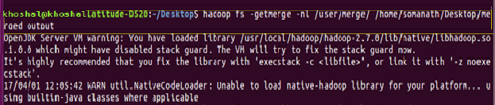

Local system Destination path - /home/Khoshal/Desktop/merged_output-nl is Optional and is used for adding new line in result

**INPUT:**

File to be merged and its Content are listed by ls command and displayed by cat

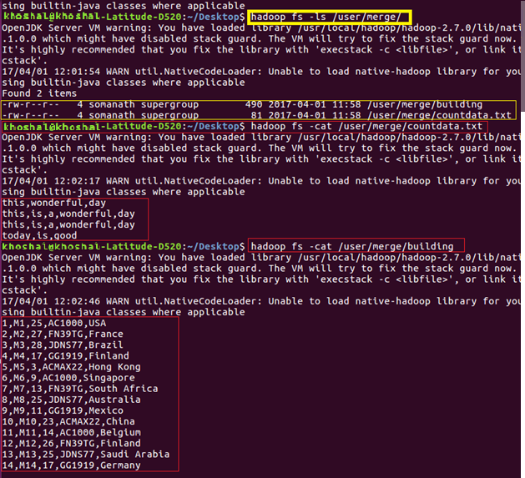

**Output:**

**Inference:** The small files in Input are merged in the output folder

