1. **Java program to display the content of a file in HDFS on screen**

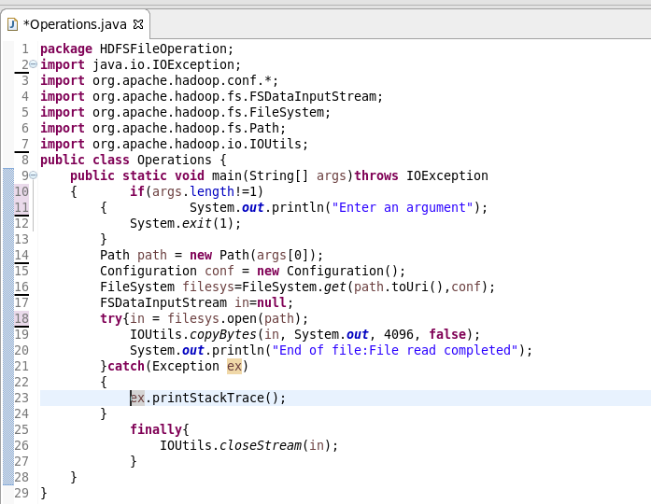

**Output:**

