1. **Java program to copy a file from local file system to HDFS**

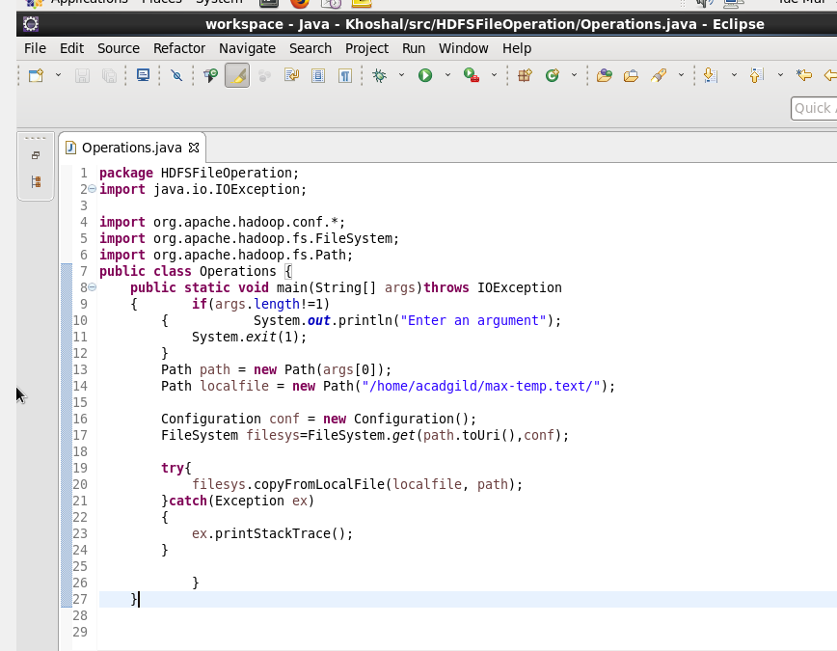

**Output:**

