# Assignment7.[5](https://github.com/SomanathSankaran/assmt7.5)

Write a map only job for the word count program and set the output format as sequence file.

**DRIVER:**

IN Driver class as It is a map only job set num reduce tasks to zero

Then set output file format as Sequence Output File format.

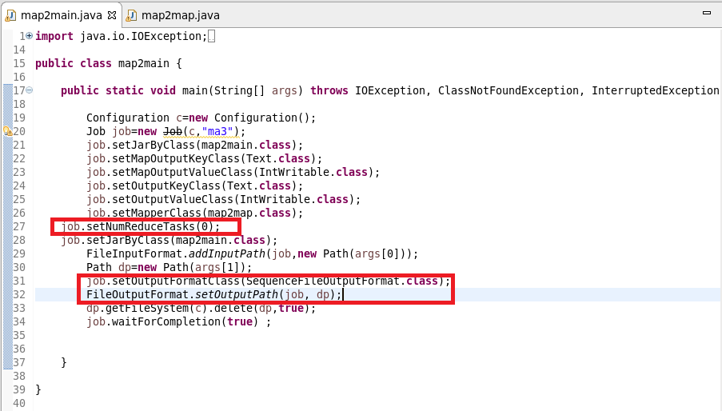

**MAPPER CLASS:**

In mapper class I used a hashmap and updated it in such a way that if the word repeats I will increase the count by 1 and put it in hash map or else give a value of 1

Cleanup Method: Override the clean method and write the final key and value instead of writing in mapper as mapper will be invoked for each line

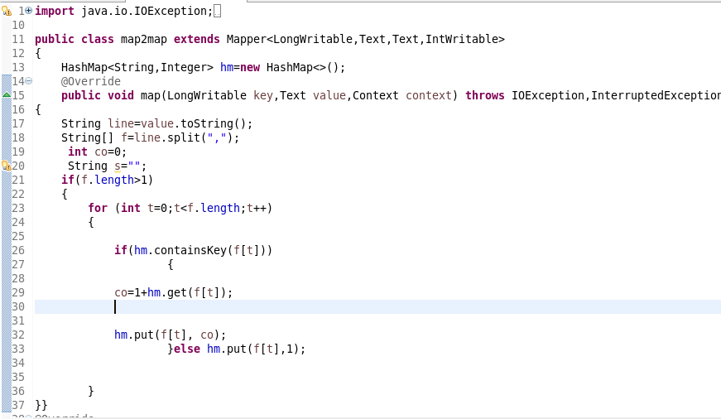

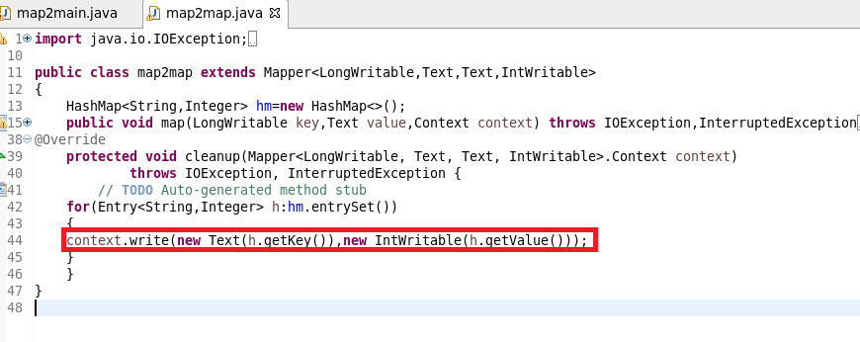

**RUNNING JAR:**

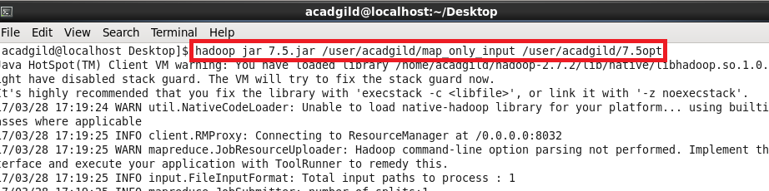

**OUTPUT:**

**USED TEXT COMMAND TO OPEN SEQUENCE FILE**

