**ASSIGNMENT8.1**

1. **Write a mapreduce program to find the total amount of petrol in volume sold by every distributor.**

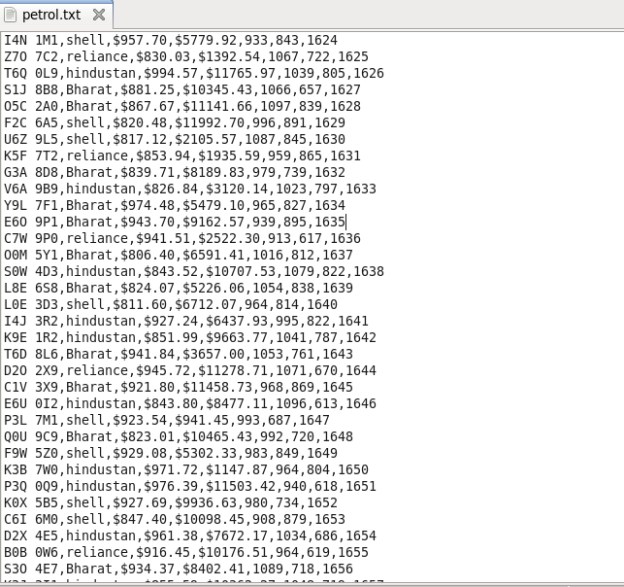

**DRIVER CLASS:**

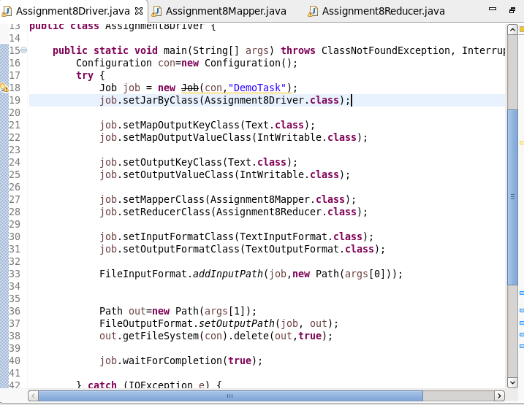

**MAPPER:**

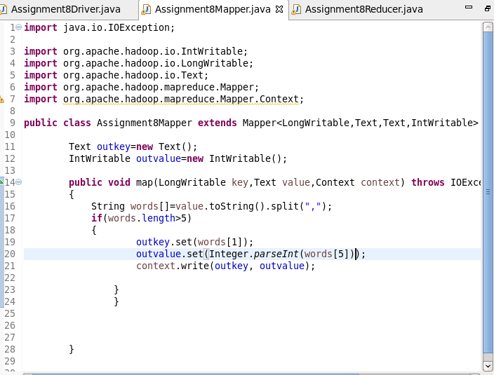

**REDUCER:**

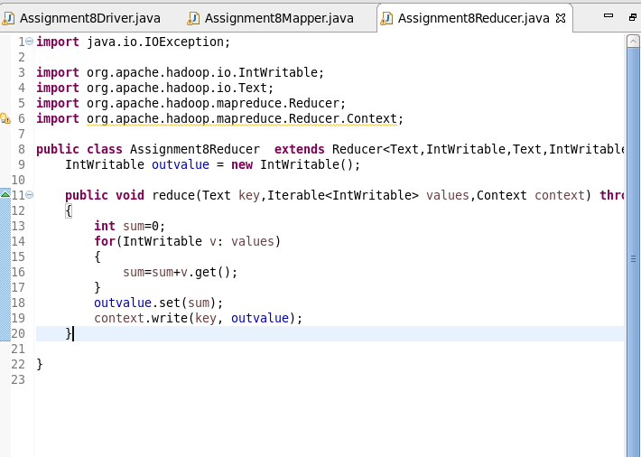

**OUTPUT:**

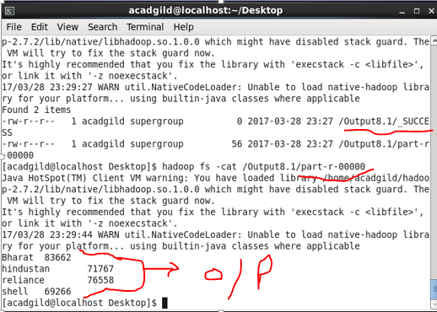

1. **Write a mapreduce program to find which are the top 10 distributors ID's for selling petrol and also display the amount of petrol sold in volume.**

**DRIVER class:**

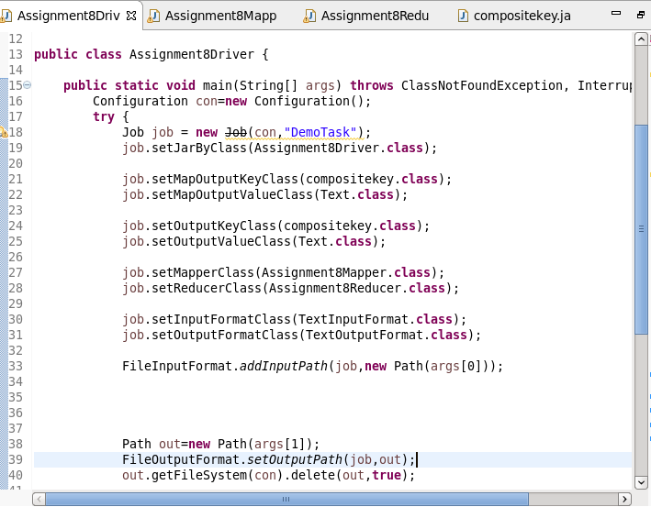

**MAPPER class:**

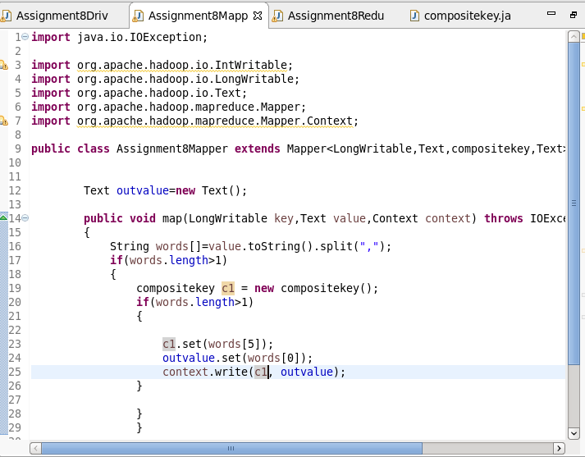

**REDUCER:**

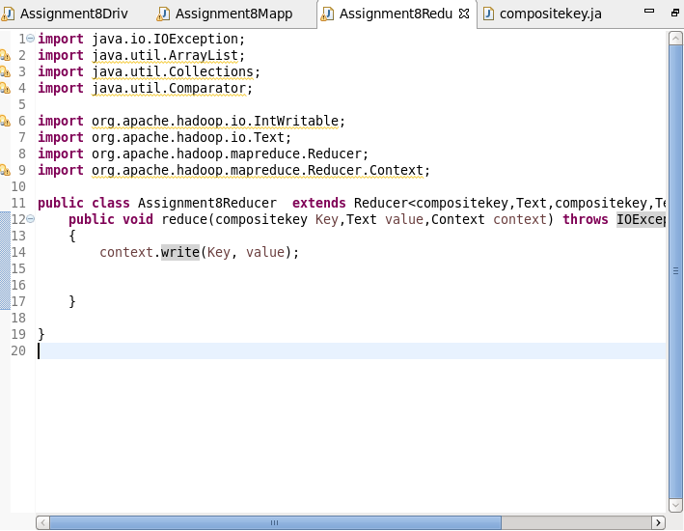

**COMPOSITE KEY:**

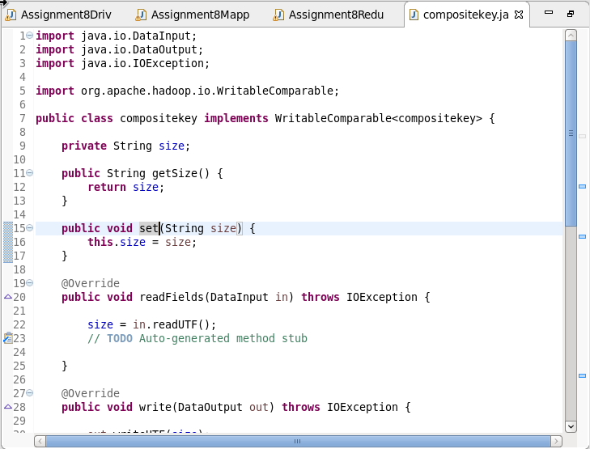

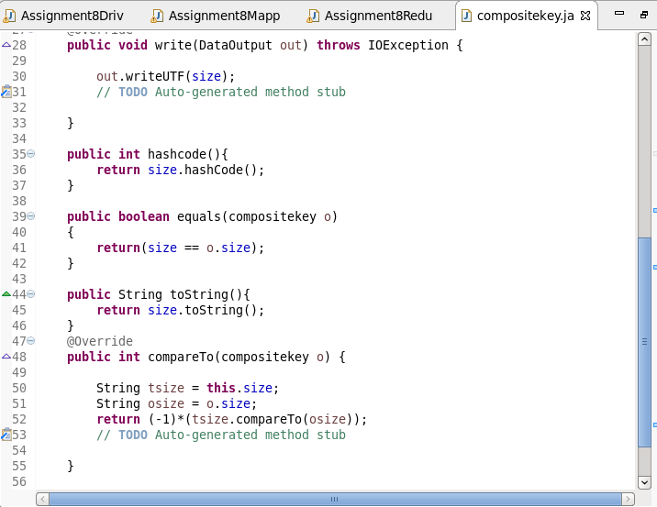

**OUTPUT:**

