COURSEWORK SUBMISSION FORM
STUDENT USE |  | STAFF USE
Module Name | Fundamentals of Statistics | First Marker’s  (acts as signature)
Module Code | 4ECON006C | Second Marker’s  (acts as signature)
Lecturer Name | Olmas Isakov | Agreed Mark
UoW Student IDs |  | For Registrar’s office use only (hard copy submission)
WIUT Student IDs | 00007717
Deadline date | March 17th
Assignment Type | GroupIndividual
Deleted numbers | 13, 39

SUBMISSION INSTRUCTIONS

COURSEWORKS must be submitted in both HARD COPY (to the Registrar’s Office) and ELECTRONIC unless instructed otherwise.
For hardcopy submission instructions refer to: http://intranet.wiut.uz/Shared%20Documents/Forms/AllItems.aspx - Coursework hard copy submission instructions.doc
For online submission instructions refer to: http://intranet.wiut.uz/Shared%20Documents/Forms/AllItems.aspx - Coursework online submission instructions.doc

MARKERS FEEDBACK (Continued on the next page)

Exercise 1
a)
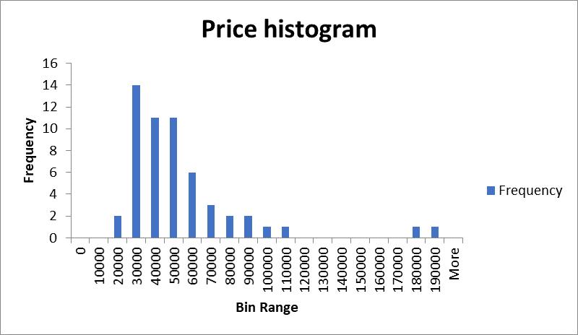

Price ($)
Mean | 48754.45
Standard Error | 4423.82
Median | 40500
Mode | 33000
Standard Deviation | 32807.92
Sample Variance | 1.08E+09
Kurtosis | 9.329548
Skewness | 2.774046
Range | 171000
Minimum | 19000
Maximum | 190000
Sum | 2681495
Count | 55
Confidence Level (90.0%) | 7403.549

According to the descriptive statistics and histogram, the distribution for the Price dependent variable is rightly skewed and there are 2 outliners at > 180,000 and 190,000 points. Furthermore, average Price for the houses of given dataset is 48,745$. The most expensive house is 190,000$ while the cheapest is 19,000$. Standard deviation for the dataset is 32,807$. Number of observations is 55.

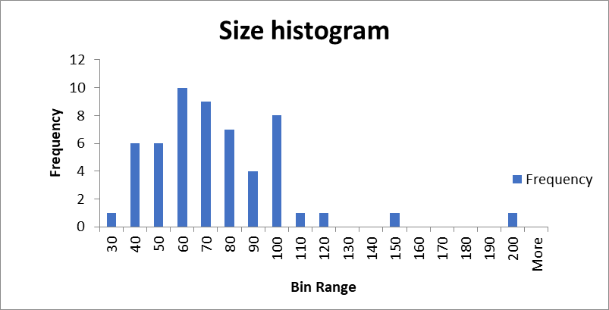
Size (m2)
Mean | 71.29091
Standard Error | 4.007793
Median | 70
Mode | 70
Standard Deviation | 29.72259
Sample Variance | 883.4323
Kurtosis | 5.781677
Skewness | 1.769467
Range | 170
Minimum | 30
Maximum | 200
Sum | 3921
Count | 55
Confidence Level (90.0%) | 6.707302

Histogram and calculations illustrate graphical and numerical summary of the Size independent variable of housing data. According to the histogram one can see that the distribution is non-normal. For the given 55 data mean is equal to 71(m2). Standard deviation is nearly equal to 30. The highest point is 200 and the lowest is 30.

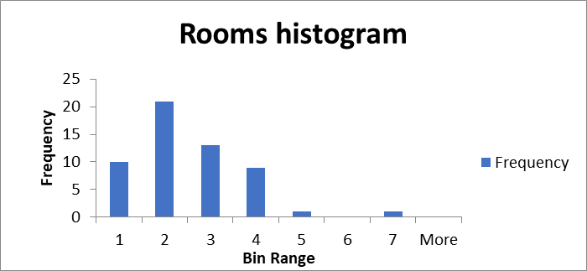
Rooms
Mean | 2.527273
Standard Error | 0.161755
Median | 2
Mode | 2
Standard Deviation | 1.199607
Sample Variance | 1.439057
Kurtosis | 2.188558
Skewness | 1.068855
Range | 6
Minimum | 1
Maximum | 7
Sum | 139
Count | 55
Confidence Level (90.0%) | 0.270707

The distribution of the Rooms independent variable is also rightly skewed and the mean is equal to 2.5 (rooms). The greatest number of rooms for a house is 7 and the least number is equal to 1. Standard deviation is equal to 1.2.

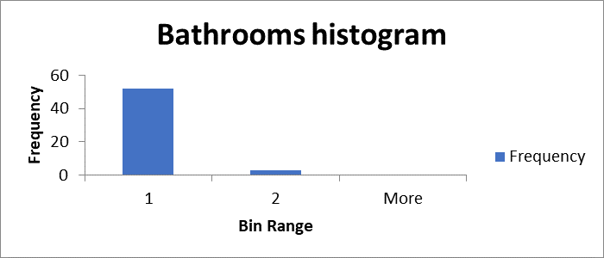
Bathrooms
Mean | 1.054545
Standard Error | 0.030903
Median | 1
Mode | 1
Standard Deviation | 0.229184
Sample Variance | 0.052525
Kurtosis | 14.81076
Skewness | 4.034002
Range | 1
Minimum | 1
Maximum | 2
Sum | 58
Count | 55
Confidence Level (90.0%) | 0.051718

According to dataset almost all the houses have 1 bathroom. Only three of houses have 2 bathrooms.

b)
 | Price ($) | Size (m2) | Rooms | Bathrooms
Price ($) | 1
Size (m2) | 0.768522 | 1
Rooms | 0.568927 | 0.890501 | 1
Bathrooms | 0.49439 | 0.682699 | 0.567024 | 1

According to the correlation table, all independent variables Size, Rooms and Bathrooms variables has positive relationship with dependent Price variable. The factor which has the most significant relationship with price of the house (dependent variable) is size of the house with the coefficient of 0.77. The factor that has the least amount of effect on the price of the house is bathrooms with coefficient of 0.49. Rooms variable has strong positive relationship as well (0.57).
Moreover, the table illustrates stronger relationship (0.89) between Rooms and Size variable rather than other relationships.

c)
General linear model using Size variable: Price(y) = b0 + b1 * Size(x)

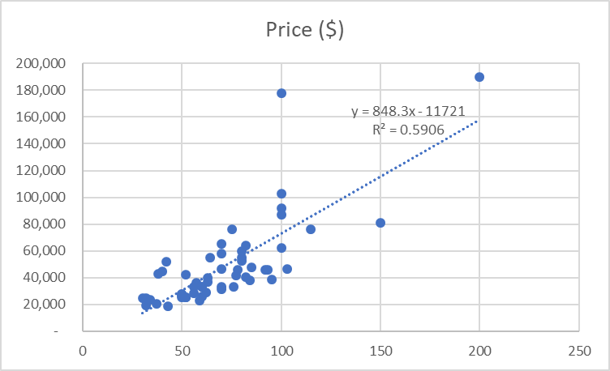

d)
SUMMARY OUTPUT
Regression Statistics
Multiple R | 0.768522
R Square | 0.590626
Adjusted R Square | 0.582902
Standard Error | 21188.38
Observations | 55
ANOVA
 | df | SS | MS | F | Significance F
Regression | 1 | 3.43E+10 | 3.43E+10 | 76.46597 | 7.3785E-12
Residual | 53 | 2.38E+10 | 4.49E+08
Total | 54 | 5.81E+10
 | Coefficients | Standard Error | t Stat | P-value | Lower 95%
Intercept | -11721.5 | 7482.8 | -1.56646 | 0.123194 | -26730.0708
Size (m2) | 848.2979 | 97.0095 | 8.744482 | 7.38E-12 | 653.721483

Estimated regression coefficients:
b0 (the intercept or estimate of β0) = -11,721
b1 (the slope of Size variable or estimate of β1) = 848.3
e)
b0 = -11,721 >>>>>> b0 < 0
The estimate of β0 is negative, so we cannot give interpretation for b0 in this situation.

b1 = 848.3
It tells us that, on average, the mean of the dependent Price variable increases by 848.3$ per 1 unit (m2) increase of the independent Size variable.

f)
Stating hypotheses:
H0: β1 = 0 or there is no significant relationship between Size and Price.
Ha: β1 ≠ 0 or there is significant relationship between Size and Price.

Rejection Region:
If t-stat >= t-crit we reject H0
Else we fail to reject H0

t-crit = | 1.674116
t-stat = | 8.744482

t-stat > t-crit, so we reject null hypotheses (H0).

Conclusion: Hence, we reject H0, we can conclude that there is significant relationship between Size and Price.

Exercise 2
a)
General linear model:
Price(y) = β0 +β1*Size(x1) + β2*Rooms(x2) + β3*Masonry(x3) + β4*Chilanzar(x4) + β5*Sergeli(x5) + β6*Mirabad(x6) + ε

Fitted linear model:
Price(y) = b0 +b1*Size(x1) + b2*Rooms(x2) + b3*Masonry(x3) + b4*Chilanzar(x4) + b5*Sergeli(x5) + b6*Mirabad(x6)

b)

SUMMARY OUTPUT
Regression Statistics
Multiple R | 0.876707
R Square | 0.768615
Adjusted R Square | 0.739692
Standard Error | 16738.74
Observations | 55
ANOVA
 | df | SS | MS | F | Significance F
Regression | 6 | 4.47E+10 | 7.45E+09 | 26.57438 | 1.09096E-13
Residual | 48 | 1.34E+10 | 2.8E+08
Total | 54 | 5.81E+10
 | Coefficients | Standard Error | t Stat | P-value | Lower 95%
Intercept | -21112.6 | 8525.978 | -2.47626 | 0.016854 | -38255.1909
Size (m2) | 1198.465 | 197.7252 | 6.061264 | 2.02E-07 | 800.9116065
Rooms | -8117.77 | 4769.98 | -1.70185 | 0.095254 | -17708.4606
Masonry | -6814.18 | 5048.909 | -1.34963 | 0.183464 | -16965.6946
Chilanzar | 9203.252 | 7009.6 | 1.31295 | 0.195442 | -4890.49217
Sergeli | -9045.32 | 6945.09 | -1.30241 | 0.198993 | -23009.3592
Mirabad | 25085.91 | 6940.799 | 3.614268 | 0.00072 | 11130.49945

Estimate for intercept (b0) and partial slopes (b1, b2, b3, b4, b5, b6)

b0 (intercept) = | -21112.6
b1 (Size) = | 1198.465
b2 (Rooms) = | -8117.77
b3 (Masonry) = | -6814.18
b4 (Chilanzar) = | 9203.252
b5 (Sergeli) = | -9045.32
b6 (Mirabad) = | 25085.91

c)
Adjusted R square = 0.74
74% of variability in Price is explained by this model.

d)
Test for overall significance
Stating hypotheses:
H0: β1=β2=β3=β4=β5=β6=0
Ha: at least one of the parameters is equal to 0.

Rejection region:
If p-value <= α we reject H0
Else we fail to reject H0

p-value = 1.09095991870139E-13
α = 0.01

p-value < α >>>>>>> We reject H0
Conclusion: in this case p-value is less than α value, so we may conclude that overall model is significant for predicting the price of the house.

e)

Test for significance of partial slope of Size
Stating hypotheses:
H0: β1 = 0
Ha: β1 ≠ 0

Rejection region:
If p-value (Size) <= α we reject H0
Else we fail to reject H0

p-value (Size) = 2.02125657973017E-07
α = 0.01

p-value < α >>>>>>> We reject H0
Conclusion: in this model p-value for Size is less than α value, so we may conclude that there is significant relationship between size and price of the house.

Test for significance of partial slope of Rooms
Stating hypotheses:
H0: β2 = 0
Ha: β2 ≠ 0

Rejection region:
If p-value (Rooms) <= α we reject H0
Else we fail to reject H0

p-value (Rooms) = 0.0952536978451363
α = 0.01

p-value > α >>>>>>> We fail to reject H0
Conclusion: in this model p-value for Rooms is less than α value, so we may conclude that there is no significant relationship between rooms and price of the house.
f)
Size(β1) independent variable is statistically significant to predict the price of the house for this model.

Exercise 3
a)
Designated table for two-way ANOVA (number of replications = 2)

 | Masonry | Concrete
Chilanzar | 28,500 | 25,000
 | 33,500 | 28,000
Yunusabad | 58,000 | 42,000
 | 81,000 | 190,000
Mirabad | 76,000 | 103,000
 | 60,000 | 37,000
Sergeli | 33,000 | 38,900
 | 25,700 | 46,500

b)
Stating hypotheses:

Firstly, interaction effect should be checked for the model.

Interaction:
H0: There is no interaction effect between District and Structure variables.
Ha: There is interaction effect between District and Structure variables.

For Structure variable:
H0: Structure type does not influence to the Price.
Ha: Structure type influences to the Price.

For District variable:
H0: District does not influence to the Price.
Ha: District influences to the Price.

Rejection region for all above tests:
If p-value (each variable has its own p-value) <= α we reject H0.
Else we fail to reject H0.
c)
Anova: Two-Factor With Replication
SUMMARY | Masonry | Concrete | Total
Chilanzar
Count | 2 | 2 | 4
Sum | 62000 | 53000 | 115000
Average | 31000 | 26500 | 28750
Variance | 12500000 | 4500000 | 12416667
Yunusabad
Count | 2 | 2 | 4
Sum | 139000 | 232000 | 371000
Average | 69500 | 116000 | 92750
Variance | 2.65E+08 | 1.1E+10 | 4.46E+09
Mirabad
Count | 2 | 2 | 4
Sum | 136000 | 140000 | 276000
Average | 68000 | 70000 | 69000
Variance | 1.28E+08 | 2.18E+09 | 7.7E+08
Sergeli
Count | 2 | 2 | 4
Sum | 58700 | 85400 | 144100
Average | 29350 | 42700 | 36025
Variance | 26645000 | 28880000 | 77915833
Total
Count | 8 | 8
Sum | 395700 | 510400
Average | 49462.5 | 63800
Variance | 4.88E+08 | 3.19E+09
ANOVA
Source of Variation | SS | df | MS | F | P-value | F crit
Sample | 1.06E+10 | 3 | 3.55E+09 | 2.086671 | 0.180394 | 2.923796
Columns | 8.22E+08 | 1 | 8.22E+08 | 0.483857 | 0.506381 | 3.457919
Interaction | 1.54E+09 | 3 | 5.14E+08 | 0.302555 | 0.822919 | 2.923796
Within | 1.36E+10 | 8 | 1.7E+09
Total | 2.66E+10 | 15

Interaction: | p-value (for interaction) = | 0.822919 | α = 0.1 | p-value > α, fail to reject H0
District (Sample): | p-value (for District) = | 0.180394 | α = 0.1 | p-value > α, fail to reject H0
Structure type (Columns): | p-value (for Structure) = | 0.506381 | α = 0.1 | p-value > α, fail to reject H0

Conclusion:
Firstly, test for interaction effect failed to reject null hypotheses, thus we may conclude that there is no interaction effect for this model.
Test for significant relationship between the district and price of the house resulted in failing to reject H0, so we may conclude that there is no significant relationship between them. The same result with the Structure type, there is no significant relationship between structure type and price of the house.

