Jamaica Outing Platform
Special Project Proposal — Expanded Edition
Students: Khrisean Stewart, Anesia Edward
Class: Special Project
Date: June 21, 2026 (Revised August 21, 2026 — as-built OutYah)

Project Overview
This project is a web platform that helps users discover and plan outings across Jamaica. The platform will feature bars, restaurants, nightlife venues, tourist attractions, and recreational activities, organized by parish or available island-wide.
Registered users can browse curated locations — such as Monte Carlo, Devon House, skate parks, arcades, and cinemas — and build outing plans for solo visits or time with friends. Rather than relying on unfiltered map search results, the platform will present approved listings with reliable information, quality images, and tools to plan activities within a specific area.

Problem Statement
Many people struggle to find suitable places to visit when they are outside their home parish. Students and young adults who relocate for school or work often lack local knowledge and have no easy way to identify venues that match their interests.
Existing tools such as Google Maps provide a large volume of unfiltered results, inconsistent photos, and limited context for planning a coordinated outing. Users frequently need to search multiple platforms — for example, Google Maps for locations and Instagram for visuals — only to find that information may be outdated or incomplete. As a result, it is difficult to organize venues into a practical plan for a night out or day trip.

Proposed Solution
The Jamaica Outing Platform will offer a curated directory of venues and activities, giving administrators control over what appears on the site. Each listing will include essential details such as location, contact information, booking options, and high-quality images sourced from curated uploads and Instagram where appropriate.
Users will be able to log in, explore options by parish or category, and create outing plans tailored to a specific area or occasion. An admin portal will allow the team to add venues not listed on Google Maps, update information, and manage which locations are visible to the public.

Key Features
- Discover venues — Browse bars, restaurants, nightlife, tourist sites, and entertainment by parish or across Jamaica
- Curated listings — View approved places with location, images, contact details, and booking information
- Outing planner — Select venues and organize a plan for solo outings or group visits
- Admin portal — Add, edit, and control listings, including venues absent from Google Maps
- Visual presentation — Display current, appealing images so users can assess the atmosphere of each location

Technology Stack
Technology | Purpose
Vite | Frontend development and build tooling
JavaScript / TypeScript | Application logic and user interface
Supabase | Authentication, database, and storage for listings and user plans
Google Maps / Places API | Location data and map integration
Instagram | Supplementary images to showcase venue aesthetics

Project Scope

In scope
- User authentication and profiles
- Curated venue listings with location, images, contact, and booking details
- Filtering by parish and activity type
- Outing planning based on selected venues and areas
- Admin tools to manage and limit visible content

Key differentiators
- Replace unfiltered map results with approved listings only
- Use curated and social media images instead of low-quality map photos
- Organize content by parish, category, and area for easier planning

Out of scope
- Native mobile application
- Full social media or review platform
Submitted for teacher review prior to project development.

Platform Update — Image-Only Discovery Feed
To make the platform faster to browse and easier to trust, the outing directory is being redesigned around a vertical, image-only feed similar in feel to TikTok or Instagram Reels — but restricted to photos, not video. Each post is a single image (or a short image carousel) tied to a specific venue, submitted by a registered user or the venue's admin-approved page. There is no text-based review or long caption feed; the visual itself is the primary way users judge a place before deciding to go.
This keeps the original goal of the project intact — replacing noisy, unfiltered map results with a trustworthy, curated view of what's actually around a user — while making discovery feel immediate and social rather than like reading a directory.

How the feed works
- Users scroll a full-screen, one-post-at-a-time vertical feed of venue photos.
- Every post is tagged with a venue, category (bar, restaurant, nightlife, attraction, recreation), and parish.
- A heart icon lets a user Favorite the venue directly from the image without leaving the feed.
- Tapping a post opens the full Venue Detail screen with all photos for that location, contact details, and booking information.
- The feed can be filtered the same way search results are — by parish, category, or “nearby.”
- Only approved images are shown; the admin portal moderates every upload before it becomes public (see Content Moderation below).

Why image-only (not video, not long-form posts)
- Keeps uploads lightweight and fast to review for a small admin team.
- Matches how people already decide where to go — a good photo of the venue's vibe is usually enough.
- Avoids turning the platform into a general social network, which stays explicitly out of scope.
- Simpler storage and bandwidth requirements than hosting and transcoding video.

Updated Key Features
- Image-first discovery — explore curated places with an Instagram-style photo strip of approved venue posts, filterable by parish and category
- One-tap favoriting — save a venue straight from the feed or the detail page
- Curated listings — approved places with location, images, contact details, and call-to-book / time-slot booking info
- Outing planner — select venues, reorder stops, and organize a solo or group plan
- Get Directions — send the planned stops straight into Google Maps for turn-by-turn navigation
- Admin portal — approve or reject uploaded images, add venues missing from Google Maps, and manage visibility
- Parish & category filtering — narrow the feed or search results to a specific area or activity type
- Shareable plans — generate a public link so friends can view a plan and add stops to their own planner
- Events calendar — browse dated Jamaica events with venue links and schedule status
- Landing page — branded marketing home that routes into Explore, Events, and Plan
- Place reviews — Google-sourced reviews plus signed-in OutYah reviews on venue detail pages
- Map explore — toggle a Jamaica map of curated places alongside the feed

User Roles
Role | Description
Guest | Can browse the public feed, search venues, favorite and build a local plan. Cloud sync of favorites/plan requires sign-in. Cannot submit photos or access admin.
Registered User | Can favorite venues, upload venue photos (pending admin approval), create/manage outing plans, share plans, and write OutYah reviews.
Venue Contributor | A registered user who regularly submits photos for a specific venue; posts still require admin approval.
Admin | Approves or rejects submitted images and venues, edits listing details, and manages user accounts.

Class Model (UML)
The class model below defines the core data objects the platform is built on: who users are, how an image Post links a User to a Venue, how Venues are organized by Category and Parish, and how Favorites and an OutingPlan (made up of PlanItems) tie everything together for planning purposes.
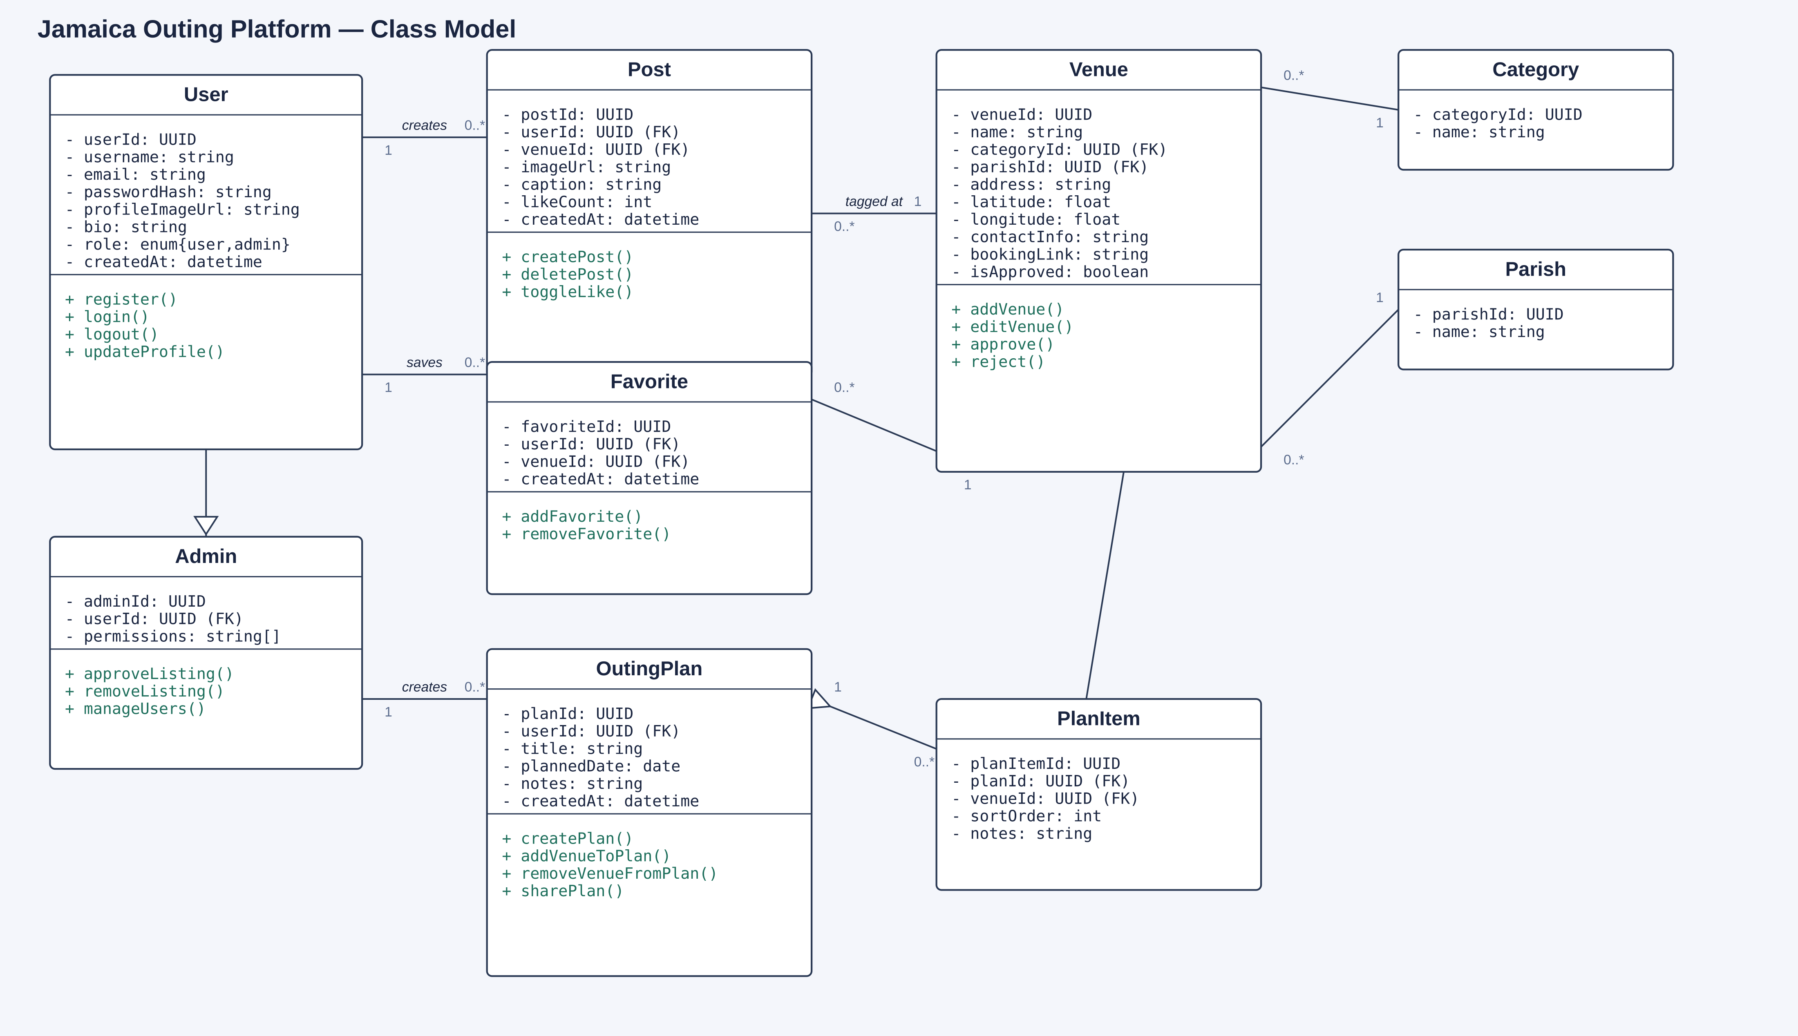
Figure 1 — Class diagram for the Jamaica Outing Platform data model.

Class summaries
Class | Purpose
User | A registered account; can create Posts, save Favorites, and build OutingPlans.
Admin | Specializes User with moderation permissions (approve/remove listings, manage users).
Post | A single image submitted by a User for a Venue; the unit shown in the feed.
Venue | A bar, restaurant, attraction, or activity location with contact and location details.
Category | The type of venue — bar, restaurant, nightlife, attraction, or recreation.
Parish | One of Jamaica's 14 parishes, used to organize and filter venues and posts.
Favorite | A saved link between a User and a Venue.
OutingPlan | A named, dated collection of venues a User intends to visit.
PlanItem | A single ordered stop (Venue) inside an OutingPlan.

Basic Wireframe — User Flow
The platform is a website (built with Vite/React and Supabase), not a native mobile app, so the wireframe below is shown as browser pages rather than phone screens. It walks through a typical visit: the user lands on the home feed, searches or filters for something specific, opens a venue's page, favorites it or adds it to a plan, and finally clicks Get Directions to actually go there. The layout is built responsively, so the same pages resize down to a mobile browser as well.
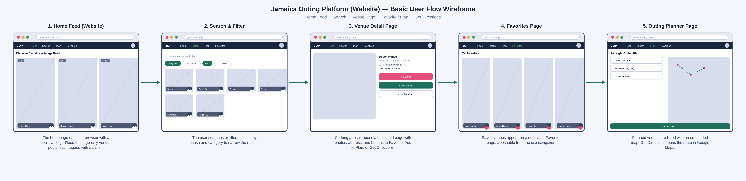
Figure 2 — Website page flow from the home feed through search, favoriting, planning, and directions.

Flow walkthrough
- Home Feed (Website) — the homepage loads a scrollable, image-only grid/feed of venue posts, each tagged with a parish.
- Search & Filter — the user searches by name or filters the site by parish and/or category.
- Venue Detail Page — clicking a result opens a dedicated page with photos, address, contact info, and three actions: Favorite, Add to Plan, and Get Directions.
- Favorites Page — venues saved from the feed or a venue page are collected on a dedicated Favorites page in the site navigation.
- Outing Planner Page — venues added to a plan are listed in visiting order alongside an embedded map; Get Directions opens the full route in Google Maps.

Functional Requirements
- Users shall be able to register, log in, and log out of an account.
- Users shall be able to browse curated places and an image-first strip of approved venue posts.
- Users shall be able to filter or search the feed and directory by parish and/or category.
- Users shall be able to favorite and unfavorite a venue from the feed or its detail page.
- Registered users shall be able to submit a photo for an existing venue, pending admin approval.
- Users shall be able to view full venue details, including images, address, contact info, and booking links.
- Users shall be able to create an outing plan, add or remove venues, and reorder stops (move up / move down).
- Users shall be able to open turn-by-turn directions to a planned venue or full route in Google Maps.
- Users shall be able to share an outing plan via a public link and import a shared plan into their own planner.
- Users shall be able to browse a landing page and an events schedule for Jamaica outings.
- Users shall be able to read Google and OutYah place reviews on a venue detail page.
- Admins shall be able to approve or reject submitted images and venues before they go live.
- Admins shall be able to add, edit, or hide venues, including ones not found on Google Maps.

Non-Functional Requirements
- Performance — the feed should load the next image within roughly 1–2 seconds on a typical mobile connection.
- Usability — the core action (find a place, favorite it, get directions) should be reachable in three taps or fewer.
- Moderation — no user-submitted image becomes publicly visible until an admin approves it.
- Availability — Supabase-hosted authentication, database, and storage should support the expected student-project user base without a dedicated backend server.
- Data integrity — a Venue cannot be deleted while it still has active Posts, Favorites, or PlanItems referencing it; those must be reassigned or removed first.

Content Moderation & Admin Workflow
Because anyone can be a registered user, every image submission enters an approval queue rather than posting instantly. This keeps the feed consistent with the project's core promise: curated, trustworthy content instead of unfiltered map results.
- A registered user submits a photo and tags it to an existing venue (or requests a new venue be added).
- The post enters a Pending state and is not shown in the public feed.
- An admin reviews the image for quality, accuracy, and appropriateness in the admin portal.
- The admin approves (post becomes public and visible in the feed) or rejects it (post is removed, contributor is notified).
- Admins can also retroactively hide or remove a previously approved post or venue if it is later found to be inaccurate or inappropriate.

Revised Technology Stack
The original stack still applies. The additions below are specifically to support an image-first, feed-based experience:
Technology | Purpose
Vite | Frontend development and build tooling
JavaScript / TypeScript | Application logic and user interface
Supabase (Auth, Database, Storage) | Authentication, database, and storage for listings, user plans, and uploaded images
Supabase Storage buckets / CDN delivery | Fast, resized delivery of feed images so scrolling stays smooth
Google Maps / Places API | Location data, map integration, and turn-by-turn Get Directions links
Instagram | Supplementary reference images to showcase venue aesthetics during curation

Revised Project Scope

In scope (updated)
- User authentication and profiles
- Image-only post submission with an admin approval queue
- Vertical, feed-style browsing in addition to search and category/parish filtering
- Curated venue listings with location, images, contact, and booking details
- Outing planning based on favorited or discovered venues, with Get Directions support
- Shareable outing plan links for group coordination
- Events browsing with date/time schedule metadata
- Branded landing page and island-wide curated catalog
- Admin tools to approve, edit, and control listings, including venues absent from Google Maps

Still out of scope
- Native mobile application
- Video posts or stories
- Full social media features such as public comments, direct messaging, or a follower/following graph

Conclusion & Next Steps
This expanded proposal keeps the original goal — helping people confidently find and plan outings across Jamaica — while sharpening the product concept around a fast, visual, image-only feed that is easier to browse than a traditional directory and easier to trust than unfiltered map results. The class model and wireframe above are intended as a starting reference for development; both can be refined further once wireframes move into high-fidelity mockups and the database schema is implemented in Supabase.
Submitted for teacher review prior to project development.
As-Built Update — August 21, 2026
OutYah (live at https://vtdi-platform.vercel.app) implements the proposal features below. Product name branding uses Terobytez. Stack: Vite + React, Supabase (Auth/DB/Storage), Google Maps/Places, Tailwind CSS, hosted on Vercel.
Shipped features matching this document:
User authentication (register, log in, log out) and profile
Parish and category filtering, text search, and map explore
Curated venue listings with images, address, phone, hours, and booking contact / time slots
Image-first approved photo posts on Explore and venue detail; user photo submit with admin approval queue
One-tap favorites and Favorites page
Outing planner with ordered stops, reorder controls, Get Directions, and shareable plan links
Events schedule browsing
Admin portal for places, events, posts (including approve/reject), and visibility
Place reviews (Google + OutYah)
Branded landing page
Still out of scope (unchanged): native mobile app; video posts; full social graph (DMs, followers, public comment threads as a social network).
Submitted as the as-built Special Project document for OutYah.

