Enterprise and Digital Innovation, Ara Institute of Canterbury Ltd

BCDE215 Web Development

Website Development Practice

v. 1 April 2021

Your task is to create a single web page that matches the images shown in the separate screenshot files. Make sure you view the screenshots full size (zoom 100%). Note that Screenshots 2 & 3 have white space on either side of the main page content.

NOTE: The screenshot tool took imperfect images of the pages – there is no space above or below the image of fish in the header. The following image shows this space, but it should not be there (and isn’t in the answer).

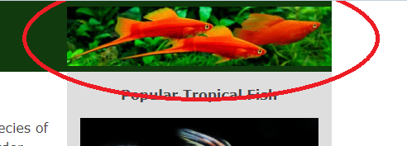

The text you need for your web page is in the file “Text for Page.txt” and images you need are in the “images” folder.

Note that you should edit only the files **index.html** and **stylesheet.css**.

**Requirements:**

* The page should be responsive. Do not be concerned about the images being very large in the single-column layout before the layout changes to two columns.
* The font family used is Verdana, falling back to Arial if it is not available.
* The header and footer are coloured #113a0e.
* The columns on the left and right are coloured #c1d8be.
* The main text font color is #444444.
* The current menu item (Swordtails) is red (#ff0000).
* When the mouse hovers over a link (including in the main menu), the colour of the word(s) should change to red (#ff0000).
* All links should go to placeholder.html (this is supplied).
* All footer items are links.
* Look at the page text carefully to find other features that might not be pointed out here.
* Your HTML and CSS should validate without errors.