Khronos COLLADA 1.4 Conformance Testing Framework
(Release 1.0.0)

Primary Author:
Alfred Leung, Feeling Software

Authors:
Tony Wong, Yumetech Inc.
Mark Barnes, Biodroid Productions Lda.

With many helpful suggestions from Christian Laforte and Guillaume Laforte.

Introduction

COLLADA is growing at an incredible rate, with new features being added continually. It is apparent that automated conformance testing is needed to objectively assess quality and completeness of new implementations. The solution is to create an extensible COLLADA testing framework that fully supports current and future features of COLLADA on the major target applications: 3DSMax, Feeling Viewer, Maya, and XSI. It must be designed to easily add support for new applications as well as new data sets. It must also be able to easily save, distribute, load, and compare previous results.

Synopsis

This document is intended to be a complete user manual for the Conformance Testing Framework. It will begin with general use cases such as installation, creation of test procedures, running of tests, and then move onto more advanced usages such as various comparisons, regular expressions, and other special features. Graphical user interface (GUI) screenshots are used to illustrate the use cases. This document also describes some software development concepts such as file structure, and present information needed to enhance the Conformance Testing Framework to meet the needs of the future.

Table of Contents

1.0 Introduction 1
2.0 Synopsis 1
3.0 Table of Contents 2
4.0 Table of Figures 3
5.0 Installation 4
6.0 Configuration 5
7.0 Start Up 5
8.0 Documentation 5
9.0 General Usage 6
9.1 Opening/Creating a Test Procedure 6
9.2 Menus and the Toolbar 9
9.3 Preferences 10
9.4 Adding Tests 11
9.5 Running Tests 15
9.6 Exporting To HTML 17
9.7 Context Menus 17
10.0 Advanced Usage 19
10.1 Comparisons 19
10.2 Show Previous 22
10.3 Regular Expressions 23
10.4 Blessing and Result Generation 24
10.5 Transporting 26
10.6 Command Line Interface 27
10.7 Creating Data Sets 27
11.0 Design and File Structure 30
11.1 CTF 30
11.2 Standard Data Sets 31
11.3 Application Settings 32
11.4 Test Procedures 32
11.5 Scripts 33
11.6 Image Comparators 34
11.7 Core 35
12.0 Known Issues 36
13.0 Appendix 38

Table of Figures

Figure 1: "Open Test Procedure" dialog 6
Figure 2: "New Test Procedure" dialog 8
Figure 3: Blank test procedure 9
Figure 4: Menus in Conformance Testing Framework 10
Figure 5: “Preferences” dialog 11
Figure 6: “Application Settings” dialog 12
Figure 7: “Edit Settings” dialog 13
Figure 8: “Select Data Set” dialog 14
Figure 9: Tests not yet ran 15
Figure 10: Progress dialog while running tests 15
Figure 11: Tests ran 16
Figure 12: Tests ran with side by side blessed previews 16
Figure 13: Exported HTML file 17
Figure 14: Context menus 19
Figure 15: “Compare Execution With” dialog 20
Figure 16: “Compare Image With” dialog 20
Figure 17: “Image Comparison” dialog 21
Figure 18: “Image Diff” dialog 21
Figure 19: "Compare Log With" dialog 22
Figure 20: "Show Previous" dialog 22
Figure 21: "Regular Expression Editor" 24
Figure 22: Examples of results 25
Figure 23: Blessed Viewer 26
Figure 24: Top level of file structure 30
Figure 25: StandardDataSets subdirectory in file structure 31
Figure 26: ApplicationSettings subdirectory in file structure 32
Figure 27: TestProcedures subdirectory in file structure 33
Figure 28: Scripts subdirectory in file structure 33
Figure 29: Interface for FApplication 34
Figure 30: ImageComparators subdirectory in file structure 35
Figure 31: Interface for FImageComparator 35
Figure 32: Core subdirectory of file structure 36
Figure 33: An overall view of the testing framework file structure 40

Installation

The Conformance Testing Framework currently only officially supports 32-bit Windows due to calls to win32api to kill processes and start files with default applications.

Unzip the package (e.g. COLLADA-1.4-CTS-1.0.0-<date>.zip) into any directory with a short path name (e.g. C:\CTF\). See 12.0 Known Issues for information about why it should be short.

The installation of the Conformance Testing Framework requires the installation of several python related tools. It is recommended that they are installed in the following order. A version of each can be found in the Prerequisites directory.

Python (http://www.python.org) & Win32 Extensions (http://www.python.org/windows/win32)
- The language that a majority of the Conformance Testing Framework is written in. It is an interpreted language and needs to be installed in order to run software written with it.
- Python Win32 Extensions are included in the ActivePython distribution of Python (http://www.activestate.com/Products/ActivePython). The executable to install only the Win32 Extensions is also included with the Conformance Testing Framework for those who have already installed Python or do not want to install ActivePython.
- Python 2.4.2 was used to develop the Conformance Testing Framework but any newer version should work as well.
wxPython (http://www.wxpython.org)
- A framework used to display various UI elements. It is the Python binding for wxWidgets.
- wxPython 2.6.1.0 was used to develop the Conformance Testing Framework but any newer version should work as well.
PyOpenGL (http://pyopengl.sourceforge.net)
- A framework used to display graphics and get information about video drivers. It is the python binding for OpenGL.
- PyOpenGL 2.0.1.09 was used to develop the Conformance Testing Framework but any newer version should work as well.
- A 64-bit Windows distribution can be found here (http://www.lfd.uci.edu/~gohlke/pythonlibs/#pyopengl).

The Feeling Viewer v3.0.2 is also packaged with the Conformance Testing Framework to enable preview within the GUI.

Note for Maya tests: By default, the Conformance Testing Framework uses ctfHwRenderer, which can be found in the Prerequisites directory, as the renderer in Maya's rendering settings. It is the same as hwRenderer except with a few enhancements. Be sure to place this xml file in <MayaPath>/bin/rendererDesc directory if you plan on using it.

Finally, the .NET framework is also needed if the validation feature is used since it is currently implemented as a .NET executable. It is also needed if crash detection is enabled. It can be disabled in the configuration file (see 6.0 Configuration).

Known Problems

The pacakge must be installed in a short directory name such as c:/ctf to avoid creating file paths longer then 255 characters.

Python 2.6 issues a Deprecation Warning: the sha module is deprecated. This can be ignored.

Configuration

Before running the Conformance Testing Framework for the first time, there are a few settings that must be configured in order to obtain maximum use. Most of these settings are related to the file paths for the DCCs, and are all found in the config.txt file located in the main directory. For example, if the Conformance Testing Framework was extracted to C:/CTF, then the configuration file should be at C:/CTF/config.txt. Each line of the configuration file represents a setting and each setting is made up of a description, followed by a tab (or a series of tabs), followed by the value. Note: this format must be respected.

Start Up

To start the Conformance Testing Framework GUI, simply double-click FTestSuite.py in the main directory where it was extracted. At this point, one can either open the sample test procedure included with the package or create a new test procedure (see 9.1 Opening/Creating a Test Procedure).

The Conformance Testing Framework also supports a command line interface. To access it, change directory to the main directory where it was extracted and type FTestSuite.py -help for usage information. Typing only FTestSuite.py will bring up the GUI. See 10.6 Command Line Interface for more information about the command line interface.

Documentation

This document is the main source of information about the Conformance Testing Framework.

Other sources of documentation include:
- in-application documentation available through the Help menu, which links to this document
- inline code documentation in the Scripts, and Core/Common classes. The documentation in the Scripts classes can be used to derive classes for DCCs not initially supported in the Conformance Testing Framework. The documentation in the Core/Common classes contains information about useful functions used throughout the Conformance Testing Framework, including the Scripts classes.
- source code in the Core/Logic classes contain information about the API of the main logic of the Conformance Testing Framework and if desired, can be used to create an interface different from the GUI or command line interface included in this release.
- source code in all python files (extension .py). The python files are actually text files that contain source code.

General Usage

Opening/Creating a Test Procedure

When the Conformance Testing Framework is started, it presents the user with an empty workspace. Aside from the “Window”, “Help”, and “Exit” options, only opening and creating test procedures through the “File” menu are available (see Figure 4 for screenshot of menus).

Opening a test procedure is simple. The Conformance Testing Framework saves all test procedures in a directory called TestProcedures. When “Open Test Procedure” is selected from the “File” menu, all the test procedures found in the TestProcedures directory are presented to the user to select one to open, as shown in Figure 1. Depending on the size of the test procedure, it may take a few seconds to load. The “Test Procedure Comments” area in Figure 1 displays any comments that were provided when the test procedure was created.

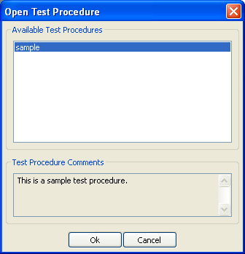
Figure 1: "Open Test Procedure" dialog

Creating a new test procedure is done by first selecting “New Test Procedure” from the “File” menu. The “New Test Procedure” dialog, shown in Figure 2, is then displayed for specifying the steps for the test procedure. After pressing “OK”, a directory with the name specified in "Title of Test Procedure" is created in the TestProcedures directory to store files for this test procedure.

As shown in Figure 2, there are 4 operations that the user can select: “Import”, “Export”, “Render”, and “Validate”. The “Import” operation is used to import or open a file in the selected application. It is the only operation that requires specifying an application. The first import uses the data set scene while subsequent imports use the last output of the previous export, or the data set scene if there were no exports. The “Export” operation is used to export to COLLADA format what was imported. The “Render” operation is used to render an image file from the imported file. And “Validate” is used to validate the output from the previous step against the COLLADA schema. The Feeling Viewer is an exception since it can only view COLLADA files. Thus “Import” refers to open and render, while “Export” and “Render” are not allowed. The applications shown are those installed in the Conformance Testing Framework. Adding new DCC applications is described in 11.5 Scripts.

Below the operations and applications section, there is a combo box and button used to specify the settings to use as the global defaults for that step. The values in the combo box, as well as the label above it, dynamically change depending on the values selected in the operation and application section. The “Add/View” button brings up the “Edit Settings” dialog (see Figure 7) which can be used to add or view more settings, and is explained in 9.4 Adding Tests.

When “Add” is pressed, the currently selected application, operation, and setting are put in the "Chosen Operations" section. These are the order of operations for the test procedure when “Ok” is pressed. Pressing the “Delete Last” button will remove the last line from the “Chosen Operations” list. Finally, the Comments section is used to specify any comments that will be displayed in the “Open Test Procedure” dialog.

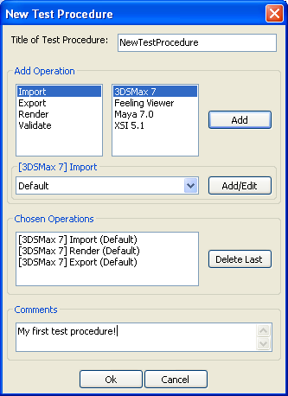
Figure 2: "New Test Procedure" dialog

After the test procedure has been created, the workspace displays the test procedure in tabular format, as shown in Figure 3. Currently there are no tests in the test procedure, thus there are no rows in the grid. All menus (see Figure 4) are now enabled. In the grid, any of the columns can be sorted by clicking on the label of the column, or hidden by using the options in the “Preferences” dialog (see Figure 5). Sorting is done by number of errors and warnings for the columns that have it; the remaining columns sort intuitively.

The standard columns are:
- Test ID: Id of the test; it is useful for advanced user who want to look into the directory structure (see 11.4 Test Procedures)
- Category: test scene’s Category, which is the second directory above the test scene
- Subcategory: test scene’s Subcategory, which is the directory directly above the test scene
- Test Filename: name of the file used as the test scene
- Blessed: preview of a blessed image or animation; if there is none, then it is blank
- Test Scene: preview of the test scene file
- Result: nothing if test is not ran; color- coded “Passed” or “Failed” depending on if all steps succeeded or ignored; it also shows a detailed description of what happened in each step (see 10.4 Blessing and Result Generation for description of how results are generated)
- Different from Previous: "N/A" if there was no previous; "Yes" or "No" depending on if the current execution matches that of the previous execution; executions match if number of errors, number of warnings, comments, environments, and outputs are the same
- Logs: generated log files for each of the steps
- Comments: user specified comments for the test
- Description: description that comes with the data set test scene
- Time: time the test was started
- Environment: graphics driver information from GLGetString function

There are also columns for each of the steps. In addition to the application and operation names, they have a numeric identifier, beginning with 0, representing their position in the test procedure.

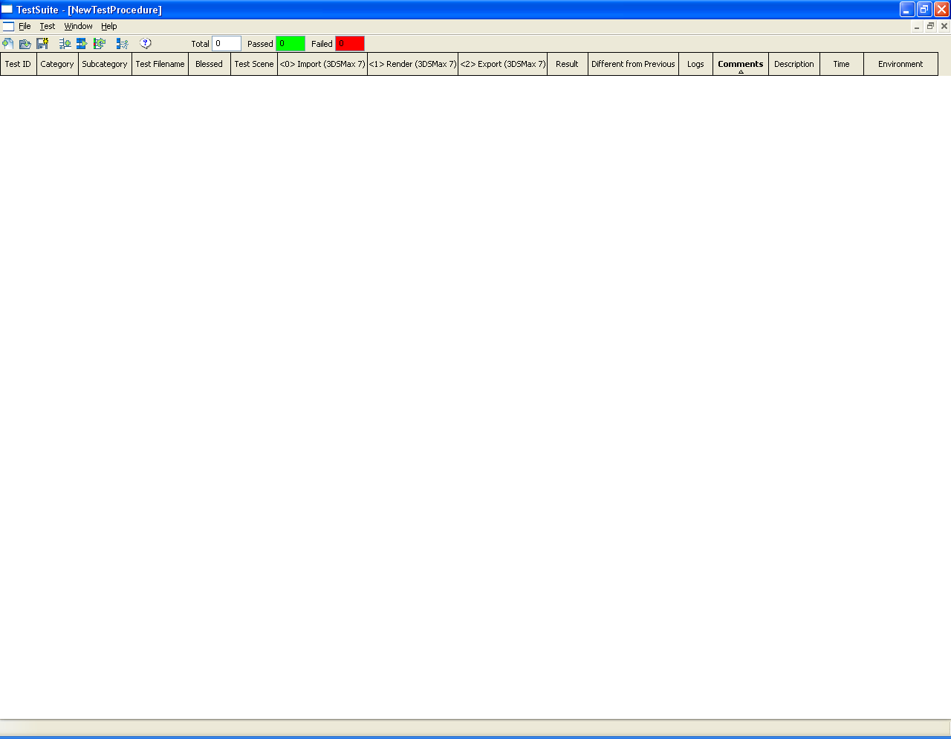
Figure 3: Blank test procedure

Menus and the Toolbar

The menus are shown in Figure 4, as well as the toolbar below which contains shortcuts for common tasks. From left to right, they are: “New Test Procedure”, “Open Test Procedure”, “Save Test Procedure As”, “Add Tests”, “Run Selected”, “AutoUpdate Results”, “Animate Selected Only”, and “Help”. Next to the tool bar buttons are three fields indicating total number of tests, number of passed tests, and number of failed tests in the test procedure,

The options in the “File” menu are:
- New Test Procedure: creates a new test procedure (see Figure 2)
- Open Test Procedure: opens a previously saved test procedure (see Figure 1)
- Save Test Procedure As: saves current test procedure to another name
- Export All to HTML: exports all tests in current test procedure to a HTML file
- Export Selected to HTML: exports selected tests in current test procedure to a HTML file
- Preferences: sets preferences for current test procedure (see Figure 5)
- Close: closes current test procedure
- Reload: reopens the current test procedure and updates the information when changing execution properties in simplified grid (see Figure 20) or another window.
- Exit: exits Conformance Testing Framework

The “Test” menu in consists of the following items:
- Add Tests: add tests to current test procedure (see Figure 6)
- Run Selected: runs selected tests; if a test has ran, it will run again in a new execution
- Run All: runs all tests in current test procedure; if a test has ran, it will run again in a new execution
- Run Remaining: runs all tests that have yet to be ran
- Animate Selected Only: toggles animating all previews or animating only select tests; animating only selected tests significantly improves performance
- AutoUpdate Results: tells Conformance Testing Framework to update all results based on current blessed images/animations/executions; will not override a user defined result (see 10.4 Blessing and Result Generation for details)
- Regular Expression Editor: edit regular expressions in current test procedure (see Figure 21)

The “Windows” menu contains menu items which are standard for Windows platform. Finally, the “Help” menu contains the following items:
- Help: opens the help document, this file
- About: displays information about the Conformance Testing Framework

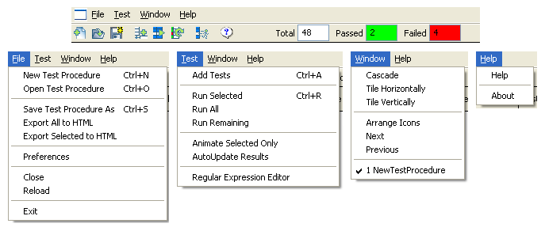
Figure 4: Menus in Conformance Testing Framework

Preferences

The “Preferences” dialog, shown in Figure 5, is found in the “File” menu and contains various preferences that can be set for a specific test procedure. First, the “Additional Previews” section is used to specify what previews are shown in the steps columns of the grid (see Figure 3). Besides the preview of the current result, the Conformance Testing Framework can also preview other convenient images/animations: the blessed one, or the one from the same step in the previous execution. If checked, they are shown side by side in the grid cell with the blessed in the far left, the previous in the middle, and the current on the right. Next, the “Previews Size” section refers to the size, in pixels, of the previews. The “Diff Viewer” section is used to specify the diff program to compare log files. The path can be entered manually or using a file chooser through the “Browse” button. %base and %mine are used as variables that will be replaced with the file path of the compared files. Finally, the “Grid Columns” section is used to specify the visible columns in the grid and in what order they will be shown. “<<” is used to move a selected column from the hidden side to the shown side, and “>>” is used to do the opposite. “<Move Up” and “<Move Down” is used to specify the ordering of the column in the shown side.

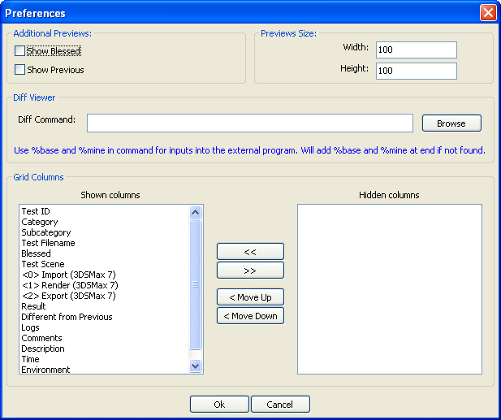
Figure 5: “Preferences” dialog

Adding Tests

Adding tests can be done through the “Test” menu. When adding new tests to the test procedure, several options need to be set in two main dialogs, the “Application Settings” and “Select Data Set” dialogs shown in Figure 6 and Figure 8 respectively. The first of the two dialogs assigns settings to each of the steps for the newly added tests. Each step has its own combo box and “Add/View” button. The default values of the combo boxes are the global settings assigned in the “New Test Procedure” dialog (see Figure 2). Any change made in the “Application Settings” dialog overrides the global settings for the tests being added only.

There is some notation that needs to be clarified. Selecting ::New:: is used to create a new setting with the default entries for that type of setting (application and operation). The title will be empty and must be entered before saving. Any setting enclosed with << and >> is a setting already used by the test procedure and thus stored with it. This allows the test procedure to be transported to another machine even if that machine does not have the setting. The other setting names are settings on the current machine in the file structure for the given application and operation (see 11.3 Application Settings for details).

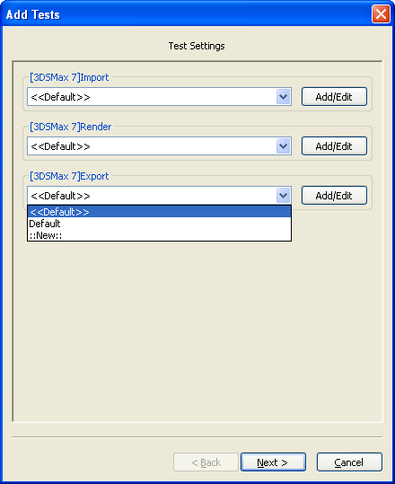
Figure 6: “Application Settings” dialog

Clicking on any of the “Add/View” buttons in the “Application Settings” dialog brings up the “Edit Settings” dialog (see Figure 7) which can be used to create, edit, or view settings. The “Title of Setting” field and shown setting entries are taken from the value of the combo box next to the “Add/View”. When “Save” is pressed, the setting is saved on the hard disk in the file structure (see 11.3 Application Settings for details), making it available in the combo box. Each setting must have a unique name. If there is already a setting with the specified name, it will merely overwrite the any existing saved setting. An empty value for a setting entry is interpreted as the default value defined by the Conformance Testing Framework when ::New:: is selected. All other values are fed to the application as is.

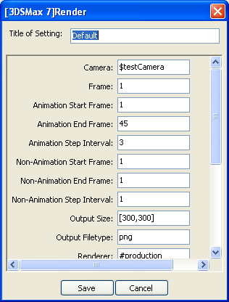
Figure 7: “Edit Settings” dialog

The second main dialog to add tests to a test procedure is the “Select Data Set” dialog, shown in Figure 8. There are two ways to select the data set for the new tests. One way is by using the tree representation of the StandardDataSets directory, the directory where all test scenes must be stored (see 11.2 Standard Data Sets for details). All found test scenes are enclosed in [ and ] in the tree representation. If not enclosed, then it refers to a directory. It is possible that the tree ends with a directory with no test scene; a directory just to store textures is one example. The Conformance Testing Framework will convert all the checked data sets into a regular expression. It will then add the corresponding test scenes to the test procedure. The user can also specify the regular expression explicitly by selecting the bottom bullet and typing in a python regular expression. The “Update” button can be used to update the tree based on the regular expressions to check whether the regular expression selects the desired tests. It also verifies that the regular expression is valid. The Conformance Testing Framework stores the regular expression, whether generated or given, and is used to verify if new test scenes are found when the test procedure is opened (see 10.3 Regular Expressions for more information). Note that because there is only one regular expression for every unique series of settings, a dialog will show up when adding tests using a series of settings that already has a regular expression attached to it. This dialog asks whether to append or overwrite the previous regular expressions. If unsure, select append since it will not lose any information.

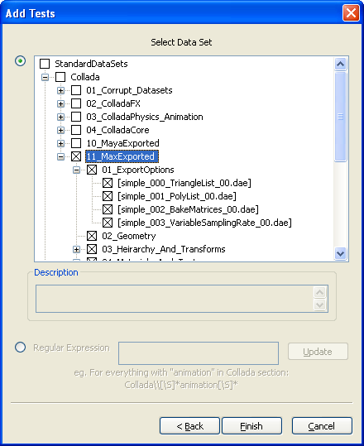
Figure 8: “Select Data Set” dialog

Once tests have been added to the test procedure, the grid is filled in with as much information as possible, as shown in Figure 9. Each test is represented by a row in the grid. The columns “Test ID”, “Category”, “Subcategory”, “Test Filename”, “Blessed”, and “Test Scene” are filled in. The “Description” column may or may not be filled in depending on if the test scene had a description (see 11.2 Standard Data Sets for more information). Multiple tests can be selected through the usual mouse controls: combinations of SHIFT and CTRL. In Figure 9, three tests were selected. The grid displays previews for standard format images such as BMP, JPG and PNG. For other files, a message stating that it cannot be previewed is displayed.

A new test starts with no executions. An execution is created each time the test is run and contains all the information gathered during the run, such as the outputs, results, times, environmental variables, etc. The test contains information about the test scene and the settings. Above all this is the test procedure, which contains the information about the tests that are in it.
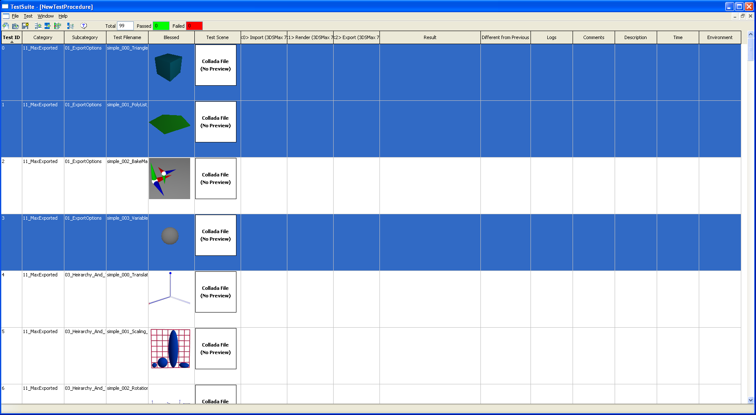
Figure 9: Tests not yet ran

Running Tests

Running tests can be done through the “Test” menu. There are options to run all the tests, run selected tests, and run remaining tests. The steps are separated into sections defined by the “Import” operation. Each section is run in a batch to minimize the loading time of the DCCs. For example, a test procedure with the steps Import Max → Export Max → Import Maya → Export Maya → Import Feeling Viewer would be split into 3 sections. The first section is the Import and Export for Max; the second is the Import and Export for Maya; and the third is the Import for Feeling Viewer. It will perform the first section for each test that needs to be run before moving onto the second and third sections. When running tests, a progress dialog, as shown in Figure 10, is displayed to give feedback. Canceling running of the tests is done with the “Cancel” button. The cancellation will happen in between sections. Once cancelled, all results obtained so far are deleted and the Conformance Testing Framework is back to as if the running never occurred.

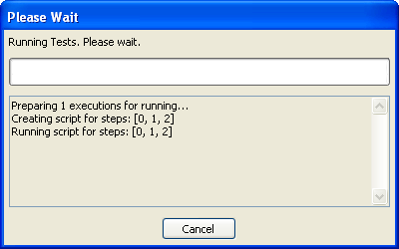
Figure 10: Progress dialog while running tests

Crash detection has been implemented using .NET by adding a watcher on the file system. If no file I/O is used within a specified amount of time, then the operation is considered to have crashed. The Conformance Testing Framework will then look for the last test that actually finished by checking to see if there are files with the expected file names in the output directory. It will then run each subsequent test individually to isolate the test that crashed. Crash detection and the timeout value are specified in the configuration file (see 11.1 CTF).

After tests have run, all the columns except for “Comments”, and possibly “Description”, are filled in. The “Comments” column can be edited at anytime by the user. Figure 11 shows the effect of running the three tests that were selected in Figure 9. As specified in 9.3 Preferences, one could turn on previewing the current results side by side with the blessed images and/or results from the previous execution. Previewing with the blessed was done in Figure 11.

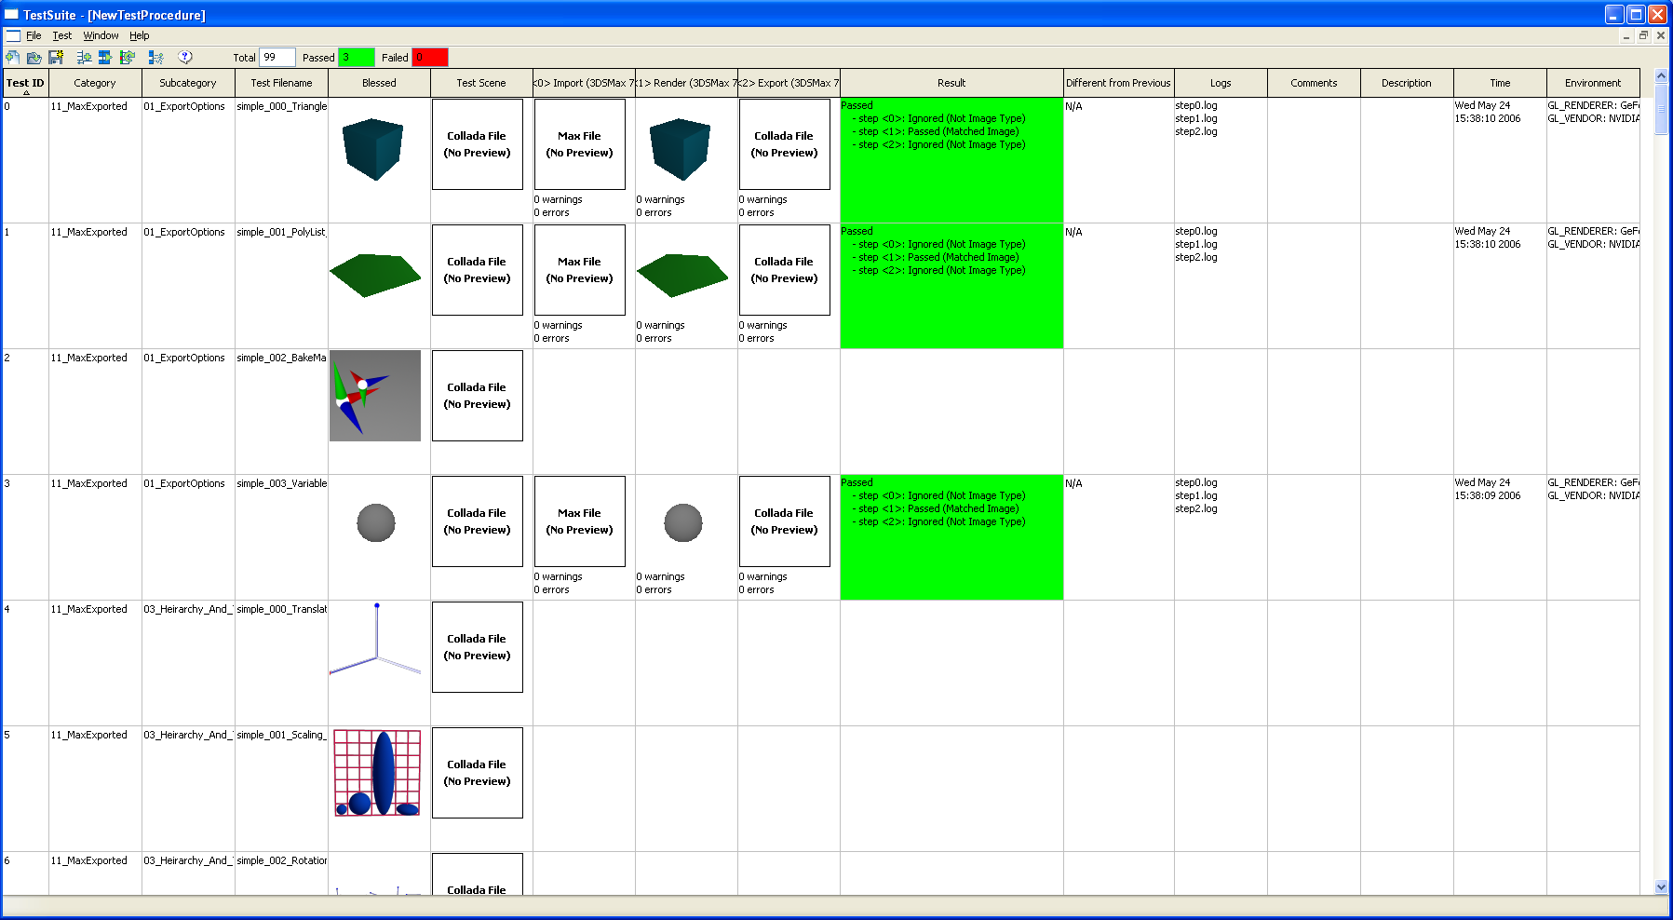
Figure 11: Tests ran

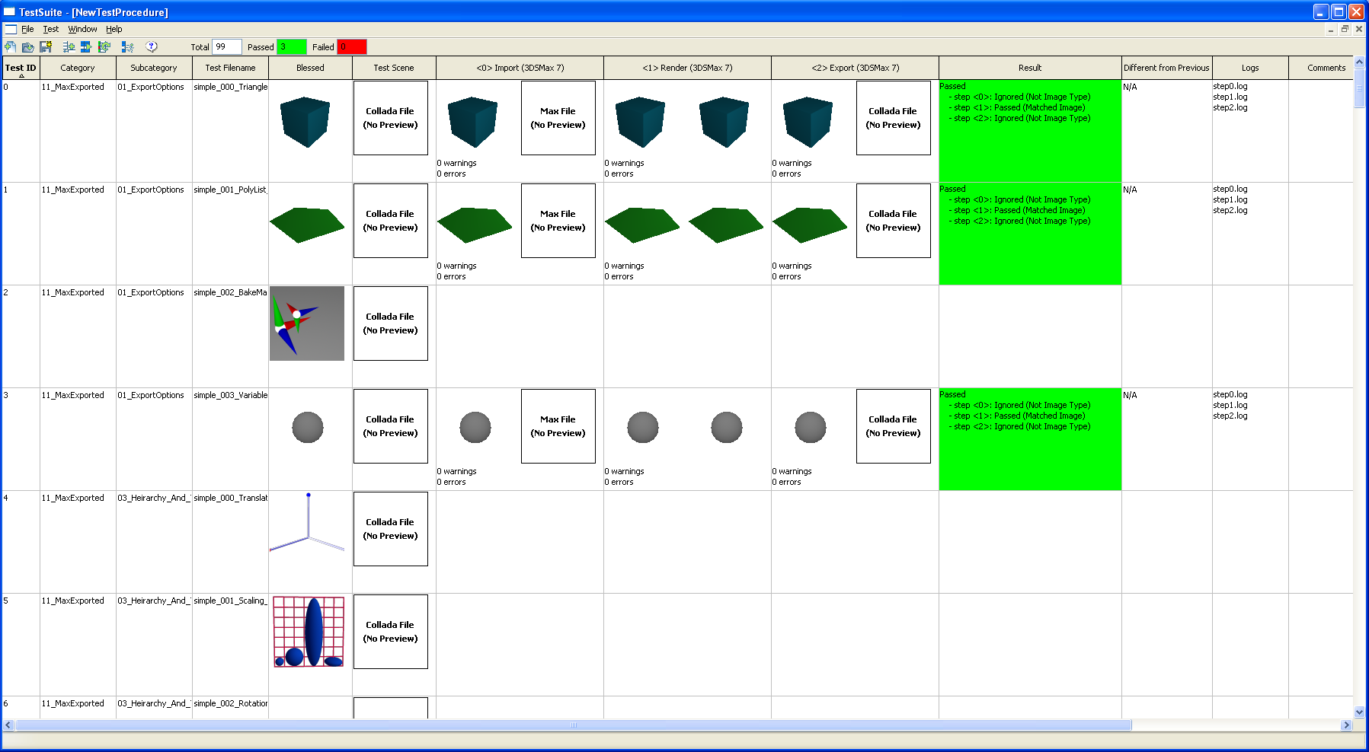
Figure 12: Tests ran with side by side blessed previews

Exporting To HTML

There are two options in the “File” menu for exporting to HTML: export all tests, or export only the selected ones. A file chooser to specify the HTML file is presented when either of these options is selected. After a selection is made, the Conformance Testing Framework will generate a HTML file, as shown in Figure 13, and put all the linked files into a directory with the proper name as the HTML file but with _Files appended. For instance, if the HTML file was at C:/CTF/exported.html, then all the linked files will be created at C:/CTF/exported_Files.

The HTML file will also include the side by side blessed and previous previews if that option was chosen in the “Preferences” dialog (Figure 5). The height and width of the previews from the Conformance Testing Framework is also taken into consideration when exporting to HTML.

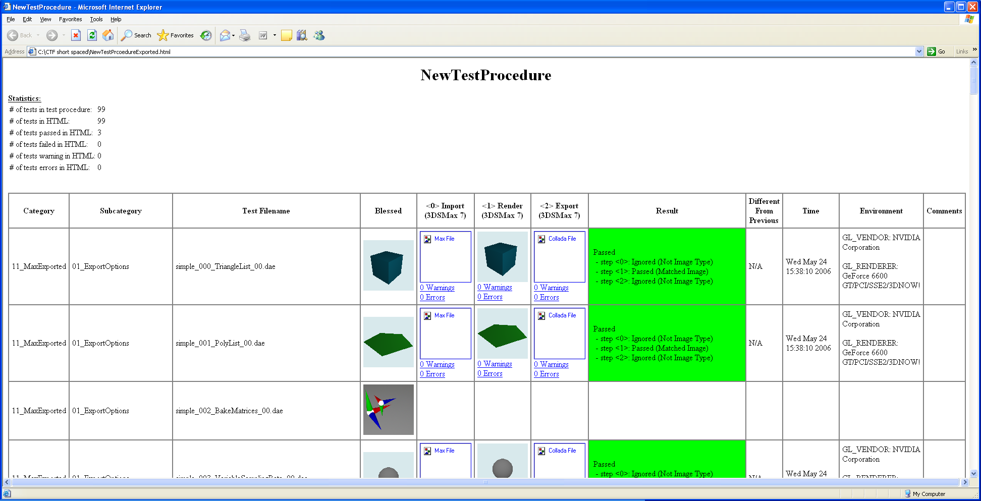
Figure 13: Exported HTML file

Animations are displayed as stills in the HTML file, where the last frame is shown. Clicking on the preview will go to another HTML page that shows all the frames of the animations. All images and log files are exported to the directory for linked files.

Context Menus

There are a number of context menus that can be triggered from within the Conformance Testing Framework. Figure 14 reveals most of them. The nine standard ones (top left context menu in Figure 14) can be triggered at anytime by right clicking anywhere in the grid. Additional menu items are triggered by right clicking on specific cells of the grid. On the top row of Figure 14, from left to right, are context menus for: standard, non-COLLADA image, animation, and COLLADA image. On the bottom row, from left to right, are context menus for log in image/animation cell, log in log cell, comment, and result. Bold menu items are triggered when the user double clicks on the cell in that area. If the context menu does not have any bold menu items, then nothing happens when double clicking on that cell.

The context menu items are:
- Run Selected: runs selected tests; if a test has ran, it will run again in a new execution
- Show Previous: shows all the previous executions for the selected test (see 10.2 Show Previous); single execution selection only
- Compare Execution With: opens the “Compare Execution With” dialog (see Figure 15); single execution selection only
- View Settings: views the settings for this test (not editable Figure 6); single execution selection only
- Change Settings: opens the “Application Settings” dialog (see Figure 6) and if changes were applied and confirmed, it deletes the current test and replaces it with a new one with the new settings and same test scene
- Delete Execution: prompts for permanent deletion of the selected execution; if it is the only execution in the test it clears the results but does not delete the test
- Delete Test: prompts for permanent deletion of the selected test and its executions
- View Blessed: opens the “Blessed Viewer” dialog (see Figure 23) to manage blessed images or animations
- Bless Execution: blesses the execution making other executions that match this one for the test scene considered passed in the result (see 10.4 Blessing and Result Generation for more information)
- Update Execution Result: Updates the execution’s result by comparing with blessed results; it will remove any user defined result for that execution (see 10.4 Blessing and Result Generation for more information)
- View Full Image: opens the image file with the default viewer on the system
- Default Bless Image: blesses the image so that other images matching this one for the test scene are considered passed in the result; it also makes this one the one displayed in the “Blessed” column, and used for comparisons (see 10.4 Blessing and Result Generation for more information)
- Bless Image: blesses the image so that other images matching this one for the test scene are considered passed in the result (see 10.4 Blessing and Result Generation for more information)
- Compare Image: opens the “Compare Image With” dialog (see Figure 16)
- View Animation: opens the animation using FAnimationViewer.py, a simple animation viewer with controls similar to Figure 17 except only with one animation
- Bless Animation: same as Bless Image except with an animation
- Compare Animation: same as Compare Image except with an animation
- View in Feeling Viewer: opens the COLLADA file in the Feeling Viewer GUI
- Show Asset Tags: displays the asset tags in a COLLADA file in the default text editor on the system
- View Log or Open x: opens the log file with the default text editor on the system
- Compare Log or Compare x: opens the “Compare Log With” dialog (see Figure 19)
- Edit Comments: edits the text displayed in the “Comments” cell
- Toggle Result: if the result is pass, it becomes fail and vice versa; no effect if no result yet

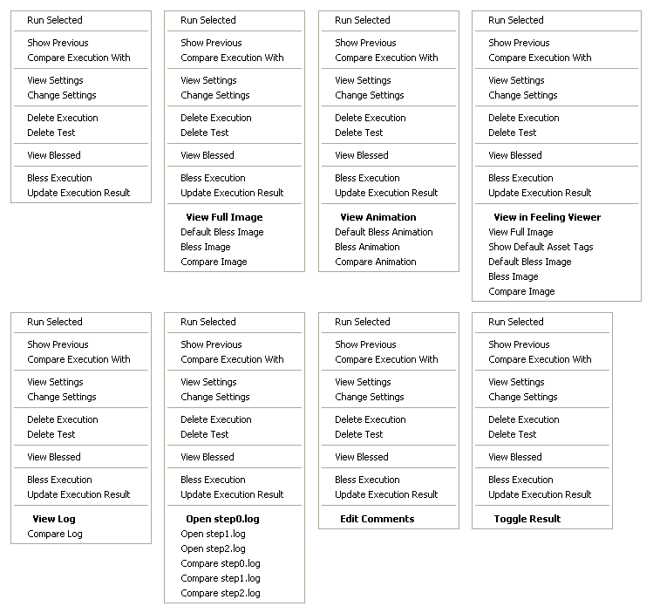
Figure 14: Context menus

Advanced Usage

Comparisons

There are three things that can be compared using the Conformance Testing Framework: executions, images or animations, and logs. All are activated through the context menu by right clicking on the first thing that is being compared and using a dialog to select the second one.

For execution comparisons, the “Compare Execution With” dialog, shown in Figure 15, is used to specify what to compare with. “Include Last Blessed Execution” refers to whether the latest blessed execution is included in the comparison. This option has no effect if there are no blessed executions in the data set with the same steps as the current test procedure. The “Compare With” and “Browse” sections are used to determine where to select the second execution to compare with. “Different Execution” compares the currently selected execution with a previous execution of the same test. If this is selected, only the “Execution” line is shown in the “Browse” section. The combo box will contain all the executions for the current test. If the execution to compare against is from another test, then “Different Test” should be selected from the “Compare With” section. In that case, only “Test” and “Execution” are shown. First, the test must be chosen from the combo box, which will contain all tests in the current test procedure. Then, the “Execution” combo box is enabled to select the execution to compare with. The final option in this dialog, and the one shown in Figure 15, is “Different Test Procedure”. In this case, the test procedure must be selected before the other combo boxes become available. The “Test Procedure” combo box will show all test procedures with steps matching the current test procedure. After the selection, a new grid similar to the one for “Show Previous” (see Figure 20), will display the comparison with the two executions and the blessed execution at the top if specified.

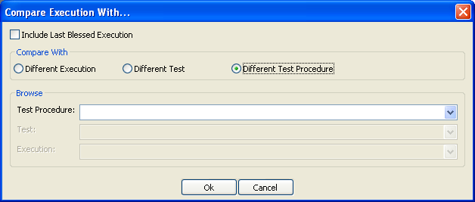
Figure 15: “Compare Execution With” dialog

Specifying an image or animation comparison is done through the “Compare Image With” or “Compare Animation With” dialog; the first is shown in Figure 16, and the latter differs only in the title. They are similar to the “Compare Execution With” dialog but with the addition of specifying the step that the image or animation is taken from. The “Step” combo box contains all the steps for the execution selected. Clicking “OK” opens the “Image Comparison” dialog.

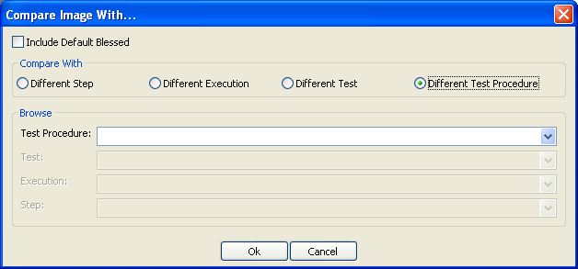
Figure 16: “Compare Image With” dialog

The “Image Comparison” dialog, shown in Figure 17 is used to view images or animations side by side. The blessed image is shown on the far left if it was chosen, otherwise it is left out. The image that was use to bring up the context menu is shown in the middle, and the image that was selected using the “Compare Image With” dialog (see Figure 16) is shown at the far right. Along with each image is a description that shows which test procedure, test id, execution name, and test filename the image or animation came from. The arrow buttons are used to change frames either independently or together. The “Diff Blessed”, and “Diff Image2” buttons bring up the “Image Diff” dialog (see Figure 18). The left shows the absolute pixel by pixel difference, and the right shows the grayscale relative difference where the most different pixel is shown in white.

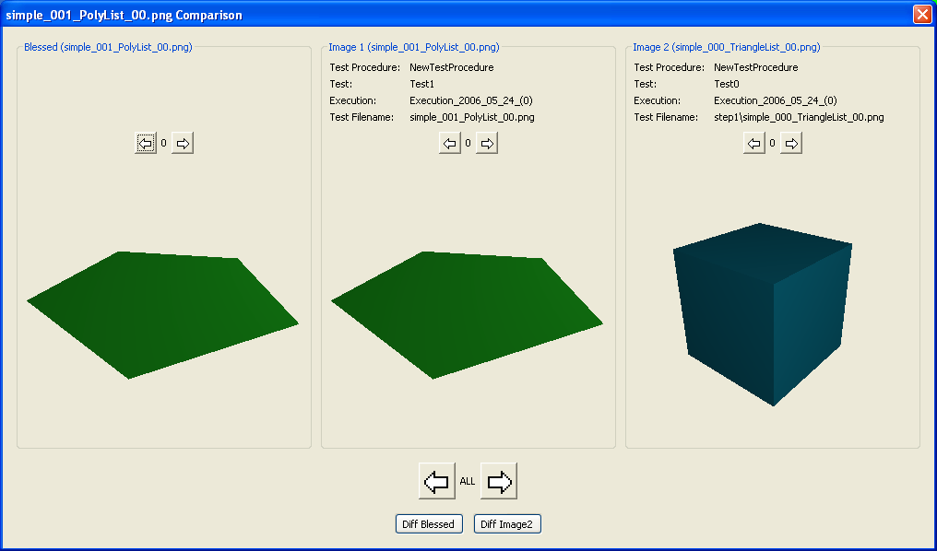
Figure 17: “Image Comparison” dialog

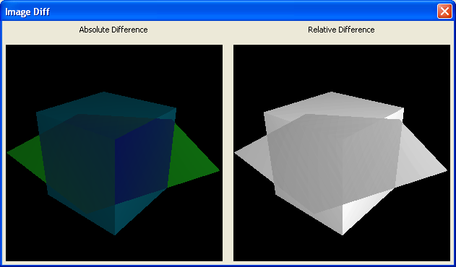
Figure 18: “Image Diff” dialog

Specifying a log comparison is done through the “Compare Log With” dialog, shown Figure 19. Note that this dialog only shows up if a diff program has been specified in the “Preferences” dialog (see Figure 5), otherwise a dialog saying there’s no diff program selected is displayed. Again, it is similar to the previous two compare dialogs (see Figure 15 and Figure 16) but without the mention of blessed, since there are no blessed logs in the Conformance Testing Framework. Clicking on “OK” button opens the diff between the first file that was selected from the context menu and the one selected through the “Compare Log With” dialog.

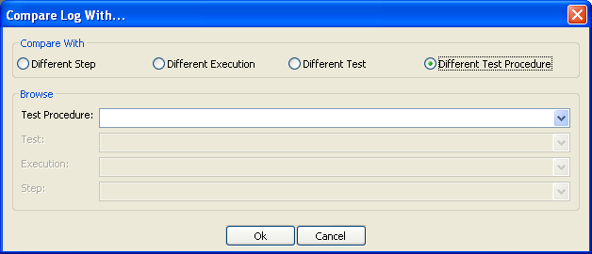
Figure 19: "Compare Log With" dialog

Show Previous

The “Show Previous” option in the context menu is used to show all the executions of the selected test in a separate grid, shown in Figure 20, which has a subset of the options available in the main grid. The “Animate Selected Only” option, and settings from the “Preferences” dialog used in the “Show Previous” grid are the same as in the main grid.

This simplified grid is the same type of grid that is shown for comparisons of executions. For this type of grid, the only changes that can be made to the execution are changes to the results. Changes made here are updated in the main grid of the current execution only; other test procedures opened in the Conformance Testing Framework are not updated. The “Reload” option in the “File” menu can be used to update them.

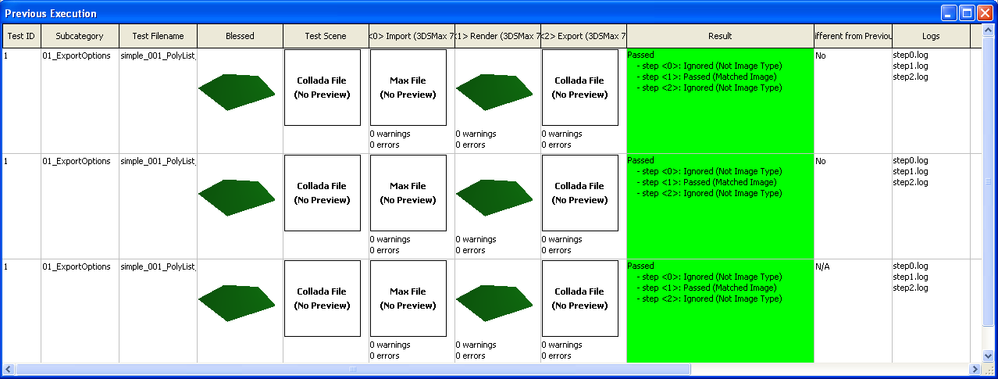
Figure 20: "Show Previous" dialog

Regular Expressions

Whenever tests are added to a test procedure, the settings and a regular expression is stored with it to remember the description of the tests that were added. This allows the Conformance Testing Framework to automatically detect new data sets that were added to the file structure that may be of interest to the test procedure. A regular expression is stored for each set of unique settings. It uses the same syntax and semantic as python regular expressions. In the “Application Settings” dialog (see Figure 6), if the data set was selected using regular expressions, then the regular expression is saved as is. Even when adding tests using the tree representation, the Conformance Testing Framework will create a large regular expression by taking the or of all the test scenes that were selected. When adding tests using settings that already have a regular expression, the Conformance Testing Framework will prompt the user whether to append or overwrite the previous expression. Appending will simply take the old and new regular expression and or them. Overwriting will discard the old regular expression all together.

When a test procedure is opened, it will search the data set file structure (see 11.2 Standard Data Sets) with each of the regular expressions saved and determine if there are any test scenes that match but are not in the test procedure with the specified settings. If so it prompts the user whether to add them. Tests that are deleted from the test procedure generate another regular expression. This regular expression is used to specify which test scenes to ignore for a specified series of settings. Thus it will not ask the user about test scenes that match the regular expression but were deleted at one point. Furthermore, if the user accepts not to add newly detected test scenes, those test scenes will also be added to regular expression for ignored tests via the or operation.

Regular expressions can be viewed and edited using the “Regular Expression Editor”, shown in Figure 21, accessible through the “Test” menu. The left side presents all the regular expressions saved with the test procedure. Clicking on one of them will update the right side with the information about the regular expression. The top right side shows the settings that the regular expression is associated with. Clicking the “Add/Edit” button will display more details about it. The bottom right shows the regular expressions and can be edited. Each of the regular expressions, one for ignored and one for detect, is broken up into pages. Each page is a string of at most 30000 characters that represents a python regular expression. A data set that matched any of the pages of the regular expression is said to match the regular expression. Pressing “Apply” saves the changes and pressing “Delete” deletes the entire regular expression from the test procedure. The regular expressions are checked syntactically before saving.

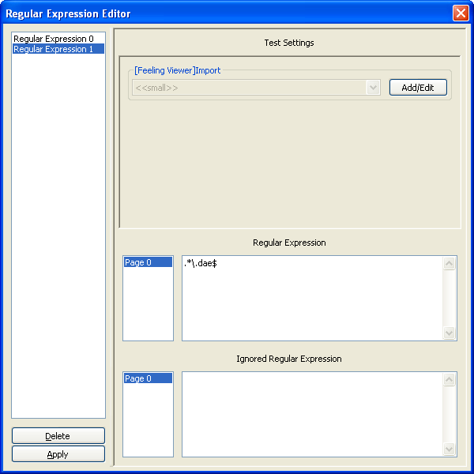
Figure 21: "Regular Expression Editor"

Blessing and Result Generation

The Conformance Testing Framework allows for two types of blessing: images/animations and executions. A blessed image/animation or execution signifies that the image/animation or execution is expected. There can be multiple blessed images/animations or executions. However, there can only be one default blessed image/animation, which is the one used in the comparisons and shown in the grid as an aid to Khronos Adopters during integration. Blessing is done using the context menus (see Figure 4 for menus). When blessing, the necessary files are created in the data sets file structure (see 11.2 Standard Data Sets) so that all test procedures have access to it. Once the blessing is finished, the Conformance Testing Framework updates the execution that the blessed image/animation or execution came from, but it does not update other executions. Results are not updated when a test procedure is opened either. For example, a test procedure has two tests using the same test scene (possibly with different settings) and only one step, Import Feeling Viewer. The outputted images happen to be exactly the same and do not correspond with any that were blessed so the generated result after running is that both executions fail. When the user blesses one of those images, the execution that the image belonged to is updated and the result changes to a pass. However the second execution is not and remains a failure until the user explicitly tells the Conformance Testing Framework to update.

One way to explicitly update a result is by using the “AutoUpdate Results” button on the toolbar, or the equivalent in the “Test” menu. This will go through all the tests in the test procedure and update all the execution results based on what is currently in the data sets file structure. However, it will not update results that the user toggled. Toggling is done by either double clicking on the cell in the “Result” column of the execution, or through the context menu. This allows the user to pass or fail an execution independent of what is in the data set file structure. “AutoUpdate Results” does not update these types of results. To do so requires selecting the execution and selecting the “Update Execution Result” option from the context menu.

Figure 22 shows some possible results. The result generation is done by first checking to see if there is a previous execution for the test and if the result was toggled by the user. If this is the case and the current execution is the same as the previous execution, then the Conformance Testing Framework will take the same result as the previous. If this was not the case, then it checks to see if any of the blessed executions match the given execution. It passes if there is and a result similar to the third image in Figure 22 is shown in the “Result” column. Executions match if the number of errors, number of warnings, comments, environments, and outputs are the same.

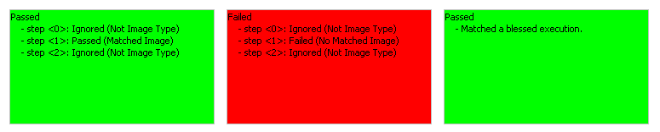
Figure 22: Examples of results

If there is no match in the previous execution or the blessed executions, it will finally check each step individually and present a result similar to the first and second image of Figure 22. Any step fails if the DCC did not produce the file it should have. A validation step fails if the validation failed. All other steps with no images or animations are ignored; thus only the Render steps and Feeling Viewer Import steps are checked. Blessed images are grouped by extension in the file structure (see 11.2 Standard Data Sets), and the blessed animations are in a group by themselves. The group of the outputs for each step is determined and checked against the corresponding group in the blessed images/animations. If there is no corresponding blessed group for a step, then that step is ignored. If there is a blessed group, the Conformance Testing Framework will look in that group and compare all the images/animations until there is a match, and the step passes, or until there are not more images/animations in that group, and the step fails. An execution fails if any of its steps fail. The “Result” column of the grid shows the results of each step if it reached this level of verification, as in the first two results in Figure 22.

The “View Blessed” option in the context menu is used to open the Blessed Viewer, as shown in Figure 23, which is used to view all the blessed images and animations for the selected test. On the left is a list of all the blessed images and animations. Clicking on any of the names will display the corresponding image or animation on the right side. The controls are the same as with the other viewers in the Conformance Testing Framework. The “Unbless” button is used to delete the blessed image so that it will not play any part of further result generation. However, none of the results of the tests will be automatically updated because of this change.

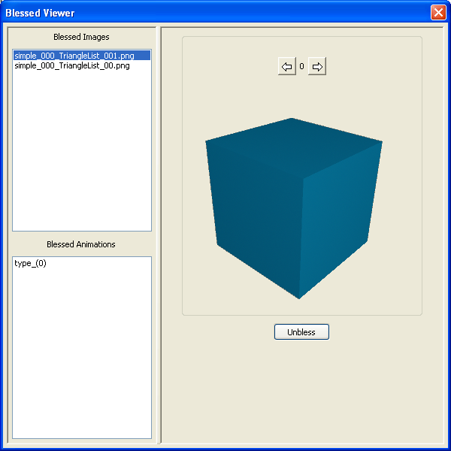
Figure 23: Blessed Viewer

Transporting

The Conformance Testing Framework has been designed to easily transport different components between machines. The data sets can be transported by simply copying the relevant directory in the StandardDataSets directory to the StandardDataSets directory on the new machine. Note that for this reason, the data sets should use relative paths. The Conformance Testing Framework will recognize it, and if regular expressions are used in the test procedures, they will add it to the test procedure as well.

Test procedures can be transported to another machine by simply copying the directory in the TestProcedures directory corresponding to the test procedure to be transported and moving it to the TestProcedures directory on the new machine. The Conformance Testing Framework will update all the paths to correspond to the new path of the test procedure. All the settings that are used by the transported test procedure are transported as well. However, the data set is not; thus if the new machine does not have the data set, then it cannot be run again. Of course, it can view the results though.

Application settings can be transported to another machine by copying the text file from the ApplicationsSettings subdirectory to the ApplicationsSettings subdirectory of the new machine. It must be put in the correct directory with respect to the application and operation; otherwise the wrong settings will be given to the DCC, which could cause instability.

Command Line Interface

The command line interface is accessible using FTestSuite.py and a couple of parameters. FTestSuite.py –help will print out the usage information. The command line interface can perform a limited number of tasks which can be used to automate testing. These tasks include opening a testing procedure (using file) and adding all missing test scenes detected by the regular expression (using addMissingTests), run all the tests (using runAll), and export HTML files (using html). The option for showing blessed/previous preview side by side can be specified (using showBlessed and showPrevious), as well as the preview width and height (using previewWidth and previewHeight). The command line version can also generate a small statistics file that contains the number of tests passed/failed/total (using statistics). One additional feature of the command line version that is not in the GUI version is its ability to export to HTML only the tests that are different from previous or have no previous (using diffHtml).

Creating Data Sets

Data sets are put in the StandardDataSets directory in the file structure (see 11.2 Standard Data Sets). The Conformance testing framework will only search here for the data sets. Explaining how it works is best done with an example. The following is one of the data sets that come with the Conformance Testing Framework version 1.3.

StandardDataSets\Collada\10_MayaExported\01_ExportOptions\simple_000_TriangleList_00\

The Category is 10_MayaExported.
The Subcategory is 01_ExportOptions.
The Data Set Name is simple_000_TriangleList_00.

The test scene should be in the directory with a proper name same as the Data Set Name (in this case it is simple_000_TriangleList_00.dae).

Important: Besides the test scene, there should be no other file with the same proper name as the data set name. This is an important note for XSI since it creates a .scntoc file with the same proper name as the name of the scene in the data set directory. Deleting that file suffices.

To make using the Conformance Testing Framework more consistent with respect to settings, every scene should have a camera with the same name. While designing a data set, one should keep in mind the default setting for the cameras in the Conformance Testing Framework are:

- Feeling Viewer: ""
- Maya: "|testCamera"
- Max: "$testCamera"
- XSI: "testCamera"

If the user uses the Conformance Testing Framework’s default setting and the camera is not in the scene, it will not render properly.

External files used by the test scene can be placed anywhere. As long as it is not in a directory with a name the same as the proper name of the file, the Conformance Testing Framework will not see it as a test scene. External files should be referenced using a relative path if possible. This simplifies things considerably when distributing data sets. Although not mandatory, it is suggested if the external file is only used by one test scene to just put it in the same directory as the test scene. If it is used in many, you can put it in a higher directory.

The Conformance Testing Framework version 1.3 only supplies test scenes that are COLLADA files. However, it does handle some test scenes in .max, .mb, .ma, and .scn format. The following are some notes on how to create scenes that have relative paths in those file formats.

3ds Max 7
The conformance test will set sysInfo.currentdir of Max to be the same as the directory that the test scene is in. When creating data sets for Max, use MaxScript to change the absolute texture paths to be relative paths. To do this, for each material in the scene, change all its maps that use an external file to be relative. Here are some examples illustrating how to do so for types of textures and maps (see MaxScript reference if the type you want is not here):

Standard
sceneMaterials[1].diffuseMap.filename = "..\..\..\Textures\Texture_1.jpg"

Double sided textures
sceneMaterials[2].material1.diffuseMap.filename = "..\..\..\Textures\AlphaTexture.tif"
sceneMaterials[2].material1.opacityMap.filename = "..\..\..\Textures\AlphaTexture.tif"
sceneMaterials[2].material2.diffuseMap.filename = "..\..\..\Textures\AlphaTexture.tif"
sceneMaterials[2].material2.opacityMap.filename = "..\..\..\Textures\AlphaTexture.tif"

Composite
sceneMaterials[1].materialList[2].diffuseMap.filename = "..\..\..\Textures\Texture_6.tga"
sceneMaterials[1].materialList[3].diffuseMap.filename = "..\..\..\Textures\Texture_7.tga"
sceneMaterials[1].materialList[4].diffuseMap.filename = "..\..\..\Textures\Texture_8.tga"
sceneMaterials[1].materialList[5].diffuseMap.filename = "..\..\..\Textures\Texture_9.tga"
sceneMaterials[1].materialList[6].diffuseMap.filename = "..\..\..\Textures\Texture_10.tga"

Blend
sceneMaterials[1].map1.diffuseMap.filename = "..\..\..\Textures\Texture_1.jpg"
sceneMaterials[1].map2.diffuseMap.filename = "..\..\..\Textures\Texture_2.jpg"

Maya 7.0
Maya uses relative paths relative to the scene's Project directory. The Project directory is determined by the options when "Save Scene As..." is selected. There is a button near the bottom of the dialog labeled "Set Project". Set it to one directory above the lowest common directory being referenced since Maya does not allow ".." in the relative paths. For instance, assume the scene is referencing these two files:

- C:/test/textures/image1.jpg
- C:/test/special/files/file1.mb

In this case, set the Project directory to C:/test. The scene itself can be saved anywhere. This method seemed to not work for cg examples.

XSI 5.1
XSI seems to use relative paths well if the project file structure is used. Thus, the Conformance Testing Framework uses the searchAndReplacePath method offered by the XSI SDK to simulate relative paths. It will search and replace "C:\CTFReplaceWithFilepath" with the directory that the file is in for all external file paths. For instance, a scene located at C:\test\xsi\scene.scn and a texture file it is referencing is located at C:\test\textures\image1.jpg. Then the file reference (in the File→External Files) should be linked to C:\CTFReplaceWithFilepath\..\textures\image1.jpg.

Design and File Structure

The file structure is designed to be simple yet powerful, allowing additional data sets, applications, and application settings to be added easily. Section 10.5 Transporting explains how these components can be transported to other machines. An overall view of this file structure is located in the Appendix (see Figure 33). Sections of it are presented here and elaborated.

CTF

The top directory of the Conformance Testing Framework, shown in Figure 24, is CTF. All the __init__.py files are only used by python to recognize the directory as a package and can be ignored by the user. glut32.dll is a dll used by pyOpenGL and can also be ignored. config.txt is a text file that needs to be edited to specify configurations mostly related to the machine’s paths and crash detection (see 6.0 Configuration). FTestSuite.py is the python script that initiates the Conformance Testing Framework. The Documentation directory includes documentation for the Conformance Testing Framework and only contains this file. The Prerequisites directory contains several programs that need to be installed in order to run the Conformance Testing Framework (see 5.0 Installation). The directories ApplicationSettings, Core, Scripts, StandardDataSets, and TestProcedures are explained in the following sections.

CTF
- __init__.py
- FTestSuite.py
- config.txt
- glut32.dll
- ApplicationSettings
- Core
- Documentation
- README.doc
- ImageComparators
- Prerequisites
- <installation files for Conformance Testing Framework prerequisites>
- Scripts
- StandardDataSets
- TestProcedures
Figure 24: Top level of file structure

Standard Data Sets

The StandardDataSets subdirectory, partly shown in Figure 25, contains all the test scenes that are available to the Conformance Testing Framework. The test scenes are at least three levels from the StandardDataSets directory; Figure 25 shows it at four levels. The highest of the three levels is taken as the Category, the middle as the Subcategory, and the lowest as the data set name. The test scene’s proper filename must be the same as the data set name. Directories below the data set directory are ignored when searching for test scenes. If “Animation” or “animation” is found in the Category, Subcategory, or data set name, the test scene is considered an animation. The Category, Subcategory, and data set name in Figure 25 are 10_MayaExported, 01_ExportedOptions, and simple_000_TriangleList_00 respectively. The test scene is simple_000_TriangleList_00.dae. The comments.txt file is used to store the comments for the test scene and is shown in the “Description” column of the Conformance Testing Framework.

Within the data set directory, the Conformance Testing Framework creates a directory called Blessed to store the blessed images/animations or executions. The file default.txt in this directory contains information about the default blessed image/animation. It stores the relative link from the Blessed directory to the image, or series of images for animations. Animations are stored in the animations directory. Each blessed animation has its own directory in the format type(#) to store all the frames of the animation. Blessed images are grouped by file extension. Figure 25 shows the png group with one file it in. Other blessed PNG images will go in this directory as well. Finally, blessed executions go in the executions directory. Executions are categorized into types based on their steps. executionsManager is a text file that contains a mapping from steps to the relative directory, from Core, of the types. Within the type(#) directory, each blessed execution is stored in its own directory with the format blessed_(#).

CTF
- StandardDataSets
- Collada
- 10_MayaExported
- 01_ExportedOptions
- simple_000_TriangleList_00
- simple_000_TriangleList_00.dae
- comments.txt
- Blessed
- default.txt
- animations
- type(0)
- <application/operation outputs>
- executions
- executionsManager
- type(0)
- blessed_(0)
- serializedExecution.obj
- step0
- <application/operation outputs>
- serializedExecution.obj
- png
- simple_000_TriangleList_001.png
Figure 25: StandardDataSets subdirectory in file structure

Application Settings

The ApplicationsSettings subdirectory, partly shown in Figure 26, contains all the saved settings that the user created for the operations and applications. By default, there is no such subdirectory but one will be generated at run time when the first setting is saved. Under this subdirectory are directories for each of the three operations available (Import, Export, Render). And within these directories are directories for each of the applications that have saved settings. Each setting is a text file with extension txt where each line contains a setting entry. A setting entry is of the form settingPrettyName(\t)settingTag(\t)settingValue, where (\t) denotes a tab character; an example is Anti-Aliasing(\t)antiAliasing(\t)false. New application settings can be added to the testing framework through these files in addition to using the GUI.

CTF
- ApplicationSettings
- Import
- 3DSMax 7
- Default.txt
- Export
- Render
Figure 26: ApplicationSettings subdirectory in file structure

Test Procedures

The TestProcedures directory, partly shown in Figure 27, contains all the test procedures, along with their corresponding tests and executions. Each test procedure is made up of tests, which is a link to the test scene along with application settings and steps to perform. Each test is made up of executions, which contains the results for running through the steps once. The directory structure reflects this.

Each test procedure will have its own directory below the TestProcedures directory with the same name as that of the test procedure. The serialized*.obj files within all these directories are required for opening saved test procedures and should not be touched. The prefs.obj file contains the preferences that are stored with the test procedure assigned using the “Preferences” dialog (see 9.3 Preferences). The remaining file in the TestProcedures directory is the comments.txt file, which contains the test procedure’s comments and may be edited. The workingDir directory is given to the application specific python script in the BeginScript call (see 11.5 Scripts) so it can use it to save temporary scripts and other files.

For each test in the test procedure, there is a directory below the one for the test procedure, called Test# where # is a unique id for that test. Finally each execution has its own a directory below that of the corresponding test. The Executions directory name also contains the date ran and a number unique for that day. This helps users identify executions for comparisons in the Conformance Testing Framework. Under the Executions directories are directories, labeled step0, step1, etc, for each of the steps in the test. Each step directory contains the files generated by the DCC, as well as the log file, for that operation.

CTF
- TestProcedures
- NewTestProcedure
- prefs.obj
- serializedTestProcedure.obj
- comments.txt
- Test0
- serializedTest.obj
- Execution_2006 05_24_(0)
- serializedExecution.obj
- Step0
- Step0.log
- <application/operation results>
- WorkingDir
- <temporary files from application specific python scripts>
Figure 27: TestProcedures subdirectory in file structure

Scripts

The Scripts directory, shown in Figure 28, contains all the python scripts used to represent different DCCs to the logic of the testing framework. FApplication.py contains the abstract class, FApplication, from which all other scripts in this directory are inherited. It is fully documented and can be a template to create new scripts for DCCs that are not initially supported. FApplication’s interface is shown in Figure 29. The initially supported DCCs are Autodesk Max (FMax.py), Autodesk Maya (FMaya.py), Softimage XSI (FXsi.py), and Feeling Software’s Feeling Viewer (FViewer.py). The Conformance Testing Framework searches the Scripts directory to find which applications are available; thus adding new applications require only inheriting a class from FApplication and placing the file in this directory.

CTF
- Scripts
- FApplication.py
- FViewer.py
- FMax.py
- FMaya.py
- FXsi.py
Figure 28: Scripts subdirectory in file structure

GetPrettyName(): return string
- returns the unique name for this application which is shown to the user

GetOperationsList(): return operations
- returns a list of operations that are available by this application
- this method may be overridden; the default behavior is to return a list of the three operations: import, export, and render

GetSettingsForOperation(operation): return settings
- returns a list of settings with default values for a given operation

BeginScript(workingDir)
- called before writing any operations; can be used to create scripts, and other initializations
- workingDir is the path where this object can leave temporary files such as the script

EndScript()
- called after writing all operations but before RunScript is called; can be used for closing the scripts and other finalizations
RunScript()
- runs the script that was written by calling the DCC with the script as input

WriteImport(filename, logname, outputDir, settings, isAnimated):
return outputs
- writes importing filename with specified settings to the current script
- logname is the filename of the log file for this operation
- outputDir is the directory to save any outputs
- isAnimated is true if filename is an animated scene
- returns a list of filenames relative to outputDir that is generated by running the script

WriteRender(logname, outputDir, settings, isAnimated): return outputs
- writes rendering the currently imported file with specified settings to the current script
- logFilename is the filename of the log file for this operation
- outputDir is the directory to save any outputs
- isAnimated is true if the imported file is an animated scene
- returns a list of filenames relative to outputDir that is generated by running the script

WriteExport(logname, outputDir, settings, isAnimated): return outputs
- writes exporting the currently imported file with specified settings to the current script
- logFilename is the filename of the log file for this operation
- outputDir is the directory to save any outputs
- isAnimated is true if the imported file is an animated scene
- returns a list of filenames relative to outputDir that is generated by running the script
Figure 29: Interface for FApplication

Image Comparators

The ImageComparators directory, shown in Figure 30, contains all the python scripts used to represent different image comparators to the logic of the testing framework. The actual image comparator that is used is set in the config.txt file with the tag name imageComparator. For instance, to use the byte by byte comparator, the field in the config.txt should say FByteComparator. This value is loaded into memory when the CTF is opened.

FImageComparator.py contains the abstract class, FImageComparator, from which all other image comparators in this directory are inherited. It also contains the FCompareResult class which is returned for each comparison and used by the CTF. Both these classes are fully documented. FImageComparators’s interface is shown in Figure 31. The currently supported image comparators are the byte by byte comparator and a mipmap pyramid difference comparator.

CTF
- ImageComparators
- __init__.py
- FByteComparator.py
- FImageComparator.py
Figure 30: ImageComparators subdirectory in file structure

CompareImages(filename1, filename2): return result
- returns the result, as FCompareResult, of the comparison of two images given by their filenames.
- FCompareResult is an object is made up of two members: a Boolean value to represent if the images are the same or not, and a python object that can be set by a FImageComparator in order to get information in the GetMessage method.

GetMessage(compareResultList): return message
- returns a string to be written in the result column of the CTF; returning empty string will use the default message (a vague pass/fail message).
- compareResultList is a list of FCompareResult that this FImageComparator generated through the CompareImage method. The list is the entire list of all blessed images/animations if there is no match. This, along with the extra member in the FCompareResult, is sufficient to display an informative message on why it failed. If there is a matching blessed image/animation, then the list will only have a single element, namely the matching FCompareResult.
Figure 31: Interface for FImageComparator

Core

The Core subdirectory, shown in Figure 32, contains all essential files for the Conformance Testing Framework and need not be edited unless the user needs to reprogram it. Classes that act close to entry points are stored directly in the Core subdirectory; the only real entry point is FTestSuite.py in the main directory. Most of these classes are wrappers that use the API from the Core/Logic directory and provide an interface of their own for the user. The command line, GUI, and HTML exporter are the interfaces that were implemented in the Conformance Testing Framework version 1.3. The SchemaValidate.exe file in this directory is a simple .NET program that validates xml files against a schema. The Conformance Testing Framework uses this program to validation COLLADA files against the schema that is in the Core directory, COLLADASchema.xsd. This schema is currently the COLLADA 1.4.1 schema but edited slightly to remove the xs:import statements since SchemaValidate.exe can not handle this. The FileWatcher.exe file in this directory is a simple .NET program that watches for file I/O in a directory and times out after a specified amount of time of inactivity. It is used for crash detection.

The images subdirectory in the Core directory is used to store all the images used by the Conformance Testing Framework. The Common subdirectory stores the classes and scripts that are general and can be used throughout the Conformance Testing Framework. One class that may be useful from the Scripts directory is FUtils.py, which contains some useful file path related methods. The Gui subdirectory contains classes relating to the GUI and is used mostly by FTestSuiteGUI.py from the Core directory. It is separated into the classes relating to the grid, Core/Gui/Grid, and those relating to dialogs, Core/Gui/Dialog. Finally, the Logic subdirectory is used to store the main logic for the Conformance Testing Framework. A developer can use the interface that it provides through the classes FTestProcedure.py, Ftest.py, FExecution.py, FReults.py, FSetting.py, and FSettingEntry.py to develop a new interface for the Conformance Testing Framework. FTestSuiteGUI.py, FTestSuiteCommand.py, and FHtmlExporter.py in the Core directory were developed this way.

- Core
- SchemaValidate.exe
- FileWatcher.exe
- COLLADASchema.xsd
- <python classes relating to entry points>
- Common
- <python scripts for common methods or general classes>
- Gui
- <python general GUI classes>
- Dialog
- <python dialog classes>
- Grid
- <python grid and related classes>
- images
- <images used in the Conformance Testing Framework>
- Logic
- <python classes for main logic of Conformance Testing Framework>
Figure 32: Core subdirectory of file structure

Known Issues

Here is a list of major known issues with the Conformance Testing Framework:
- Problem with long file path names. This is an issue with Windows since it does not allow file paths to be greater than 255 characters in length. It becomes noticeable especially with blessing animations or executions, with long file path names in data sets, and with the Conformance Testing Framework installed in a long file path to begin with.
- Running out of memory when the entire test suite is run at once. An error dialog appears repeatedly on every image refresh. This is caused by the display of animated images in the CTS Framework. The problem can be avoided by having "Test > Animate Selected Only"option turned on and not selecting an animated test case in the framework.
- “IndexError: list index out of range” error when running tests. Changes to the core files of the test framework require the creation of a new test procedure. Running a test procedure created from a previous release of the the framework can cause this error. The solution is to remove the old test procedure and create a new one.

Appendix
CTF
- __init__.py
- FTestSuite.py
- config.txt
- glut32.dll
- ApplicationSettings
- Import
- 3DSMax 7
- Default.txt
- <other settings>
- <other DCCs>
- Export
- Render
- Core
- SchemaValidate.exe
- FileWatcher.exe
- COLLADASchema.xsd
- <python classes relating to entry points>
- Common
- <python scripts for common methods or general classes>
- Gui
- <python general GUI classes>
- Dialog
- <python dialog classes>
- Grid
- <python grid and related classes>
- images
- <images used in the Conformance Testing Framework>
- Logic
- <python classes for main logic of Conformance Testing Framework>
- Documentation
- README.doc
- CTF_How_To.doc
- CTF_Template.dae
- CTF_Template.mb
- CTSManual.doc
- HowToAddSoftware
- README.doc*
- build_information_template.txt
- release notes.txt
- submission_details_template.txt
- ImageComparators
- __init__.py
- FByteComparator.py
- FImageComparator.py
- FPyramidDiff.py
- <image comparison scripts>
- Prerequisites
- <installation files for Conformance Testing Framework prerequisites>
- Scripts
- __init__.py
- CoherencyTest.py
- FApplication.py
- FMax.py
- FMaya.py
- FMaya_UIRender.py
- FViewer.py
- FXComposer.py
- FXsi.py
- SchemaValidate.py
- <other application specific python scripts for DCCs>

- StandardDataSets
- collada
- library_geometries
- geometry/mesh/triangles
- collada_triangles
- collada_triangles.dae
- <directories for textures and files used in test scene>
- Blessed
- default.txt
- animations
- type(0)
- <application/operation outputs>
- executions
- executionsManager
- type(0)
- blessed_(0)
- serializedExecution.obj
- step0
- <application/operation outputs>
- <other steps>
- <other blessed of same type>
- <other types>
- png
- collada_triangles.png
- <other blessed png for test scene>
- <other blessed image groups>
- <other subcategories>
- <other categories>
- Textures
- <textures used in multiple test scenes>
- <other file formats/data sets>
- TestProcedures
- NewTestProcedure
- prefs.obj
- serializedTestProcedure.obj
- comments.txt
- Test0
- serializedTest.obj
- Execution_2006 05_24_(0)
- serializedExecution.obj
- Step0
- Step0.log
- <application/operation results>
- <other steps>
- <other executions>
- <other tests>
- WorkingDir
- <temporary files from application specific python scripts>
- <other test procedures>
Figure 33: An overall view of the testing framework file structure

