References
[1] https://en.wikipedia.org/wiki/Time-Sensitive_Networking
[2] http://www.ni.com/white-paper/53851/en/
[3] https://www.deterministicethernet.com/time-sensitive-networking--tsn-
[4] https://arxiv.org/pdf/1807.00078.pdf
[5] Delay and Jitter Characterization for Software-Based Clock Synchronization Over WLAN Using PTP (Aneeq Ahmad et. al)
[6] http://www.ni.com/white-paper/54730/en/
[7] https://www.kth.se/polopoly_fs/1.569790!/J.Eidson.pdf
[8] http://www.hte.hu/documents/12453/58124/Sylvestre_Kiss_Oscilloquartz.pdf
[9] IEEE Std 802.1AS-2011, “IEEE std. for local and metropolitan area networks - timing and synchronization for time-sensitive applications in bridged local area networks,” Mar. 2011.
[10] https://www3.nd.edu/~cpoellab/teaching/cse40815/Chapter9.pdf
[11] The Flooding Time Synchronization Protocol (Maróti, Kusy, Simon, Lédeczi)
[12] Mahmood et al. “Clock synchronization over IEEE 802.11 a survey of methodologies and protocols”

In industrial environment, closed-loop control applications such as robot manufacturing, round table production, machine tools, packaging and printing needs ultra-tight synchronization because of real-time and time-slotted communication, and isochronous task execution [4]
A typical closed-loop control cycle consists of a down-link transaction to a set of sensors periodically, which is followed by up-link responses by the sensors to the controller. The control events are executed within a cycle time and may occur isochronously. Cycle time is the time from the transmission of a command by the controller to the reception of its response from the devices. TSN [9] specifies a very precise end-to-end latency and reliability constraints on each transaction that it must be completed within a 1ms cycle time with 99.999 % reliability. Furthermore, a jitter constraint of 1µs is imposed on the delivery of responses which requires better than ±500ns synchronization accuracy among devices. Any violation of latency and jitter in control commands can damage the production line and cause the safety issues [4].
Ethernet-based automation networks, PROFINET and IEEE 802.1 TSN, use IEEE 1588 variants to ensure determinism. TSN contains a series of standards related to ultra reliability, low latency and resource management aspects while IEEE 802.1AS is the standard for transport of precise timing and synchronization [9].
To transport packets with bounded delays in RT traffic, time-slotted communication is an effective mechanism. Existing industrial wired and wireless networks implement a variant of time-slotted communication. It requires perfect time synchronization as any timing error leads to the overlap of time slots among the devices, which disrupts the communication reliability [4].

IEEE 802.1AS
IEEE 802.1AS is now a profile of IEEE 1588 that will be used for TSN and has some performance and scalability benefits over other profiles. We believe over time that 802.1AS will become the dominant profile in industry [6]. Principal functions of IEEE 802.1AS includes picking the best clock, the grandmaster, as the root of a spanning tree (BMC Algorithm) to form a master-slave hierarchy and Synchronize each clock to its parent, i.e. the next upstream clock in the spanning tree[7]. IEEE 802.11AS can provide very accurate synchronization in the order of µs or even better by using hardware timestamping after signal transmission and reception. To communicate the timestamps from master to slave IEEE 802.11AS uses two-way protocol (see section #) to enable the measurement of round-trip time of the timing signal.

Time Transfer
→ One-way protocols: e.g. GPS, Loran, IRIG-B
One-way clock synchronization protocols are based on unidirectional communication from the time master station to the slave station. In such protocols, A acts as a broadcast station and may send out timing signals either continuously or periodically. The delivery time of a broadcast signal cannot be calculated and hence another separate method is required to compute the time delay of signal transfer. Synchronization protocols such as flooding time synchronization protocol uses this time transfer technique.

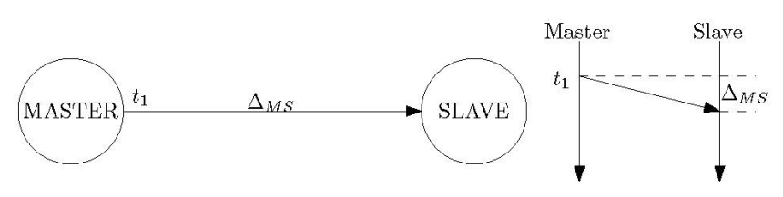

Offset = t2 – t1 – ΔMS (1)

→ Two-way protocols: e.g. NTP, PTP, two-way satellite time and frequency transfer (TWSTFT)
Two-way clock synchronization protocols involve bidirectional communication between master and slave stations. Such protocols enable measurement of the round trip time of the timing signal.

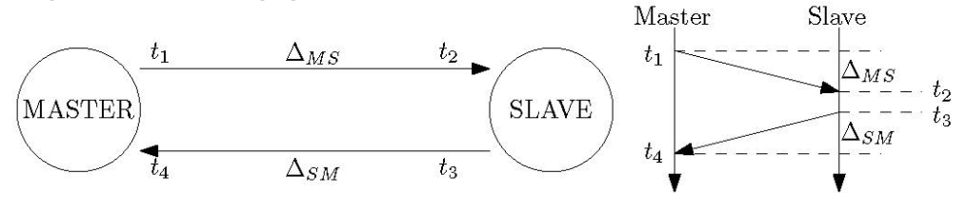
Offset = ((t2 – t1) – (t4 + t3)) /2 – (ΔMS – ΔSM)/2 (2)

The offset depend on knowing both ΔMS and ΔSM and Time transfer precision degraded by path jitter. Time transfer accuracy degraded by path asymmetry which must either be modeled or determined by calibration measurements other than the two-way messages. Physical layer (PHYs), bridges and routing are major sources of asymmetry [7].

If the propagation delay in both directions is symmetric (ΔMS, ΔSM), then (2) shows that the offset can be calculated precisely by with hardware timestamping. However, commercial-off-the shelf (COTS) wireless devices cannot do hardware timestamp for PTP packets. To overcome this limitation, version 2012 of the IEEE 802.11 [1] has introduced timing measurement action frames (see section TIMEMSMT protocol), which provide hardware timestamps for application synchronization. However, as of now, such WLAN NICs are not available in the market. The proprietary WLAN devices of [9] can perform hardware timestamping but result in nonconformity with the standard and higher costs than COTS devices. Hence, to maintain standard conformity and avoid large deployment costs, synchronization over COTS WLAN devices is to be materialized using software timestamps [5].
Deploying software-based WLAN synchronization is cost effective, but suffers from the jitter of software timestamps. The jitter can be reduced if timestamps are drawn as close to the physical layer (PHY). This will avoid the jitter coming from higher layers of the protocol stack and will also circumvent the uncertainty introduced by the channel access scheme of IEEE 802.11. However, the processing done inside the WLAN chipset after transmission and reception and drawing of the timestamps still imparts uncertainty to the actual time of packet reception or transmission. Moreover, the assumption for symmetric path delays cannot always hold because of potentially different propagation delays during transmission and reception. Consequently, any path delay asymmetry during propagation will result in a bias, which will be reflected in the offset calculation as indicated by (2) [8].

From the above analysis we can say that the performance of synchronization protocol is heavily affected by Packet Delay Variation and Packet Delay Asymmetry.

Simulation Results
we carried out a ns3 simulation for time synchronization using various parameters. The simulation scenarios are explained below with their outcomes.

1. one-way transfer protocols
We simulated a network with 1-10 number of stations attached with an access point. The access point broadcasts the beacon with clock sync timestamps drawn at hardware (PHY) layer. We placed the stations in varying distances from one meter to 150 meters and recorded the results at illustrated in the following table.

Table 1: Clock Synchronization with
Distance (Meter) | Clock Error (Nano Seconds)
1 | 3
10 | 33
20 | 66
30 | 100
40 | 133
50 | 166
60 | 200
70 | 233
80 | 266
90 | 300
100 | 333
125 | 416
150 | 500
160 | No Signal

Convergence time is one message transmission time ie beacon broadcast time.

Clock Error When time is drawn at MAC or APP layer
[To Do]

2. Two-way protocols

Results to be drawn

