References
[1] https://en.wikipedia.org/wiki/Time-Sensitive_Networking
[2] http://www.ni.com/white-paper/53851/en/
[3] https://www.deterministicethernet.com/time-sensitive-networking--tsn-
[4] https://arxiv.org/pdf/1807.00078.pdf
[5] Delay and Jitter Characterization for Software-Based Clock Synchronization Over WLAN Using PTP (Aneeq Ahmad et. al)
[6] http://www.ni.com/white-paper/54730/en/
[7] https://www.kth.se/polopoly_fs/1.569790!/J.Eidson.pdf
[8] http://www.hte.hu/documents/12453/58124/Sylvestre_Kiss_Oscilloquartz.pdf
[9] IEEE Std 802.1AS-2011, “IEEE std. for local and metropolitan area networks - timing and synchronization for time-sensitive applications in bridged local area networks,” Mar. 2011.
[10] https://www3.nd.edu/~cpoellab/teaching/cse40815/Chapter9.pdf
[11] The Flooding Time Synchronization Protocol (Maróti, Kusy, Simon, Lédeczi)

[6]

TSN and IEEE 1588
TSN adds a series of features that includes following to the Ethernet standard (IEEE 802 aka LMSC)
• Mechanisms for time synchronization (IEEE 802.1AS)
• Mechanisms for using coordinated time to schedule traffic (IEEE 802.1 Qbv)
• Mechanisms to assure simple/scalable system configuration (IEEE 802.1 Qcc)
The IEEE 1588 standard provides sets of options for time synchronization. There are multiple profiles in 1588 where each profile selects which options it will use. This impacts what hardware and software is needed to support the profile and causes incompatibilities between profiles. Support for each of these profiles requires different network switches and different end devices.
When the IEEE 802 group was deciding how to provide time synchronization they elected to use 1588. IEEE 802 selected a profile and added it to their standards work directly to assure appropriate investment and control. This is the IEEE 802.1AS standard.
IEEE 802.1AS is now a profile of IEEE 1588 that will be used for TSN and has some performance and scalability benefits over other profiles. We believe over time that 802.1AS will become the dominant profile in industry.

==============================
In industrial environment, closed-loop control applications such as robot manufacturing, round table production, machine tools, packaging and printing needs ultra-tight synchronization because of real-time and time-slotted communication, and isochronous task execution [4]
A typical closed-loop control cycle consists of a down-link transaction to a set of sensors periodically, which is followed by up-link responses by the sensors to the controller. The control events are executed within a cycle time and may occur isochronously. Cycle time is the time from the transmission of a command by the controller to the reception of its response from the devices. TSN [9] specifies a very precise end-to-end latency and reliability constraints on each transaction that it must be completed within a 1ms cycle time with 99.999 % reliability. Furthermore, a jitter constraint of 1µs is imposed on the delivery of responses which requires better than ±500ns synchronization accuracy among devices. Any violation of latency and jitter in control commands can damage the production line and cause the safety issues [4].
Ethernet-based automation networks, PROFINET and IEEE 802.1 TSN, use IEEE 1588 variants to ensure determinism. TSN contains a series of standards related to ultra reliability, low latency and resource management aspects while IEEE 802.1AS is the standard for transport of precise timing and synchronization [9].
To transport packets with bounded delays in RT traffic, time-slotted communication is an effective mechanism. Existing industrial wired and wireless networks implement a variant of time-slotted communication. It requires perfect time synchronization as any timing error leads to the overlap of time slots among the devices, which disrupts the communication reliability [4].

IEEE 802.1AS
IEEE 802.1AS is now a profile of IEEE 1588 that will be used for TSN and has some performance and scalability benefits over other profiles. We believe over time that 802.1AS will become the dominant profile in industry [6]. Principal functions of IEEE 802.1AS includes picking the best clock, the grandmaster, as the root of a spanning tree (BMC Algorithm) to form a master-slave hierarchy and Synchronize each clock to its parent, i.e. the next upstream clock in the spanning tree[7]. IEEE 802.11AS can provide very accurate synchronization in the order of µs or even better by using hardware timestamping after signal transmission and reception. To communicate the timestamps from master to slave IEEE 802.11AS uses two-way protocol (see section #) to enable the measurement of round-trip time of the timing signal.

Time Transfer
→ One-way protocols: e.g. GPS, Loran, IRIG-B
One-way clock synchronization protocols are based on unidirectional communication from the time master station to the slave station. In such protocols, A acts as a broadcast station and may send out timing signals either continuously or periodically. The delivery time of a broadcast signal cannot be calculated and hence another separate method is required to compute the time delay of signal transfer. Synchronization protocols such as flooding time synchronization protocol uses this time transfer technique.

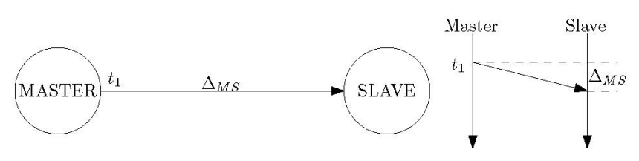

Offset = t2 – t1 – ΔMS (1)

→ Two-way protocols: e.g. NTP, PTP, two-way satellite time and frequency transfer (TWSTFT)
Two-way clock synchronization protocols involve bidirectional communication between master and slave stations. Such protocols enable measurement of the round trip time of the timing signal.

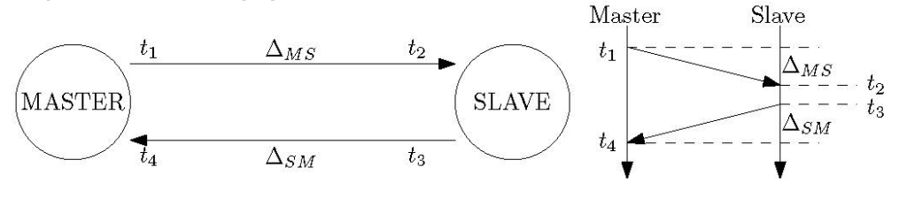
Offset = ((t2 – t1) – (t4 + t3)) /2 – (ΔMS – ΔSM)/2 (2)

The offset depend on knowing both ΔMS and ΔSM and Time transfer precision degraded by path jitter. Time transfer accuracy degraded by path asymmetry which must either be modeled or determined by calibration measurements other than the two-way messages. Physical layer (PHYs), bridges and routing are major sources of asymmetry [7].

If the propagation delay in both directions is symmetric (ΔMS, ΔSM), then (2) shows that the offset can be calculated precisely by with hardware timestamping. However, commercial-off-the shelf (COTS) wireless devices cannot do hardware timestamp for PTP packets. To overcome this limitation, version 2012 of the IEEE 802.11 [1] has introduced timing measurement action frames (see section TIMEMSMT protocol), which provide hardware timestamps for application synchronization. However, as of now, such WLAN NICs are not available in the market. The proprietary WLAN devices of [9] can perform hardware timestamping but result in nonconformity with the standard and higher costs than COTS devices. Hence, to maintain standard conformity and avoid large deployment costs, synchronization over COTS WLAN devices is to be materialized using software timestamps [5].
Deploying software-based WLAN synchronization is cost effective, but suffers from the jitter of software timestamps. The jitter can be reduced if timestamps are drawn as close to the physical layer (PHY), which is in the interrupt service routine (ISR) inside the device driver. This will avoid the jitter coming from higher layers of the protocol stack and will also circumvent the uncertainty introduced by the channel access scheme of IEEE 802.11. However, the processing done inside the WLAN chipset after transmission and reception, interrupt handling (IH) by the CPU, and drawing of the timestamps still imparts uncertainty to the actual time of packet reception or transmission. Moreover, the assumption for symmetric path delays cannot always hold because of potentially different propagation delays during transmission, reception, and IH. Consequently, any path delay asymmetry during propagation will result in a bias, which will be reflected in the offset calculation as indicated by (2) [8].

From the above analysis we can say that the performance of synchronization protocol is heavily affected by Packet Delay Variation (PDV) and Packet Delay Asymmetry (PDA) whereas PDV and PDA depend on the number of switching / routing nodes, the traffic load and QoS mechanisms.

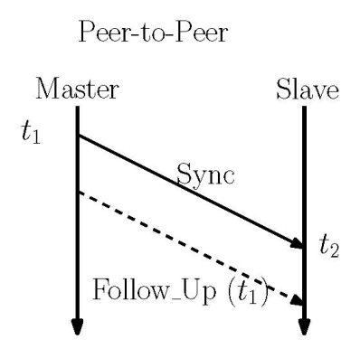

[10] Challenges for Time Synchronization  Traditional protocols (e.g., NTP) are designed for wired networks  WSNs pose a variety of additional challenges  Environmental effects  sensors often placed in harsh environments  fluctuations in temperature, pressure, humidity  Energy constraints  finite power sources (batteries)  time synchronization solutions should be energy-efficient  Wireless medium and mobility  throughput variations, error rates, radio interferences, asymmetric links  topology changes, density changes  node failure (battery depletion)  Other challenges  limited processor speeds or memory (lightweight algorithms)  cost and size of synchronization hardware (GPS)

Uncertainties in Radio Message Delivery
Send Time – Depending on the system call overhead of the system and on the current load (nodeterministic)
Access Time – message stays in the radio device and waiting for access to the transmit channel (nodeterministic)
Transmission Time – depending on the length of the message and the speed of the radio (deterministic)
Propagation Time – depending on distance between sender and receiver (speed of light - deterministic)
Encoding Time – for the radio chip to encode and transform a part of the message to electromagnetic waves and vice versa (deterministic) [11].

[5]
According to IEEE 1588, the timestamping instant is defined as the moment when the start of frame delimiter (SOF) within the frame (packet) header during transmission and reception passes the “reference plane” of the clock. However, if the timestamp is drawn at an instant other than this designated instant, then the timestamp needs to be corrected, so that it reflects the time when the SOF within the frame would have passed the reference plane of the clock. For interrupt-driven timestamping, the timestamps are drawn inside the ISR after packet transmission or reception. Mapping the software timestamps to the timestamping instant mentioned by IEEE 1588 requires determining all the delay sources that affect packet handling inside the chipset and inside the OS. This inevitably leads to identifying all the delay sources that affect software-based synchronization. For a simpler analysis in this work, the reference point is shifted from SOF to the instant when the frame check sequence (FCS) at the end of the WLAN frame is sent during transmission and is received during reception. Later on, the WLAN chipset can be calibrated, so that the timestamps reflect the instant when the SOF passes the reference plane of the clock to stay compatible with PTP
………...
Table I also shows that the jitter coming from the software components is larger than that coming from WLAN chipset. However, depending upon the packet size and data rate, the delay occurring inside the WLAN chipset can be larger than the actual propagation delay on the wireless channel. Thus, delay asymmetry inside the chipsets is more critical than any asymmetry originating from variations in the channel. Consequently, for software timestamping-based synchronization, the jitter can be attributed primarily to the CPU and the OS while the synchronization bias comes from the WLAN chipsets. Its should be noted that Table I encompasses all the delays in (2) and (3), which are required to map the software timestamps to the reference timestamping instant, which is the end of FCS. Hence, by calibrating the WLAN chipset and measuring the IH and timestamping delays at the Tx and the Rx, the bias can be totally removed without using any Delay Req messages, provided the propagation delay does not change. If the WLAN devices are moving and is not constant, then Delay Req messages should be used. However, even in this case, the propagation delay for a Sync cannot always be presumed equal to a Delay Req message because of potentially different packet sizes and/or data rates. Thus, delays inside the chipset still need to be compensated accordingly to make sure that propagation delays in either direction are symmetric. Hence, the compensated delays from the LUT mentioned in Section IV are required regardless of whether Delay Req messages are being used or not [5].

