Test 04_4

Using database MyOrder and create web page, named Test4.jsp.
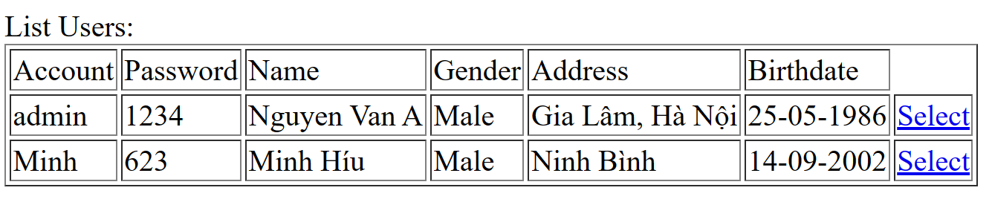
a. Load table from [Users] table.
b. Click [Select] link, show [ShowDetail.jsp] page as following:
