Professor: Terri Hoare
Prepared by:
Muhammad Khubaib Sarfraz (10394873)



CRISP- DM:
Customer Churn Model

Contents
CRISP-DM 4
Business Understanding 4
Data Understanding & Data Preparation 5
Modeling 6
Evaluation 7
Deployment 8
Appendix A 9
Class balancing Python Code. 9
Taking mean of missing Values in ‘Balance’ Variable. 9
Appendix B 9
Importing libraries. 9
Encoding Categorical varaible 10
Splitting Data into Test and Train 10
Appendix C 10
Feature Scaling 10
Classifying and Fitting the model 10
Confusion Matrix with 83% Accuracy 10
Appendix D 11
Monte Carlo 11
Optimal number of Tree 11
Optimal Depth of Trees 11
12
Appendix E 12
Updating Model with Optimized Parameters 12
References 13

Abstract
The purpose of this report to build up a model for a banking sector, in order to reduce their customer churn ratio and increase their profitability. For this purpose, Python and RapidMiner is used for model building and selection. Therefore, Random forest is selected to predict the customer churn ratio based on several variables.
These days, false client is being happened everywhere throughout the world. So it is vital for business to target the right customer and retain them for long term benefit. Increase rate of customer churn can incur a huge loss for company in terms of time and resources.
Moreover, it is very critical to comprehend that what is customer churn? what it does? It implies as opposed to getting the new client keep up/hold the current client. The expense for obtaining the new client is multiple times more than hold the current the client. what's more, its troublesome assignment to distinguish the beneficial clients for associations. Hence, this problem is properly addressed by the data mining techniques, machine learning algorithms with the help of data warehouse.
This report focuses on finding those important variables which help and prevent customer churn, so that organization can retain existing customers. Furthermore, it will help organization to forecast their future profit and make their policies accordingly to enhance their profitability.

CRISP-DM

CRISP-DM is stands for cross industry standard process for data mining. It was created in1996 to standardize the organization process. CRISP-DM gave an understanding to organization on how to manage, understand, handle and take out meaningful patterns from the large amounts of data they have. CRISP-DM makes it easy unify the data mining process. Hence, nowadays almost each company has implemented this process.
CRISP-DM process consists of six different stages and this report will follow these six below mentioned steps:
- Data gathering
- Business requirements/ Understanding the problem
- Data preparation
- Modelling
- Evaluation
- Deployment

Business Understanding

We selected Bank Customer dataset, which has around 10,000 rows and consists of data from three countries. In this data set we tried to find out the loyalty of the customers based on different variables. These variables help banks to understand which variables are important to retain their customers, so that they can target those variable to gain long term benefits. All of this can be possible with the help of data mining techniques.
In dataset there are 12 columns which are as below
- customer ID – Distinctive Identification number.
- Credit Score – Credit score/rating of customers.
- Geography – Where Customer is based
- Gender – Sexual orientation of customer.
- Age – Customer age.
- Balance – Balance in Customer account.
- Number of Products – Number of bank’s products customer is using.
- Credit card – Weather Customer has credit card or not
- Active Member – Customer is active member or Not
- Estimated salary – Customer approximate Salary
- Exited – Label Variable (1 – Loyal, 2- Churn)
In Modelling our output variable is Exited and important columns for finding out the behavior are Credit Score, Age, Balance, Credit card, Active Member and estimated salary.

Data Understanding & Data Preparation

To fully understand and get the insights of data, python is used to plot all the variables as shown below:
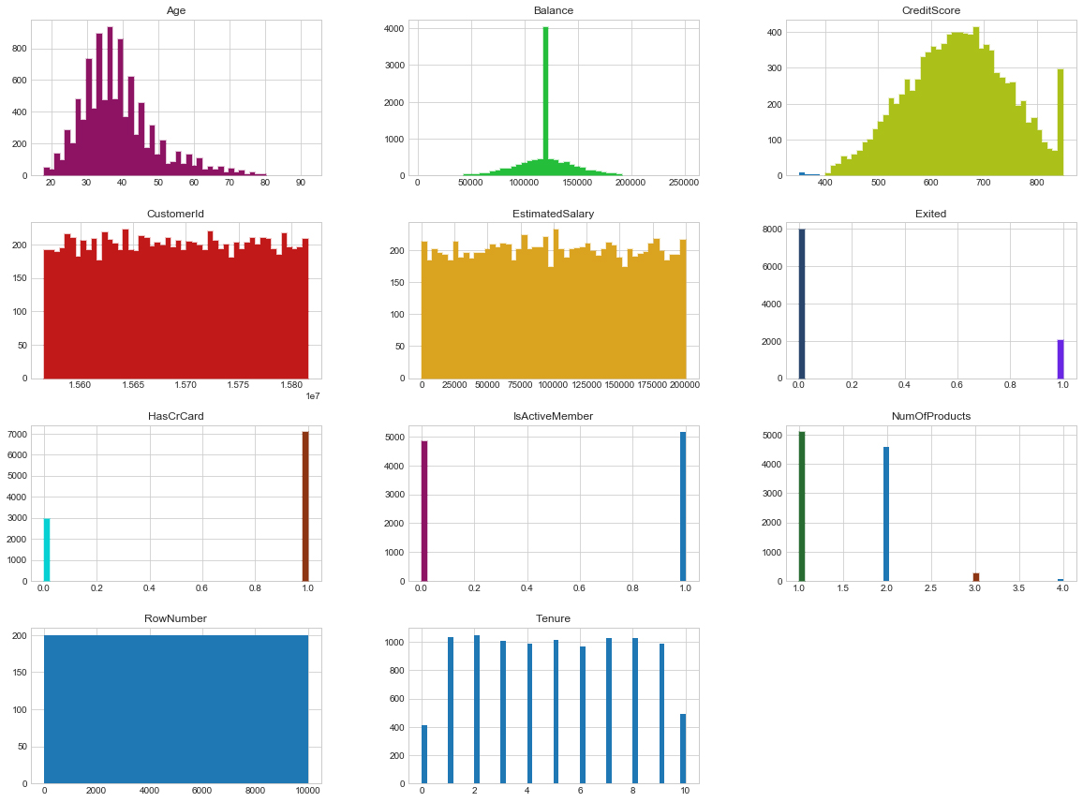
As shown in the exploratory analysis, there are two irrelevant variables in the data, namely Row Number and Customer Id, which are of no use to us for the relevant analysis. Furthermore, the most important insight is to look at the dependent variable which ‘Exited’ variable, that shows weather the customer churn or does not churn and we can clearly see the imbalance class. Hence, if we proceed our analysis without balancing class the results will be misleading. Therefore, both classes are balanced using sklearn in Python (Attached in Appendix A).
If we look at variable AGE, we can deduce that many customers are of age between 30-40 years. Moreover, for the Balance variable, we had several missing values which are corrected by taking the mean values of the Balance variables in python (Attached in Appendix A)

Modeling

Now when all the data is prepared, it is than used to create a Random Forest Model in Python. For that we purpose several libraries are needed to be called in python (List attached in Appendix B).
- After calling the relevant libraries, CSV file of Bank churn model is imported in python using “pd.read_csv”, as mentioned earlier now this data has been corrected for missing values in ‘Balance’ variable.
- Next step before feeding data to algorithm is to encode the categorical variable; in this case we have ‘Country’ variable with three countries. Hence, three categories are created i.e 1,2 and 3. (Shown in Appendix B)
- Subsequent step is to import sklearn.model_selection library to divide data for testing and training, initially data is divided into 70:30 ratios to perform the analysis which created four new variables namely; X_train, X_test, y_train, y_test.(Shown in Appendix B)
- Furthermore, feature scaling is applied to the data set which helps to normalize the data within a particular range. Sometimes, it also helps in speeding up the calculations in an algorithm.
Process of feature scaling is shown in Appendix C
- Finally, in the last step we fit the model using RandomForestClassifier from Python. Primarily, we used the default values for depth of tree and used 100 n-estimator (number of tree) to check the accuracy of the model. Moreover,using y_predict and y_test variables, confusion matrix is created and 83% accuracy is obtained (Appendix C). There are almost 3521 accurate and 757 wrong predictions when the model is ran on unseen data.

Evaluation

Now when the basic model is prepared, next step is to optimize our model to increase the efficiency on unseen data and reduce the wrong predictions. Therefore, first step is to discover the ideal data test and training split ratio by appling Monte Carlo model. For this purpose, different data splitting ratios and entered into our Random forest model to perform a loop and find out the optimal value to achieve highest accuracy (Appendix D). Furthermore, the results are then displayed on a chart shown below, which clearly indicate that using 20:80 ratio will provide a highest accuracy of the model instead of using 30:80 ratio.
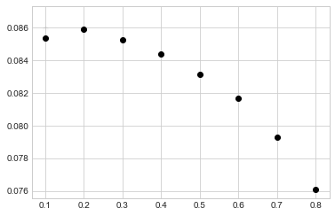
Next step is optimizing the number of trees in the model to check weather performance increase or not. For this purpose, we use ROC curve and AUC in python and visualize them to find the best performing values (As shown in Appendix D). Therefore, we can observer in the following picture that using 20 trees in the model will give the highest accuracy and increasing trees further will just increase the computational time not the accuracy, which will remain constant.
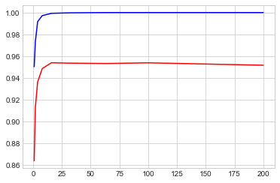

Final step in optimizing the parameters is to find out the ideal trees depth in the model. Initially in the model default values are used, but now using python code (Shown in Appendix D) optimal values are predicted and visualize below:
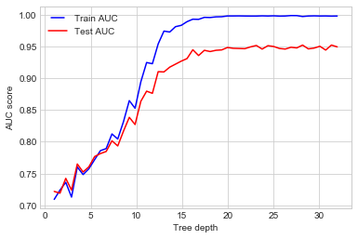
We can conclude that by using Tree Depth size of 15 we can achieve higher accuracy of the model.
Finally, once above mentioned parameters are optimized, it’s time to update our model according to these parameters (Shown in Appendix E)

Deployment
Now, after optimizing the parameters, all the above steps are repeated by splitting the data into 20:80 ratio, using right number of n-estimator and tree depth. Finally, the model is fitted again by using RandomForest Classifier and we found out that model performance increased drastically which can be seen in the confusion matrix shown below. Therefore, using parameter optimization helped to achieve 93% accyracy.

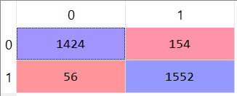

Appendix A

Class balancing Python Code.
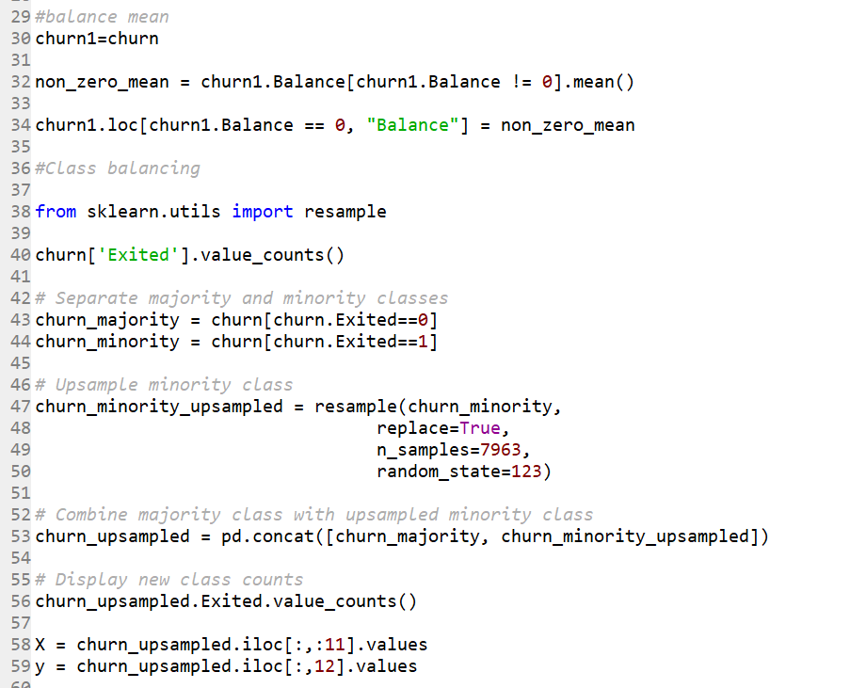

Taking mean of missing Values in ‘Balance’ Variable.
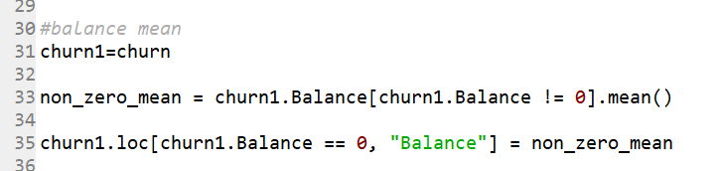

Appendix B

Importing libraries.
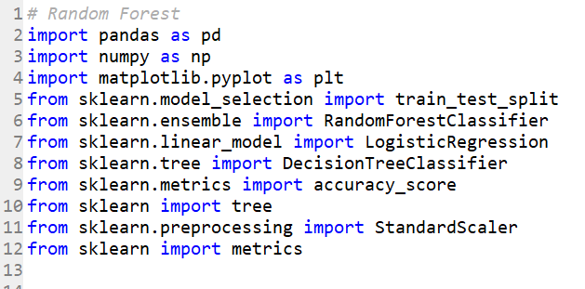

Encoding Categorical varaible
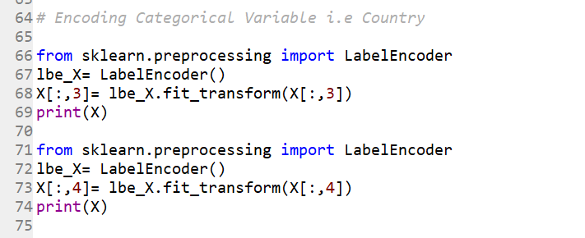

Splitting Data into Test and Train
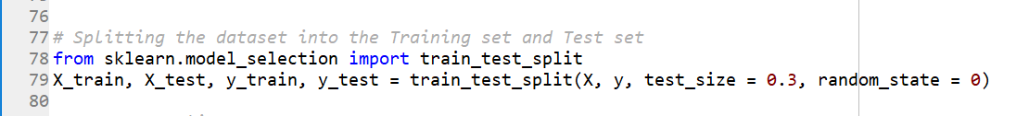

Appendix C

Feature Scaling

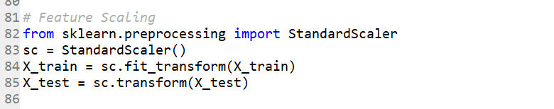

Classifying and Fitting the model
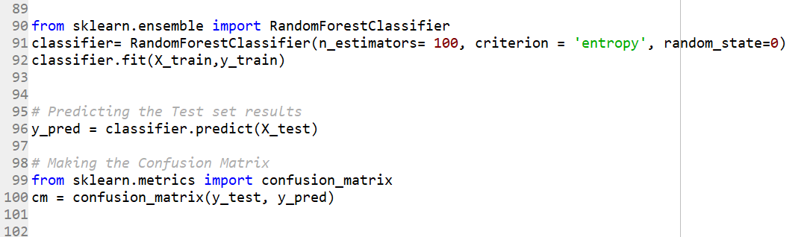

Confusion Matrix with 83% Accuracy
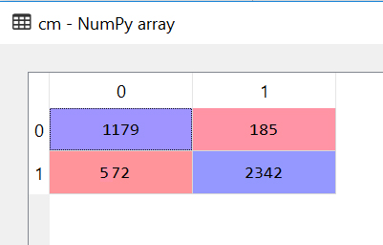

Appendix D

Monte Carlo

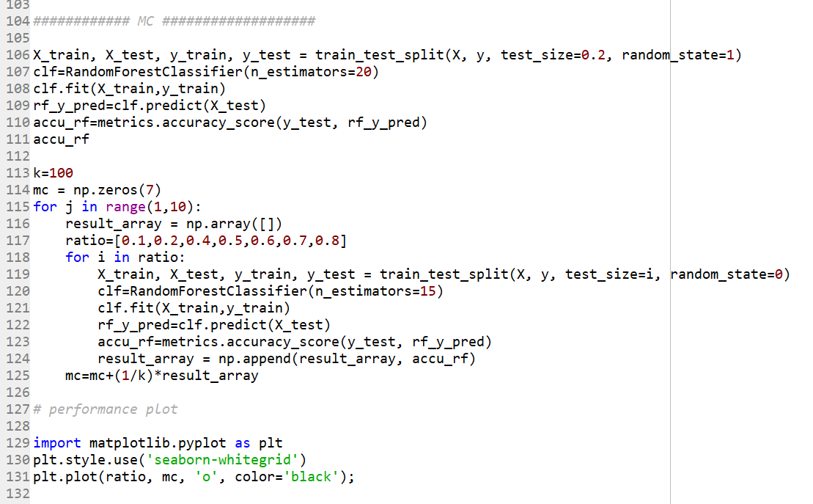

Optimal number of Tree
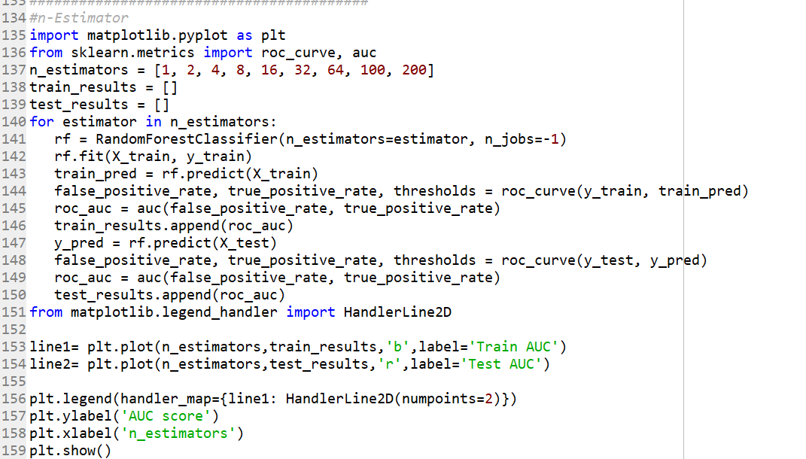

Optimal Depth of Trees

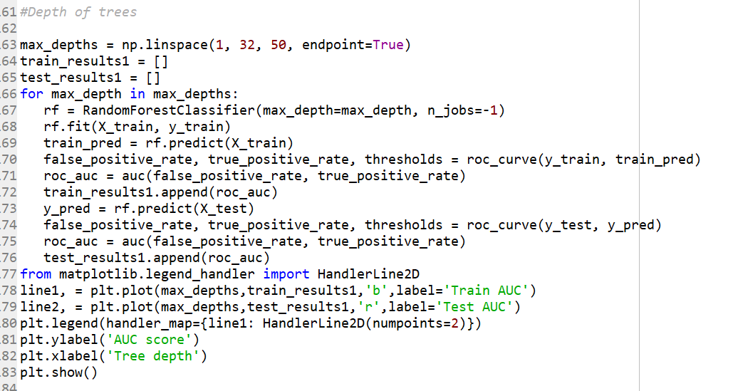

Appendix E

Updating Model with Optimized Parameters

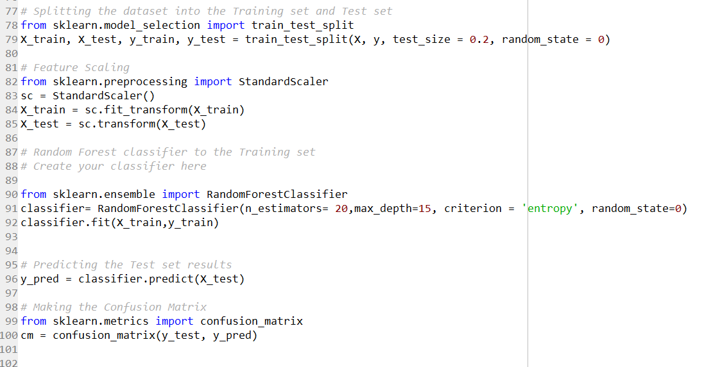

References
- E.W.T. Ngai, Li Xiu and D.C.K. Chau, “Application of data mining techniques in customer relationship management: A literature review and classification,” Expert Systems with Applications, vol. 36, 2009, pp. 2592–2602
- W. Verbeke, D. Martens, C. Mues, and B. Baesens, “Building comprehensible customer churn prediction models with advanced rule induction techniques,” Expert Syst. Appl., vol. 38, no. 3, pp. 2354–2364, 2011.
- W. H. Au, K. C. C. Chan, and Y. Xin, “A novel evolutionary data mining algorithm with applications to churn prediction,” Evol. Comput. IEEE Trans., vol. 7, no. 6, pp. 532– 545, 2003
- H.S. Kim and C.H. Yoon, “Determinants of subscriber churn and customer loyalty in the Korean mobile telephony market,” Telecommunications Policy, vol. 28, 2004

