# Assignment 1: Lists

## Question 1: Given a list of elements all elements are equal except one. Write a code to find the odd man out (Stray number)

### Code:

listEle = [24,24,24,25,24,24,24,24]

if len(listEle) == 1:

print(None)

listEle.sort()

if listEle[0] != listEle[1]:

if listEle[0] == listEle[2]:

print(listEle[1])

else:

print(listEle[0])

else:

print(listEle[-1])

### Working:



## Question 2: Given a list of elements, find the elements which is close to it’s mean

### Code:

listEle = [25,23,20,1,5,6]

summ = 0

for x in listEle:

summ += x

mean = summ/len(listEle)

diff = 9223372036854775807 # this is the maxint

no = listEle[0]

for x in listEle:

if abs(x - mean) < diff:

diff = abs(x-mean)

no = x

print(no)

### Working:



## Question 3: Find the average speed of vehicle, given the distance travelled for fixed time intervals, e.g. [0,0.1,0.25,0.45,0.55,0.7,0.9,1.0]

### Code:

listEle = [0, 0.1, 0.25, 0.45, 0.55, 0.7, 0.9, 1]

summ = 0

for x in listEle:

summ += x

print(summ/len(listEle))

### Working:



## Question 4: Find the number of people in a bus, given the data of people onboarding & alighting at each station

### Code:

onboard = [43, 23, 33, 14, 65, 6, 1]

alight = [23, 23, 43, 14, 26, 6, 17]

passengers = 0

for x in range(len(onboard)):

passengers += onboard[x] - alight[x]

print(passengers)

### Working:



## Question 5: Find the missing number, given the original list and modified one

### Code:

origlist = [1,2,3,4,5,6,7,8]

modded = [1,2,3,4,5,6,7]

for x in origlist:

if x in modded:

continue

else: print(x)

### Working:



## Question 6: Find the difference between two lowest numbers in the list

### Code:

newlist = [1,2,3,4,5,6]

if len(newlist) < 2:

print(None)

quit()

newlist.sort()

print(newlist[1]-newlist[0])

### Working:



## Question 7: In a given list, count no. of elements smaller than their mean

### Code:

newlist = [1,2,3,4,5,6,7,8,9,10]

summation = 0

for x in newlist:

summation += x

mean = summation/len(newlist)

newlist.sort()

count = 0

for x in newlist:

if x < mean: count+=1

else: break

print(count)

### Working:



# 

# Assignment 2: Strings

## Question 1: Correct the malformed time string, for e.g. “5:70:65” to “6:11:05”

### Code:

# Correct the malformed time string

timeString = input("enter the time in hh:mm:ss format")

timeList = timeString.split(':')

hh = timeList[0]

mm = timeList[1]

ss = timeList[2]

hh = int(hh)

mm = int(mm)

ss = int(ss)

Newtime = ""

if ss >= 60:

mmExtra = ss // 60

mm = mm + mmExtra

ss = ss % 60

if mm >= 60:

hhExtra = mm // 60

hh = hh + hhExtra

mm = mm % 60

if hh >= 24:

hh = hh % 24

Newtime = str(hh).zfill(2) + ":" + str(mm).zfill(2) + ":" + str(ss).zfill(2)

print(Newtime)

### Working:

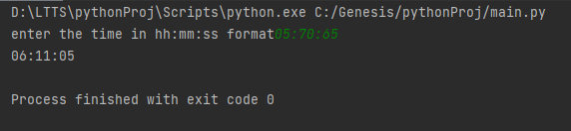

## 

## Question 2: Correct the malformed date string, for e.g. “45/8/2018” to “14/9/2018”

### Code:

# Correct the malformed date string, for e.g. "45/8/2018" to "14/9/2018"

dateString = input("enter the date in dd/mm/yyyy: ")

dateList = dateString.split('/')

dd = dateList[0]

mm = dateList[1]

yyyy = dateList[2]

dd = int(dd)

mm = int(mm)

yyyy = int(yyyy)

newDate = ""

dictionary = {1: 31, 3: 31, 4: 30, 5: 31, 6: 30, 7: 31, 8: 31, 9: 30, 10: 31, 11: 30, 12: 31}

if (yyyy % 4) == 0:

if (yyyy % 100) == 0:

if (yyyy % 400) == 0:

dictionary[2] = 29

else:

dictionary[2] = 28

else:

dictionary[2] = 29

else:

dictionary[2] = 28

days = 0

for i in range(1, mm):

days += dictionary[i]

days += dd

i = 1

while dictionary[i] < days:

days -= dictionary[i]

i += 1

if i > 12:

yyyy += 1

i = 1

newDate = str(days) + "/" + str(i) + "/" + str(yyyy)

print(newDate)

### Working:

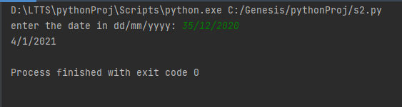

## Question 3: Convert IP address from “a.b.c.d” format into integer and vice versa

### Code:

# Convert the ip address from "a.b.c.d" format into integer and vice versa

ip = input("Enter the ip address in a.b.c.d format: ")

power = 0

integer = 0

for i in ip.split('.')[::-1]:

integer = integer + int(i) * 256**power

power += 1

print(integer)

ipAdd = ""

for i in range(3, -1, -1):

num = integer // (256**i)

ipAdd = ipAdd + str(num)

integer = integer % (256**i)

if i > 0:

ipAdd = ipAdd + '.'

print(ipAdd)

### Working:

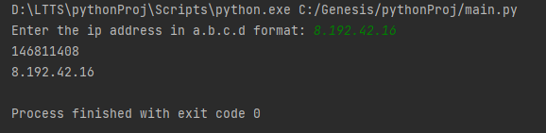

## Question 4: Check whether given string is isogram or not

### Code:

# Check whether given string is isogram or not

string = input("Enter the string to check: ")

string = string.lower()

charList = []

for char in string:

if char.isalpha():

if char in charList:

print("string is not an isogram")

quit()

else:

charList.append(char)

print("String is an isogram")

### Working:

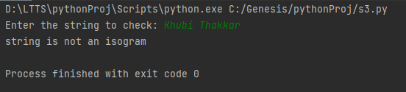

## Question 5: Given a string, find mexican wave

### Code:

# Given a string, find mexican wave

string = input("Enter the string: ")

string = string.lower()

new = []

for i, val in enumerate(string):

mexican = string[:i] + string[i].upper() + string[i+1:]

new.append(mexican)

print(new)

### Working:

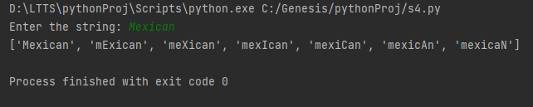

## Question 6: Given a number, find the largest number by deleting single digit(order of digits will remain same)

### Code:

# Given a number, find the largest number by deleting single digit(order of digits will remain same)

number = input("Enter the number: ")

number = int(number)

greatest = 0

listNum = []

for i in range(1, len(str(number))+1):

a = ((number//(10**i)) * (10 ** (i-1))) + (number % (10 ** (i-1)))

listNum.append(a)

for nums in listNum:

if nums > greatest:

greatest = nums

print(greatest)

### Working:

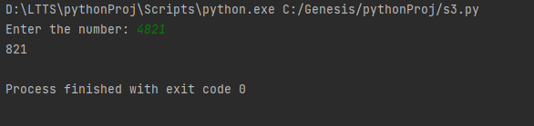

## Question 7: Given a number find the largest number by shuffling the digits

### Code:

number = input("Enter the number: ")

number = int(number)

List = []

output = 0

for i in range(len(str(number))):

a = ((number % (10 ** (i + 1))) - (number % (10 ** i))) // (10 ** i)

List.append(a)

List.sort(reverse=True)

for num in List:

output = (output * 10) + num

print(output)

### Working:

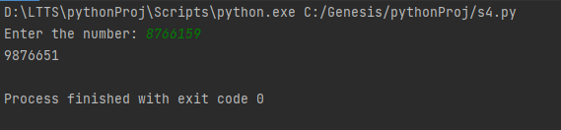

## Question 8: Compute the word frequency in given message

### Code:

statement = input("Enter the statement: ")

statement = statement.lower()

wordList = statement.split(' ')

dictionary = {}

for word in wordList:

if word in dictionary.keys():

dictionary[word] += 1

else:

dictionary[word] = 1

print(dictionary)

### Working:

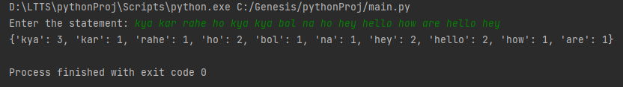

## Question 9: RGB to Hex conversion and vice version, e.g. (255,0,255) into 0xFF00FF

### Code:

rgb = input("Enter the RGB code: ")

codeList = rgb.split(',')

conversion_table = ['0', '1', '2', '3', '4', '5', '6', '7', '8', '9', 'A', 'B', 'C', 'D', 'E', 'F']

final = ""

for code in codeList:

decimal = int(code)

hexadecimal = ''

if decimal > 0:

while decimal > 0:

remainder = decimal % 16

hexadecimal = conversion_table[remainder] + hexadecimal

decimal = decimal // 16

elif decimal == 0:

hexadecimal = '00'

final = final + hexadecimal

print('0x' + final)

### Working:

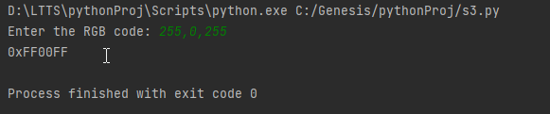

## Question 10: Generate accumulated strings, e.g. abcd ⇒ A-Bb-Ccc-Dddd

### Code:

string = input("Enter the input: ")

charList = []

for i in range(len(string)):

charList.append(string[i])

output = []

for index in range(len(charList)):

output.append(charList[index].upper())

loop = index

while loop > 0:

output.append(charList[index])

loop -= 1

if index < len(charList) - 1:

output.append("-")

outputString = ""

for i in range(len(output)):

outputString = outputString + output[i]

print(outputString)

### Working:

