1. Screenshot new writtten code
2. Method overloading

1. Passing Parameter

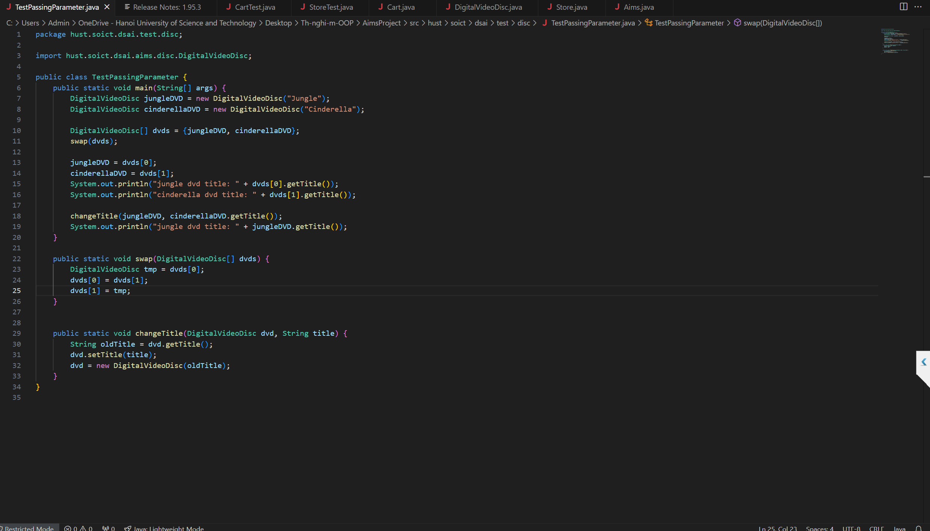

1. toString() method, searchById(), searchByTitle()

1. printCart()

1. CartTest

1. StoreA screen shot of a computer program

   Description automatically generated
2. StoreTestA screen shot of a computer

   Description automatically generated
3. Screenshot of code debugging and the results

1. Updated use-case diagram and class diagramA diagram of a diagram

   Description automatically generatedA screenshot of a computer

   Description automatically generated
2. Answer the questions

***- Is JAVA a Pass by Value or a Pass by Reference programming language?***

- JAVA is a Pass by Value programming language.

When we pass a variable to a method, we pass the value of the variable, not the reference of the variable.

So, the original variable is not changed when we change the variable in the method.

***- After the call of swap(jungleDVD, cinderellaDVD) why does the title of these two objects still remain?***

- In the swap method, o1 and o2 are copies of the references to jungleDVD and cinderellaDVD.

Inside the swap method, you are just swapping the references (o1 and o2), but not the actual objects that these references point to.

***After the call of changeTitle(jungleDVD, cinderellaDVD.getTitle()) why is the title of the JungleDVD changed?***

- In the changeTitle method, you are copying the reference to jungleDVD.

However, this reference copy still points to the same jungleDVD object in memory.

When you call dvd.setTitle(title), you are modifying the state of the object that dvd points to, which is the same object as jungleDVD in the main method. Therefore, the title of jungleDVD is changed.