SAKO TRG-42 SNIPER RIFLE
Intro

1. SAKO TRG-42 sniper Rifle ek Bolt-action repeating Rifle hai jis mein mag detachable hai. Trg - 42 Rifle ke construction ke vishesta base raile hai. Jismein rx, base rail cover ke saath fore end or folding stk ko joda gaya hai. Barreled action solid mtg ke vajah se is ke accuracy power kafi jyada hai. Iske alawa front end ke sath rear stk, jo base rail per lagya gaya hai, ka TRG rif ki final accuracy per koi prabhav nahi padta hai. TRG 42/22 ke version ka anter kevel chune gaye calliber ke karan rx, Bolt or mag ka akar hai. Jab bhi ek markhsmen high op Safety, excellient handeling, dwara use kiya jata hai to wpn ka main feature wpn ki pin pt accuracy mana jata hai.In features ke karan yeh wpn mil snipers or units dwara upyog ke liye vishesh roop se suitable hai. rx ke upper MIL-STD 1913 rail or MMRS rail sahi tarike se jude hone ke karan alag alag aiming device lagane ki anumati deta hai (Day Scope, ni sight/NVD aur laser pt/ Tgt designator). mil, trg, Fg and Regt.

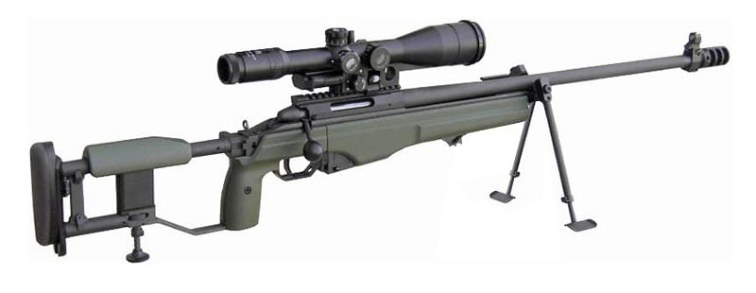

Tech Data
a) Brand - SAKO
b) Model - TRG-42
c) Country origin - Finland
d) op - Manual op Bolt action
e) cal - .338’’ (8.6 × 70mm)

1. wt
- Khali Rif - 5.3 kg
- Scope - 1.024kg
- Bhari rif with scope - 6.726kg
- Khali mag - 187gm
- Bhari mag - 402gm
- Bolt - 406gm

2. Length

- Fully extended butt - 1205mm
- Folded butt - 990mm
- Barrel - 690mm
- Rifling pitch - 254mm 1 turn
- Low Bipod - 300mm
- High Bipod - 410mm
- Cheeck pad mov - 50mm
3. Ballastic
- Cart case - 8.6 × 70mm (Rimless)
- Wt - 43gm
- Bullet wt - 250 grain (16gm)
- Envlope - Gilding metal
- Carts length - 90mm

4. Trigger pull - 1.3 – 2.3 kg
5. MV - 900m/s
6. Bolt Through - 118mm
7. Fg Pin mov - 6.5mm
8. Mag cap - 05 Rds
9. Mech Safety - Lock
10. Applied Safety - Trigger Safety
11. Body Mtrl - Alloy Aluminium P
12. Barrel - Steel (Non chromium plated) Cold hammer
Forged

13. Optical Sight/NVD - MIL STD -1913(Picatinny) MMRS Interface 30 MOA

14. Recoil pad - Polyurethane Rubber

3. Visheshtayen :-
(a) Bolt Action wpn.
(b) High op Safety.
(c) Free Floated or Removable Barrel.
(d) Adjustable Trigger.
(e) High Mag scope.
(f) Din or Raat ke liye alag alag sighting sys.
(g) Bipod ki suvidha.
(h) Kam Recoil .
(j) Base Rail, ITRS aur MMRS ki suvidha.
(k) std units or dimensions ke sath iski banawat.
(l) Butt stk adjustable hone ke karan baayen or daayen hath ke firer ke liye ek saman istemal karne yogya.
(m) Steel plate mag.
(n) .338 Lapua Magnum Amn.
(o) Snap shooting ke liye aasan.
(p) Manual op.
(q) Adjustable cheek pad, Recoil pad or Mono pad ki suvidha.
Hathiyar ke mukhya hisse purje :-
4. SAKO TRG - 42 sniper Rifle nimn hisse purjon se milkar bani hai.
(a) Barreled rx
(b) Bolt
(c) Base rail and ITRS or MMRS rail
(d) Rear stk
(f) Fore-end
(g) Trigger mechanism
(h) mag
(j) Base rail cover

