SAKO TRG-42 SNIPER RIFLE
Intro

1. SAKO TRG-42 sniper Rifle ek Bolt-action repeating Rifle hai jis mein magazine detachable hai. Trg - 42 Rifle ke construction ke vishesta base raile hai. Jismein receiver, base rail cover ke saath fore end or folding stock ko joda gaya hai. Barreled action solid mounting ke vajah se is ke accuracy power kafi jyada hai. Iske alawa front end ke sath rear stock, jo base rail per lagya gaya hai, ka TRG rif ki final accuracy per koi prabhav nahi padta hai. TRG 42/22 ke version ka anter kevel chune gaye calliber ke karan receiver, Bolt or mag ka akar hai. Jab bhi ek markhsmen high operating Safety, excellient handeling, dwara use kiya jata hai to wpn ka main feature wpn ki pin point accuracy mana jata hai.In features ke karan yeh wpn military snipers or units dwara upyog ke liye vishesh roop se suitable hai. Receiver ke upper MIL-STD 1913 rail or MMRS rail sahi tarike se jude hone ke karan alag alag aiming device lagane ki anumati deta hai (Day Scope, Night sight/night vision device aur laser point/ Tgt designator). Military, training, firing and regiment.

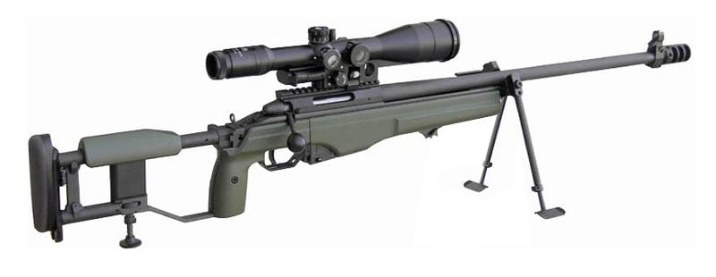

Tech Data
a) Brand - SAKO
b) Model - TRG-42
c) Country origin - Finland
d) Operation - Manual operated Bolt action
e) Calibre - .338’’ (8.6 × 70mm)

1. Weight
- Khali Rif - 5.3 kg
- Scope - 1.024kg
- Bhari rif with scope - 6.726kg
- Khali mag - 187gm
- Bhari mag - 402gm
- Bolt - 406gm

2. Length

- Fully extended butt - 1205mm
- Folded butt - 990mm
- Barrel - 690mm
- Rifling pitch - 254mm 1 turn
- Low Bipod - 300mm
- High Bipod - 410mm
- Cheeck pad movement - 50mm
3. Ballastic
- Cart case - 8.6 × 70mm (Rimless)
- Wt - 43gm
- Bullet wt - 250 grain (16gm)
- Envlope - Gilding metal
- Carts length - 90mm

4. Trigger pull - 1.3 – 2.3 kg
5. Muzzle velocity - 900m/s
6. Bolt Through - 118mm
7. Firing Pin Movement - 6.5mm
8. Mag Capacity - 05 Rds
9. Mech Safety - Lock
10. Applied Safety - Trigger Safety
11. Body material - Alloy Aluminium P
12. Barrel - Steel (Non chromium plated) Cold hammer
Forged

13. Optical Sight/NVD - MIL STD -1913(Picatinny) MMRS Interface 30 MOA

14. Recoil pad - Polyurethane Rubber

3. Visheshtayen :-
(a) Bolt Action weapon.
(b) High operating Safety.
(c) Free Floated or Removable Barrel.
(d) Adjustable Trigger.
(e) High Mag scope.
(f) Din or Raat ke liye alag alag sighting System.
(g) Bipod ki suvidha.
(h) Kam Recoil .
(j) Base Rail, ITRS aur MMRS ki suvidha.
(k) Standard units or dimensions ke sath iski banawat.
(l) Butt stock adjustable hone ke karan baayen or daayen hath ke firer ke liye ek saman istemal karne yogya.
(m) Steel plate magazine.
(n) .338 Lapua Magnum Amn.
(o) Snap shooting ke liye aasan.
(p) Manual operated.
(q) Adjustable cheek pad, Recoil pad or Mono pad ki suvidha.
Hathiyar ke mukhya hisse purje :-
4. SAKO TRG - 42 sniper Rifle nimn hisse purjon se milkar bani hai.
(a) Barreled receiver
(b) Bolt
(c) Base rail and ITRS or MMRS rail
(d) Rear stock
(f) Fore-end
(g) Trigger mechanism
(h) Magazine
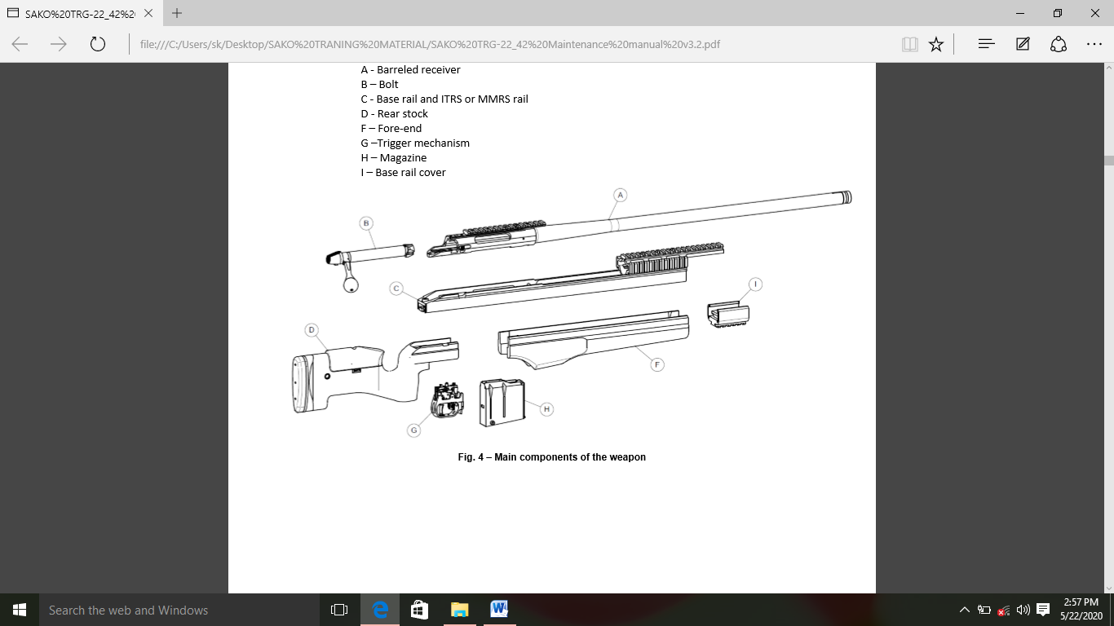
(j) Base rail cover

