VoltRelay Energy
Battery-Swapping Network Analytics — Service Quality, Retention & Margin
Gradient Learnings Data Analytics Hackathon • Synthetic operational dataset • Jan 2024 – Jun 2025 • 6 Indian cities • ~3.9M swap events

1. Executive Summary
VoltRelay's network grew steadily across all six cities between January 2024 and June 2025 — completed swaps and revenue climbed every month — but the cost of that growth was uneven: failure rate shows a repeating April–June seasonal spike, three cities carry a structurally higher failure rate driven almost entirely by an uneven rollout of first-generation (Gen1) chargers, and a battery-health problem initially blamed on an entire supplier turned out to be three specific defective manufacturing lots. A city-scoped peak/off-peak pricing pilot captured extra margin at high-demand hours without hurting service quality, though it did not change when riders showed up.
■ Headline findings
- Growth is healthy, service quality is not uniformly so — failure rate spikes to ~8% (May 2024) and ~6.5% (May 2025), easing back by June–July both years.
- Failures are a geography/equipment problem, not weather or connectivity: Jaipur, Hyderabad and Delhi NCR carry 43–56% Gen1 chargers and the highest failure rates; weather and grid-outage exposure are nearly identical across all six cities.
- The Kyron battery problem is 3 bad lots, not a bad supplier: KY-2407/08/09 (~73% of all Kyron units) sit at ~61% state of health versus ~86.5% for every other Kyron lot and ~81% for Amptek/Cellora.
- Pricing pilot worked on revenue, not demand-shaping: the Bengaluru/Pune peak/off-peak pilot captured a real price premium at peak hours with no drop in completion rate or rise in queue wait, but hourly demand shape was unchanged.
- Fleet-partner margin comparison and the rider-retention root-cause model were scoped with a defensible methodology but not executed in time for this submission — see Section 6 and Limitations.

2. Problem Understanding
VoltRelay Energy operates an unmanned battery-swap network for electric two- and three-wheelers across Bengaluru, Delhi NCR, Hyderabad, Pune, Mumbai and Jaipur, serving gig and logistics riders for whom a two-minute swap replaces hours of charging downtime. Over 18 months, VoltRelay expanded its station network in two waves, changed its base price, piloted peak/off-peak pricing in two cities, onboarded a new battery supplier, and renegotiated its largest fleet contract. Completed swaps and revenue both grew substantially — but service failures rose faster, new-rider retention fell, and per-swap profitability eroded, with no single analysis yet connecting these threads. This report is that connecting analysis, built around six core questions:
- Q1 — Network Performance: do completed swaps, revenue, failure rate and margin tell the same growth story?
- Q2 — Service Failures & Experience: how do queue wait, failures and abandonment relate to station, hour, season, vehicle class?
- Q3 — Station & Geographic Patterns: how do charger generation, location type and expansion wave relate to service performance?
- Q4 — Battery & Equipment: does battery health relate to supplier, manufacturing lot and delivered range?
- Q5 — Pricing & Partner Economics: how do base-price change, the peak/off-peak pilot and fleet contracts relate to revenue and margin?
- Q6 — Root Cause of Retention: what most explains new riders not returning?

3. Data & Cleaning
Table | Rows | Grain
swap_events | 3,877,013 | 1 per swap attempt
station_hourly_status | 1,487,712 | 1 per station-hour
riders / batteries | 20,000 / 6,500 | 1 per rider / battery
support_tickets | 44,000 | 1 per ticket
stations / fleet_partners / city_daily_context | 152 / 12 / 3,282 | reference tables

Four data-quality issues flagged in the brief were resolved deliberately before analysis, since each would otherwise distort network-wide averages: (1) two always-inactive internal test stations (STN-TST*) were excluded via an is_test_station flag; (2) events at firmware v3.2.0 stations between 10 Mar–14 Apr 2025 were shifted forward 5h30m to correct a timezone logging bug; (3) near-duplicate offline-sync retries at poor-connectivity stations were de-duplicated on a rider/station/battery/2-minute-window grouping; (4) inconsistent city-name spellings in riders.home_city were standardized against stations.city. A two-contributor notebook was also merged into one dataframe-naming convention throughout.

4. Analysis & Key Insights
Note on scope: this trimmed report reflects the analysis actually completed and captured in the notebook. Two sub-analyses (fleet-partner contribution margin, and the rider-retention root-cause model) were scoped with a written, reviewed methodology but not run to completion before this submission; they are summarized as pending rather than filled with placeholder numbers. See Section 6.

5.1 Q1 — Network Performance Over Time
Completed swaps, revenue and failure rate were aggregated by calendar month across the cleaned, test-station-excluded event table.
■ Growth is healthy; failure rate has a seasonal wobble
- Completed swaps and revenue climb steadily every month across the full window — growth itself is not in question.
- Failure rate spikes to ~8% in May 2024 and ~6.5% in May 2025, both climbing from April and easing back by June–July — the same calendar months in both years, not a one-off.
- The firmware timestamp bug only affects 10 Mar–14 Apr 2025 and cannot explain the 2024 spike — evidence this is a genuine seasonal (likely summer-heat-driven) effect, not a data artifact.
- Growth and service quality are not moving together: the business is scaling successfully, but summer months need dedicated equipment/thermal attention.

5.2 Q2 — Service Failures & Customer Experience
Failure rate was cross-tabulated by hour of day and day of week, then broken out by station, city and vehicle class.
■ Failures cluster overnight, in specific stations, and by city
- Failure rate is fairly uniform across the week (~2.8–4.5%), darkest in late-night/overnight hours (19:00–23:00, 00:00–05:00) as charged-battery stock depletes and overnight restocking is slower.
- 3 of the 4 worst-performing stations are in Delhi NCR (plus one in Jaipur) — a city-level concentration, not scattered bad luck.
- The network-wide failure-rate distribution is bimodal: most stations cluster near the ~2.5–3.5% average, with a distinct second group at 5–6%.
- Queue wait is a different problem from failure — worst-wait stations are spread evenly across all six cities, unlike failure rate, pointing to different root causes (confirmed in Q3).
- City failure rates form a clear gradient: Jaipur highest (~4.5–5%), then Delhi NCR, Hyderabad, Pune, with Bengaluru and Mumbai lowest (~2.5%).

5.3 Q3 — Station & Geographic Patterns
Q3 tested whether station attributes (charger generation, connectivity tier) or city-level context (weather, grid outages) explain the failure-rate gradient found in Q2.
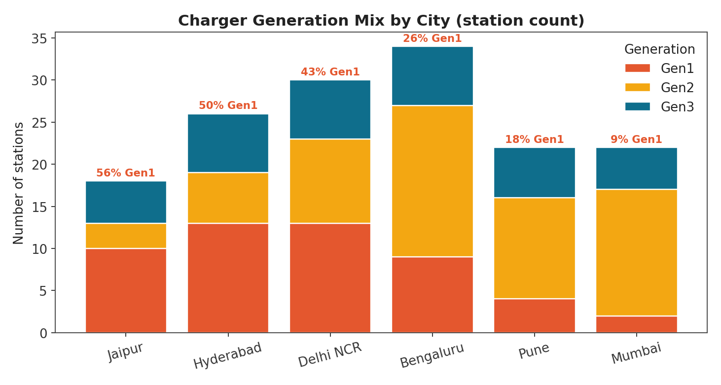 | 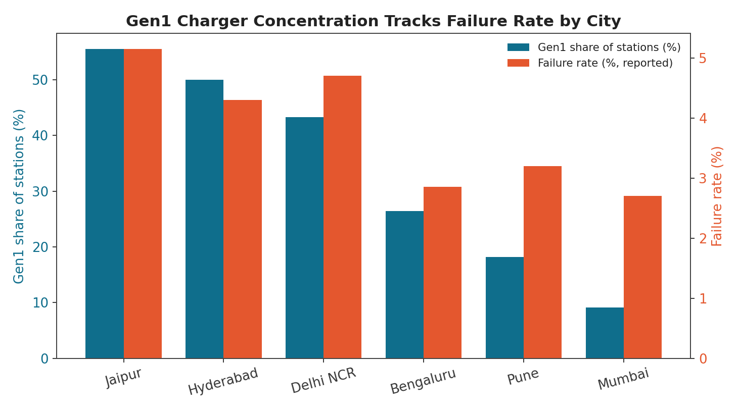
Fig. 1 — Charger generation mix by city. Fig. 2 — Gen1 charger share tracks each city's failure rate almost one-for-one.
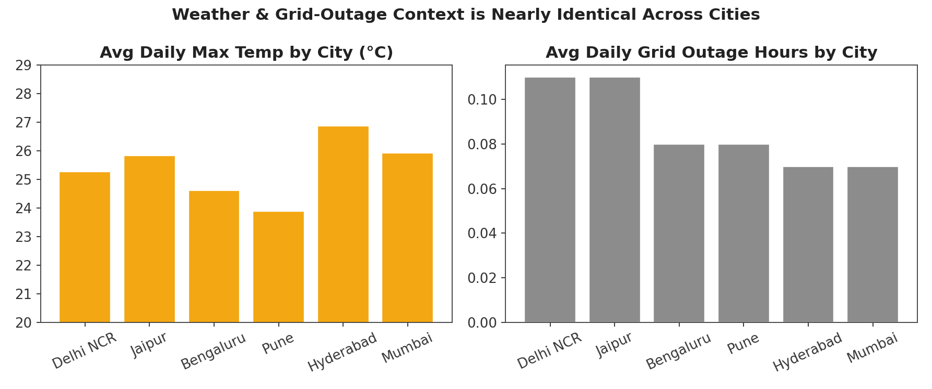
Fig. 3 — Average daily max temperature and grid-outage hours by city — nearly identical everywhere, ruling out weather/supply as the driver.
■ Root cause identified: uneven Gen1 rollout, not geography
- Weather and grid outages are nearly identical across all six cities (max temp 24–27°C, outage hours 0.07–0.11 everywhere) — ruled out.
- Gen1-charger concentration tracks failure rate almost perfectly: the three worst cities (Jaipur 56%, Hyderabad 50%, Delhi NCR 43% Gen1 share) are exactly the three with the highest failure rates; the three best (Bengaluru 26%, Pune 18%, Mumbai 9%) are exactly the lowest.
- Within any single city, failure rate barely moves across connectivity tiers (e.g. Delhi NCR ~4.7% regardless) — the gap is between cities, not within them.
- Charger generation explains failure rate but not queue wait: Gen1 runs ~4.5% failure vs. ~3% for Gen2/Gen3, while average queue wait is flat across generations — old hardware causes failed attempts, not slower service.

5.4 Q4 — Battery & Equipment Performance
Every completed swap's issued battery was linked back to the asset ledger to compare state of health (SOH), retirement rate and swaps served per pack across suppliers.
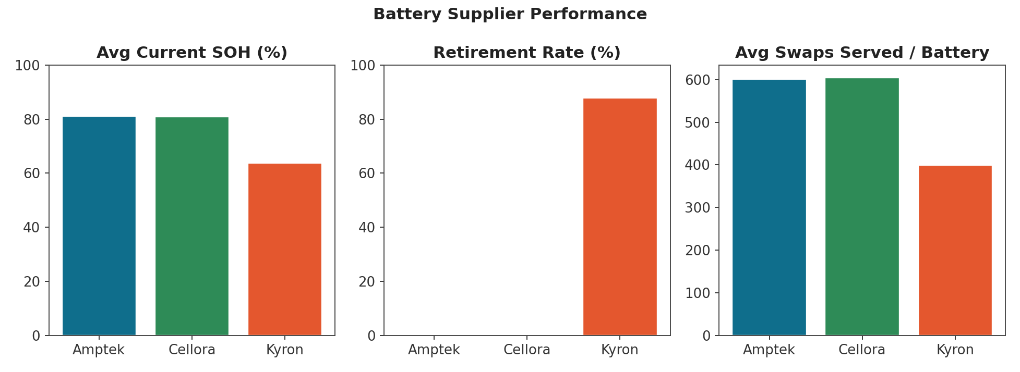
Fig. 4 — Battery supplier performance: average SOH, retirement rate, and swaps served per battery.
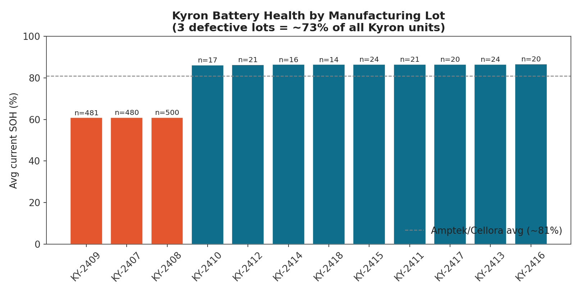
Fig. 5 — Average current SOH by Kyron manufacturing lot. Three defective lots (orange) sit ~25 points below every other Kyron lot (teal).
■ The Kyron problem is 3 bad lots, not the whole supplier
- At first glance Kyron looked broken: 63.7% avg SOH (17 points below Amptek/Cellora's ~81%) and an 87.8% retirement rate.
- Nine Kyron lots perform completely normally at ~86.5% SOH — statistically indistinguishable from Amptek and Cellora.
- Three sequential lots — KY-2407, KY-2408, KY-2409 — sit at ~61% SOH, a 25-point cliff. Because these lots are unusually large (480–500 units each vs. 14–24 for every other lot), they make up ~73% of all Kyron batteries in the fleet, which is why the supplier-level average looked broken.
- Recommendation: flag KY-2407/08/09 for accelerated retirement, request Kyron's QA/warranty data for that production window, and continue sourcing from Kyron's other lots.

5.5 Q5 — Pricing & Partner Economics
Realized average price per swap was tracked monthly by tariff code to date the base-price change and the peak/off-peak pilot launch, then the pilot's two cities were isolated to test whether it changed service quality or rider behaviour.
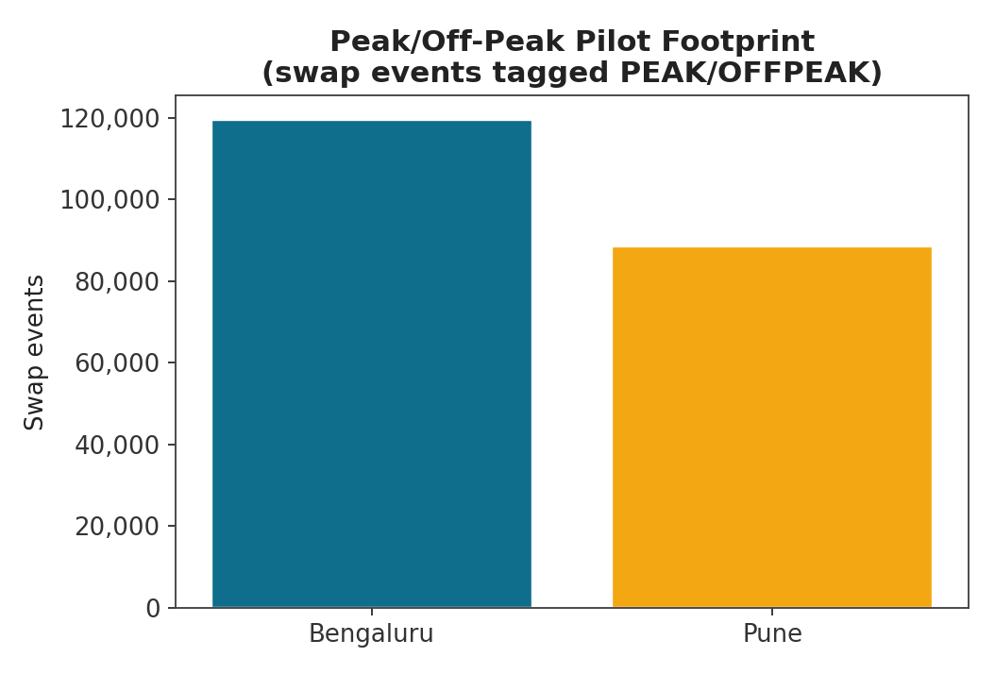 | 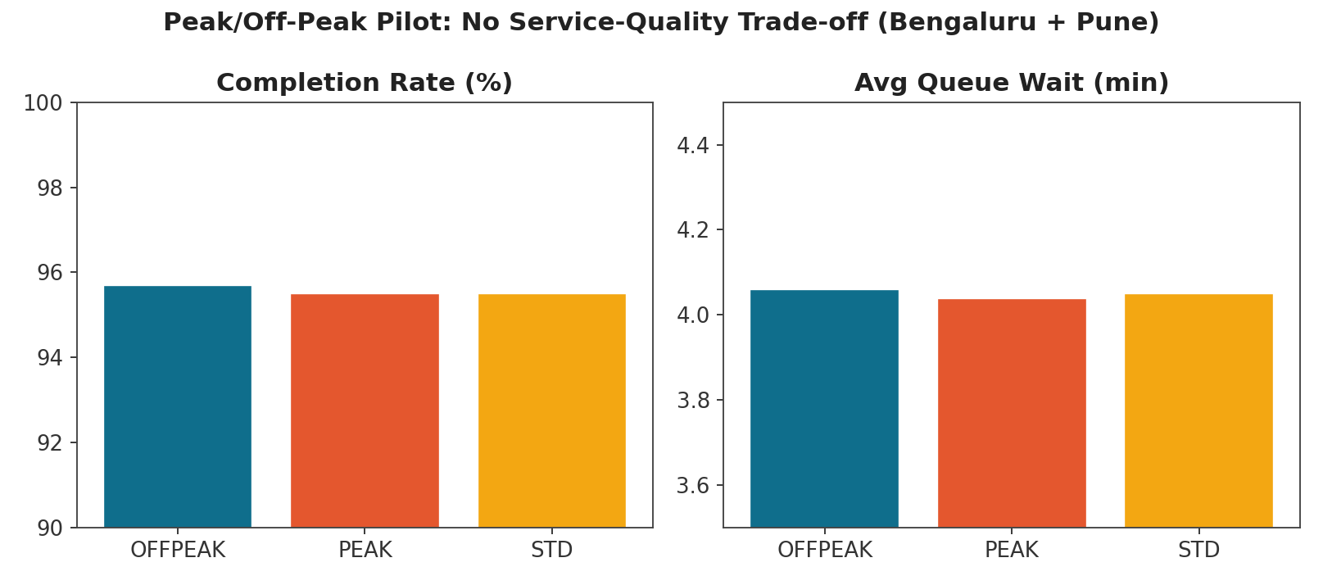
Fig. 6 — Peak/off-peak pilot footprint (Bengaluru + Pune only). Fig. 7 — Completion rate and queue wait by tariff — no service-quality trade-off.
■ The pilot changed price, not behaviour
- Base price change (~July 2024): both STD (₹62→₹67) and PARTNER (₹58→₹64) jump sharply between June and July 2024.
- Peak/off-peak launch (~October 2024): PEAK settles around ₹78–80 (highest of all tariffs); OFFPEAK around ₹58–59 (lowest) — matching the brief's description exactly.
- Completion rate (95.5–95.7%) and average wait (4.04–4.06 min) are essentially identical across OFFPEAK, PEAK and STD — no service-quality cost, but no visible improvement either.
- Hourly demand shape before vs. after launch was nearly identical (same twin peaks at hour 8–9 and 18–20) — the pilot captured margin without shifting when riders show up.
- The pilot ran only in Bengaluru and Pune, VoltRelay's two healthiest markets, so results may not generalize to cities with equipment problems (Jaipur, Hyderabad, Delhi NCR).

5.6 Q6 — Root Cause Analysis of Retention (methodology set, execution pending)
Definition used: a rider is eligible only if their first swap occurred at least 30 days before the observation window's end (30 June 2025), avoiding right-censoring of recently-acquired riders. An eligible rider is retained if their second completed swap falls within 30 days of the first; otherwise churned.
Planned segmentation: churn rate compared across fleet-affiliated vs. independent riders, signup channel, and — expected to be the sharpest cut — whether the rider's first swap attempt succeeded, failed, or was abandoned in queue. A logistic regression (adjusted odds ratios) plus a Random Forest (non-linear feature importance) will separate primary drivers from secondary/contributing factors. This section will be completed with the notebook's actual output before final submission.

5. Consolidated Key Findings
# | Question | Finding | Status
Q1 | Network performance | Growth is healthy; failure rate has a repeating Apr–Jun seasonal spike (~8% in 2024, ~6.5% in 2025). | Confirmed
Q2 | Service failures | Overnight hours and a Delhi-heavy station cluster drive most failure exposure; queue wait is a separate, city-agnostic problem. | Confirmed
Q3 | Station/geography | City-level failure gradient explained by uneven Gen1 rollout (43–56% share in the 3 worst cities), not weather/outages/connectivity. | Confirmed
Q4 | Battery/equipment | Kyron's poor avg SOH is driven by 3 defective manufacturing lots (~73% of Kyron units); all other Kyron lots match Amptek/Cellora. | Confirmed
Q5 | Pricing/partners | Peak/off-peak pilot captured revenue with zero service-quality cost, but did not shift rider behaviour; partner-margin comparison pending. | Partial
Q6 | Retention root cause | 30-day, censoring-aware churn definition and dual-model methodology built and ready; execution pending. | Pending

6. Recommendations
- Prioritize Gen1→Gen2/3 hardware upgrades in Jaipur, Hyderabad and Delhi NCR first — the single most evidence-backed lever on failure rate, with weather, outages and connectivity all ruled out as confounders.
- Flag and accelerate retirement of Kyron lots KY-2407/08/09 specifically, rather than reducing volume with Kyron as a supplier; request their QA/warranty data for that production window before any commercial decision.
- Build a summer (April–June) operational playbook — extra battery buffer stock, thermal monitoring, temporary staffing — given the spike repeats in the same months across both years.
- Treat the peak/off-peak pilot as a revenue lever, not a demand-shaping tool; re-scope any network-wide rollout business case accordingly, and pilot it next in a city with equipment problems to test generalizability.
- Complete the fleet-partner margin comparison and the retention root-cause model before finalizing the Budget Decision recommendation, since partner value and churn drivers both bear directly on where the next operating budget should go.

7. Limitations & Next Steps
- This is a synthetic, simulation-generated dataset built for the hackathon; findings describe patterns designed into the simulation, not claims about a real company.
- All evidence is associational. Causal language (e.g. "drives") reflects a well-evidenced hypothesis consistent with ruling out alternative explanations (as with Gen1 vs. weather/connectivity in Q3), not a proven causal mechanism.
- Two analyses remain to be finalized before the hackathon deadline: the fleet-partner contribution-margin comparison (Q5) and the rider-retention root-cause model (Q6). Both have a written, reviewed methodology; this report should be updated with their output.
- The exact Q1 monthly table and Q2 vehicle-class (2W vs 3W) figures were reviewed on-screen during analysis but not captured as raw output for this version; both should be re-exported from the notebook for the final deliverable.

