Learner Support Prioritisation
Milestone 1.2: Data Preparation Note and Exploratory Analysis
Prepared by: Thavhiwa Khuliso John | Date: 1 November 2026
Dataset: public student performance data (Portuguese course), 649 learners, 33 columns. This is not internal programme data.

1. Purpose
The programme team wants a fair, transparent way to decide where facilitator attention may be needed first, before final results are known. This milestone prepares the data and explores which early signals relate to low final results, using only variables cleared as appropriate in Milestone 1.1. A "support priority" here means a prompt for a supportive conversation, not a judgement about a learner.

2. Data preparation
The source file (student-por.csv) is semicolon-delimited. It was loaded with the delimiter set to semicolon, giving 649 rows and 33 columns, matching the brief. All analysis was done on a working copy so the original data stayed unchanged.
Check | Result | Decision
Rows and columns | 649 / 33 | Matches the brief
Missing values | 0 | No imputation needed
Duplicate rows | 0 | Nothing removed
Absences | 0 to 32, skewed | Kept (real values); grouped into bands for analysis
Zero grades | G1: 1, G2: 7, G3: 15 | Flagged, not removed: a zero may mean non-completion rather than a true score

Three helper fields were added to the working copy: a flag for a final grade below 10 (used only to check patterns afterwards), an absence band, and a G1 band. "Below 10" is an assumption for a below-pass result on the 20-point scale.

3. Handling grades (grade leakage)
The goal is early support, so only information available before the decision should guide prioritisation. The three grades are treated differently:
Grade | Treatment | Reason
G1 | Allowed as the early academic signal | Earliest available result
G2 | Allowed only if the decision is made after period 2 | Very closely related to G3 (correlation 0.92); it would dominate any rule
G3 | Excluded from live prioritisation; used only to check findings afterwards | It is the final outcome, so using it would leak the answer into an early decision

4. Exploratory findings
Each chart shows the share of learners in a group who finished below 10. Overall, 100 of 649 learners (15%) finished below 10.
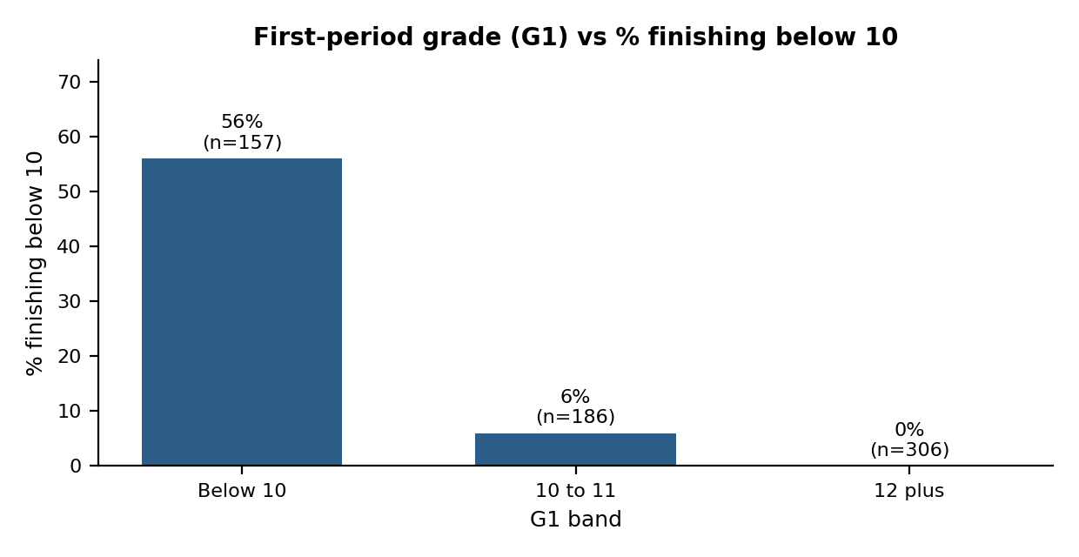
Figure 1. Learners with a G1 below 10 were far more likely to finish below 10 (56%, versus 6% for G1 of 10 to 11 and none for 12 or more).
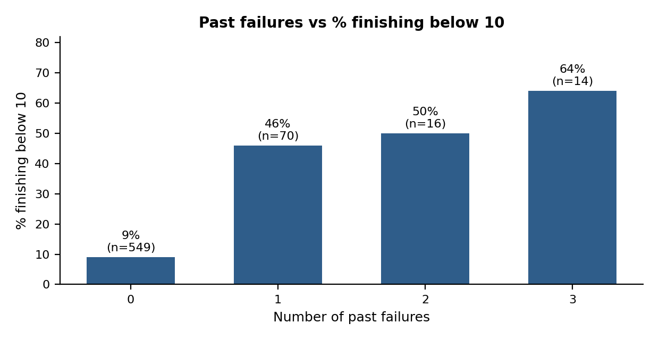
Figure 2. Even one past failure was linked to a much higher rate of low final grades (46% to 64%, versus 9% with none). The group with three failures is small (14 learners).
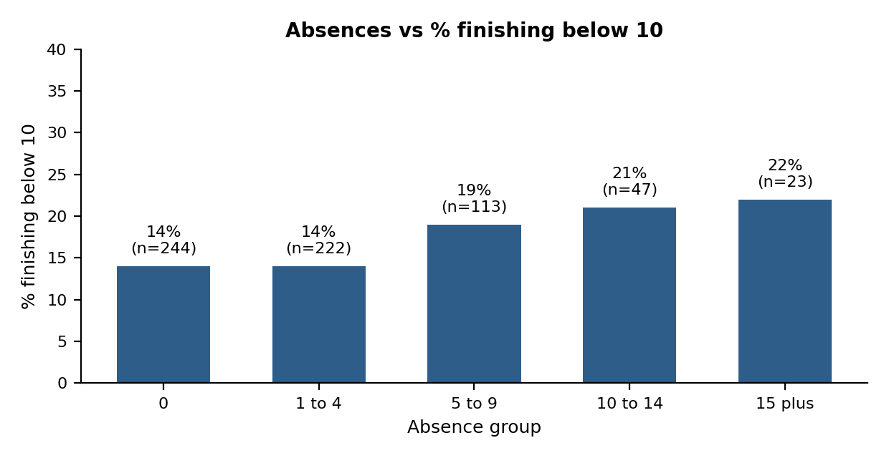
Figure 3. The link with absences is weak: rates rise gradually from 14% to 22%, and the highest groups are small. Absences are a prompt to ask, not a score.
Supporting signals
Signal | Group | % finishing below 10
Study time (self-reported) | 1 / 2 / 3 / 4 | 24% / 13% / 7% / 6%
School support | Yes / No | 12% / 16%

Learners already receiving school support did not do worse, so support status should be used to coordinate help, never as a penalty.
Correlation with the final grade (G3)
Measure | Correlation with G3
G1 | 0.83
G2 | 0.92
Past failures | -0.39
Study time | 0.25
Absences | -0.09

5. Timing check: G1 or G2?
Rule | Flagged | Caught | % of low finishers caught | % of flagged who finished low
G1 below 10 | 157 | 88 | 88% | 56%
G2 below 10 | 145 | 89 | 89% | 61%
G1 of 10 or less | 252 | 98 | 98% | 39%

G1 identifies nearly as many eventual low finishers as G2 while being available a full period earlier, so it supports earlier help. Widening the G1 rule catches more learners but flags many more, which raises facilitator workload. This trade-off is for Milestone 2.1. Many flagged learners still finish above 10, so a flag must lead to a conversation, never a conclusion.

6. Limitations
- These are associations in group data, not causes, and they say nothing certain about any individual learner.
- This is a public dataset, not the programme's learners, so results may not transfer.
- Study time and absences are approximate or self-reported, and absences have many possible causes such as illness, transport or home responsibilities.
- Small groups (15 or more absences, three failures) give unstable percentages.
- Grades can miss barriers that scores do not show.

7. Ethical position and next steps
No demographic, family or lifestyle variables are used in the analysis of signals. Every flag will need facilitator review, and the purpose is supportive follow-up, not labelling or exclusion.
Next, in Milestone 2.1, these findings will be turned into a simple, transparent tier rule using G1, past failures, study time and absences, and tested against final grades.

