UML System Design Document
Mansyd Interior Design & Projects
  - Full-stack business management application
Architecture, domain model, behavior, security boundaries, and deployment view derived from the current Angular and Spring Boot repositories.

Document control | Value
Version | 1.0
Prepared | 2026-08-18
Backend | Java 21 • Spring Boot 3.5 • PostgreSQL • Flyway
Frontend | Angular 20 • standalone components • lazy-loaded routes
Scope | Current implementation in the backend and frontend repositories

Audience
Developers, maintainers, reviewers, and project stakeholders who need a shared technical model of the system.

1. Purpose and scope
This document describes the implemented architecture of the Mansyd Interior Design & Projects application. It uses UML-style context, component, deployment, class, sequence, and state views to explain how the Angular client, Spring Boot API, PostgreSQL schema, and supporting file storage collaborate.

1.1 Modeling conventions
- Solid arrows show primary request, dependency, or creation direction; dashed arrows show configuration influence.
- Multiplicity labels reflect database foreign keys, uniqueness constraints, and JPA relationship annotations.
- DTOs are summarized at module boundaries rather than modeled individually to keep the diagrams readable.
- Audit logs and notifications are cross-cutting records invoked by business services after material actions.
- All models describe the checked-in implementation; they are not aspirational future-state diagrams.

1.2 System synopsis
Customers register, manage their profile, submit service requests, review quotations, follow orders and projects, view appointments and documents, receive notifications, and submit payments. The carpenter role manages the full operational lifecycle, including customers, quotes, projects, billing, inventory, suppliers, expenses, appointments, portfolio content, reports, and audit history.

1.3 Principal quality attributes
Attribute | Implementation evidence
Security | Server-side role checks, session authentication, CSRF cookie/header validation, CORS allow-list, BCrypt passwords
Integrity | Transactional services, JPA relationships, Flyway constraints, unique lifecycle links, enum checks
Traceability | AuditLog records for create, update, submit, issue, approve, reject, archive, and status changes
Responsiveness | Angular lazy-loaded routes and typed API services; paged backend list responses
Operability | Actuator health endpoint, environment-driven configuration, Docker/Nginx assets

2. System context and actors
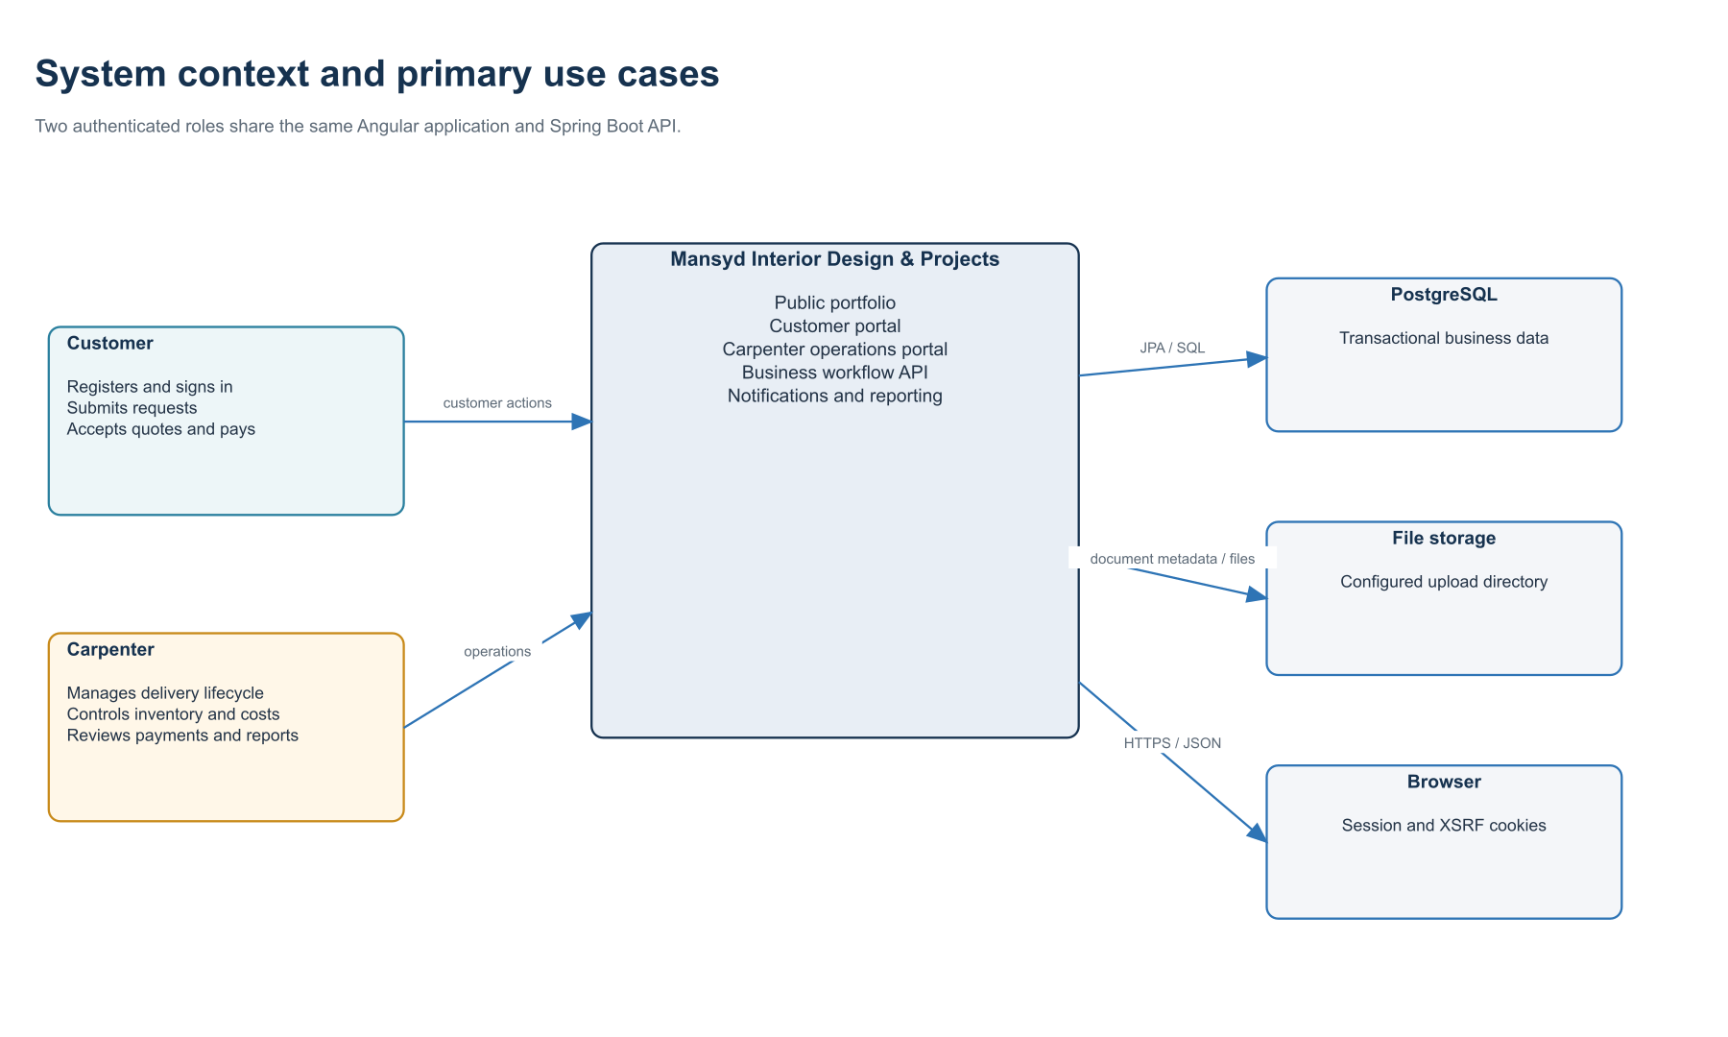
Figure 1. System context and primary actors.

2.1 Role capabilities
Capability | Customer | Carpenter
Identity and profile | Register, sign in/out, update own profile | Sign in/out; inspect customer records
Commercial workflow | Submit requests; review and accept/reject quotations | Triage requests; author quotations; manage orders/projects
Billing | View invoices; submit payment proof | Create/issue invoices; approve/reject payments
Operations | View appointments, project timeline, documents | Manage inventory, suppliers, expenses, appointments, documents
Oversight | Receive personal notifications | Reporting overview, low-stock view, audit log, role notifications

3. Component architecture
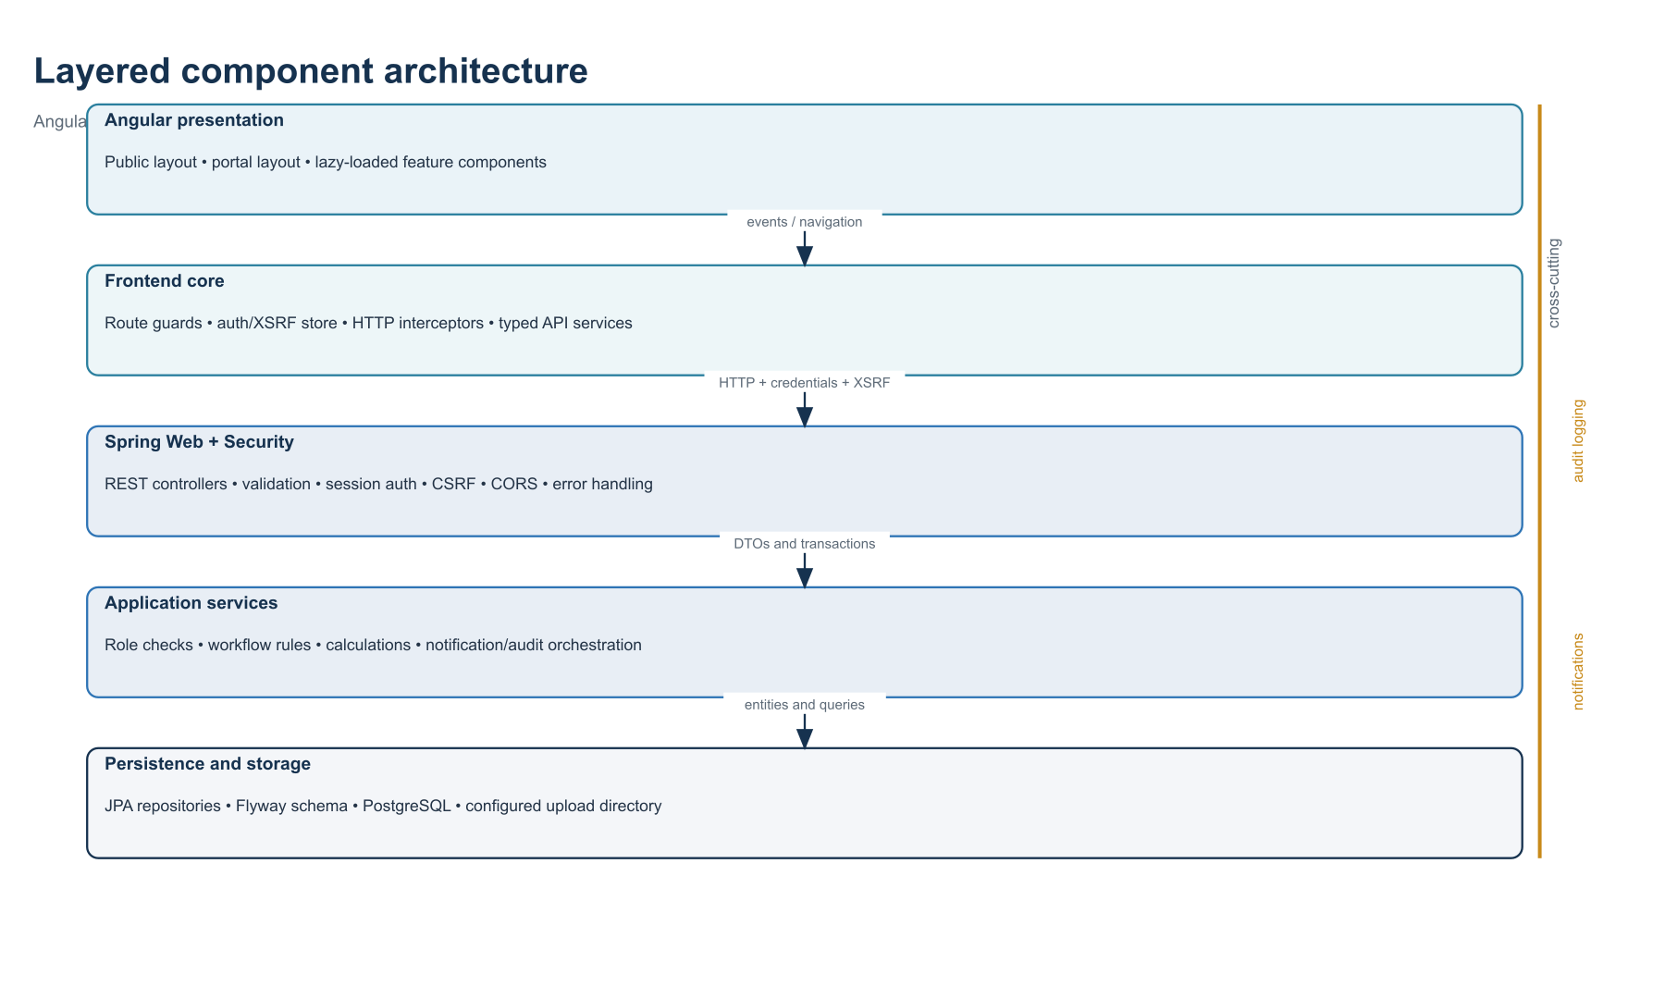
Figure 2. Layered component architecture and cross-cutting services.

3.1 Frontend modules
Area | Representative components/services
Shell and navigation | PublicLayoutComponent, PortalLayoutComponent, role-specific lazy route trees
Core request pipeline | AuthService, CSRF token store, auth/loading/error interceptors, route guards
Customer features | Profile, requests, quotations, orders, projects, billing, appointments, notifications, documents
Carpenter features | Requests, quotes, orders, projects, portfolio, billing, inventory, expenses, reporting, audit logs
API boundary | Typed *ApiService classes and feature-specific model records/interfaces

3.2 Backend module pattern
Most business modules follow Controller → Service → Repository → Entity/DTO. Services enforce role and ownership rules, validate allowed state transitions, persist changes transactionally, and then invoke audit or notification services when the action is externally meaningful.

4. Deployment view
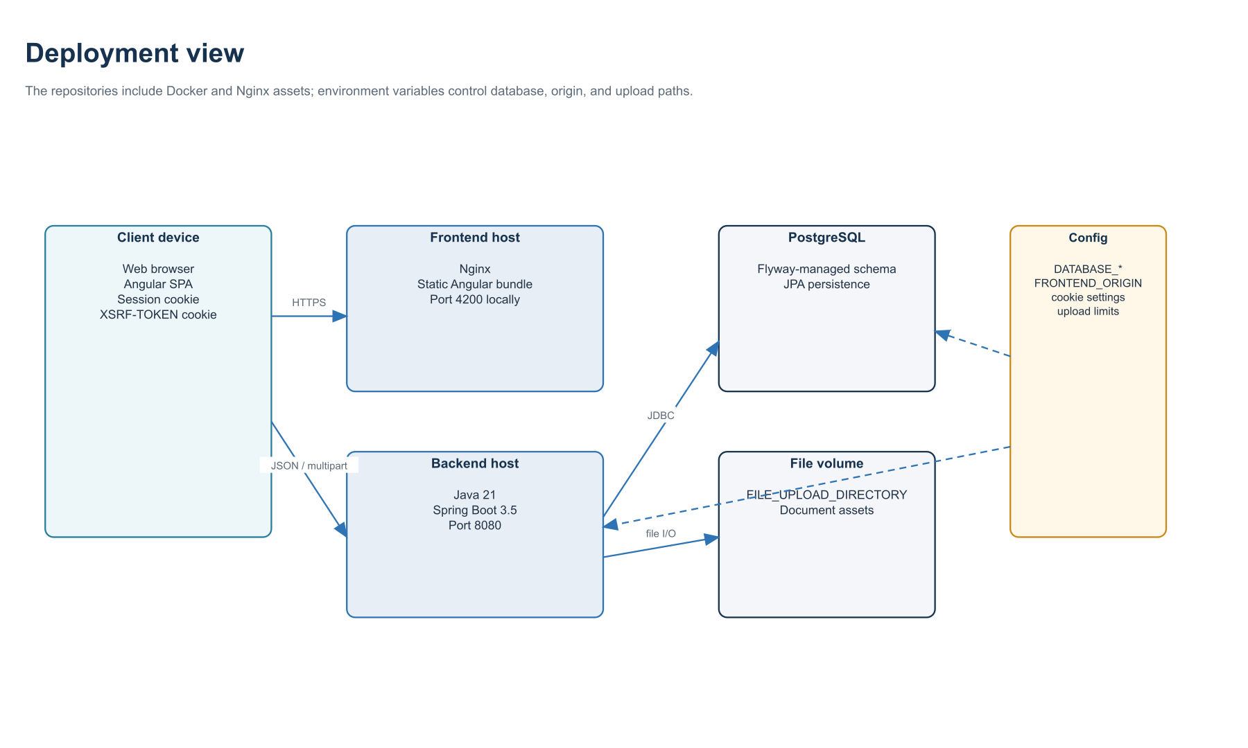
Figure 3. Logical deployment and configuration boundaries.

4.1 Runtime interfaces
Interface | Protocol / control
Browser → frontend | HTTPS static assets; client-side routing
Browser → backend | JSON and multipart HTTP; credentials included; X-XSRF-TOKEN on unsafe methods
Backend → PostgreSQL | JDBC through Spring Data JPA; schema validated and migrated by Flyway
Backend → file volume | Configured upload directory; request limits 10 MB per file and 20 MB per request
Operations | Actuator health/info; OpenAPI and Swagger UI endpoints

5. Domain class model
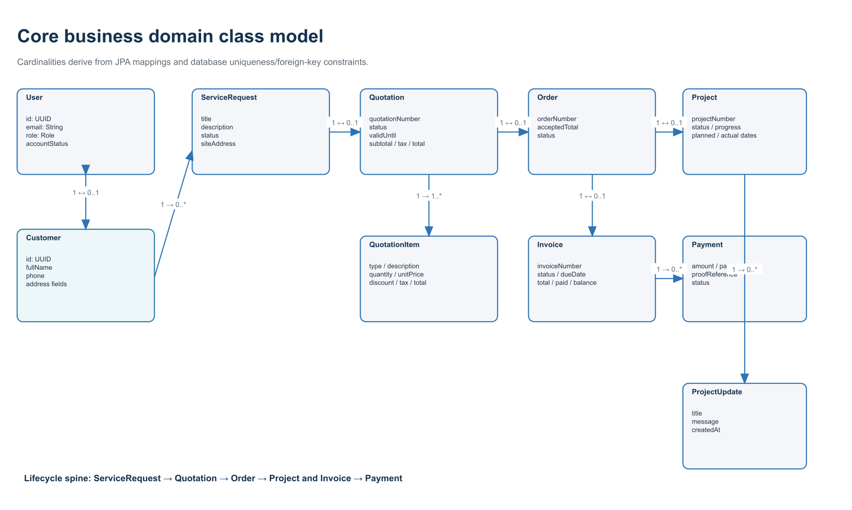
Figure 4. Core commercial and delivery entities.
The central lifecycle is deliberately constrained by unique one-to-one links: one service request can have at most one quotation; one quotation at most one order; one order at most one project and one invoice. This simplifies lifecycle ownership while payments and updates remain one-to-many details.

5.1 Supporting operational entities
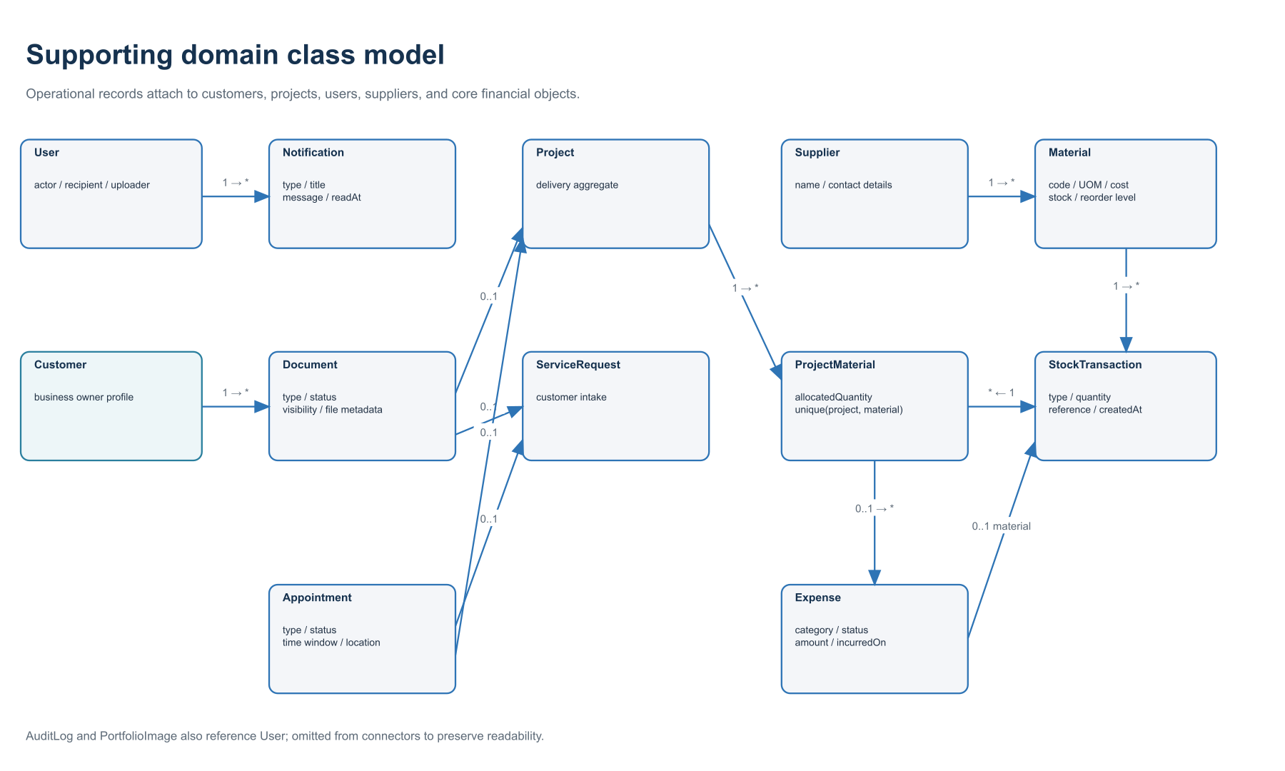
Figure 5. Operational, inventory, document, and communication entities.
Documents, appointments, and expenses may be attached to optional lifecycle entities while retaining a required customer or user context where appropriate. ProjectMaterial is the associative entity for allocated inventory, protected by a unique project/material key.

5.2 Entity responsibility catalog
Aggregate / entity | Responsibility
User + Customer | Authentication identity and customer business/contact profile
ServiceRequest | Initial statement of customer need and triage status
Quotation + QuotationItem | Priced offer, tax/discount calculations, customer decision
Order + Project + ProjectUpdate | Accepted work, delivery status, progress, and visible timeline
Invoice + Payment | Amount due, payment evidence, review decision, and balance reconciliation
Supplier + Material + StockTransaction + ProjectMaterial | Procurement reference, stock ledger, and project allocation
Expense | Project/supplier/material-linked cost and reimbursement state
Appointment + Document | Scheduled touchpoints and customer-visible business artifacts
Notification + AuditLog | User attention and immutable operational trace

6. Behavioral sequences
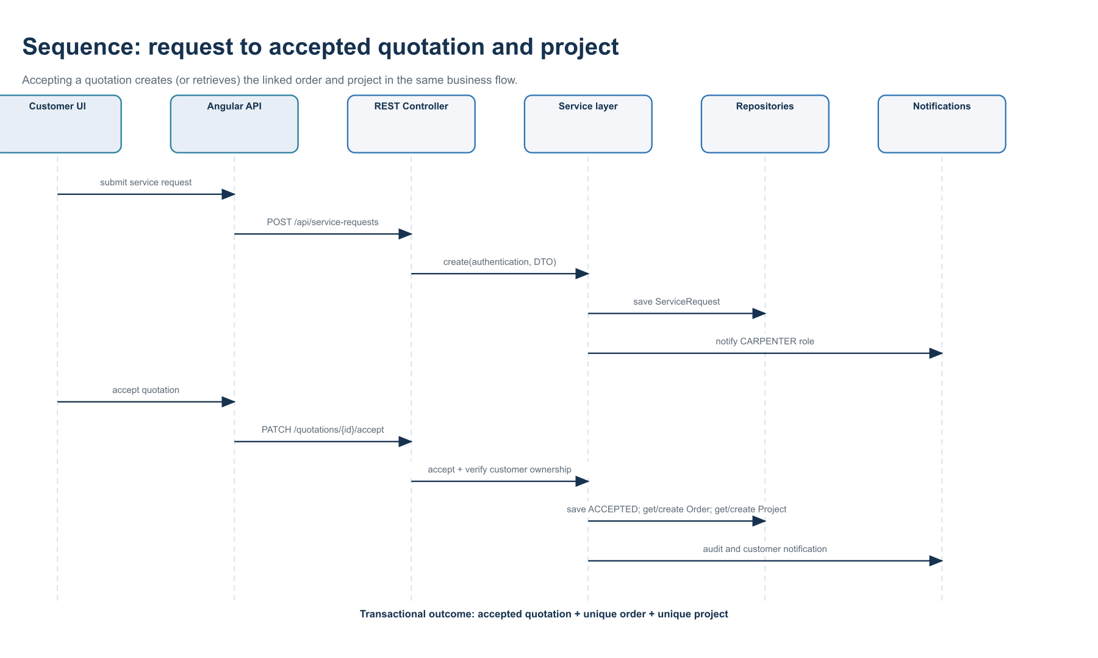
Figure 6. Request, quotation acceptance, order, and project creation sequence.

6.1 Business rules shown
- The customer submits a request under an authenticated CUSTOMER session.
- The request service persists the record, writes an audit entry, and notifies users with the CARPENTER role.
- The carpenter authors and submits a quotation; the customer may act only on a quotation belonging to that customer.
- Acceptance changes the quotation state and invokes idempotent get-or-create operations for the unique order and project.
- Subsequent order and project state changes remain carpenter-controlled and are validated against allowed transition maps.

6.2 Invoice and payment approval
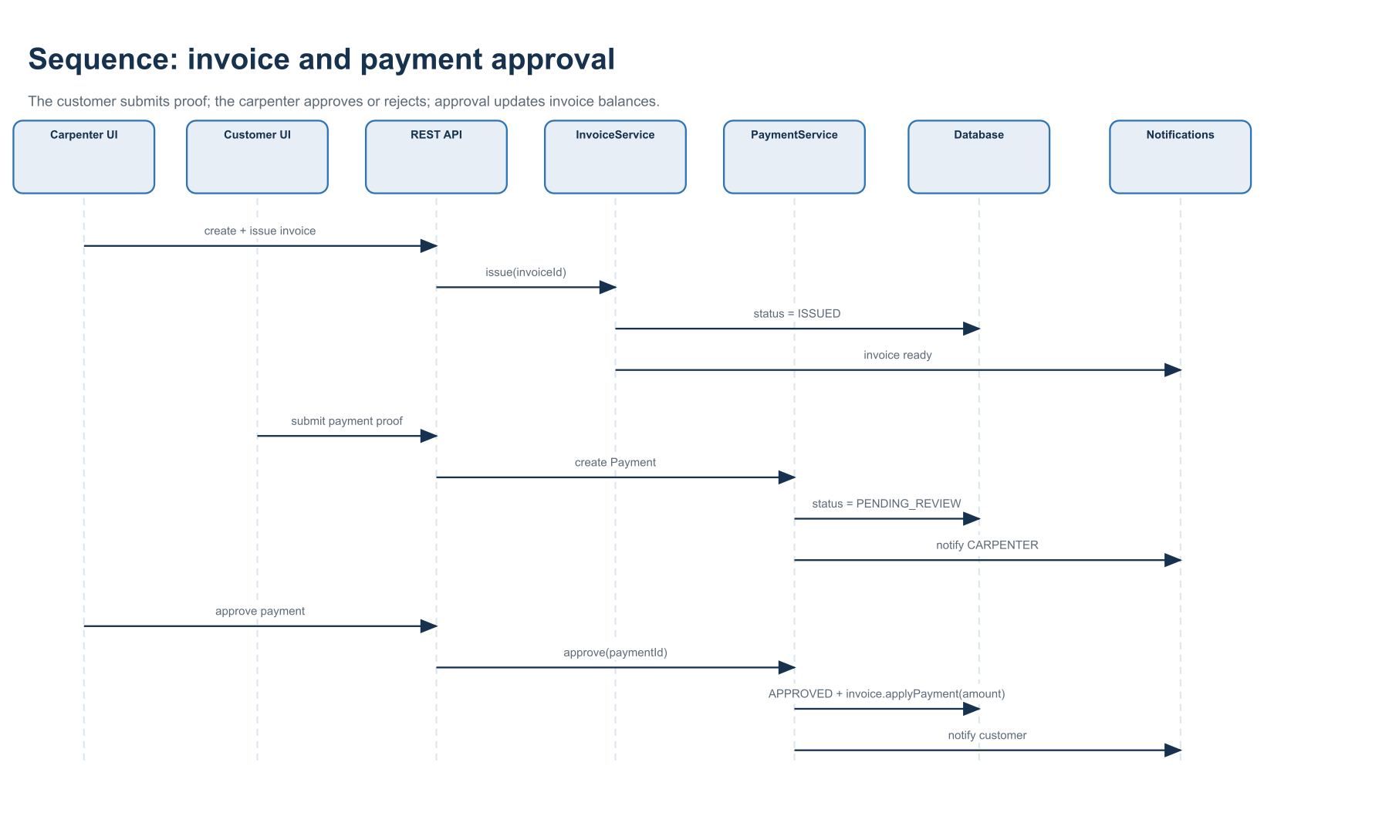
Figure 7. Invoice issue and payment approval sequence.
A submitted payment remains PENDING_REVIEW until the carpenter decides. Approval applies the payment amount to the invoice, which recalculates paid amount, balance due, and the invoice status. Both approval and rejection create an audit record and notify the customer.

6.3 Authentication request path
- The browser first obtains or receives the XSRF-TOKEN cookie and sends credentials with API requests.
- Login and registration are public POST endpoints; authenticated sessions are stored server-side through Spring Security.
- Angular guards check session state and role before activating customer or carpenter route trees.
- For unsafe methods, the auth interceptor copies XSRF-TOKEN into the X-XSRF-TOKEN header.
- The backend validates CSRF, authentication, global URL rules, and module-level role/ownership rules before business execution.

7. State and lifecycle model
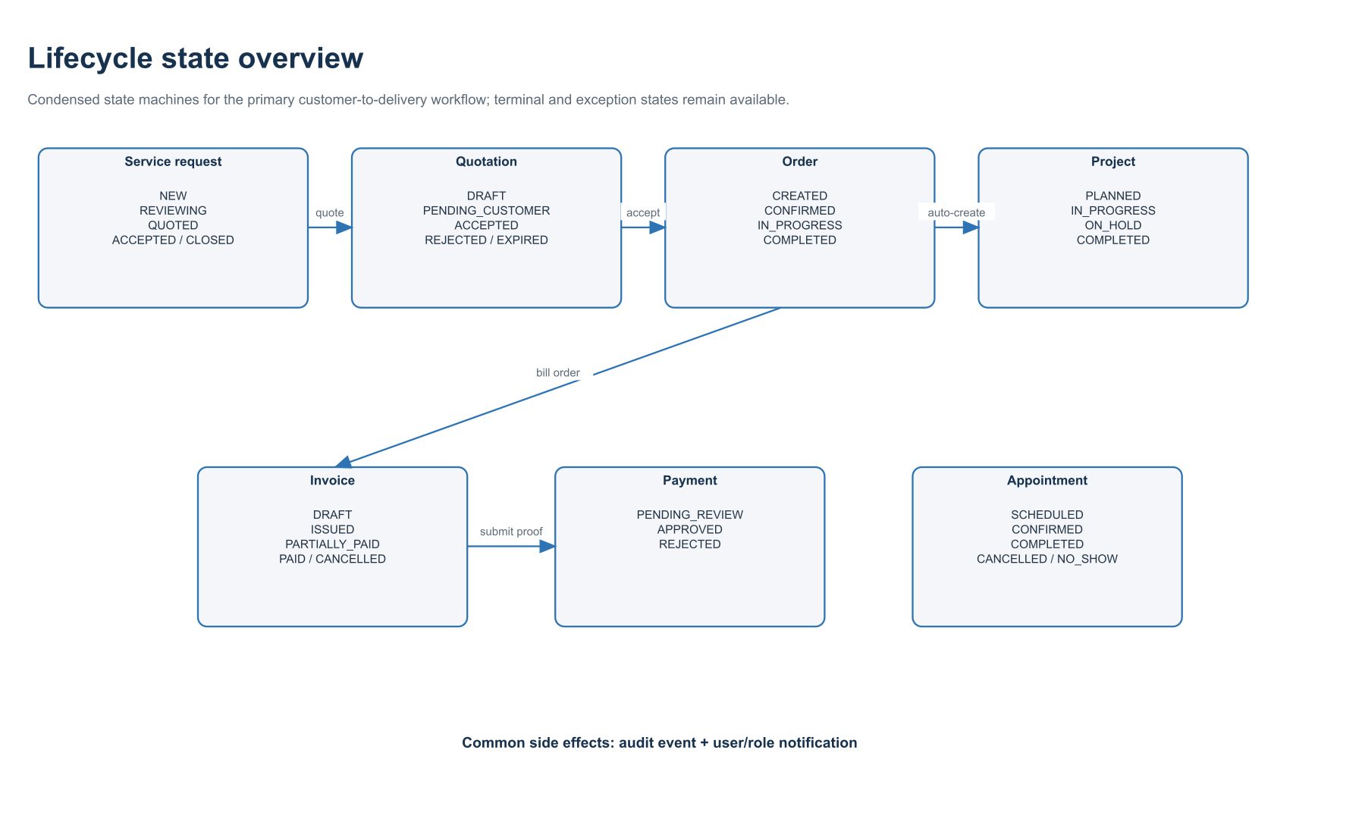
Figure 8. Condensed lifecycle states and creation triggers.

7.1 State-control summary
Object | Primary decision owner | Important behavior
Service request | Carpenter | Customer creates; carpenter moves through review/quote/closure states
Quotation | Carpenter then customer | Carpenter drafts/submits; customer accepts or rejects; acceptance creates order/project
Order | Carpenter | Operational delivery states are guarded by an allowed-transition map
Project | Carpenter | Status, progress, planned/actual dates, and timeline updates
Invoice | Carpenter | Draft creation, issue/cancel; payment application derives paid/balance status
Payment | Customer then carpenter | Customer submits evidence; carpenter approves or rejects once
Appointment | Carpenter | Create/update/status transitions; customer receives notifications

8. Security and authorization model

8.1 Security boundary
Security is enforced on the server even when Angular guards hide routes. Spring Security permits registration, login, CSRF initialization, public portfolio reads, health, and API documentation. Other endpoints require authentication; business services then enforce role and customer ownership.
Control | Implementation
Authentication | Spring Security session; maximum one concurrent session per user
Password storage | BCryptPasswordEncoder
CSRF | CookieCsrfTokenRepository; readable XSRF cookie, validated request header
CORS | Single normalized FRONTEND_ORIGIN; credentials allowed; constrained methods/headers
Authorization | CARPENTER/CUSTOMER roles plus service-level ownership checks
Error contract | Structured JSON ApiError for unauthenticated and validation/business failures
Account control | ACTIVE, DISABLED, and LOCKED account statuses

8.2 Access matrix
Resource | Public | Customer | Carpenter
Portfolio | Read images/content | Read | Read and upload
Requests / quotations | — | Own records and decisions | All records and lifecycle management
Orders / projects | — | Own read access | All read/update/status/timeline
Invoices / payments | — | Own invoices; submit payment | Create/issue/cancel; review payments
Inventory / suppliers / expenses / reports / audit | — | — | Operational access
Appointments / documents / notifications | — | Own/visible records | Create and manage operational records

9. REST endpoint and module map
API family | Core operations | Primary role
/api/auth | register, login, logout, session, csrf | Public / authenticated
/api/customers | own profile; customer list/detail | Customer own / Carpenter
/api/service-requests | create, list own/all, update, change status | Both, scoped
/api/quotations | CRUD/items, submit, accept, reject | Both, lifecycle-scoped
/api/orders and /api/projects | list own/all, status, project updates | Both, scoped
/api/invoices and /api/payments | invoice lifecycle; payment submit/review | Both, scoped
/api/materials and /api/stock-transactions | catalog, stock ledger, project allocation | Carpenter
/api/suppliers and /api/expenses | supplier CRUD; expense workflow | Carpenter
/api/appointments | schedule, query, update, status | Both, scoped
/api/documents | create, list, update, archive; customer-visible list | Both, scoped
/api/notifications | list, unread count, mark read | Authenticated user
/api/reports and /api/audit-logs | overview and trace queries | Carpenter
/api/portfolio | public list/content; authenticated upload | Public / Carpenter

9.1 Shared API conventions
- UUID identifiers are used across persistent entities.
- Paged list endpoints return a shared PageResponse shape.
- Input DTOs use Jakarta validation; errors are normalized by GlobalExceptionHandler.
- Dates/times use Java LocalDate, Instant, or offset-aware frontend strings according to the record type.
- OpenAPI documentation is exposed through springdoc and Swagger UI.

10. Design observations and extension points

10.1 Strengths of the current design
- The commercial lifecycle is explicit, traceable, and protected by unique links and state transition checks.
- Role checks live in backend services, avoiding reliance on client-side route protection.
- Audit and notification concerns are reusable services invoked consistently across important actions.
- The Angular architecture mirrors backend domains through typed models and API services.
- Flyway migrations form an auditable, environment-repeatable schema history.

10.2 Notable architectural considerations
- Document rows currently model file metadata and lifecycle associations; production deployments should ensure the configured file volume is durable, backed up, and access-controlled.
- Session cookies should enable secure transport settings in production and FRONTEND_ORIGIN should be restricted to the deployed frontend.
- Notifications are persisted in the application database; real-time delivery or email/SMS would be separate adapters around NotificationService.
- Reporting is implemented as application queries over transactional data; higher data volumes may justify read models or scheduled aggregates.
- The one-quotation-per-request and one-invoice-per-order constraints are deliberate current rules; supporting revisions or milestone billing would require schema and aggregate changes.

10.3 Recommended diagram maintenance
- Update the class model whenever a Flyway migration adds or changes a relationship.
- Update lifecycle diagrams whenever an allowed-transition map or enum changes.
- Update the component and endpoint maps when a new Angular feature route or REST controller is introduced.
- Treat the repositories and generated OpenAPI description as the source of truth when resolving discrepancies.

Appendix A. Implementation sources
The models in this document were derived from the following checked-in source areas.
Concern | Source location
Database entities and relationships | backend/src/main/resources/db/migration/V1…V14
JPA mappings and domain rules | backend/src/main/java/com/carpenter/business/**
Security | backend/.../config/SecurityConfig.java and security package
REST surface | backend module *Controller.java classes
Application workflows | backend module *Service.java classes
Frontend navigation | frontend/src/app/app.routes.ts and dashboard role route files
Frontend API boundary | frontend/src/app/core/services and core/models
Deployment/runtime | pom.xml, application.yml, Dockerfile, nginx.conf, package.json

Appendix B. UML legend
Notation | Meaning
1 ↔ 0..1 | Required source with an optional unique dependent
1 → 0..* | One parent can own or reference many dependent records
Solid arrow | Request, dependency, creation, or data relationship
Dashed arrow | Configuration or non-runtime structural influence
Blue component | Application-managed component or record
Gold accent | Cross-cutting or operational concern

